



Datum: [2 October 2015]

Versie: 1.0

Installation

FieldAnywhere

# Inhoudstafel

1 Prerequisites 4

2 Installation 5

|  |  |  |  |
| --- | --- | --- | --- |
| **Goedkeuring voor gebruik** | | | |
| **Delaware Consulting** | **Naam** | **Handtekening** | **Datum** |
| **Opgesteld door:** | Robin Vantorre |  | 2/10/2015 |
|  |  |  |  |
|  |  |  |  |
|  |  |  |  |
| **Goedgekeurd door:** |  |  |  |
|  |  |  |  |

|  |  |
| --- | --- |
| **Distributie** | |
|  |  |
|  |  |
|  |  |

|  |  |  |
| --- | --- | --- |
| **Historiek van veranderingen** | | |
| **Versie** | **Datum** | **Beschrijving** |
| **1.0** | 2/10/2015 | Start document |
|  |  |  |
|  |  |  |
|  |  |  |

# Prerequisites

Make sure you have folder containing the following files:

* 1 powershell file: ex Add-AppDevPackage
* Folder dependencies
* Folder Add-AppDevPackage.resources
* 1 APPX File (name of the file varies)
* 1 Security Certificate

# Installation

1. Run the PowerShell file with PowerShell  
   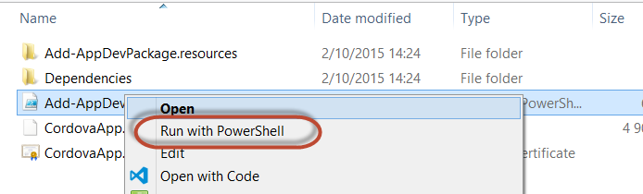
2. Accept the security certificate by pressing Y and hit <Enter>
3. App gets installed  
   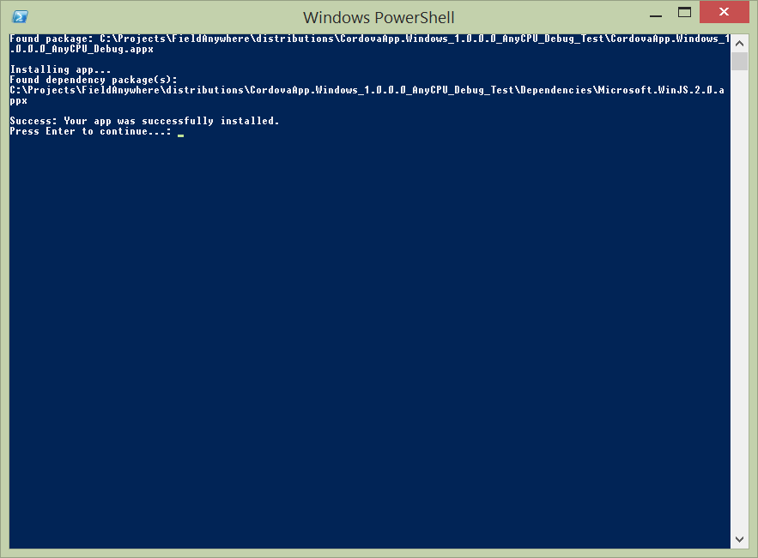

Note: If a previous version of the app was installed, uninstall this version before installing the new version.