

Snag
Workplace issue reporting and defensible health & safety compliance, built for New Zealand SMEs
Feature Prospectus — prepared 20 July 2026
For prospective customers and investors

Executive Summary
Snag is a mobile-first app that lets any worker report a problem — a broken guard rail, a near-miss, a serious injury — in under a minute, and gives supervisors and admins the tools to triage, investigate, and close it out with a record that stands up to scrutiny. It runs on two lanes: everyday niggles (fixits and improvements) move through a simple status board, while serious incidents (hazards and injuries) are gated behind a guided investigation — checklist, witnesses, evidence, root cause, corrective actions — before they can be closed.
For customers: less time on paperwork, a single place workers actually use (because it takes seconds, not minutes), and — increasingly — compliance scaffolding most competitors don't offer: guided notifiable-event decisions, due-diligence exports an officer can put in front of a board, and records that are structurally impossible to quietly delete.
For investors: New Zealand's Health and Safety at Work Act 2015 already asks small businesses (fewer than 20 workers — roughly 97% of NZ businesses) to show they've engaged with risk; the 2026 Amendment Act narrows and sharpens that duty rather than removing it. Snag's data model was built compliance-first — row-level security on every table, RPC-only writes, a full audit trail, records that can't be deleted — and the product now ships features (Section “Compliance, built in” below) that translate that architecture into things a customer's officer can actually point to. That's a real moat: it's expensive to retrofit, and cheap to have built in from day one.

What can Snag do?
Everything below is shipped and running today — screenshots throughout are from a seeded demo organisation, not mockups of unbuilt features.

Report in seconds
A worker opens the app, describes what's wrong, picks a type, optionally attaches a photo, and submits — most reports take under a minute. No login friction for one-off reporters either: a site can generate a public QR code so a visitor, contractor, or member of the public can report a hazard without ever creating an account.
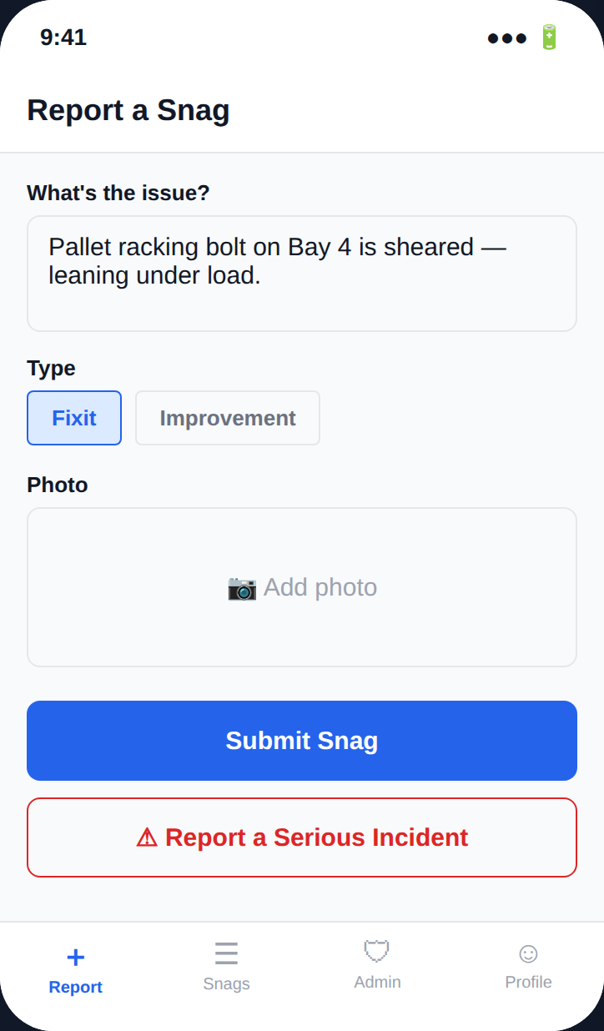
Reporting screen — description, type, optional photo, and the serious-incident escalation path.

Two lanes: niggles vs. serious incidents
Everyday fixes and safety-critical events are deliberately kept apart. Niggles (fixit/improvement) move through a lightweight flagged → in progress → resolved board. Hazards and incidents enter the serious lane, where resolving them is gated behind a real investigation — nothing slips through because someone marked it “done” in a hurry. Duplicate reports of the same underlying issue can be merged into one trackable record instead of being resolved five separate times.
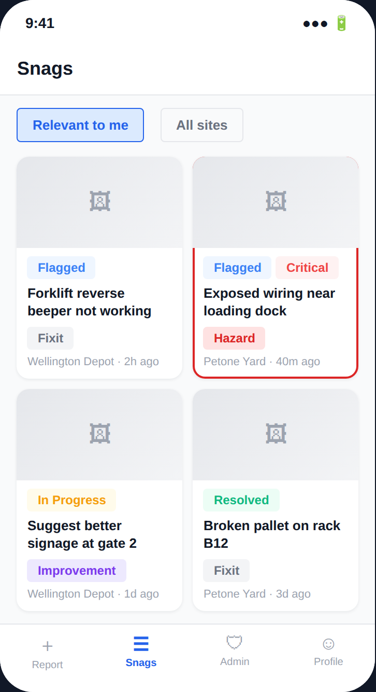
The Snags list — filterable, colour-coded by status/type/severity, injury-severity items pinned to the top.

Guided investigation & defensible records
A serious incident can't be closed until a supervisor works through a first-response checklist (make the area safe, preserve the scene, capture evidence, identify witnesses, find the root cause), records at least one witness statement and one piece of evidence, and documents a root cause. From there, a formal 5-Whys root cause analysis can be delegated to anyone on site; corrective actions require independent verification (the person who marks an action done can't also be the one who signs it off); and a hot or formal debrief captures findings, attendees, and lessons learned. The whole file — checklist, statements, evidence, RCA, corrective actions, debrief — exports as a single timestamped PDF.
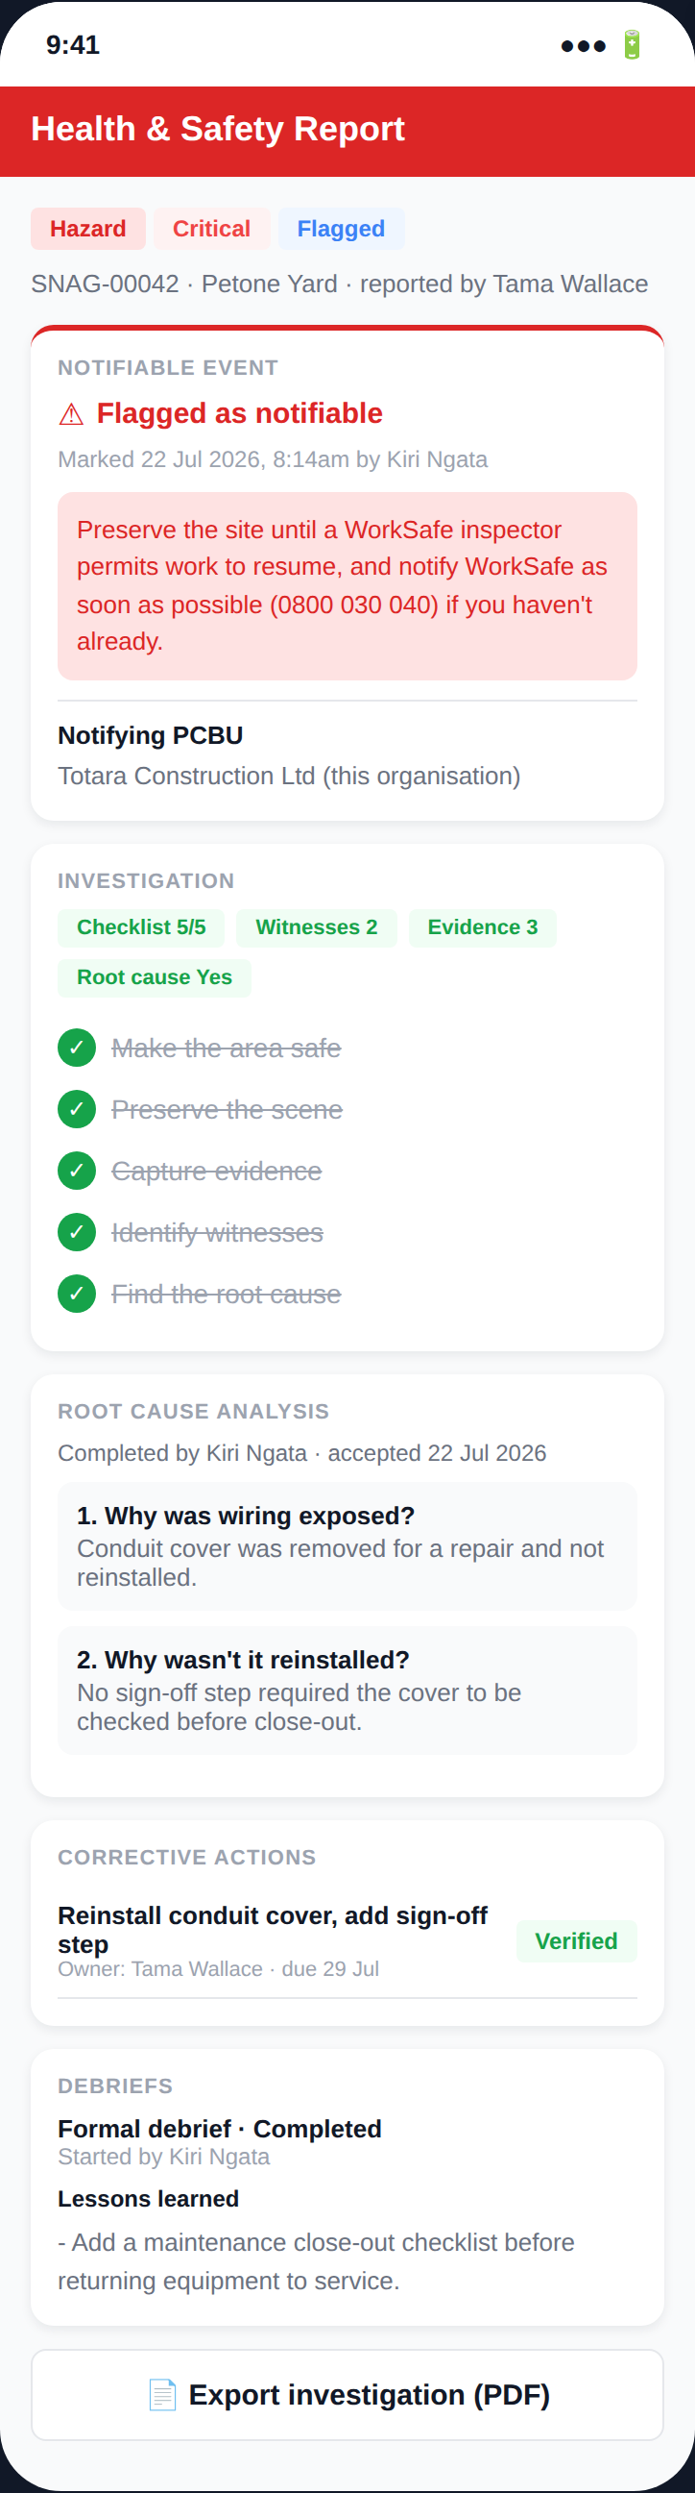
A serious incident's full record — notifiable-event decision, investigation, RCA, corrective actions, and debrief in one place.

Compliance, built in
This is the newest and most differentiated part of the product — a direct response to New Zealand's HSWA obligations, not a generic “safety app” feature list:
- Notifiable-event decision support — a guided prompt walks a supervisor through WorkSafe's notifiable-event criteria the moment a serious incident is reviewed, immediately surfaces the “preserve the site” instruction, and timestamps the decision — visible in the screenshot above.
- Retention & privacy minimisation — serious/notifiable records are kept in full indefinitely for defensibility; ordinary resolved niggle records are automatically minimised after a conservative period, so personal data isn't retained forever by default.
- Governance due-diligence export — a quarterly PDF an officer can generate straight from the app, summarising open risk, notifiable events, and site-by-site outstanding work — the artefact a board actually wants to see, not a raw stats screen.
- Multi-PCBU notification nomination — when a contractor or another business is involved in a shared-site incident, the app records who's taking on the (single, shared) WorkSafe notification obligation.
General guidance, not legal advice: compliance content in-app carries this caveat throughout, and any customer-facing legal claims should be reviewed by a qualified NZ health & safety lawyer before release.

Team & site management
Admins and supervisors get an outstanding-work view per site (open investigations, unassigned reports, overdue corrective actions), work groups that auto-route new snags to the right team, multi-site and multi-organisation support (including contractors who work across more than one customer's sites), and full member/role/invite management via QR join codes.
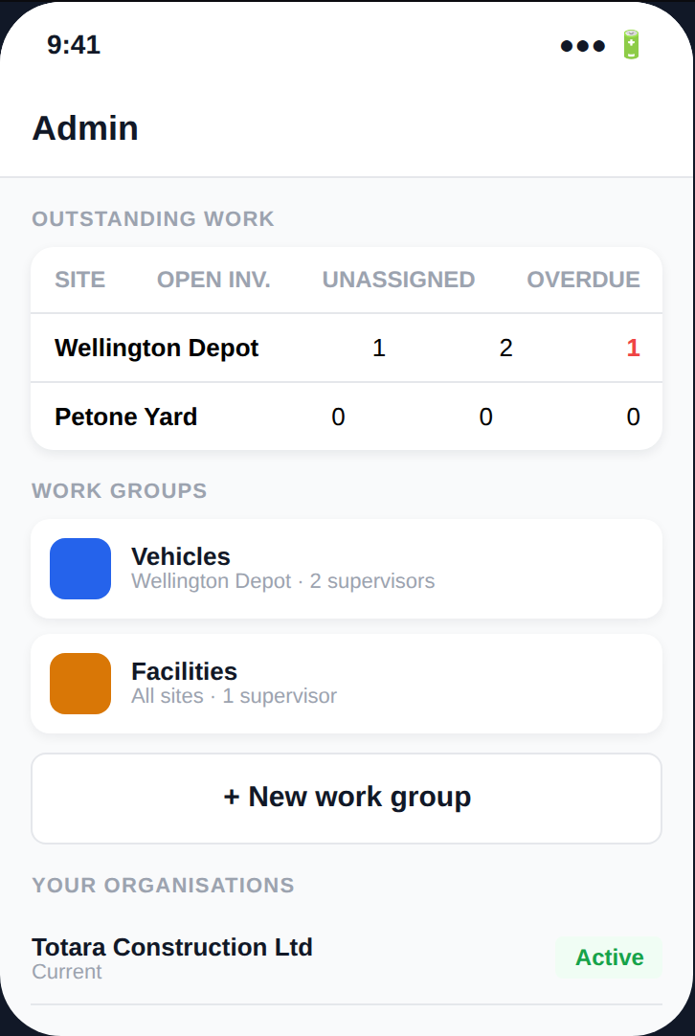
Admin dashboard — outstanding work by site and work-group routing.

Reporting & insight
Live organisation-wide stats (by status, type, severity), a per-site breakdown of open work, and — new — the one-tap governance export described above.
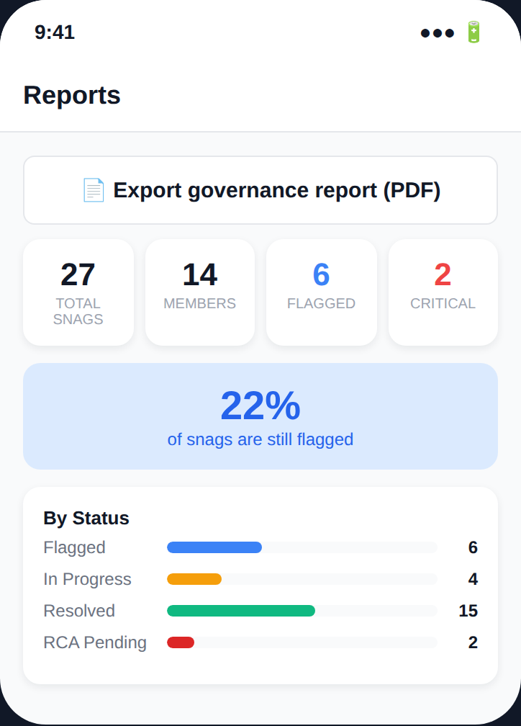
Reports screen, including the new governance-export action.

Security & trust architecture
This is as much a product feature as an engineering choice: every table has row-level security scoped to the signed-in user's organisation and site; every write goes through a permission-checked server function, never a raw table edit; every meaningful action is written to an append-only audit log; and once a snag is created, it can never be deleted — a structural guarantee, not a policy someone has to remember to follow.

Who it's for
Small and mid-sized New Zealand businesses under HSWA — construction, trades, manufacturing, logistics, and other industrial/field-based operations — where workers are spread across sites, paperwork is the thing that never quite gets done, and a serious incident needs a record that holds up months later, not a group-chat screenshot. The two-lane model and QR-based onboarding mean a whole site crew can be reporting within minutes, with no IT rollout.

Roadmap
Sequenced, not speculative — each item below builds on what's already shipped:
- Access & Concierge — a Health & Safety Representative role with read visibility into hazard/incident data, and a premium “Compliance Concierge” tier: Snag's own staff triaging ambiguous or high-severity notifiable-event calls across customers, without ever touching a customer's own investigation record.
- Post-election backlog — a critical-risk taxonomy and a psychosocial-hazard category, deliberately held until the Health and Safety at Work Amendment Act 2026's post-election fate is confirmed, so the product isn't built around a law that could still change.

Appendix
Screenshots throughout this document are captured from a seeded demonstration organisation created for this purpose, not a live customer's data. All compliance-related statements are general guidance for product-planning purposes, not legal advice — see the callout in “Compliance, built in” above.

