

**IZMIR INSTITUTE OF TECHNOLOGY DEPARTMENT OF COMPUTER ENGINEERING**

**TERM PROJECT:**

**“HOTEL MANAGEMENT**

**SYSTEM DATABASE”**

By: **GROUP 18**

Hazim Alper ATA– 260201044

Umut YILDIZ – 260201028

Burak CABADAN – 260201006

Burak SALER – 260201032

Date: 08.11.2021

**All Entities and Their Attributes**

**Customer** (customerID, first_name, last_name, gender, birth_date, nationalID, age, address, phone)

**Employee** (employeeID, first_name, last_name, gender, birth_date, age, address, phone)

**EmployeeType** (type_name, salary)

**Booking** (bookingID, bookerID, customers, booking_date, enter_date, exit_date)

**Room** (roomID, status, phone)

**RoomType** (type_name, description)

**Image** (image_name)

**RoomPrice**(date_from, date_to, price)

**Comment**(commentID, description, score)

**Relationship Sets**

**r_room_type** (type_name, roomID); // total participation one-to-many

**r_book_room** (roomID, bookingID); // many-to-many

**r_bill** (bookingID, customerID, bill_time, paid_time, total_price, exp_time, payment_method, status());

// total participation many-to-many

**r_book_item**(bookingID, customerID) // many-to-many

**r_image** (image_name); // one-to-many

**r_employee_type** (employeeID, employee_type); // total participation one-to-many

**r_room_comment** (roomID, commentID); // one-to-many

**r_emp_comment** (employeeID, commentID); // one-to-many

**r_comments** (customerID, commentID): // one-to-many

**r_price_season**(type_name, date_from, date_to); // one-to-many

**r_emp_book** (bookingID, employeeID); // one-to-many

**ER Diagram**

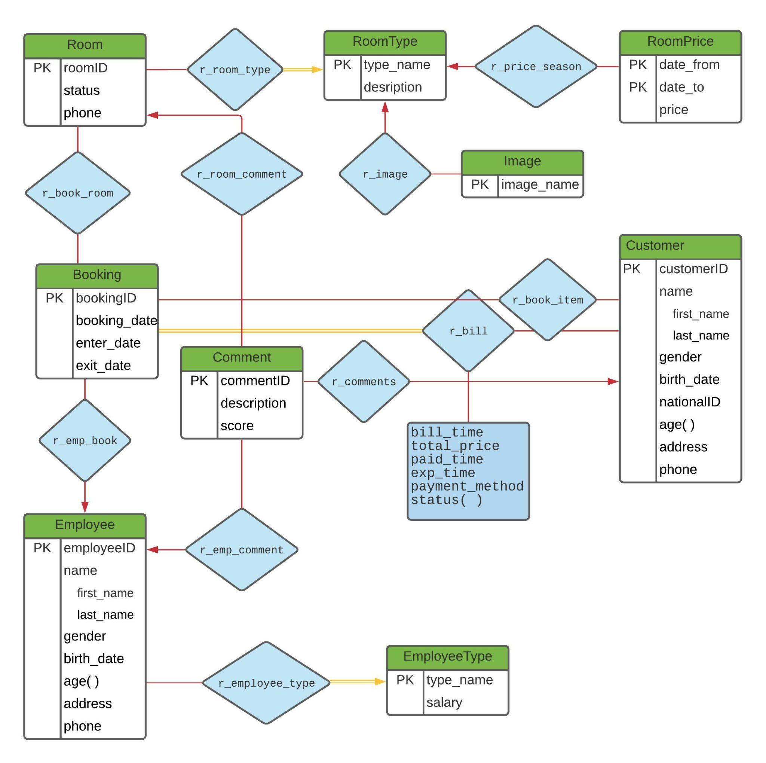[Diagram Link](https://lucid.app/lucidchart/b7f60037-6fa3-487e-b899-4cc250cd3623/edit?invitationId=inv_53ea57b9-6b86-4c2d-8d5a-d9e76ca78546)

**System Users**

• People who want to stay at hotel,

• Person who wants to run and manage a hotel,

• People who want to work in a hotel (receptionist…) .

**Business Rules**

Room/ Room Type

• A room cannot have more than one room type.

• A room type can describe more than one room.

Room/ Booking

• A booking may contain more than one room.

• A room may be included in more than one booking.

Booking/ Customer - (r_bill)

• A customer can make many booking

Booking/ Customer - (r_book_item)

• A booking may include many customer

Room Type/ Image

• A room type may have many images.

• An image must be for one room type.

Employee/Employee Type

• An employee must have one employee type.

Room/ Comment

• A comment must have one room.

• A room may have many comments.

Employee/ Comment

• A comment must have one employee.

• An employee may have many comments.

Comment/ Customer

• A comment must have one customer.

• A customer may make many comments.

PriceSeason/ Room Type

• A room must have one price season.

• A price season may be used by many room types.

Employee/Booking

• An employee may be in relation with may booking.

• A booking may not be booked by more than one employee.

**Relational Schemas**

**ERD to Relational Schema**

Step 1:

**Customer** (customerID, first_name, last_name, gender, birth_date, nationalID, age, address, phone)

**Employee** (employeeID, first_name, last_name, gender, birth_date, age, address, phone)

**EmployeeType** (type_name, salary)

**Booking** (bookingID, bookerID, customers, booking_date, enter_date, exit_date)

**Room** (roomID, status, phone)

**RoomType** (type_name, description)

**Image** (image_name)

**RoomPrice**(date_from, date_to, price)

**Comment**(commentID, description, score)

**r_room_type** (type_name, roomID); // total participation one-to-many

**r_book_room** (roomID, bookingID); // many-to-many

**r_bill** (bookingID, customerID, bill_time, paid_time, total_price, exp_time, payment_method, status());

// total participation many-to-many

**r_book_item**(bookingID, customerID) // many-to-many

**r_image** (image_name); // one-to-many

**r_employee_type** (employeeID, employee_type); // total participation one-to-many

**r_room_comment** (roomID, commentID); // one-to-many

**r_emp_comment** (employeeID, commentID); // one-to-many

**r_comments** (customerID, commentID): // one-to-many

**r_price_season**(type_name, date_from, date_to); // one-to-many

**r_emp_book** (bookingID, employeeID); // one-to-many

Step 2:

**Customer** (customerID, first_name, last_name, gender, birth_date, nationalID, age, address, phone)

**Employee** (employeeID, first_name, last_name, gender, birth_date, age, address, phone, type_name)

**EmployeeType** (type_name, salary)

**Booking** (bookingID, bookerID, booking_date, enter_date, exit_date, employeeID)

**Room** (roomID, status, phone, type_name)

**RoomType** (type_name, description)

**Image** (image_name, type_name)

**RoomPrice**(date_from, date_to, price, type_name)

**Comment**(commentID, description, score, roomID, employeeID, customerID)

**r_room_type** ~~(type_name, roomID); // total participation one-to-many~~

**r_book_room** (roomID, bookingID); // many-to-many

**r_bill** (bookingID, customerID, bill_time, paid_time, total_price, exp_time, payment_method, status());

// total participation many-to-many

**r_book_item**(bookingID, customerID) // many-to-many

**r_image** ~~(image_name); // one-to-many~~

**r_employee_type**~~(employeeID, employee_type); // total participation one-to-many~~

**r_room_comment**~~(roomID, commentID); // one-to-many~~

**r_emp_comment** ~~(employeeID, commentID); // one-to-many~~

**r_comments** ~~(customerID, commentID): // one-to-many~~

**r_price_season**~~(type_name, date_from, date_to); // one-to-many~~

**r_emp_book** ~~(bookingID, employeeID); // one-to-many~~

Step 3:

**Customer** (customerID, first_name, last_name, gender, birth_date, nationalID, age, address, phone)

**Employee** (employeeID, first_name, last_name, gender, birth_date, age, address, phone, type_name)

**EmployeeType** (type_name, salary)

**Booking** (bookingID, bookerID, booking_date, enter_date, exit_date, employeeID)

**Room** (roomID, status, phone, type_name)

**RoomType** (type_name, description)

**Image** (image_name, type_name)

**RoomPrice**(date_from, date_to, price, type_name)

**Comment**(commentID, description, score, roomID, employeeID, customerID)

**r_book_room** (roomID, bookingID); // many-to-many

**r_bill** (bookingID, customerID, bill_time, paid_time, total_price, exp_time, payment_method, status());

// total participation many-to-many

**r_book_item**(bookingID, customerID) // many-to-many

**Screenshots**

1. After executing script in oracle live sql. (There are 12 statements that tries to drop tables before creation. That is the reason of 12 warnings.)

~~

2) Schema

3) The console output, after script is run in worksheet.

ORA-00942: table or view does not exist

ORA-00942: table or view does not exist

ORA-00942: table or view does not exist

ORA-00942: table or view does not exist

ORA-00942: table or view does not exist

ORA-00942: table or view does not exist

ORA-00942: table or view does not exist

ORA-00942: table or view does not exist

ORA-00942: table or view does not exist

ORA-00942: table or view does not exist

ORA-00942: table or view does not exist

ORA-00942: table or view does not exist

Table created.

1 row(s) inserted.

1 row(s) inserted.

1 row(s) inserted.

Table created.

1 row(s) inserted.

1 row(s) inserted.

1 row(s) inserted.

1 row(s) inserted.

1 row(s) inserted.

1 row(s) inserted.

1 row(s) inserted.

Table created.

1 row(s) inserted.

1 row(s) inserted.

1 row(s) inserted.

1 row(s) inserted.

1 row(s) inserted.

1 row(s) inserted.

1 row(s) inserted.

1 row(s) inserted.

1 row(s) inserted.

Table created.

1 row(s) inserted.

1 row(s) inserted.

1 row(s) inserted.

1 row(s) inserted.

1 row(s) inserted.

Table created.

1 row(s) inserted.

1 row(s) inserted.

1 row(s) inserted.

1 row(s) inserted.

1 row(s) inserted.

1 row(s) inserted.

1 row(s) inserted.

1 row(s) inserted.

1 row(s) inserted.

Table created.

1 row(s) inserted.

1 row(s) inserted.

1 row(s) inserted.

1 row(s) inserted.

1 row(s) inserted.

1 row(s) inserted.

1 row(s) inserted.

1 row(s) inserted.

1 row(s) inserted.

1 row(s) inserted.

1 row(s) inserted.

1 row(s) inserted.

1 row(s) inserted.

1 row(s) inserted.

1 row(s) inserted.

1 row(s) inserted.

1 row(s) inserted.

1 row(s) inserted.

1 row(s) inserted.

1 row(s) inserted.

Table created.

1 row(s) inserted.

1 row(s) inserted.

1 row(s) inserted.

1 row(s) inserted.

1 row(s) inserted.

1 row(s) inserted.

1 row(s) inserted.

1 row(s) inserted.

1 row(s) inserted.

1 row(s) inserted.

1 row(s) inserted.

1 row(s) inserted.

1 row(s) inserted.

1 row(s) inserted.

1 row(s) inserted.

1 row(s) inserted.

1 row(s) inserted.

1 row(s) inserted.

1 row(s) inserted.

1 row(s) inserted.

Table created.

1 row(s) inserted.

1 row(s) inserted.

1 row(s) inserted.

1 row(s) inserted.

1 row(s) inserted.

1 row(s) inserted.

1 row(s) inserted.

1 row(s) inserted.

1 row(s) inserted.

1 row(s) inserted.

Table created.

1 row(s) inserted.

1 row(s) inserted.

1 row(s) inserted.

1 row(s) inserted.

1 row(s) inserted.

1 row(s) inserted.

1 row(s) inserted.

1 row(s) inserted.

1 row(s) inserted.

1 row(s) inserted.

Table created.

1 row(s) inserted.

1 row(s) inserted.

1 row(s) inserted.

1 row(s) inserted.

1 row(s) inserted.

1 row(s) inserted.

1 row(s) inserted.

1 row(s) inserted.

1 row(s) inserted.

1 row(s) inserted.

1 row(s) inserted.

1 row(s) inserted.

1 row(s) inserted.

Table created.

1 row(s) inserted.

1 row(s) inserted.

1 row(s) inserted.

1 row(s) inserted.

1 row(s) inserted.

1 row(s) inserted.

1 row(s) inserted.

1 row(s) inserted.

1 row(s) inserted.

1 row(s) inserted.

Table created.

1 row(s) inserted.

1 row(s) inserted.

1 row(s) inserted.

1 row(s) inserted.

1 row(s) inserted.

1 row(s) inserted.

1 row(s) inserted.

1 row(s) inserted.

1 row(s) inserted.

1 row(s) inserted.

1 row(s) inserted.

1 row(s) inserted.

1 row(s) inserted.

1 row(s) inserted.

1 row(s) inserted.

1 row(s) inserted.