**Object-Oriented Programming Concepts in JavaScript**

**Mustafa Gamal**

**Code Wave, Frontend G13**

Abstract

object oriented programming (OOP) and its applications in JavaScript. A thorough examination of setters and getters has been laid in JS further usage and purpose of these methods in controlling access over the properties of an object while ensuring data integrity. The report states how they function with clear and sounds code examples demonstrating appropriate implementation within JS classes. Examples include how setters can validate inputs before assigning a property and how getters return computed or formatted values based on the internal state of the object.

The report goes beyond singular objects to talk about relationships between classes. It explains the three types of relationships in OOP: association, aggregation, and composition, with a detailed explanation of every association type and how they affect the organized structure of the code and maintenance. Each explanation is complemented with a practical example in JS code of how that relationship will look in terms of implementation and how it affects the interaction between the different parts of an application. For example, the report analyses composition as a strong "has-a" relationship, where one object directly contains the other as integral parts, while aggregation represents a weaker such relationship, where two objects are associated, but the two objects keep independent lifecycles.

The report highlights theoretical understanding and practical application in it. Each of the terms has clearly defined explanation that is followed by a JS code implementation in practice of how such concepts worked in reality. The report thus empowers the reader with knowledge and skills to allow them optimally apply the given OOP principles in their JS development, so that the coding environment can be made more robust, scalable and maintainable. Bridging the theory and the practice, therefore, the report endeavors to fill the gap between abstract concepts and their real-world applications so there develops a better understanding and using such concepts becomes possible while they revolve around OOP in JS.

INTRODUCTION

OOP is the best paradigms for programming, which gives a lot of advantages from code organization, reusability, and maintainability perspective when it comes to managing complex software systems. JavaScript, though it is not a purely object-oriented language like Java or C++, does include and uses many OOP principles and has a mechanism for their effective implementation. Any JavaScript developer must possess an intense understanding of the principles of OOP to write easily readable code that is also scalable and maintainable

Among the most important OOP powers that can be set on objects while accessing and controlling properties that enhance encapsulation at the same time guarantee code robustness are setters and getters. By controlling the access and alteration of properties, setters and getters make applications more predictable and less fault-prone. The knowing not only of the object itself but also among classes reveals how they relate to other worlds. Again, association, aggregation, and composition are all possible categories of relationships: relationships that can be established and depend on each other by means of different object interactions. In addition, inheritance is known to play a major role in code reusability or to yield certain base-dependency relationships among classes. Inheritance creates a specific class built on a generic class of inherited properties and methods while extending or modifying them as specific needs arise.

It would provide thorough interpretation of each of these core OOP concepts within the JavaScript environment, suggesting pristine theoretical explanations and good practical examples sharing code snippets. Every concept would be defined minutely, explaining its purpose and then its functionality, along with specific examples demonstrating practical usage in a JavaScript environment. The aim is to ensure a full understanding of these OOP principles and their application to JavaScript development while enabling the most robust thing: codebases that can sustain much in terms of maintenance, leveraging the advantage of object-oriented programming with JavaScript.

***1 - Setters and Getters: Controlling Access to Object Properties***

Setters and getters are specific methods, which help control access to the objects' properties in JavaScript. They play important roles in enforcing the fundamental principle of encapsulation in object-oriented programming. By encapsulating an object's internal state, a property could restrict direct access to its properties, so that modification is predictable and safe. Property values are changed by external code through these intermediary setters and getters, rather than by direct read/write access to properties.

Getters: The getter retrieves the value of a property from the class. It allows without exposing the internal representation. This is useful in performing computations or formatting, for example, before returning a value.

***Figure No :01 Applying Getter***

Setters: a way by which the value of a property is assigned such that validation or transformation of the input can be carried out before assignment, thereby safeguarding data integrity.

***Figure No :02 Data Validation with Setters***

***Benefits of Setters and Getters:***

***Encapsulation:***

Encapsulate control over what can be accessed and how, hence protecting internal states for modification.

***Data Validation:***

Validates input before allowing assignment thus disallowed invalid data in making your code more robust.

***Computed Properties:***

Would have a return which is actually a computed value based on the internal state of the property, thus affording greater flexibility.

***Abstraction:***

Hides how internal implementation will take place for which property will be stored and how to access it, increasing maintainability, as well as making potential changes internally without compiling an external effect in which the code operates***.***

Using setters and getters definitely improve the JavaScript code maintainability, robustness, and flexibility, slowly turning that code into-strong object-oriented designs, resulting then in living, breathing, and well-structured applications. They are essential instruments for creating JavaScript code in a professional manner.

***2 - Relationships Between Classes***

There are no isolated classes like in object oriented programming but they interact and relate with each other in a real world way. Knowing these relationships-Association, Aggregation and Composition-is important to make a well-designed software that could be sustained in future. These relationships are those objects of different classes entering into interaction or dependence with one another.

***Association:***

A relationship between two classes in general sense is represented by Association. Association implies that that instances of one class can interact with those of another class. It's mostly bi-directional as both classes know the existence of each other. This is the most general type of relationship; it doesn't say anything about interaction or lifecycle dependence of the objects.

***Figure No :03 Example with Association***

***Aggregation:***

It's a "has-a" relationship that one class can have objects from other classes, while still allowing those objects to exist separately in independent classes. This is a much weaker type of containment than composition. The issue is not tied to the lifecycle of the contained object living with regard to the containing object's lifecycle.

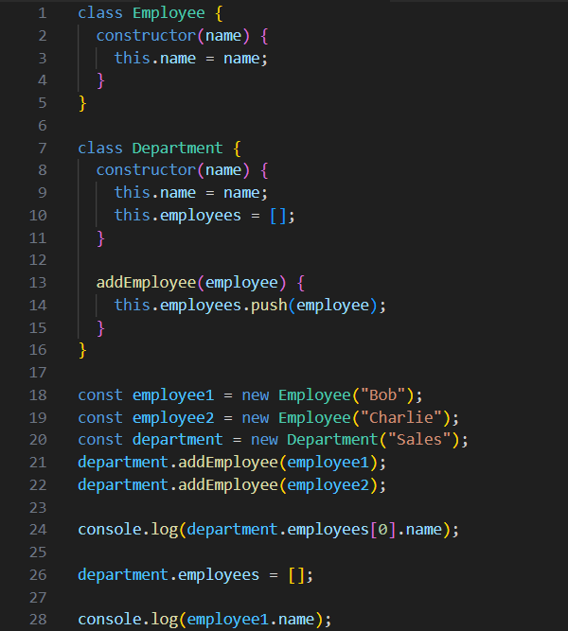 ***Figure No :04 Example with Aggregation***

***Composition:***

denotes a more serious "has-a" relationship, wherein one class comprises or contains objects of another class; such contained objects also cannot exist independently. The lifespan of these objects is, thus, strongly bound to that of the object containing it. If the object containing the other object is destroyed, then the object contained will also be destroyed.

***Figure No :05 Example with Composition***

It would be significantly helpful in understanding the nature of different relationship types for designing well-structured, maintainable object-oriented systems. Well, one should select the right relationship type according to the requirements of the application and how it will interact with other objects. Modeling relationships properly creates more robust and flexible code.

***3 - Inheritance***

It enables creating new classes, which may be called as child classes or subclasses, from parent classes or superclasses. The properties and methods of the parent class will now be inherited by the child class, thus enabling code reusability and establishing a relationship between classes in a hierarchical manner. Thus, organization of code is increased; redundancy decreased. In JavaScript, the extends keyword is used for inheritance.

Concept of Inheritance and its Use in JavaScript

Now inheritance establishes the "is-a" relationship. For example, Dog "is-a" Animal, which means Dog is an Animal, though Dog may also have special characteristics absent from other Animals, like barking. In this case, we have the benefit of not having to repeat common properties and methods for every specific type of animal. This promotes an organization very much like how natural concepts are organized as a hierarchy.

It is the extends keyword that creates the inheritance relationship in JavaScript. The child class automatically inherits property and method declarations from parent class. The super() keyword is used in the child class constructor, to call the parent class constructor and initialize properties inherited from parent. A child class can also override any inherited method without any issues.

***Figure No :06 Example with Inheritance***

***Conclusion***

this report dealt with primary object-oriented tools and constructs in JavaScript, with a comprehensive introduction to setters and getters, along with class relations, as well as inheritance. These are critical enablers of writing well-structured, maintainable, and scalable JavaScript code.

Setters and Getters give more power in control access to object properties and thereby enforce validation checking for data and even for creating computed properties. More importantly, it increases the robustness of the code while maintaining it by not allowing direct access to its inner states. In this way, it becomes possible to keep the code robust.

Different types of relationships help understand a class: association, aggregation, and composition. In this manner, the developer is empowered to model actual associations within his code, which leads to more modularly organized codebases, increases ease of managing codes and lessens complexity. Depending on the selected relationship type, the developer can then accurately reflect the relationships, dependencies, and interactions of objects.

Inheritance enables a reuse of code and clear hierarchy among all classes. The application of inheritance can prevent the redundancy of the code by creating a specialized class that inherits and even extends the parent class capabilities. This, therefore, ensures a well-structured and systematic code organization, simplistically maintaining it while enhancing its reuse.

It is important for a JavaScript developer to know these OOP concepts in order to write quality, professional-grade code. These principles enable developers to design applications that are far more robust, scalable, and maintainable, preparing them to face increasing complexity as the requirements evolve. The current report gives formal and practical understanding of such concepts in their implementation from the JavaScript perspective. By incorporating them, programmers can transform the quality and maintainability of the projects they build with JavaScript.