**Allowed Time:** 60 Minutes Total Marks: 35

**Instructions:**

1. Gossips are not allowed.
2. Teacher assistants are for your help, so be nice with them. Respect them as they are teaching you. Raise your hands if you have some problem and need help from TA. Avoid calling them by raising your voice and disturbing the environment of Lab.
3. TA may deduct your marks for any kind of ill-discipline or misconduct from your side.
4. Evaluation will be considered final and you cannot debate for the marks. So, focus on performing the tasks when the time is given to you.



**Task 01: ________________________ ________ (5 Marks, 10 min)**

Write a C program that takes two positive integers as input and swaps their values without using any additional variables. The program should then display the swapped values.

**Sample Output:**

Enter 1st number: 5

Enter 2nd number: 8

After swapping:

First number = 8

Second number = 5

**Task 02: _________________________ __________ (5 Marks, 10 min)**

Write a C program that takes two positive integers as input and calculates their product without using the * operator.

**Sample Output:**

Enter 1st number: 3

Enter 2nd number: 4

Product of 3 and 4 is 12

**Task 03: _________________________ ______ (10 Marks, 15 min)**

Digital Clockt:

Write a C program to print a 24-hour digital clock using loops.

Execution Flow: Use loops to print 00:00 to 23:59.

Constraints: No arrays or built-in time functions allowed

**Sample Output:**

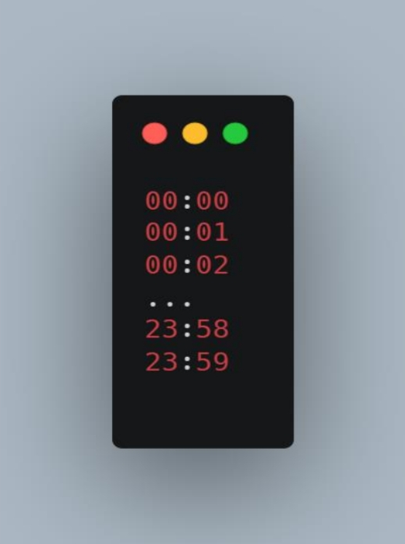

**Task 04: _____________________ ________ (15 Marks, 20 min)**

Scenario-Based Problem: Secret Lucky Discount Scheme

A store is offering a special discount scheme. Customers can join the scheme for $5 and get a 20% discount if their bill amount matches a lucky number. However, the store does not reveal that lucky numbers are actually perfect numbers.

**A perfect number is a positive integer that is equal to the sum of its proper divisors (excluding itself).**

Example:

6 → Divisors: 1, 2, 3 → 1 + 2 + 3 = 6 (Perfect Number)

10→ Divisors: 1, 2, 5→ 1 + 2 + 5 = 8 not equal to 10 (Not a Perfect Number)

**Program Flow:**

1. Prompt to enter bill amount

2. Ask the user if they want to join the lucky discount scheme by paying $5.

2. If no, then simply print the bill and terminate the program.

3. If yes, then if the sum of the digits of the bill amount is a perfect number (secret lucky number).

5. If yes, apply a 20% discount but also add the $5 scheme fee.

6. If no, charge the full bill plus the $5 scheme fee.

**Sample Outputs:**

Enter your bill amount: 50

Want to join the lucky discount scheme for $5? (y/n): n

Your total bill is: $50

Enter your bill amount: 28

Want to join the lucky discount scheme for $5? (y/n): y (1+2+4+7+14 = 28 equal to bill )

Congratulations! Your bill qualifies for a lucky discount!

Your total bill is: $27.4

(Original bill $28 → 20% discount ($5.6 off) → bill = 22.4 then Scheme fee $5 added → Final bill $27.4)

Enter your bill amount: 32

Want to join the lucky discount scheme for $5? (y/n): y

Sorry! Your bill does not qualify for a lucky discount.

Your total bill is: $37