C256 – Developer Introduction Notes

# Introduction to the C256 System

## Hardware

The C256 system uses a 65C816 micro-processor.

System clock is 14MHz.

Power supply required is +12V 1A with a 2.5mm plug.

Keyboard requires a PS/2 connector.

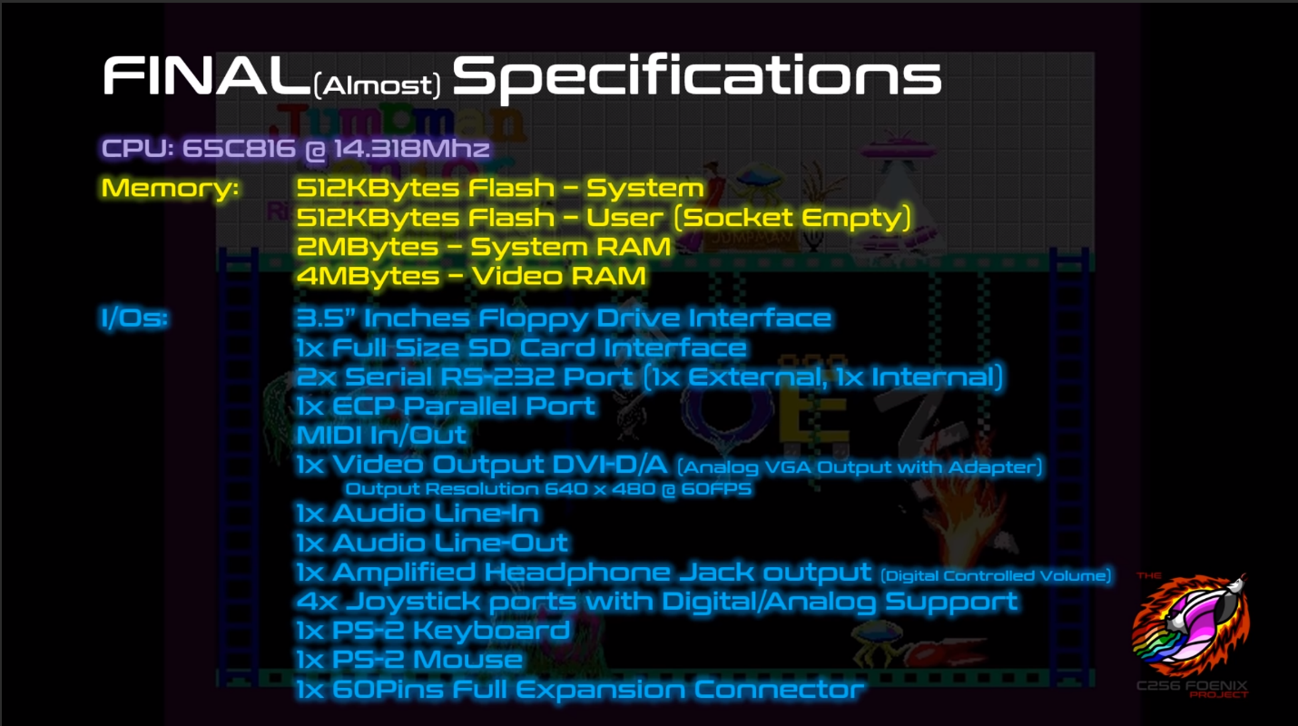

# Contributing to the IDE Development

## Git Repositories

Foenix IDE: <https://github.com/Trinity-11/FoenixIDE.git>

C256 Kernel: <https://github.com/Trinity-11/Kernel>

## Tools

To modify the Foenix IDE, you will need Visual Studio 2017 Community edition for C#.

# Using the Foenix IDE

The Integrated Development Environment consists of a 65816 emulator and a C256 Foenix memory map emulator.

## Launching the Application

To start the IDE, double-click on the FoenixIDE icon  or using a console, type “FoenixIDE.exe”.

The command-line accepts three parameters:

-h, --hex: load the program into memory for an “Intel Hex” file format;

-r, --run: auto-run the provided binary; and

-i, --irq: disable “break on interrupts” in the CPU window.

If no parameters are specified the application will launch with defaults:

* Program is loaded from ROMS\kernel.hex; if it doesn’t exist, the user is prompted to select one using the Windows File Dialog;
* Autorun is disabled; and
* Break on Interrupts is enabled.

## IDE Windows

The IDE consists of three main windows. The display, the CPU debugger and the memory editor.

# Understanding the C256 Foenix

The Foenix IDE currently emulates the C256 Foenix computer Revision B. Once Revision C is available, this document and the IDE will need to be updated.

## Memory Map

The CPU can access 24-bit worth of addresses.

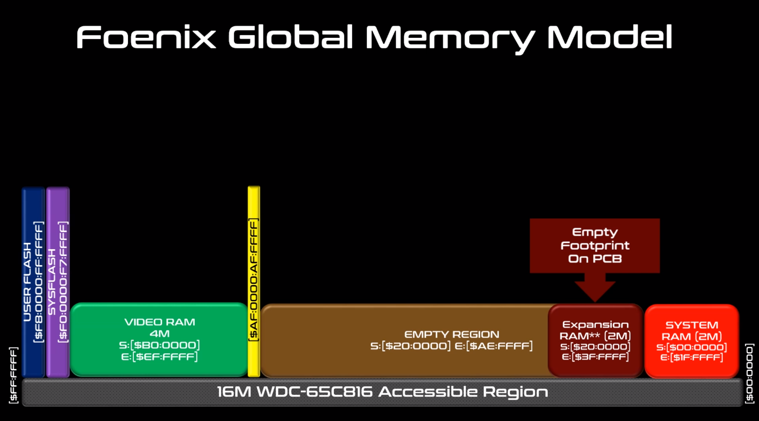

|  |  |  |
| --- | --- | --- |
| $FF:0000 - $FF:FFFF | Bank $FF | **16 MB Address Space** |
| $FE:0000 - $FE:FFFF | Bank $FE |
|  |  |
|  |  |
|  |  |
|  |  |
| $00:0000 - $01:FFFF | Bank $01 |
| $00:0000 - $00:FFFF | Bank $00 |

The address space is mapped as follows:

|  |  |
| --- | --- |
| $F8:0000 - $FF:FFFF | 512 KB User Flash (if populated) |
| $F0:0000 - $F7:FFFF | 512 KB System Flash |
| $B0:0000 - $EF:FFFF | 4 MB Video RAM |
| $AF:0000 - $AF:FFFF | IO Space |
| $40:0000 - $AE:FFFF | Extension Card |
| $20:0000 - $3F:FFFF | 2 MB RAM (optional) |
| $00:0000 - $1F:FFFF | 2 MB RAM |

On boot, Gavin copies the first 64KB of the content of System Flash (or User Flash, if present) to Bank $00. The entire 512KB are copied to address range $18:0000 to $1F:FFFF.

IO Space is mapped to Vicky: $AF:0000 to $AF:DFFF and Beatrix: $AF:E000 to $AF:FFFF.

### Gavin – Location $00:0000 to $00:FFFF

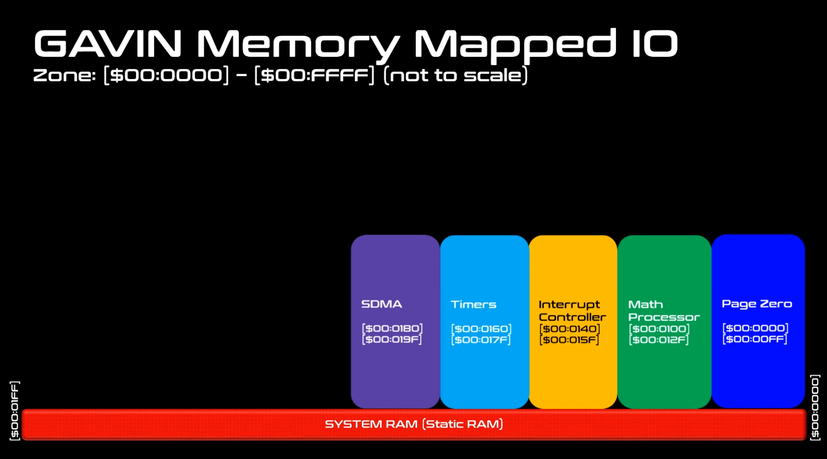

#### Math Co-Processor

The C256 provides a math co-processor to perform long addition, multiplications and divisions.

To perform an operation, you write the little-endian values in the appropriate address locations and the results are automatically returned in the result addresses.

##### Multiplications

There are two multiplier locations: $00:0100 and $00:0108. Multiplier 0 is unsigned and Multiplier 1 is signed. Each operand must be 16-bits, and the result is 32-bits.

|  |  |  |
| --- | --- | --- |
| **Address** | **Name** | **Description** |
| $00:0100 | M0_OPERAND_A | 16-bit unsigned value |
| $00:0102 | M0_OPERAND_B | 16-bit unsigned value |
| $00:0104 | M0_RESULT | 32-bit unsigned result of the multiplication of A and B |

|  |  |  |
| --- | --- | --- |
| **Address** | **Name** | **Description** |
| $00:0108 | M1_OPERAND_A | 16-bit signed value |
| $00:010A | M1_OPERAND_B | 16-bit signed value |
| $00:010C | M1_RESULT | 32-bit signed result of the multiplication of A and B |

##### Divisions

There are two divider locations: $00:0110 and $00:0118. Divider 0 is unsigned and Divider 1 is signed. Each operand must be 16-bits. The result and remainder are 16-bits also.

|  |  |  |
| --- | --- | --- |
| **Address** | **Name** | **Description** |
| $00:0110 | D0_OPERAND_A | 16-bit unsigned value for the dividend |
| $00:0112 | D0_OPERAND_B | 16-bit unsigned value for the divisor |
| $00:0114 | D0_RESULT | 16-bit unsigned result for the quotient |
| $00:0116 | D0_REMAINDER | 16-bit unsigned result for the remainder |

|  |  |  |
| --- | --- | --- |
| **Address** | **Name** | **Description** |
| $00:0118 | D1_OPERAND_A | 16-bit signed value for the dividend |
| $00:011A | D1_OPERAND_B | 16-bit signed value for the divisor |
| $00:011C | D1_RESULT | 16-bit signed result for the quotient |
| $00:011E | D1_ REMAINDER | 16-bit signed result for the remainder |

##### Long Signed Additions

There is one long signed adder located at $00:0120. Both operands must be 32-bit signed integers. The result is also 32-bit signed.

|  |  |  |
| --- | --- | --- |
| **Address** | **Name** | **Description** |
| $00:0120 | ADDER32_A | 32-bit signed value |
| $00:0124 | ADDER32_B | 32-bit signed value |
| $00:0128 | ADDER32_R | 32-bit signed result of the addition of A and B |

#### Interrupt Controller

|  |  |  |
| --- | --- | --- |
| **Address** | **Name** | **Description** |
| $00:0140 | INT_PENDING_REG0 | Pending Interrupts Register 0 |
| $00:0141 | INT_PENDING_REG1 | Pending Interrupts Register 1 |
| $00:0142 | INT_PENDING_REG2 | Pending Interrupts Register 2 |
| $00:0144 | INT_POL_REG0 | Polarity Set Interrupts Register 0 |
| $00:0145 | INT_POL_REG1 | Polarity Set Interrupts Register 1 |
| $00:0146 | INT_POL_REG2 | Polarity Set Interrupts Register 2 |
| $00:0148 | INT_EDGE_REG0 | Edge Interrupts Register 0 |
| $00:0149 | INT_EDGE_REG1 | Edge Interrupts Register 1 |
| $00:014A | INT_EDGE_REG2 | Edge Interrupts Register 2 |
| $00:014C | INT_MASK_REG0 | Interrupt Masks Register 0 |
| $00:014D | INT_MASK_REG1 | Interrupt Masks Register 1 |
| $00:014E | INT_MASK_REG2 | Interrupt Masks Register 2 |

|  |  |  |  |  |  |  |  |
| --- | --- | --- | --- | --- | --- | --- | --- |
| **Interrupt Register 0 ($00:0140, $00:0144, $00:0148, $00:014C)** | | | | | | | |
| 7 | 6 | 5 | 4 | 3 | 2 | 1 | 0 |
| Mouse | Floppy Disk | RTC | Timer 2 | Timer 1 | Timer 0 | SOL | SOF |

Description

|  |  |
| --- | --- |
| SOF | Start of Frame – 60 Frames per Second (FPS) |
| SOL | Start of Line – 60 FPS offset |
| RTC | Clock Alarm, etc..., See the chip spec for more detail for the registers: BQ4802 |

|  |  |  |  |  |  |  |  |
| --- | --- | --- | --- | --- | --- | --- | --- |
| **Interrupt Register 1 ($00:0141, $00:0145, $00:0149, $00:014D)** | | | | | | | |
| 7 | 6 | 5 | 4 | 3 | 2 | 1 | 0 |
| SDCARD | LPT1 | MPU-401 | COM1 | COM2 | Tile Coll | Sprite Coll | Keyboard |

|  |  |  |  |  |  |  |  |
| --- | --- | --- | --- | --- | --- | --- | --- |
| **Interrupt Register 2 ($00:0142, $00:0146, $00:014A, $00:014E)** | | | | | | | |
| 7 | 6 | 5 | 4 | 3 | 2 | 1 | 0 |
| Always 1 | Expansion | DAC | Video DMA | Gavin DMA | Beatrix | OPL2 Left | OPL2 Right |

### Vicky – Location $AF:0000 to $AF:DFFF

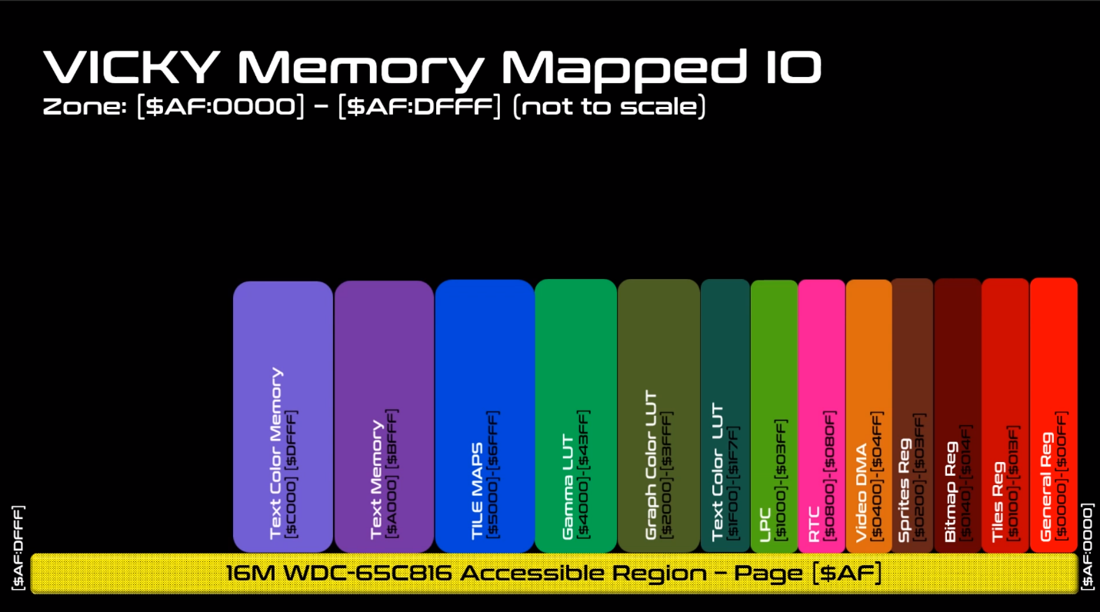

#### Vicky Memory

|  |
| --- |
| $AF:0000 - $AF:00FF (Internal Memory) Vicky General Registers |
| BORDER_COLOR_B = $AF:0005 - when in text mode, this is the border color shown.  BORDER_COLOR_G = $AF:0006  BORDER_COLOR_R = $AF:0007 |
| When in Graphic Mode, if a pixel is "0" then the Background pixel is chosen  BACKGROUND_COLOR_B = $AF:000D  BACKGROUND_COLOR_G = $AF:000E  BACKGROUND_COLOR_R = $AF:000F |
| $AF:0100 - $AF:013F (Internal Memory) Vicky Tiles Registers |
| $AF:0140 - $AF:014F (Internal Memory) Vicky Bitmap Registers |
| $AF:0200 - $AF:03FF (Internal Memory) Vicky Sprites |
| $AF:0400 - $AF:04FF (Internal Memory) Vicky VDMA |
| $AF:0800 - $AF:080F Real-time clock (RTC) |

#### Video Direct Memory Access

Memory Address Range reserved: DMA Controller $AF0400 - $AF04FF

VDMA_CONTROL_REG = $AF0400

|  |  |  |  |  |  |  |  |
| --- | --- | --- | --- | --- | --- | --- | --- |
| **VDMA Control Register ($AF:0400)** | | | | | | | |
| 7 | 6 | 5 | 4 | 3 | 2 | 1 | 0 |
| Start Tfr | - | - | - | IRQ Enable | Fill | 2D | Enable |

Description

|  |  |
| --- | --- |
| VDMA_CTRL_Enable | Enable the VDMA Transfer |
| VDMA_CTRL_1D_2D | 0 - 1D (Linear) Transfer , 1 - 2D (Block) Transfer |
| VDMA_CTRL_TRF_Fill | 0 - Transfer Src -> Dst, 1 - Fill Destination with "Byte2Write" |
| VDMA_CTRL_Int_Enable | Set to 1 to Enable the Generation of Interrupt when the Transfer is over |
| VDMA_CTRL_Start_TRF | Set to 1 To Begin Process, Need to Cleared before, you can start another |

VDMA_BYTE_2_WRITE = $AF0401 ; Write Only - Byte to Write in the Fill Function

VDMA_STATUS_REG = $AF0401 ; Read only

|  |  |  |  |  |  |  |  |
| --- | --- | --- | --- | --- | --- | --- | --- |
| **VDMA Status Register ($AF:0401) – Read-only** | | | | | | | |
| 7 | 6 | 5 | 4 | 3 | 2 | 1 | 0 |
| Tfr In Progress | - | - | - | - | Invalid Src Addr | Invalid Dest Addr | Size Error |

When Transfer is in Progress, the CPU will not be able to access Video Memory.

VDMA_SRC_ADDY_L = $AF0402 ; Pointer to the Source of the Data to be transferred

VDMA_SRC_ADDY_M = $AF0403 ; This needs to be within Vicky's Range ($00:0000 - $3F:0000)

VDMA_SRC_ADDY_H = $AF0404

VDMA_DST_ADDY_L = $AF0405 ; Destination Pointer within Vicky's video memory Range

VDMA_DST_ADDY_M = $AF0406 ; ($00:0000 - $3F:0000)

VDMA_DST_ADDY_H = $AF0407

In 1D Transfer Mode, specify how many bytes to transfer. Maximum value is $40:0000 or 4 megabytes.

VDMA_SIZE_L = $AF0408

VDMA_SIZE_M = $AF0409

VDMA_SIZE_H = $AF040A

VDMA_IGNORED = $AF040B

In 2D Transfer Mode, specify the width and height to transfer. Maximum is 65,536 in each direction.

VDMA_X_SIZE_L = $AF0408 ; Maximum Value: 65535

VDMA_X_SIZE_H = $AF0409

VDMA_Y_SIZE_L = $AF040A ; Maximum Value: 65535

VDMA_Y_SIZE_H = $AF040B

VDMA_SRC_STRIDE_L = $AF040C ; Always use an Even Number ( The Engine uses Even Ver of that value)

VDMA_SRC_STRIDE_H = $AF040D ;

VDMA_DST_STRIDE_L = $AF040E ; Always use an Even Number ( The Engine uses Even Ver of that value)

VDMA_DST_STRIDE_H = $AF040F ;

|  |
| --- |
| $AF:1000 - $AF:13FF - SUPER IO Devices --- (TOTAL USAGE) --- |
| // Super IO Details: |
| // $AF:1060 - $AF:1064 - LOGIC DEVICE 7 - KEYBOARD |
| // $AF:1100 - $AF:117F - LOGIC DEVICE A - PME (Runtime Registers) |
| // $AF:1200 - $AF:1200 - LOGIC DEVICE 9 - GAME PORT |
| // $AF:12F8 - $AF:12FF - LOGIC DEVICE 5 - SERIAL 2 |
| // $AF:1330 - $AF:1331 - LOGIC DEVICE B - MPU-401 |
| // $AF:1378 - $AF:137F - LOGIC DEVICE 3 - PARALLEL PORT |
| // $AF:13F0 - $AF:13F7 - LOGIC DEVICE 0 - FLOPPY CONTROLLER |
| // $AF:13F8 - $AF:13FF - LOGIC DEVICE 4 - SERIAL 1 |

$AF:1F00 - $AF:1F3F (Internal Memory) Vicky Text Mode 16 Color Look-up Table Foreground Color

$AF:1F40 - $AF:1F7F (Internal Memory) Vicky Text Mode 16 Color Look-up Table Background Color

$AF:2000 - $AF:23FF (Internal Memory) Graphic Mode LUT0

$AF:2400 - $AF:27FF (Internal Memory) Graphics Mode LUT1

$AF:2800 - $AF:2BFF (Internal Memory) Graphics Mode LUT2

$AF:2C00 - $AF:2FFF (Internal Memory) Graphics Mode LUT3

$AF:4000 - $AF:40FF (External Memory) 256 Bytes GAMMA LUT - RED

$AF:4100 - $AF:41FF (External Memory) 256 Bytes GAMMA LUT - GREEN

$AF:4200 - $AF:42FF (External Memory) 256 Bytes GAMMA LUT – BLUE

FONT_MEMORY_BANK0 = $AF:8000 - $AF:8FFF

FONT_MEMORY_BANK1 = $AF:9000 - $AF:9FFF

#### Screen Page 0 – Location $AF:A000

Screen Page 0 memory is used to store text characters for display.

One page of text is 128 columns by 64 rows. This adds up to 8 KB of memory of text. C256 does not display the entire buffer on the screen. Typically, we render 72 characters per row, with 56 rows.

This uses 576 x 448 of the available 640 x 480 resolution. The border size can be modified or turned off completely.

The display process reads Screen Page 0 and for each character, displays it’s character set bitmap.

#### Screen Page 1 – Location $AF:C000

An additional page of 128 x 64 is used to store the colors. Each byte is split into foreground (4bits) and background (4 bits). The high nibble (bits 7..4) are the foreground and the low nibble (bits 3..0) are the background.

The colors used (the 4 bits) are used to lookup RBG values in two lookup tables (LUT).

The foreground (FG) LUT is located at $AF:1F40 for 64 bytes – only 16 x 3 = 48 bytes are used. The extra byte may be used for alpha (transparency) later on.

The background (BG) LUT is located at $AF:1F80 for 64 bytes – only 16 x 3 = 48 bytes are used. The extra byte may be used for alpha (transparency) later on.

The colors are assigned 8-bit blue, 8-bit green, 8-bit red, 8-bit alpha (not used) for each of those colors in Text Mode.

##### Example – Color Lookup

Consider the following Foreground and Background Lookup Tables

|  |  |
| --- | --- |
| Foreground Color Lookup Table, starting at address $AF:1F40 | Background Color Lookup Table, starting at address $AF:1F80 |
| |  |  |  |  |  |  | | --- | --- | --- | --- | --- | --- | | Index | Blue | Green | Red | Alpha | Color | | 0 | $00 | $00 | $00 | $FF | Black | | 1 | $00 | $00 | $80 | $FF | Maroon | | 2 | $00 | $80 | $00 | $FF | Green | | 3 | $80 | $00 | $00 | $FF | Navy | | 4 | $00 | $80 | $80 | $FF | Olive | | 5 | $80 | $80 | $00 | $FF | Teal | | 6 | $80 | $00 | $80 | $FF | Purple | | 7 | $80 | $80 | $80 | $FF | Gray | | 8 | $00 | $45 | $FF | $FF | Orange | | 9 | $13 | $45 | $8B | $FF | Brown | | A | $00 | $00 | $20 | $FF | Dark Red | | B | $00 | $20 | $00 | $FF | Dark Green | | C | $20 | $00 | $00 | $FF | Indigo | | D | $20 | $20 | $20 | $FF | Dark Gray | | E | $40 | $40 | $40 | $FF | Slate Gray | | F | $FF | $FF | $FF | $FF | White | | |  |  |  |  |  |  | | --- | --- | --- | --- | --- | --- | | Index | Blue | Green | Red | Alpha | Color | | 0 | $00 | $00 | $00 | $FF | Black | | 1 | $00 | $00 | $80 | $FF | Maroon | | 2 | $00 | $80 | $00 | $FF | Green | | 3 | $80 | $00 | $00 | $FF | Navy | | 4 | $00 | $20 | $20 | $FF | ?? | | 5 | $20 | $20 | $00 | $FF | ?? | | 6 | $20 | $00 | $20 | $FF | ?? | | 7 | $20 | $20 | $20 | $FF | ?? | | 8 | $1E | $69 | $D2 | $FF |  | | 9 | $13 | $45 | $8B | $FF | Brown | | A | $00 | $00 | $20 | $FF | Dark Red | | B | $00 | $20 | $00 | $FF | Dark Green | | C | $40 | $00 | $00 | $FF | Blue | | D | $10 | $10 | $10 | $FF | Midnight Gray | | E | $40 | $40 | $40 | $FF | Slate Gray | | F | $FF | $FF | $FF | $FF | White | |

If a character in Screen Page 1 is $ED (the default text color combination), then the foreground color index is E and the background color index is D. Looking up the index for E will make the foreground “Slate Gray” and the background “Midnight Gray”. The image below shows this color combination in text.

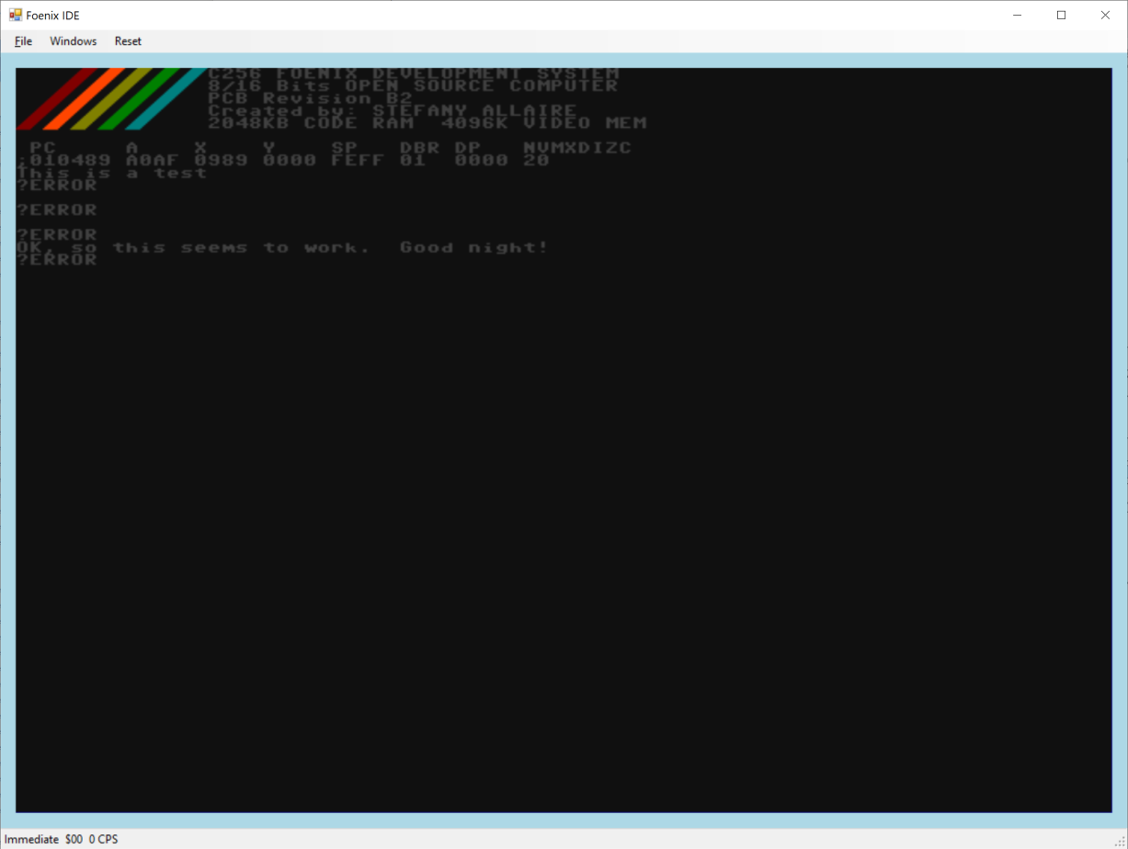

#### Text Gamma Lookup Table

The Gamma lookup table is used to adjust the color between different display devices (such as DVI versus VGA). Each of the red, green and blue can be corrected. Each table consists of 256 values.

GAMMA_B_LUT_PTR = $AF:4000

GAMMA_G_LUT_PTR = $AF:4100

GAMMA_R_LUT_PTR = $AF:4200

Gamma can be enabled or disabled.

#### Master Control Register

The Master Control Register (MCR) is used to enable/disable various video mode. The MCR is located at address $AF:0000.

|  |  |  |  |  |  |  |  |
| --- | --- | --- | --- | --- | --- | --- | --- |
| **Master Control Register ($AF:0000)** | | | | | | | |
| 7 | 6 | 5 | 4 | 3 | 2 | 1 | 0 |
| Disable Vid | Gamma | Sprite | Tilemap | Bitmap | Graph Mode | Text Overlay | Text Mode |

|  |  |  |
| --- | --- | --- |
| **MCR Bit** | **MCR Name** | **Description** |
| 0 | Mstr_Ctrl_Text_Mode_En | Enable the Text Mode |
| 1 | Mstr_Ctrl_Text_Overlay | Enable the Overlay of the text mode on top of Graphic Mode (the Background Color is ignored) |
| 2 | Mstr_Ctrl_Graph_Mode_En | Enable the Graphic Mode |
| 3 | Mstr_Ctrl_Bitmap_En | Enable the Bitmap Module in Vicky |
| 4 | Mstr_Ctrl_TileMap_En | Enable the Tile Module in Vicky |
| 5 | Mstr_Ctrl_Sprite_En | Enable the Sprite Module in Vicky |
| 6 | Mstr_Ctrl_GAMMA_En | Enable the GAMMA correction - The Analog and DVI have different color value, the GAMMA is great to correct the difference.  NOTE: This could also be used for fade-in and out. |
| 7 | Mstr_Ctrl_Disable_Vid | This bit disables the Scanning of the Video Memory, hence giving 100% bandwidth to the CPU to access graphic data.  NOTE: In this case the Border color or the background is displayed on the screen (I can't remember) to be advised |

#### Displaying Graphics

C256 has 4 MB of Video RAM available, starting at $B0:0000 and ending at $EF:FFFF.

The order in which images are drawn are:

* L0 - Sprites (Closest to the Viewer)
* L1 - Tile Layer 0
* L2 - Sprite Layers
* L3 - Tile Layer 1
* L4 - Sprite Layers
* L5 - Tile Layer 2
* L6 - Sprite Layers
* L7 - Tile Layer 3
* L8 - Sprite Layers
* L9 - Background (bitmap)

##### Bitmaps

Once the Bitmap bit is set in the MCR, Vicky will retrieve the Bitmap Control Register at address $AF:0140.

The Bitmap Control Register is shown below.

|  |  |  |
| --- | --- | --- |
| **Bitmap Control Register ($AF:0140)** | | |
| 7 .. 4 | 3 .. 1 | 0 |
| Reserved | LUT | Enable |

|  |  |  |
| --- | --- | --- |
| **BCR Bit** | **BCR Name** | **Description** |
| 0 | Enabled | Enable the bitmap |
| 1 .. 3 | LUT | Lookup Table Index 0 to 7 |
| 4 .. 7 | Reserved | Reserved |

The address pointer of the bitmap in the Video RAM is located at addresses $AF:0141 to $AF:0143. The address stored must be offset by $B0:0000. As an example, if the bitmap data is stored in at address $B1:4000 in memory, the address pointer must be $01:4000.

The bitmap width is saved in the word $AF:0144 to $AF:0145.

The bitmap height is saved in the word $AF:0146 to $AF:0147.

##### Tiles

Once the Tile bit is set in the MCR, Vicky will retrieve the Tile Control Register at addresses $AF:0100, $AF:0108, $AF:0110 and $AF:0118 to determine if a tileset should be displayed. There can be four tilesets at any given time in the display.

The Tile Control Registers are shown below.

|  |  |  |  |
| --- | --- | --- | --- |
| **Tile Control Register ($AF:0100, $AF:0108, $AF:0110, $AF:0118)** | | | |
| 7 | 6 .. 4 | 3 .. 1 | 0 |
| Tile Striding | Reserved | LUT | Enable |

|  |  |  |
| --- | --- | --- |
| **TCR Bit** | **TCR Name** | **Description** |
| 0 | Enabled | Enable the bitmap |
| 1 .. 3 | LUT | Lookup Table Index 0 to 7 |
| 4 .. 6 | Reserved | Reserved |
| 7 | Tile Striding | 0: sequential, 1: 256 x 256 Tile sheet striding |

Each tile has its own control register, video address pointer, X and Y stride.

|  |  |  |  |  |
| --- | --- | --- | --- | --- |
|  | Tile 0 | Tile 1 | Tile 2 | Tile 3 |
| Tile Control Register | $AF:0100 | $AF:0108 | $AF:0110 | $AF:0118 |
| Tile Start Address | $AF:0101 .. $AF:0103 | $AF:0109 .. $AF:010B | $AF:0111 .. $AF:0113 | $AF:0119 .. $AF:011B |
| Tile Map X Stride | $AF:0104 .. $AF:0105 | $AF:010C .. $AF:010E | $AF:0114 .. $AF:0115 | $AF:011C .. $AF:011E |
| Tile Map Y Stride | $AF:0106 .. $AF:0107 | $AF:010E .. $AF:010F | $AF:0116 .. $AF:0117 | $AF:011E .. $AF:011F |

Tile maps are stored at addresses $AF:5000, $AF:5800, $AF:6000 and $AF:6800.

##### Sprites

Once the Sprite bit is set in the MCR, Vicky will display sprites in the appropriate layer. There can be 32 sprites displayed for each screen refresh.

The Sprite Control Registers are shown below.

|  |  |  |  |
| --- | --- | --- | --- |
| **Sprite Control Register ($AF:0200 to $AF:02F8, offset by 8 bytes)** | | | |
| 7 | 6 .. 4 | 3 .. 1 | 0 |
| Reserved | Layer | LUT | Enable |

Each sprite has a Control Register, a video memory address, and X and Y locations.

### Beatrix

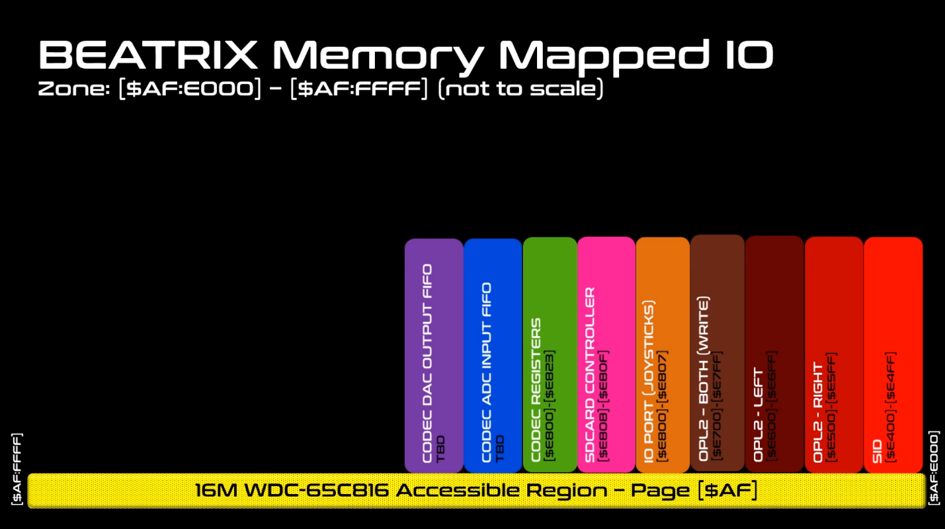

// $AF:E400..$AF:E4FF // SID (Still to be defined) Not Implemented yet

// $AF:E500..$AF:E5FF // OPL2 - Left Side

// $AF:E600..$AF:E6FF // OPL2 - Right Side

// $AF:E700..$AF:E7FF // OPL2 - Both Side (Write Sequence Only)

// $AF:E800..$AF:E807 // Joystick + AD Channel + SD Controller

// $AF:E820..$AF:E823 // CODEC Register

// $AF:E810..$AF:E81F //SD Card Stat

#### Joystick Ports

The C256 Foenix provides 4 joystick ports, located in front of the machine. The 9-pin connectors are compatible with the standard Atari/Commodore joysticks. Joystick ports are number from right to left, starting near the Reset button.

JOYSTICK0 = $AF:E800 ;(R) Joystick 0 - J7 (Next to Buzzer)

JOYSTICK1 = $AF:E801 ;(R) Joystick 1 - J8

JOYSTICK2 = $AF:E802 ;(R) Joystick 2 - J9

JOYSTICK3 = $AF:E803 ;(R) Joystick 3 - J10 (next to SD Card)

The joysticks do not generate interrupts. Polling ports at a regular interval, say with the SOF interrupt is recommended.

The joystick register has a value at rest of $9F. The bits are set to zero when a switch is closed.

|  |  |  |  |  |  |  |  |
| --- | --- | --- | --- | --- | --- | --- | --- |
| **Joystick Register ($AF:E800, $AF: E801, $AF: E802, $AF: E803)** | | | | | | | |
| 7 | 6 | 5 | 4 | 3 | 2 | 1 | 0 |
| Button | N/A | N/A | N/A | Left | Right | Down | Up |

**Note: This feature is not implemented in the Foenix IDE yet.**

#### Dip switch Ports

DIPSWITCH = $AF:E804 ;(R) $AFE804...$AFE807

**Note: This feature is not implemented in the Foenix IDE yet.**

#### SD Card

; SD Card CH376S Port

SDCARD_DATA = $AF:E808 ;(R/W) SDCARD (CH376S) Data PORT_A (A0 = 0)

SDCARD_CMD = $AF:E809 ;(R/W) SDCARD (CH376S) CMD/STATUS Port (A0 = 1)

; SD Card Card Presence / Write Protect Status Reg

SDCARD_STAT = $AF:E810 ;(R) SDCARD (Bit[0] = CD, Bit[1] = WP)

; Audio WM8776 CODEC Control Interface (Write Only)

CODEC_DATA_LO = $AF:E820 ;(W) LSB of Add/Data Reg to Control CODEC See WM8776 Spec

CODEC_DATA_HI = $AF:E821 ;(W) MSB od Add/Data Reg to Control CODEC See WM8776 Spec

CODEC_WR_CTRL = $AF:E822 ;(W) Bit[0] = 1 -> Start Writing the CODEC Control Register

**Note: This feature is not implemented in the Foenix IDE yet.**

# Sample Code

Use the VDMA in linear mode to transfer data.

## Linear Mode VDMA Transfer

SETUP_VDMA_FOR_TESTING_1D

setas

LDA #$01 ; Start Transfer

STA @lVDMA_CONTROL_REG

LDA #$FE

STA @lVDMA_SIZE_L

LDA #$9F

STA @lVDMA_SIZE_M

LDA #$00

STA @lVDMA_SIZE_H

LDA #$64

STA @lVDMA_DST_ADDY_L

LDA #$84

STA @lVDMA_DST_ADDY_M

LDA #$03

STA @lVDMA_DST_ADDY_H

LDA #$55

STA @lVDMA_BYTE_2_WRITE

LDA #$85 ; Start Transfer

STA @lVDMA_CONTROL_REG

LDA @lVDMA_STATUS_REG

RTS

## Block Mode VDMA Transfer

SETUP_VDMA_FOR_TESTING_2D

setas

VDMA_WAIT_TF

; Wait for the Previous Transfer to be Finished

LDA @lVDMA_STATUS_REG

AND #VDMA_STAT_VDMA_IPS

CMP #VDMA_STAT_VDMA_IPS

BEQ VDMA_WAIT_TF

LDA #$01 ; Start Transfer

STA @lVDMA_CONTROL_REG

LDA #200

STA @lVDMA_X_SIZE_L

LDA #00

STA @lVDMA_X_SIZE_H

LDA #64

STA @lVDMA_Y_SIZE_L

LDA #00

STA @lVDMA_Y_SIZE_H

LDA #$60

STA @lVDMA_DST_ADDY_L

LDA #$90

STA @lVDMA_DST_ADDY_M

LDA #$01

STA @lVDMA_DST_ADDY_H

LDA #$80

STA @lVDMA_DST_STRIDE_L

LDA #$02

STA @lVDMA_DST_STRIDE_H

LDA #$F9

STA @lVDMA_BYTE_2_WRITE

LDA #$87 ; Start Transfer

STA @lVDMA_CONTROL_REG

LDA @lVDMA_STATUS_REG

RTS

## Clear Screen with VDMA

Code Example of Bitmap ClearScreen with the 2D Mode who happens to work better than the 1D Mode:

CLEAR_BITMAP

setas

CLR_SCREEN_CHECK_NO_ACTIVE_DMA

; Wait for the Previous Transfer to be Finished

LDA @lVDMA_STATUS_REG

AND #VDMA_STAT_VDMA_IPS

CMP #VDMA_STAT_VDMA_IPS

BEQ CLR_SCREEN_CHECK_NO_ACTIVE_DMA

LDA #$01 ; Enable VDMA Block

STA @lVDMA_CONTROL_REG

LDA #$80

STA @lVDMA_X_SIZE_L

LDA #$02

STA @lVDMA_X_SIZE_H

LDA #$E0

STA @lVDMA_Y_SIZE_L

LDA #$01

STA @lVDMA_Y_SIZE_H

LDA #$00

STA @lVDMA_DST_ADDY_L

LDA #$00

STA @lVDMA_DST_ADDY_M

LDA #$00

STA @lVDMA_DST_ADDY_H

LDA #$80

STA @lVDMA_DST_STRIDE_L

LDA #$02

STA @lVDMA_DST_STRIDE_H

LDA #$00

STA @lVDMA_BYTE_2_WRITE

LDA #$87 ; Start Transfer

STA @lVDMA_CONTROL_REG

LDA @lVDMA_STATUS_REG

RTS