**National Cheng Kung University**

**Department of Electrical Engineering**

***Introduction to VLSI CAD (Spring 2023)***

**Lab Session 4**

**Register Files, Manhattan Distance and LFSR**

|  |  |  |
| --- | --- | --- |
| Name | Student ID | |
| 陳慕丞 | E94096097 | |
| **Practical Sections** | **Points** | **Marks** |
| Prob A | 25 |  |
| Prob B | 25 |  |
| Prob C | 25 |  |
| Report | 15 |  |
| File hierarchy, naming…etc. | 5 |  |
| Superlint | 5 |  |
| Notes: | | |

**Due Date: 15:00, March 23, 2020 @ moodle**

**Deliverables**

1. All Verilog codes including testbenches for each problem should be uploaded.

NOTE: Please **DO NOT** paste source code in the report!

1. Noted! TA will use commands in Appendix A to check your design in SoC Lab. If TA can not compile your code with the commands, you will not get full credit.
2. **If you upload a dead body which we can’t even compile, you will get NO credit!**
3. **All Verilog file should get at least 85% SuperLint Coverage.**
4. All homework requirements should be uploaded in this file hierarchy or you will not get full credit.

NOTE: Please **DO NOT** upload waveforms!

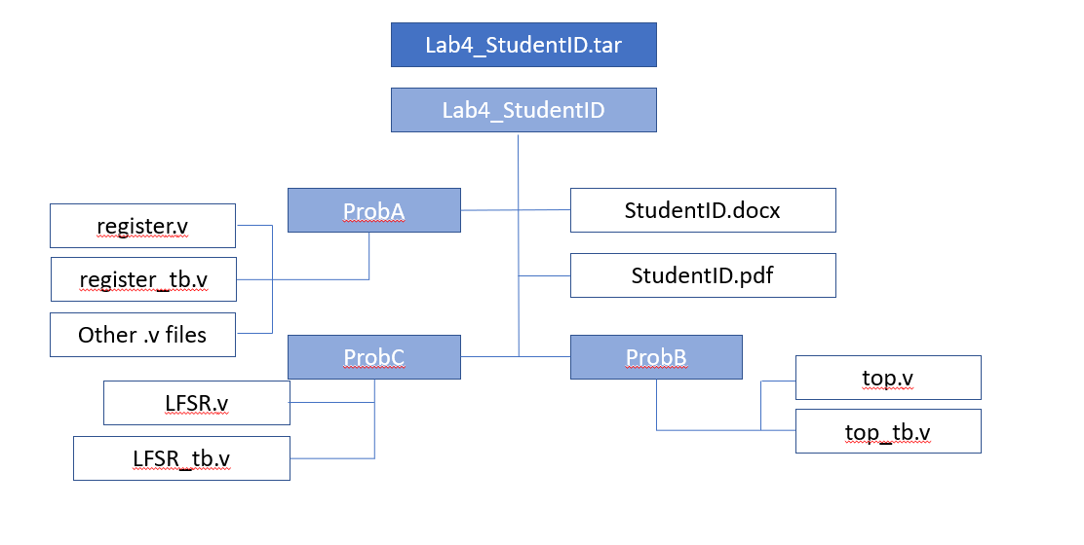

Fig.1 File hierarchy for Homework submission

Prob A: Register File

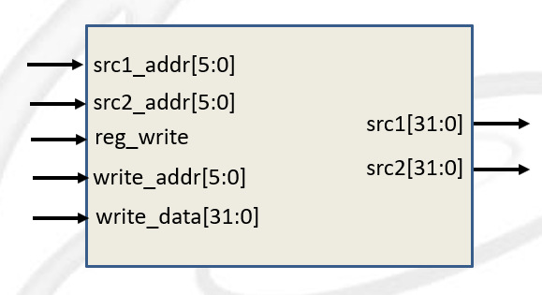

1. Based on the register file structure in LabA, please design a 64 x 32 register file by yourself.
2. Port list

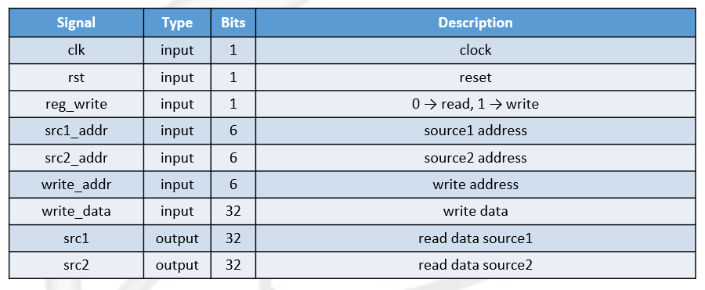

1. You should follow the file name rules as follow.

* Register file
  + File name: **register.v**
  + Module name: **register**
* Register file testbench
  + File name: **register_tb.v**

1. Show waveforms to explain that your register work correctly when read and write.

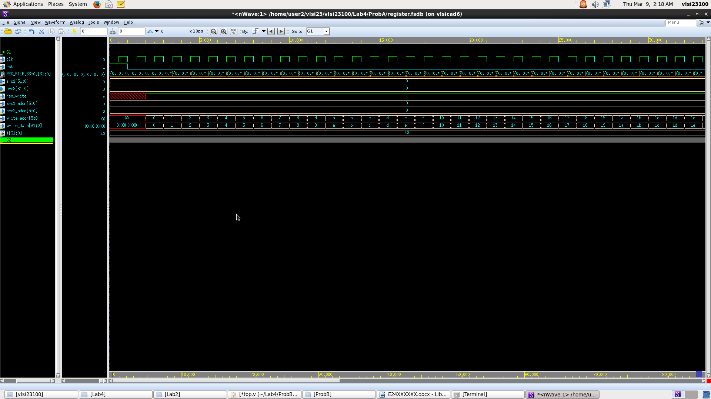

當reg_write=1，clock falling edge送入write_data時，下一個cycle的clock rising edge將write_data寫入REG_FILE[write_addr]，如上圖所示。

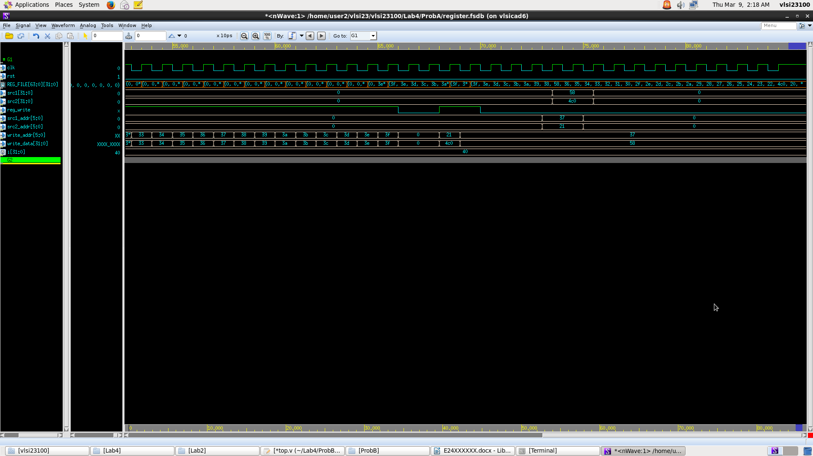

當reg_write=0，clock falling edge送入src1_addr和src2_add時，下一個cycle的clock rising edge將REG_FILE[src1_addr]輸出到src1，REG_FILE[src2_add]輸出到src2，如上圖所示。

1. Show SuperLint coverage

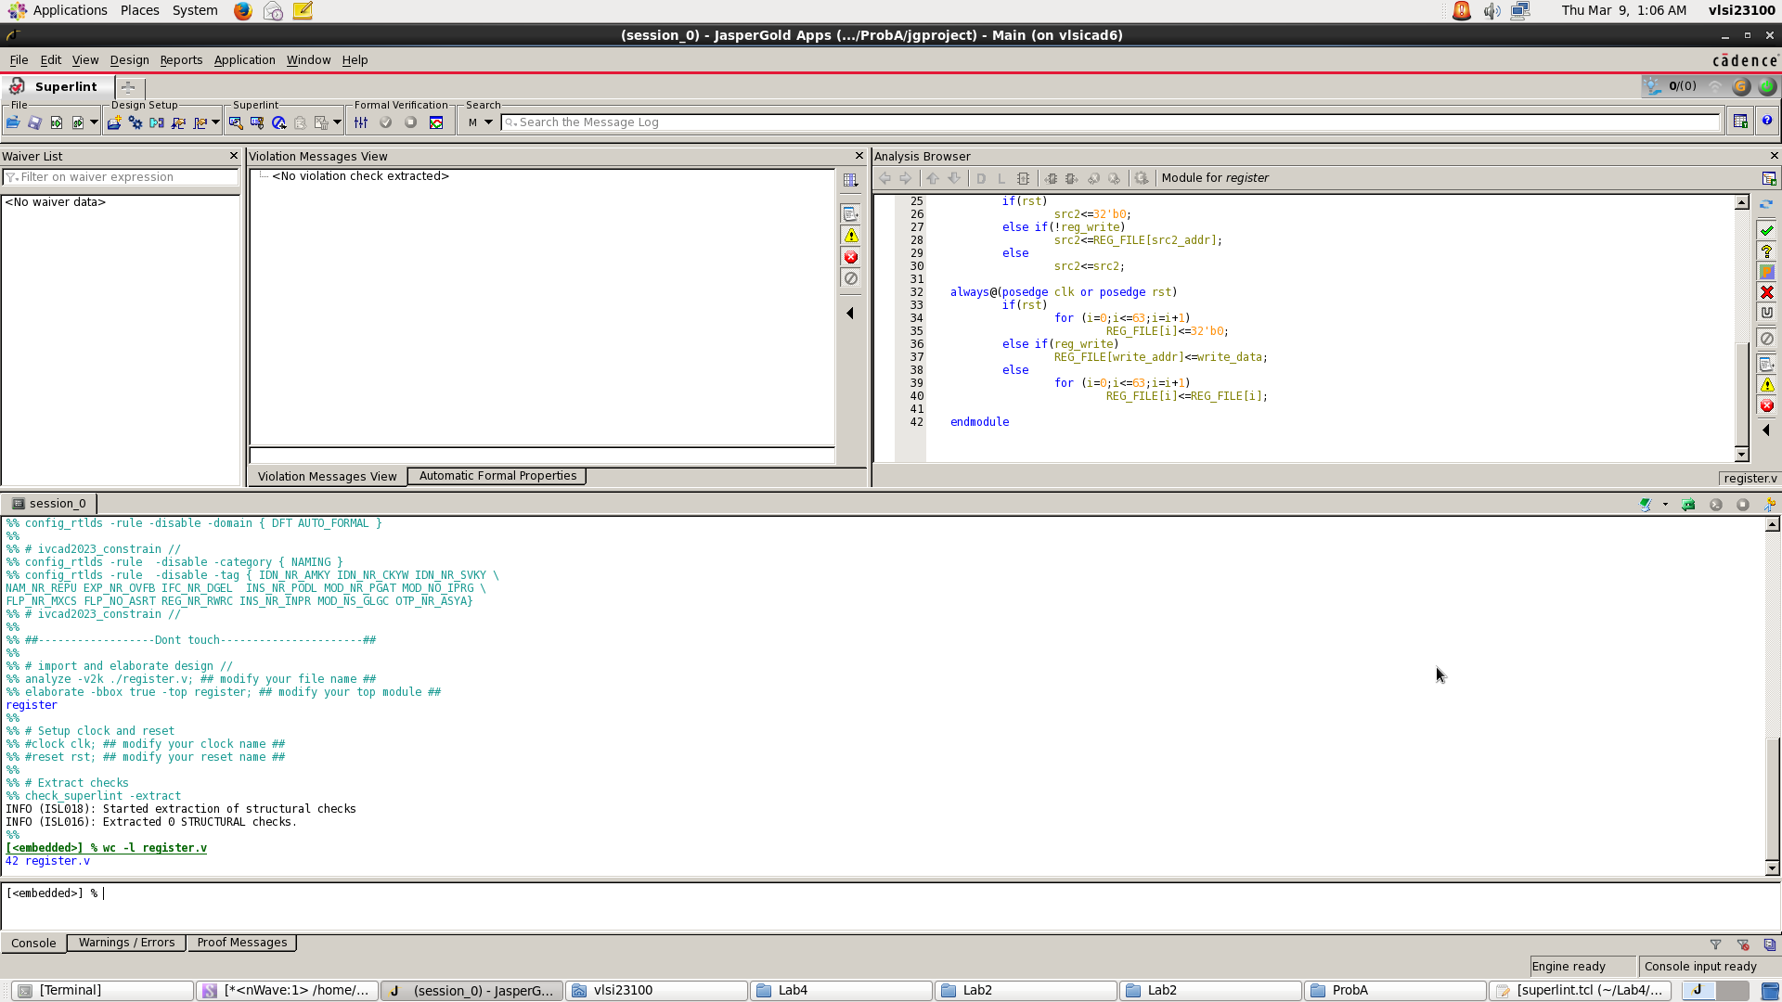

Coverage:100%

Prob B: Finding Smallest Distance

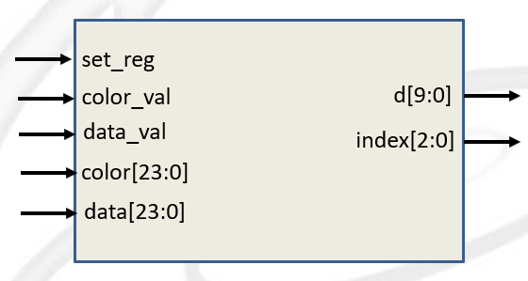

Please design a circuit that will find the smallest distance between the local registers and the input data, based on the structure given in the LAB4 slide.

Port list

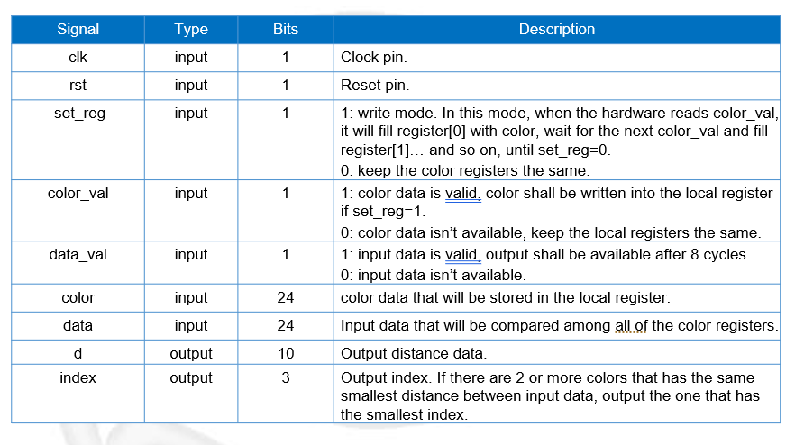

1. Show waveforms to explain that your design works correctly.

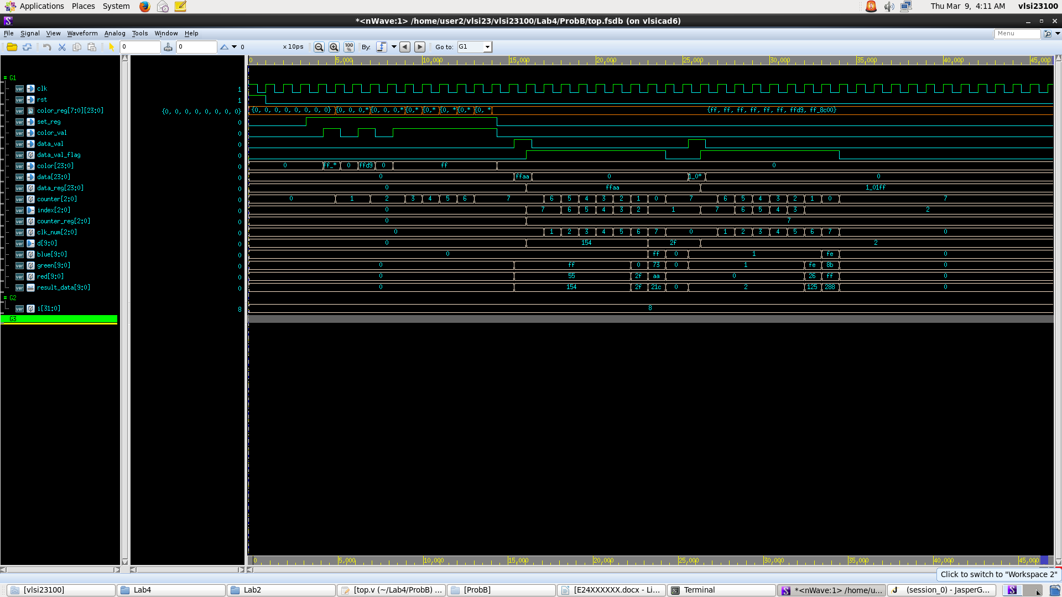

Input: clk, rst, set_reg, color_val, data_val, color, data

Output: d, index

當set_reg和color_val為1時，將color存進color_reg [counter]中，並將counter加1；當data_val為1時，將1存進data_val_flag，將data存進data_reg，將counter的值存進counter_reg(記住存到第幾個color_reg)；當data_val或data_val_flag為1時，counter每個cycle減1(每個cycle用color_reg [counter]中的值比較)，clk_num每個cycle加1(負責數是否到第8個cycle)；運算中blue為|Bi-Bj|，green為|Gi-Gj|，red為|Ri-Rj|；若比較後距離等於或小於d中的值，則將距離的值存進d中，counter的值存進index中；最後當clk_num=7時，重設counter為counter_reg中的值，data_val_flag為0。

1. Show SuperLint coverage

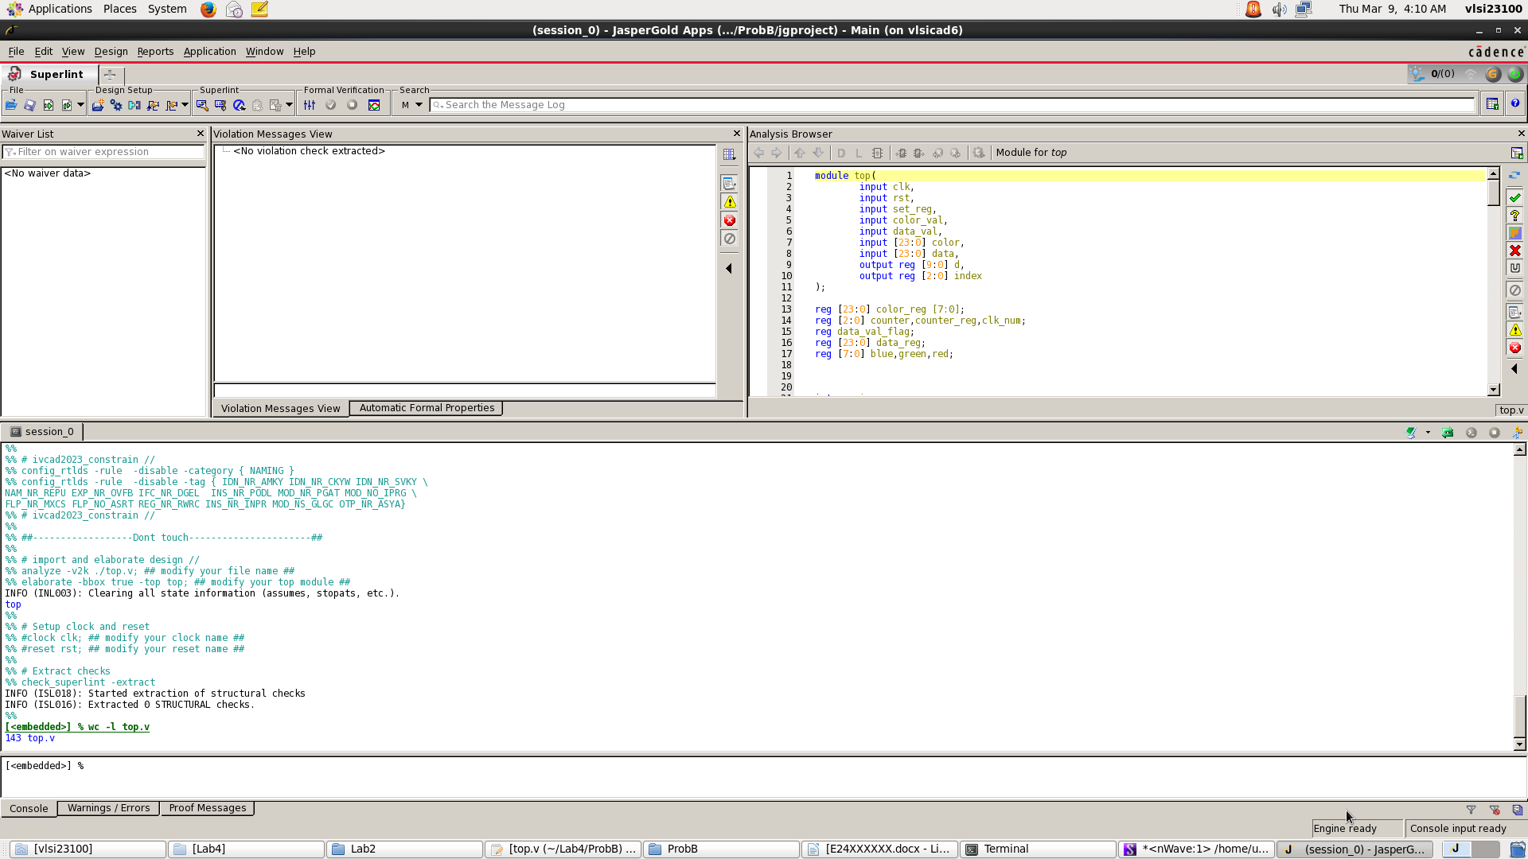

Coverage:100%

Prob C: LFSR

1. Please design an 8-bit-LFSR, with the given feedback function in the LAB4 slide.
2. Port list

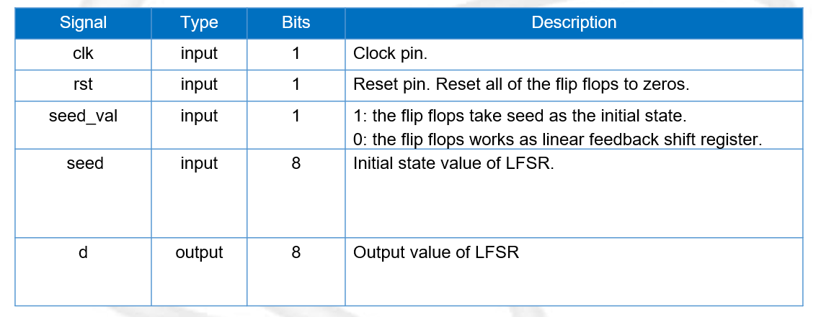

1. Feedback function



1. Show waveforms to explain that your LFSR module works correctly.

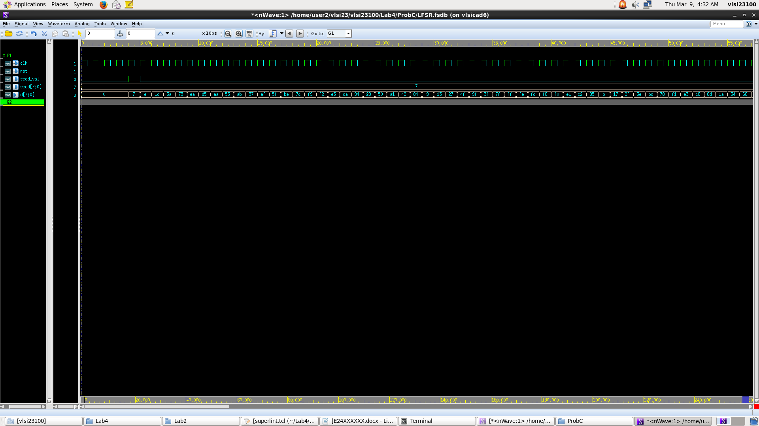

當seed_val=1時，d被initial成seed的值7，如上圖所示，當seed_val=0時，d為{d’[6:0],((d’[7]~^d’[5])^(d’[4]~^d’[3]))} (上一個cycle的d值為d’)。

1. Show the simulation result on the terminal.

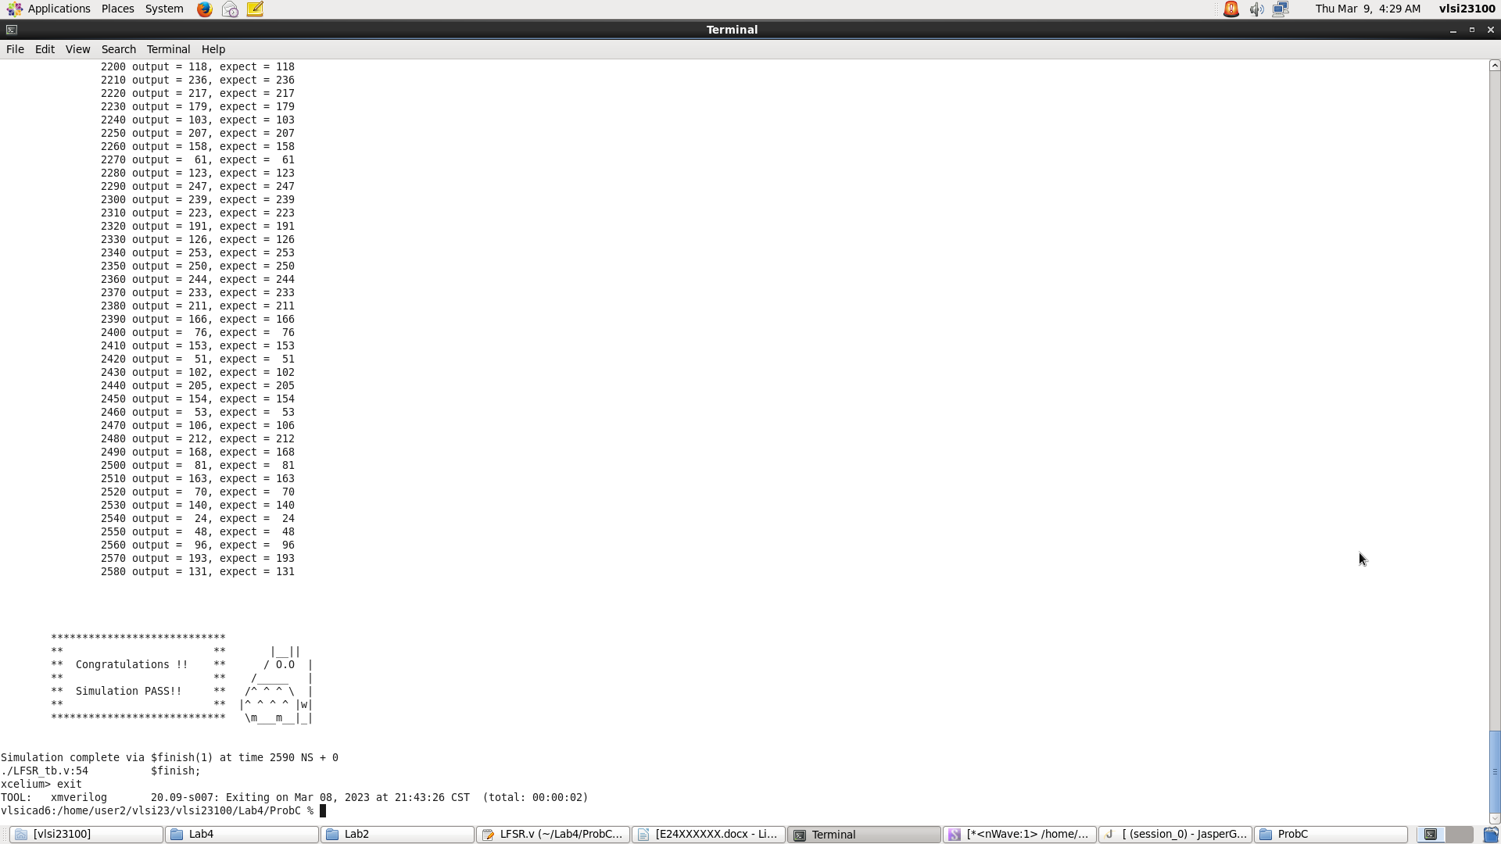

1. Show SuperLint coverage

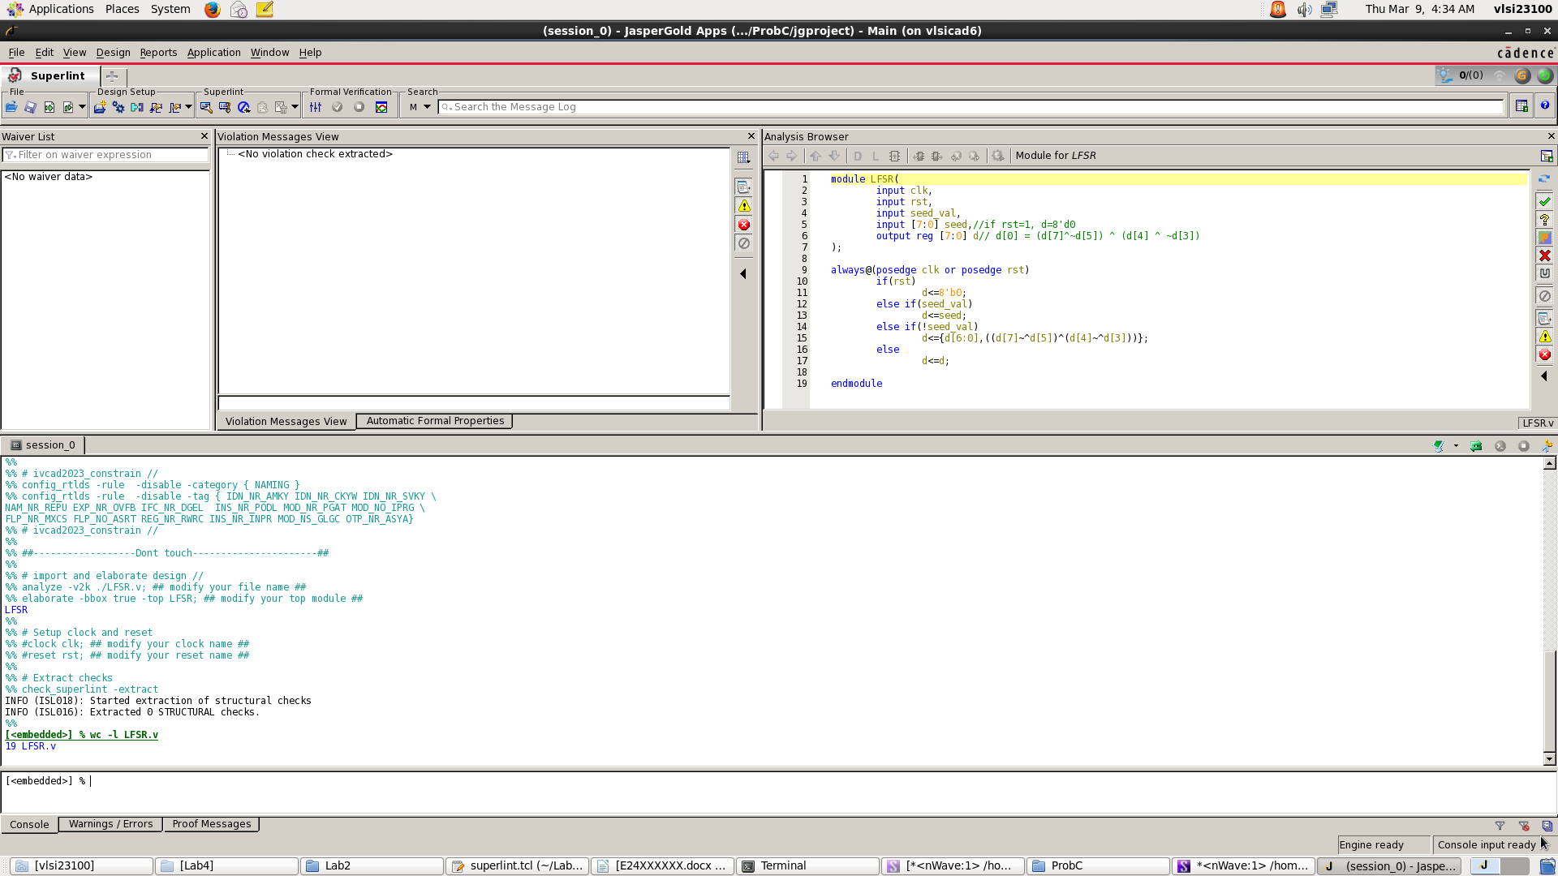

Coverage:100%

1. At last, please write the lesson you learned from Lab4

在Lab4中我學到如何實作sequential電路並應用在register,LFSR等電路中，並利用sequential電路做運算，也學到如何結合combinational和sequential電路實作比絕對值距離大小。

Appendix A : Commands we will use to check your homework

