Bahria University

# Computer Science Department



**Submitted By:**

* MUHAMMAD FARAZ
* ENROL:02-134171-147
* BS(CS)_4B
* REGISTRATION NUMBER:48536

**Submitted to:**

* Miss Laraib Tahir

**Submission Date:**

[20/10/2018]

**DEPARTMENT OF COMPUTER SCIENCE**

**BAHRIA UNIVERSITY, KARACHI CAMPUS**

|  |
| --- |
| EXERCISES |

**TASK #01**

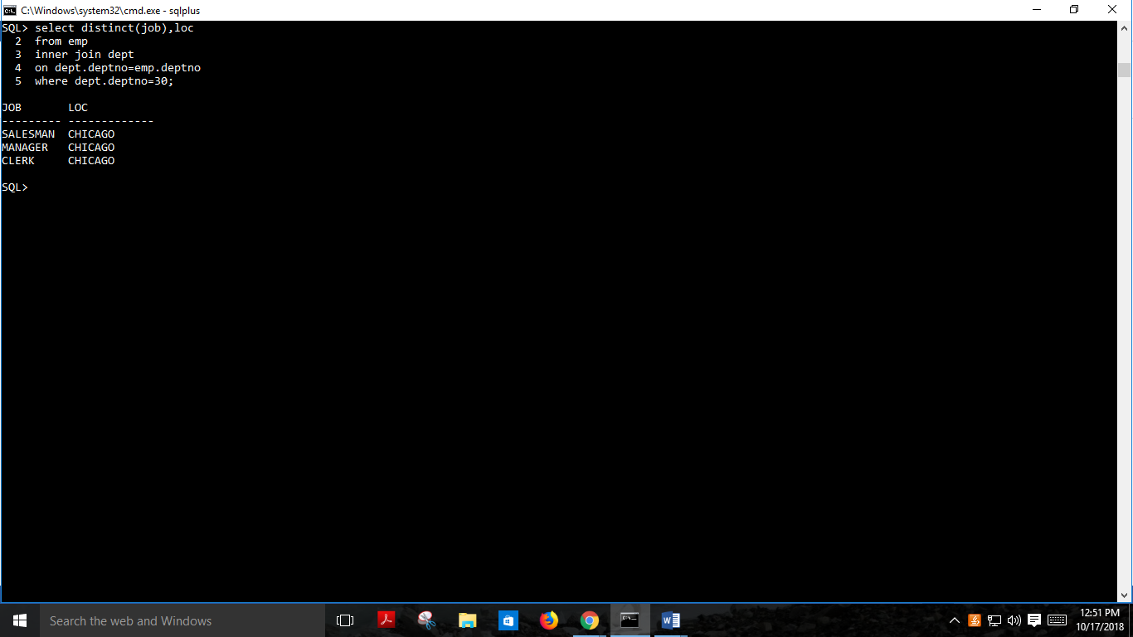

**TASK #02**

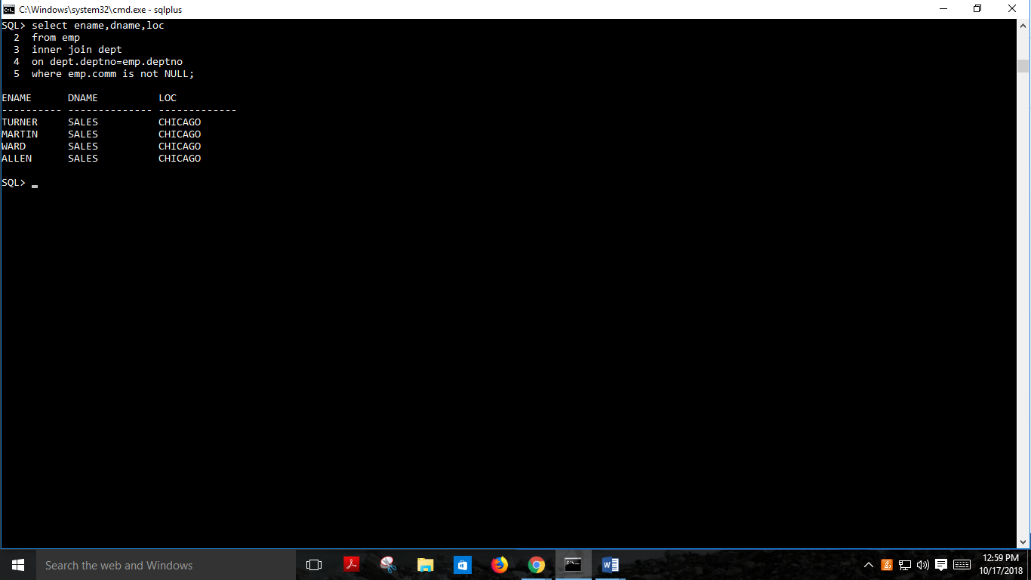

**TASK # 03**

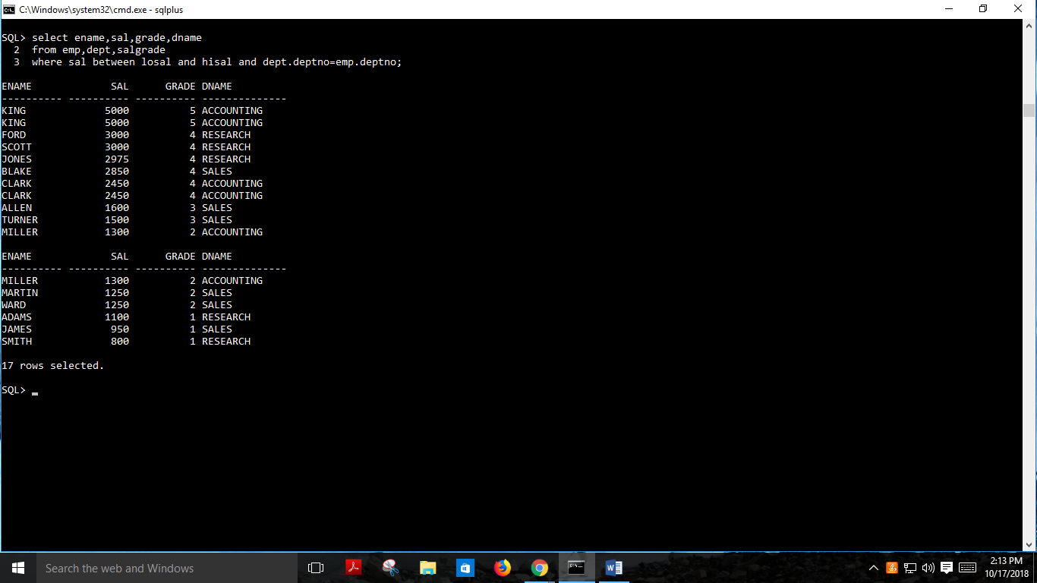

**TASK #04**

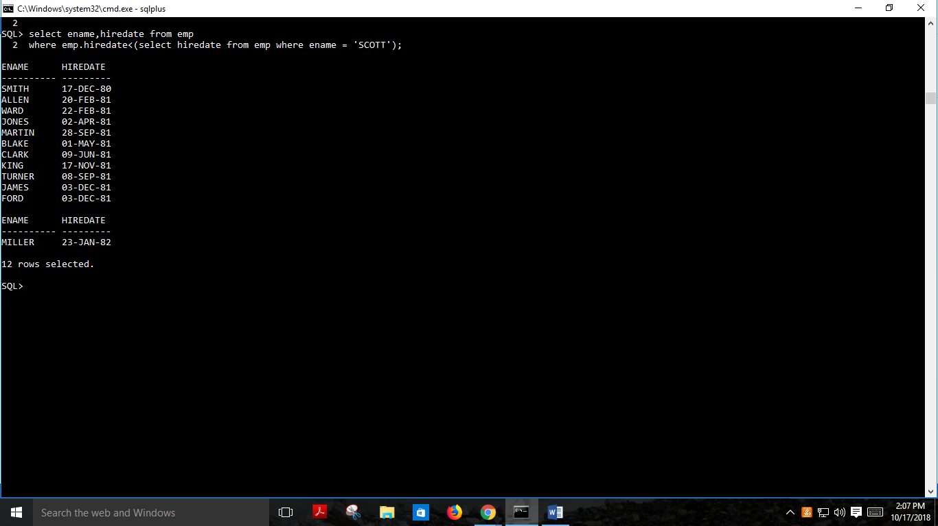

**Task #05**

