|  |  |  |  |  |  |  |  |  |
| --- | --- | --- | --- | --- | --- | --- | --- | --- |
|  | |  |  |  | | --- | --- | --- | | CSL-220: Database Management System | | | | SEMESTER | BS CS 04 - A |  | |  | |

**Task#1**

**Write a PL/SQL program using cursor which displays all employees’ names, employees’**

**salaries, their managers’ name and managers’ salaries from emp table.**

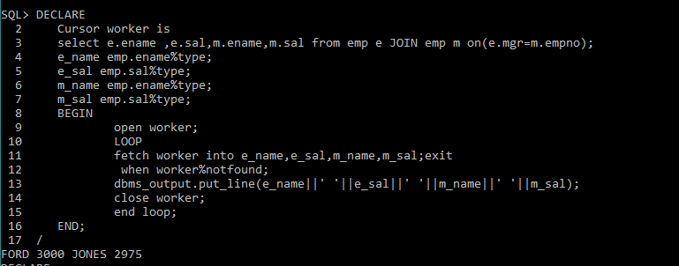

**Task#2**

**Write a PL/SQL program using cursor which displays all employees’ names, their salaries and**

**their jobs from emp table having salary greater than 4000 and are not CLERKS.**

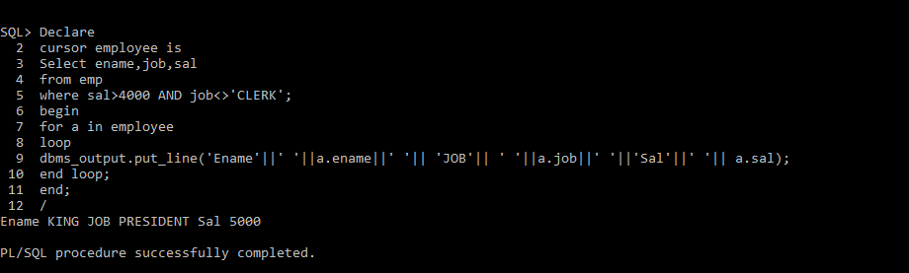

**Task#3**

**Write a PL/SQL program using cursor which displays all employees’ names, their departments’**

**names and their managers’names who don’t report to JONES. Cursor must use %FOUND**

**attribute to check the cursor.**

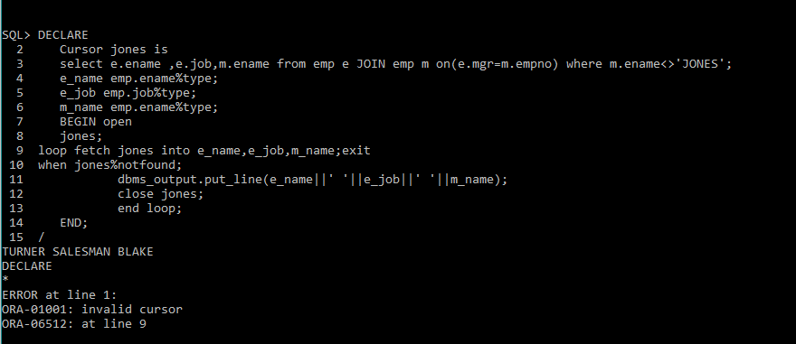

**Task#4**

**4. Write a PL/SQL program using cursor FOR LOOP which gives increments in salaries to all the**

**employees of emp table with respect to their jobs.**

**If job = ‘CLERK’ then increment must be 5% of the salary, If job = ‘SALESMAN’ then increment**

**must be 10% of the salary, If job = ‘ANALYST’ then increment must be 15% of the salary else**

**increment must be 20% of the salary.**

