|  |  |  |
| --- | --- | --- |
| f |  |  |
| **Zagazig University** |  | **Faculty of Computers & Informatics** |

**MNIST dataset**

**with**

**Deep Learning**

**by**

Mohamed Shehta Atia Gharib

seat number : 4494

**Supervised by**

**professor** / **Ahmed Rafat**

**Problem definition:**

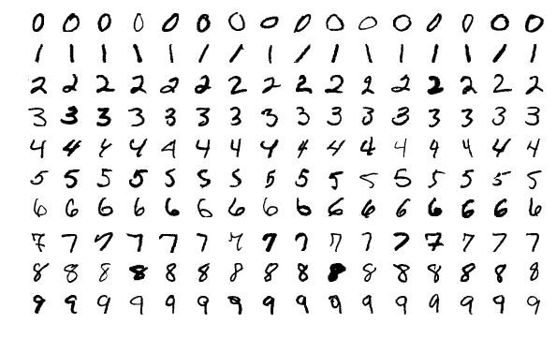The MNIST database (Modified National Institute of Standards and Technology database) is a large database of handwritten digits that is commonly used for training various image processing systems.The database is also widely used for training and testing in the field of machine learning. It was created by "re-mixing" the samples from NIST's original datasets.The creators felt that since NIST's training dataset was taken from American Census Bureau employees, while the testing dataset was taken from American high school students, it was not well-suited for machine learning experiments. Furthermore, the black and white images from NIST were normalized to fit into a 28x28 pixel bounding box and anti-aliased, whichintroduced grayscale levels.

**Data format:**

The MNIST database contains 60,000 training images and 10,000 testing images. Half of the training set and half of the test set were taken from NIST's training dataset, while the other half of the training set and the other half of the test set were taken from NIST's testing dataset.The original creators of the database keep a list of some of the methods tested on it. In their original paper, they use a support-vector machine to get an error rate of 0.8%.

**Model desigen:**

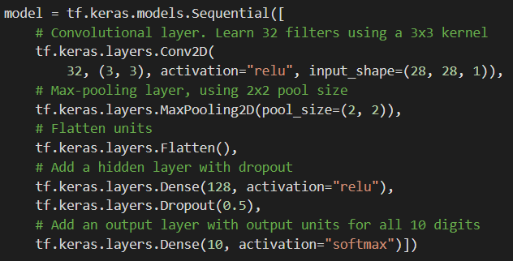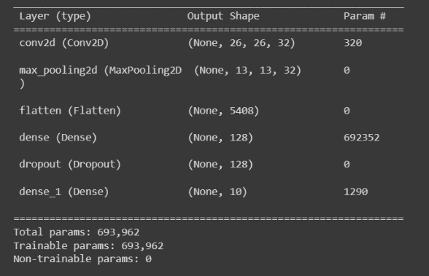Model contain from 5 layer (1 conviutional layer, 1 pooling layer , 2 dense layers and 1 dropout layer)

**Model’s hyperparameters:**

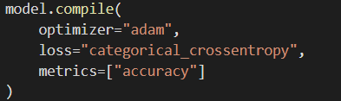I use **adam** for optimizing the model, **categorical_crossentropy** for loss function and **accuracy** for metring the model.

**Train the model:**



**Model evaluation:**

Accuracy of is 98 % for test set and 99 % for train set (nor over fitting or under fitting).

