Revision History
Date | Version | Description | Author
04/10/25 | <1.1> | Added document overview and abbreviations (may be updated in the future) | Tuna Özen
05/10/25 | <2.1> | Added Gantt Chart | Tuna Özen

TABLE OF CONTENTS

Revision History 1
1 Identification 3
1.1 Document overview 3
1.2 Abbreviations 3
1.2.1 Abbreviations 3
1.3 References 3
1.3.1 Project References 3
2 Software Development Activities 3
2.1 Software development process 3
2.1.1 Overview of process phases 3
2.1.2 Technical documentation 4
2.1.3 Deliverables 4
2.2 Software development tools 4
2.2.1 Workstation 4
2.2.2 Requirements management and documentation 4
2.2.3 Software Design 4
2.2.4 Coding and automated tests 5
2.2.5 Configuration management 5
2.3 Software development rules and standards 5
3 Responsibilities 5
3.1 Activities and responsibilities 5
4 Risk Assessment 5
4.1 Risk Analysis 5
4.2 Risk Planning 5

Identification

Document overview

This document contains the software development plan of software HMS.

The Hospital Management System (HMS) is a Java desktop application designed to assist doctors and patients in managing their hospital-related operations, as well as assisting managers with assignments and other administrative tasks.

Abbreviations

Abbreviations

HMS: Hospital Management System
UML: Unified Modeling Language
IDE: Integrated Development Environment
JDK: Java Development Kit
SRS: Software Requirement Specification
STP: Software Test Plan
SDD: Software Design Document
STR: Software Test Report
JavaFX: Java Effects

References

Project References

# | Document Identifier | Document Title
[R1] | ID | Add your documents references.  One line per document

Software Development Activities

The section lists and describes the software development activities of software development project.

Software development process

This is a course project, which adopts the waterfall model as the software development process.

Overview of process phases

The software development process for the project will be composed of the following phases:
- Planning
- Requirements Analysis
- Design
- Implementation
- Testing and Analysis

These phases will follow each other sequentially, where each phase starts just after the completion of the previous one. The following Gantt chart depicts the planned start date and duration for the phases.

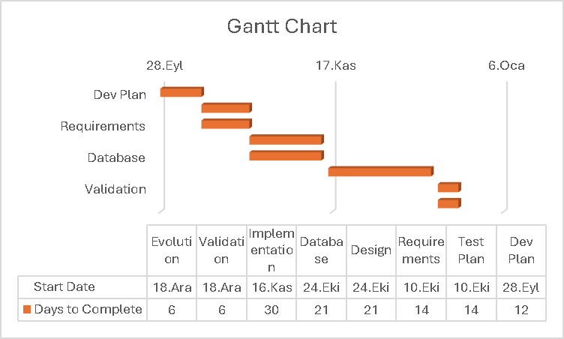

Technical documentation

The following documentation is produced during the software development phases:
- Software specification: SRS, STP
- Software detailed conception: SDD
- Software tests phases : STR
- Software analysis: SAR

Deliverables

The following items will be delivered at the end of the process:
- Technical documentation as outlined in Section 2.1.2
- Software and its configuration files

Software development tools

Workstation

Describe the typical Workstation used for development

Requirements management and documentation

Describe tools used to write and manage requirements : Microsoft Word, etc.

Software Design

Describe tools used for software design :
- Argo UML open source tool, Microsoft Visio, Rational Rose, Together J, etc.

Coding and automated tests

Describe tools used for coding and automated tests.
- Eclipse + list of plugins or MS Visual Studio 2010 + list of plugins
- Junit, etc.

Configuration management
GitHub will be used for software configuration management and tracking issues regarding the software development. A public repository will be created for this purpose.

Software development rules and standards
UML will be used for software design documentation.

Describe here other standards and rules you plan to use for software development, if any. For instance, you can follow a particular coding standard/convention (e.g., Oracle provides coding conventions for Java: http://www.oracle.com/technetwork/java/codeconvtoc-136057.html). Then you should mention it here and provide a link for it.

Responsibilities

Activities and responsibilities

Each activity has someone responsible (although multiple project members can be involved in the activity), mandatory.

Activity | Responsibility | Comment
Project management | YYY
Configuration tools management | ZZZ
Setting up the Development tools | YYY, XXX
Database design | XXX
…

Risk Assessment

Risk Analysis

Provide a risk analysis table here. See the example in the course slides.

Risk Planning

For each risk item listed in the previous subsection, provide risk indicators and action(s) to be taken when the risk takes place (i.e., strategies). See the example in the course slides.

http://www.github.com
http://www.uml.org/

