Alex Shaw

CS 5402

Homework 4

1. All code can be found at: https://github.com/alexandergshaw/cs5402-hw4
2. Please see above for link to code.
3. Plots:

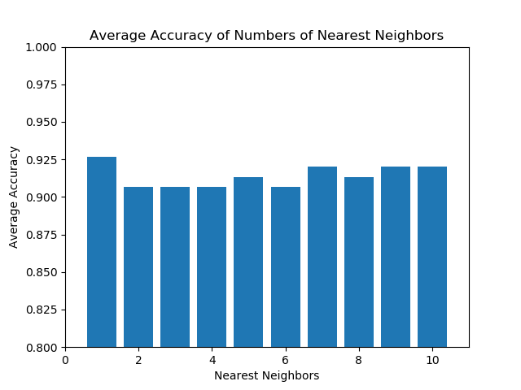

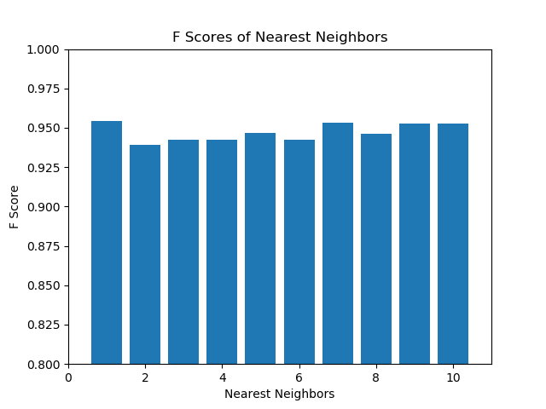

1. The average decision tree classifier (Gini) accuracy (utilizing the average from the 5-fold cross validation) is around 0.9 to 0.91 (the accuracy fluctuates slightly due to the 5-fold cross validation). The average accuracy of a KNN classifier (with k = 1) is around 0.925, with an F Score slightly above 0.95. Thus, the KNN classifier is better than the decision tree classifier.