CIS 4374 – Homework 6
Project Update: Tools, Technology and Plan Refresh
Project: Smart Parking Platform
Team: WE ARE Software Corp.
Submitted by: Muaaz Ismail

This week there are no new chapters. The goal is to make sure every part of the project is up to date and nothing is left for later. We now have a real Trello board with a 45-item product backlog and Sprint 1 under way, so I updated every section to match it. Where something changed, the reason is noted. Most reasons are a risk we found earlier or something I learned from the real backlog.

Summary of updates
Section | Status | What changed | Why
1. SRS | Updated | Rewritten around the real backlog: 16 functional requirements. Availability now comes from sensors plus manual operator updates. Added backup payment and sensor-offline requirements. | The backlog showed operators updating availability by hand, and our risks R01 and R09.
2. User stories | Updated | 19 user stories that cover all 48 backlog items, each with acceptance criteria. | Stories now trace back to the backlog cards.
3. WBS | Updated | Ten work packages that match the backlog groups and the RACI deliverables. | Every backlog item belongs to a package with an owner.
4. Timeline and Gantt | Updated | 8 two-week sprints over 16 weeks. Sprint 1 matches the cards on our Trello board. | The plan now matches the work that is really under way.
5. Backlog | Updated | Trello checklist grouped into 9 epics, with priorities and points. Added 3 items: sensor data ingestion, sensor offline alert and backup payment provider. | The new items come from risks R09 and R01.
6. Sprints and Trello | Updated | Sprint plan, current board, and a Trello and GitHub workflow. Screenshots of the board and backlog included. | Lecture 7 says to pick a tool by team size, budget and learning curve.
7. Risks and Risk Register | Updated | Added R11 (malicious repositories), R12 (API cost spikes) and R13 (backlog bigger than our capacity). | Recent security incident, our cost plan, and the size of the real backlog.
8. Communication Plan | Updated | Added sprint planning. Reporting now uses Trello progress. Added a same-day security alert rule. | Fits our Scrum-style sprints and the new security risk.
9. Roles | Updated | Same team. DevOps also owns repository access and security settings. | Someone has to own R11.
10. Cost Plan | Reviewed | Totals unchanged at $136,418. | Trello's free plan and built-in GitHub security features cost nothing extra.
11. RACI Matrix | Updated | Added two rows: backlog and sprint planning, and repository access and security. | These responsibilities were missing.

1. SRS (Software Requirements Specification)
The Smart Parking Platform lets drivers find, reserve and pay for parking, and lets operators and admins manage garages and see reports. The requirements below are tied to the backlog items (BL numbers) in the Trello checklist. Items marked new are ones I added this week.

Functional requirements
ID | Requirement | Priority | Backlog items
FR-01 | Drivers can register, log in with email and password, and reset a forgotten password. | Must | BL-41 to BL-45
FR-02 | Sessions are managed securely. Users can log out and manage their profile. | Must | BL-02, BL-09
FR-03 | Operator accounts are protected with two-factor authentication (2FA). | Should | BL-01, BL-16
FR-04 | Drivers can find parking on an interactive map, search by location, and filter by price, distance and availability. | Must | BL-03 to BL-06, BL-18, BL-27, BL-28
FR-05 | Availability is shown live. It comes from parking sensors through a gateway and from manual operator updates, and is synced in real time. | Must | BL-13, BL-19, BL-24, BL-46 (new)
FR-06 | If a sensor stops reporting, the operator is alerted and can switch that lot to manual updates. | Should | BL-47 (new), R09
FR-07 | Drivers can reserve a spot for a time window and see their reservation history. | Must | BL-07, BL-10, BL-20, BL-29
FR-08 | Drivers pay in the app through a payment gateway (Stripe or PayPal). If the main provider is down, a backup is used. | Must | BL-08, BL-21, BL-30, BL-48 (new)
FR-09 | Prices are calculated by a pricing engine using dynamic pricing rules set by operators. | Should | BL-14, BL-25
FR-10 | Refunds can be processed for cancelled or failed reservations. | Should | BL-26
FR-11 | Drivers receive email or SMS confirmations and reminders. | Should | BL-22
FR-12 | Drivers can download past receipts and see their total spending. | Could | BL-31, BL-32
FR-13 | Operators can add and edit garages, see a dashboard and current occupancy, and read customer reviews. | Must | BL-11, BL-12, BL-15, BL-17, BL-23
FR-14 | Operators get daily revenue, occupancy and peak-hour reports, a monthly dashboard, and CSV/PDF export. | Could | BL-33 to BL-36, BL-39
FR-15 | Admins can see user growth and system usage analytics. | Could | BL-37, BL-38
FR-16 | Drivers can see how much CO2 their parking choices saved. | Could | BL-40

Non-functional requirements
Category | Requirement | Linked risk
Performance | Availability changes appear in the app within 10 seconds. Normal screens load in under 3 seconds. | R03, R09
Scalability | The backend auto-scales for traffic peaks and handles at least 5,000 users at the same time. | R03
Reliability | Target 99.5 percent uptime. If a third party fails, the app degrades gracefully instead of crashing. | R01
Security | Data is encrypted in transit and at rest. Card details are never stored by us. Repositories use protected branches and secret scanning. | R02, R11
Privacy | Location is used only while the app is in use. A privacy policy is shown at sign-up. | R02
Cost control | Map and SMS calls are cached and rate-limited. Billing alerts are on from day one. | R07, R12
Usability | A first-time user can find and reserve a spot in under 3 minutes. | Stakeholder need
Compatibility | iOS 15 or newer, Android 10 or newer, and current browsers for the operator portal. | Scope
Maintainability | Every change goes through a pull request with review and passing automated tests. | R08

Constraints and assumptions
- The project runs for 4 months with a 9-person part-time team and a total budget of $136,418.
- Availability data has two sources: parking sensors that report through a gateway, and operators who update availability by hand in the portal. Manual updates are also the backup when a sensor goes offline.
- Payments run through a third-party gateway (Stripe or PayPal) with a second provider as a backup. Card data is never stored by us.
- Sensors are bought from a vendor who also handles maintenance.

2. User Stories
Each story follows the "As a ..., I want ..., so that ..." format and lists the backlog items it covers. All 48 backlog items are covered by at least one story.
ID | Story | Backlog items | Acceptance criteria
US-01 | As a driver, I want to register and log in with my email, so that my bookings are saved. | BL-41, 42, 43, 45 | Registration and login work. Passwords are stored hashed. Errors are clear.
US-02 | As a driver, I want to reset my password, so that I can get back into my account. | BL-44 | Reset link arrives by email and works once.
US-03 | As a user, I want to stay signed in, log out and edit my profile, so that I control my account. | BL-02, 09 | Session expires safely. Logout ends it. Profile changes are saved.
US-04 | As an operator, I want two-factor sign-in and profile settings, so that my garage data is protected. | BL-01, 16 | 2FA code is required at login. Profile settings can be edited.
US-05 | As a driver, I want to find parking on a map and search by place, so that I can pick a convenient lot. | BL-03, 04, 18, 27, 28 | Map shows my location. Search returns nearby lots with price.
US-06 | As a driver, I want to filter and open spot details, so that I can compare options. | BL-05, 06 | Filters work for price, distance and availability. Details page shows rates and hours.
US-07 | As a driver, I want to see live availability, so that I do not drive to a full lot. | BL-19, 24, 46 | Free spots update within 10 seconds, from sensors or operators.
US-08 | As a driver, I want to reserve a spot and pay, so that it is waiting for me. | BL-07, 08, 20, 21, 29, 30 | Spot is held for the chosen time. Payment succeeds or fails with a clear message.
US-09 | As the business, I want a backup payment provider, so that an outage does not stop bookings. | BL-48 | If the main provider fails, the backup is used automatically.
US-10 | As a driver, I want confirmations and reminders, so that I do not miss or overstay. | BL-22 | Email or SMS is sent after booking and before it ends.
US-11 | As a driver, I want history, receipts and a spending summary, so that I can track my parking. | BL-10, 31, 32 | History lists bookings. Receipts download. Total is correct.
US-12 | As an operator, I want to manage my garages and see a dashboard, so that I can run my business. | BL-11, 12, 23 | Garages can be added, edited and viewed in the dashboard.
US-13 | As an operator, I want to update availability and see occupancy, so that drivers see the truth. | BL-13, 15, 47 | Manual updates appear live. Offline sensors trigger an alert.
US-14 | As an operator, I want to set pricing rules, so that I can charge more at busy times. | BL-14, 25 | Rules are saved. Prices shown to drivers follow them.
US-15 | As a driver, I want a refund for failed or cancelled bookings, so that I am not charged unfairly. | BL-26 | Refund is issued and shown in transactions.
US-16 | As an operator, I want revenue and occupancy reports, so that I can improve performance. | BL-33, 34, 35, 36, 39 | Reports show correct totals and can be exported as CSV or PDF.
US-17 | As an admin, I want user growth and usage analytics, so that I can plan the platform. | BL-37, 38 | Charts show growth and usage over time.
US-18 | As an operator, I want to read customer reviews, so that I can improve service. | BL-17 | Reviews are listed per garage.
US-19 | As a driver, I want to see CO2 saved, so that I can see my environmental impact. | BL-40 | Tracker shows a running CO2 total.

3. WBS (Work Breakdown Structure)
The WBS has ten work packages. They line up with the deliverables in the RACI matrix and with the backlog groups, so every backlog item belongs to a package with an owner.
1.0 Smart Parking Platform
1.1 Project Management
1.1.1 Planning and schedule
1.1.2 Risk, cost and communication management
1.1.3 Sprint meetings and Trello reporting
1.2 Requirements and Design
1.2.1 SRS
1.2.2 User stories and backlog
1.2.3 UX wireframes and prototypes
1.2.4 Architecture and API design
1.3 Infrastructure and DevOps
1.3.1 Cloud environments (dev, staging, production)
1.3.2 CI/CD pipeline
1.3.3 Monitoring and billing alerts
1.3.4 Repository security settings
1.4 Backend (accounts, parking, reservations)
1.4.1 User authentication, sessions and password reset
1.4.2 Database schemas (users, parking spots, reservations, transactions)
1.4.3 Parking search and location APIs
1.4.4 Real-time availability sync and occupancy tracking
1.4.5 Reservation booking and notification services
1.5 Mobile App (driver)
1.5.1 Registration, login and profile
1.5.2 Map, search, filters and spot details
1.5.3 Checkout, payment and reservation history
1.5.4 Receipts, spending summary and CO2 tracker
1.6 Integrations
1.6.1 Maps and location (geofencing)
1.6.2 Sensor gateway and data ingestion
1.6.3 Main and backup payment providers, refunds
1.7 Operator and Admin Portal
1.7.1 Operator login with 2FA, profile and dashboard
1.7.2 Garage management, availability and pricing rules
1.7.3 Reviews, reports and exports
1.7.4 Admin analytics
1.8 Testing and Quality
1.8.1 Test plan
1.8.2 Automated regression tests
1.8.3 Integration and system testing
1.8.4 User acceptance and load testing
1.9 Security and Compliance
1.9.1 Encryption and access control
1.9.2 External security audit
1.9.3 Privacy and payment compliance review
1.10 Launch and Handover
1.10.1 Release and deployment
1.10.2 Documentation and training
1.10.3 Post-launch review

4. Timeline and Gantt Chart
The project is 16 weeks long, split into eight two-week sprints (S1 to S8). An X means the work package is active in that sprint. Sprint 1 is the one currently under way on our Trello board. The plan puts accounts and the map first, then parking data and operators, then live availability, then reservations and payments, and leaves most reports and analytics for the end because they are mostly Could items.
Work package | S1 | S2 | S3 | S4 | S5 | S6 | S7 | S8
1.1 Project management | X | X | X | X | X | X | X | X
1.2 Requirements and design | X | X
1.3 Infrastructure and DevOps | X | X |  |  |  |  | X | X
1.4 Backend | X | X | X | X | X | X | X
1.5 Mobile app | X | X | X | X | X | X | X
1.6 Integrations (location, sensors, payments) |  | X |  | X | X | X
1.7 Operator and admin portal |  |  | X | X | X | X | X | X
1.8 Testing and quality |  | X | X | X | X | X | X | X
1.9 Security and compliance |  |  | X |  |  |  | X | X
1.10 Launch and handover |  |  |  |  |  |  |  | X

Key milestones: end of sprint 2, users can sign up, search and see parking on the map. End of sprint 4, live availability working. End of sprint 5, reservations and the main payment flow working. End of sprint 6, pricing, refunds and the backup payment provider. End of sprint 7, system testing and user acceptance testing finished. End of sprint 8, launch.

5. Backlog
Our product backlog is the checklist on the "Full product backlog" Trello card. It started with 45 items. I added three more (marked new) and grouped everything into nine epics: Accounts, Map and Search, Availability, Reservations, Payments and Pricing, Notifications, Operator Portal, Receipts and Spending, and Reports and Analytics. Each item has a MoSCoW priority (24 Must, 13 Should, 11 Could) and story points. The total is 208 points.
ID | Item | Epic | Priority | Pts | Sprint | Status
BL-01 | Two-Factor Authentication (2FA) for Operators | Accounts | Should | 5 | S3 | Planned
BL-02 | Session Management & Logout | Accounts | Must | 3 | S2 | Planned
BL-03 | User: Home screen with interactive map | Map & Search | Must | 5 | S1 | Basic version done
BL-04 | User: Search bar for parking locations | Map & Search | Must | 3 | S2 | Planned
BL-05 | User: Filter by price, distance, availability | Map & Search | Should | 5 | S3 | Planned
BL-06 | User: Parking spot details page | Map & Search | Must | 3 | S3 | Planned
BL-07 | User: Reservation checkout screen | Reservations | Must | 5 | S5 | Planned
BL-08 | User: Digital payment form | Payments & Pricing | Must | 5 | S5 | Planned
BL-09 | User: Profile management page | Accounts | Should | 3 | S2 | Planned
BL-10 | User: Reservation history list | Reservations | Should | 3 | S7 | Planned
BL-11 | Operator: Dashboard overview | Operator Portal | Must | 5 | S3 | Planned
BL-12 | Operator: Add/Edit parking garage form | Operator Portal | Must | 3 | S3 | Planned
BL-13 | Operator: Update real-time spot availability | Availability | Must | 5 | S4 | Planned
BL-14 | Operator: Set dynamic pricing rules | Payments & Pricing | Should | 8 | S6 | Planned
BL-15 | Operator: View current occupancy status | Availability | Must | 3 | S4 | Planned
BL-16 | Operator: Profile settings | Accounts | Could | 2 | S2 | Planned
BL-17 | Operator: View customer reviews/feedback | Operator Portal | Could | 3 | S7 | Planned
BL-18 | Parking spot search API | Map & Search | Must | 5 | S2 | Planned
BL-19 | Real-time availability sync service | Availability | Must | 8 | S4 | Planned
BL-20 | Reservation booking service | Reservations | Must | 8 | S5 | Planned
BL-21 | Payment gateway integration (Stripe/PayPal) | Payments & Pricing | Must | 8 | S5 | Planned
BL-22 | Notification service (Email/SMS) | Notifications | Should | 5 | S7 | Planned
BL-23 | Operator garage CRUD API | Operator Portal | Must | 5 | S3 | Planned
BL-24 | Occupancy tracking algorithm | Availability | Should | 5 | S4 | Planned
BL-25 | Pricing calculation engine | Payments & Pricing | Must | 8 | S6 | Planned
BL-26 | Refund processing service | Payments & Pricing | Should | 5 | S6 | Planned
BL-27 | Geofencing/Location service API | Map & Search | Should | 5 | S2 | Planned
BL-28 | Database schema for parking spots | Map & Search | Must | 3 | S2 | Planned
BL-29 | Database schema for reservations | Reservations | Must | 3 | S4 | Planned
BL-30 | Database schema for transactions | Payments & Pricing | Must | 3 | S5 | Planned
BL-31 | User: Past receipts download | Receipts & Spending | Could | 3 | S7 | Planned
BL-32 | User: Total spending summary | Receipts & Spending | Could | 2 | S7 | Planned
BL-33 | Operator: Daily revenue report | Reports & Analytics | Should | 3 | S7 | Planned
BL-34 | Operator: Occupancy rate graph | Reports & Analytics | Could | 3 | S7 | Planned
BL-35 | Operator: Peak hours analysis | Reports & Analytics | Could | 5 | S8 | Planned
BL-36 | Operator: Export financial data (CSV/PDF) | Reports & Analytics | Could | 3 | S8 | Planned
BL-37 | Admin: User growth report | Reports & Analytics | Could | 3 | S8 | Planned
BL-38 | Admin: System usage analytics | Reports & Analytics | Could | 5 | S8 | Planned
BL-39 | Operator: Monthly performance dashboard | Reports & Analytics | Could | 5 | S8 | Planned
BL-40 | User: Environmental impact tracker (CO2 saved) | Receipts & Spending | Could | 3 | S8 | Planned
BL-41 | Driver Registration (UI) | Accounts | Must | 3 | S1 | In Progress
BL-42 | User Login (Email/Password) (UI) | Accounts | Must | 3 | S1 | To Do
BL-43 | User Authentication API (Backend) | Accounts | Must | 5 | S1 | In Progress
BL-44 | Password Reset Flow (Backend) | Accounts | Should | 3 | S1 | To Do
BL-45 | Database Schema for Users (Backend) | Accounts | Must | 3 | S1 | To Do
BL-46 (new) | Sensor gateway data ingestion | Availability | Must | 8 | S4 | New
BL-47 (new) | Sensor offline alert for operators | Availability | Should | 3 | S4 | New
BL-48 (new) | Backup payment provider (fallback) | Payments & Pricing | Should | 5 | S6 | New

Planned points per sprint: S1 = 22, S2 = 24, S3 = 26, S4 = 35, S5 = 29, S6 = 26, S7 = 22, S8 = 24. Sprints 4 and 5 are the heaviest because availability, sensors, reservations and payments are built in parallel by different developers. If we run out of time, the Could items in sprints 7 and 8 are the first to move out. This is the response to risk R13.

Backlog checklist on Trello
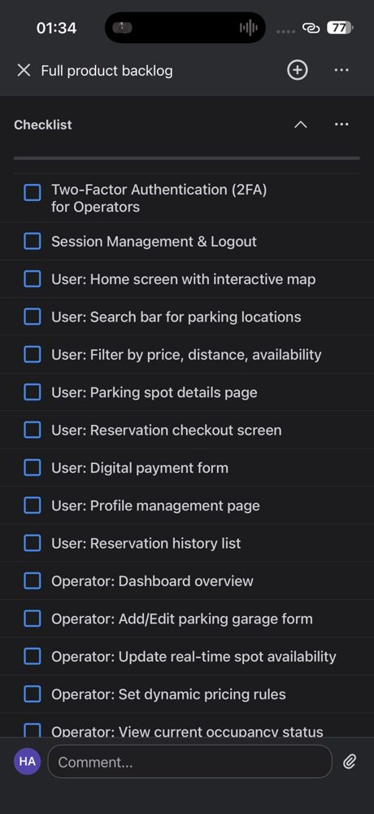  Checklist, top | 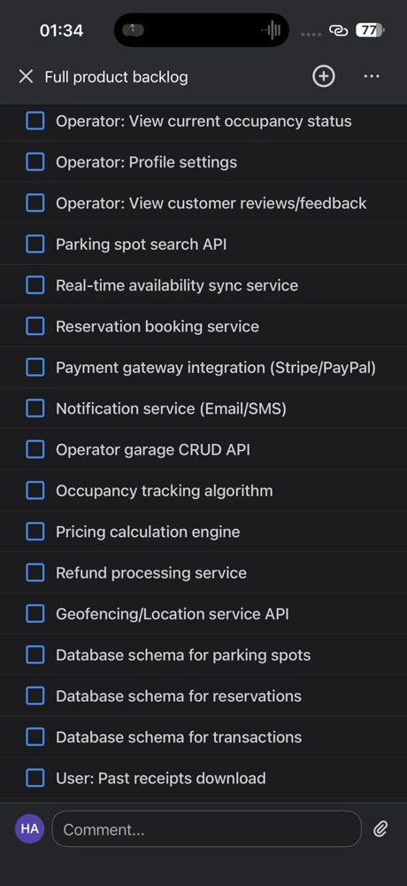  Checklist, middle | 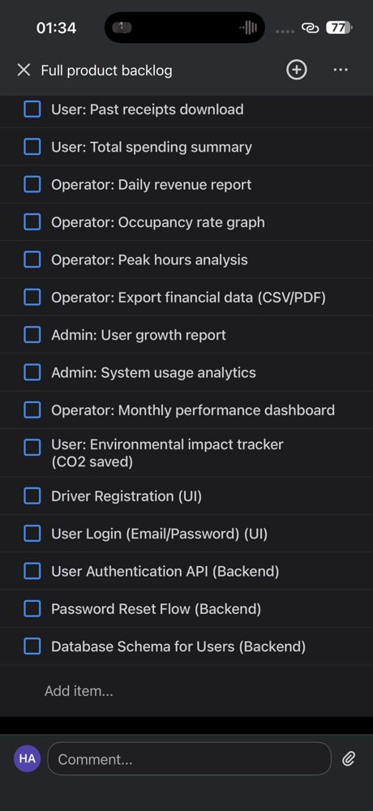  Checklist, bottom

6. Sprints and Trello Board

Sprint plan
Sprint | Weeks | Goal | Backlog items | Points
S1 | 1-2 | Accounts and basic map: registration, login, authentication API, password reset, user database, basic map | BL-03, BL-41, BL-42, BL-43, BL-44, BL-45 | 22
S2 | 3-4 | Sessions, profile, parking data and search: parking spots database, search API, search bar, location service, operator settings | BL-02, BL-04, BL-09, BL-16, BL-18, BL-27, BL-28 | 24
S3 | 5-6 | Spot details and filters, operator portal basics, garage management and operator 2FA | BL-01, BL-05, BL-06, BL-11, BL-12, BL-23 | 26
S4 | 7-8 | Availability: real-time sync, sensor gateway and offline alerts, occupancy tracking, operator availability updates, reservations database | BL-13, BL-15, BL-19, BL-24, BL-29, BL-46, BL-47 | 35
S5 | 9-10 | Reservations and payments: booking service, checkout, payment form, payment gateway, transactions database | BL-07, BL-08, BL-20, BL-21, BL-30 | 29
S6 | 11-12 | Pricing and resilience: pricing engine, dynamic pricing rules, refunds, backup payment provider | BL-14, BL-25, BL-26, BL-48 | 26
S7 | 13-14 | Notifications, history, receipts, spending, reviews, daily revenue report and occupancy graph, plus system testing, UAT and load testing | BL-10, BL-17, BL-22, BL-31, BL-32, BL-33, BL-34 | 22
S8 | 15-16 | Peak hours, exports, monthly dashboard, admin analytics, CO2 tracker, plus security audit fixes, deployment and handover | BL-35, BL-36, BL-37, BL-38, BL-39, BL-40 | 24

Why we chose Trello
Lecture 7 says to pick a tool based on team size, budget, complexity, integrations and learning curve, and its decision matrix points small teams to Trello. Trello is free, very easy to learn, and gives us a clear visual board, which suits a part-time team that needs to start quickly. Its weakness is limited reporting, so for the monthly executive briefing I count finished backlog items and checked checklist boxes, and compare them with the sprint plan. If the team grows or reporting needs increase, we can move to Jira. Azure DevOps would be overkill for a four-month project.

Current board (Sprint 1)
Our board has three lists: To Do, In Progress and Done. Cards are named "Sprint N: item (UI or Backend)". Right now Sprint 1 has one card done, two in progress and three still to do, plus the backlog card.
To Do | In Progress | In Review (planned) | Done
Full product backlog (checklist, 0 of 45 done) | Sprint 1: Driver Registration (UI) | (no In Review list yet) | Sprint 1: Basic Interactive Map UI (UI)
Sprint 1: User Login (Email/Password) (UI) | Sprint 1: User Authentication API (Backend)
Sprint 1: Password Reset Flow (Backend)
Sprint 1: Database Schema for Users (Backend)

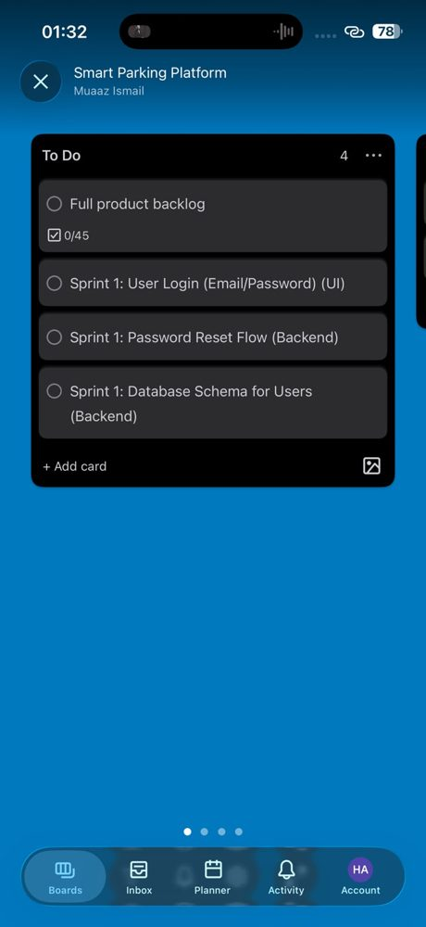  To Do list | 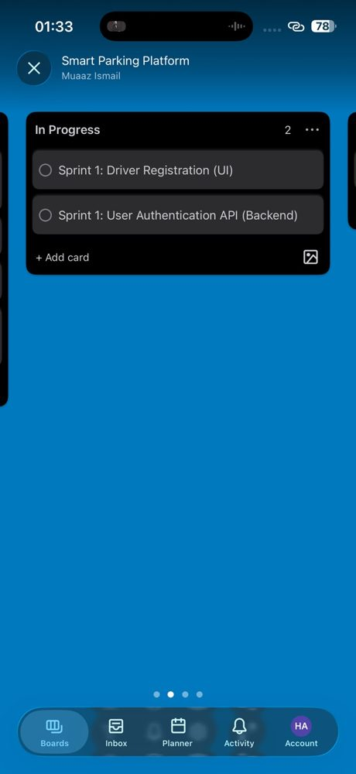  In Progress list | 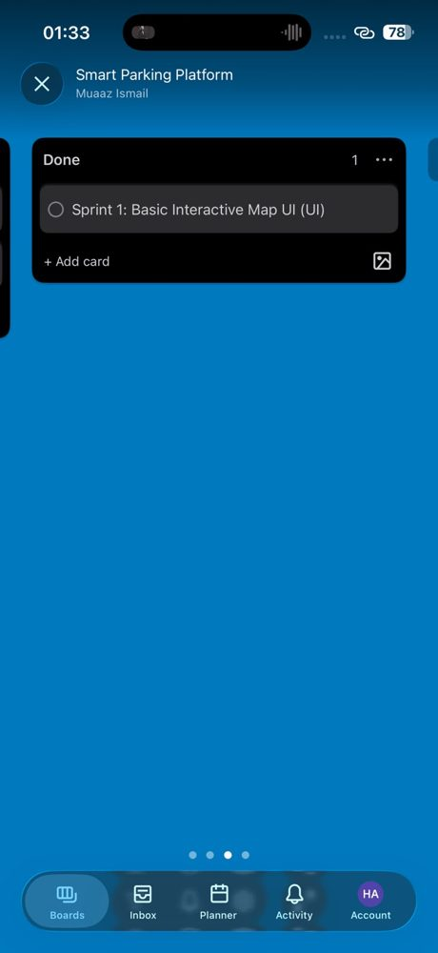  Done list

Our GitHub and Trello workflow
- Each backlog item becomes a card named after the sprint, for example "Sprint 2: Parking spot search API (Backend)".
- Starting in Sprint 2 we add an In Review list. A card moves To Do, then In Progress, then In Review, then Done.
- Each developer creates a feature branch named after the item, for example search-api. Commits are small, with meaningful messages such as "Fix login validation bug", never "changed stuff".
- The pull request is attached to its Trello card. At least one teammate reviews it, and the CI build and tests must pass before it is merged.
- No one pushes directly to main. Main stays stable and deployable, and branches are deleted after merging.
- When the pull request is merged, the card moves to Done and its checklist item is ticked on the backlog card.
- We never clone or pull a repository we have not inspected, and we keep VS Code in Restricted Mode for folders we do not trust (see R11).

7. Risks and Risk Register
I kept the ten risks from last time and added three new ones. R11 is based on the malicious repository incident reported in student repositories, where a fake font file and a tasks.json file ran code automatically when a folder was opened in VS Code. It is rated High because it could expose passwords and tokens for the whole team. R12 comes from the hidden costs section of our cost plan. R13 comes from the real backlog: 48 items is a lot for 16 weeks and a part-time team. Ratings follow the Lecture 5 risk matrix.
ID | Description | Prob. | Impact | Rating | Owner | Response Strategy | Status
R01 | Third-party payment API failure | Low | Catastrophic | HIGH | Payment Integration Lead | Mitigate: backup payment provider (BL-48). | Open
R02 | Data security breach (user data) | Moderate | Catastrophic | HIGH | Backend/API Lead | Mitigate: encryption, 2FA for operators, security audit, secret scanning. | Open
R03 | Backend scalability bottlenecks | Moderate | Major | HIGH | Backend/API Lead | Mitigate: auto-scaling and load testing in sprint 7. | Open
R04 | Delay in API keys / sandbox access | High | Moderate | HIGH | Project Manager | Mitigate: request access in sprint 1, build other items while waiting. | Monitoring
R05 | Scope creep (new features) | High | Major | HIGH | Product Owner | Avoid: change control, new ideas go to the Trello backlog. | Open
R06 | Key developer turnover | Low | Major | MEDIUM | Project Manager | Mitigate: cross-training and documentation. | Open
R07 | Cloud hosting cost overrun | Moderate | Moderate | MEDIUM | Project Manager (Finance) | Mitigate: billing alerts and monthly usage review. | Open
R08 | Mobile-backend integration failures | High | Major | HIGH | QA Lead | Mitigate: daily stand-ups, CI on every pull request. | Open
R09 | Hardware/sensor communication failure | Moderate | Major | HIGH | Mapping/IoT Lead | Transfer: vendor maintenance. Mitigate: manual operator updates (BL-13) and offline alerts (BL-47). | Open
R10 | Stakeholder pricing conflicts | Moderate | Minor | MEDIUM | Product Owner | Mitigate: regular sprint reviews with stakeholders. | Open
R11 (new) | Malicious repository or supply-chain malware on developer machines | Moderate | Catastrophic | HIGH | DevOps Engineer | Mitigate: inspect repos before clone/pull, keep VS Code Restricted Mode, protect main, rotate tokens. | Open
R12 (new) | API usage cost spike (maps and SMS) | Moderate | Moderate | MEDIUM | Project Manager (Finance) | Mitigate: caching, rate limiting, usage alerts. | Open
R13 (new) | Backlog (48 items) bigger than team capacity in 16 weeks | High | Major | HIGH | Product Owner | Mitigate: MoSCoW priorities. Could items (reports, CO2 tracker) are cut first. | Open

9 of the 13 risks now rate High. Other updates: R05 now says new ideas go to the Trello backlog, R09 now lists manual operator updates and offline alerts as backups, and R08 uses CI on every pull request.

8. Communication Plan

Meeting cadence
Meeting | How often | Who attends | Purpose
Daily Stand-up | Daily, 15 min | Development teams | Progress, plans and blockers, using the Trello board.
Sprint Planning (new) | Every 2 weeks, 1 hour | Product Owner, PM, dev team | Pick cards for the sprint from the backlog.
Sprint Review | Every 2 weeks, 1 hour | Product Owner, stakeholders, dev team | Demo working software and collect feedback.
Sprint Retrospective | Every 2 weeks, 1 hour | Internal team only | Start / Stop / Continue improvements.
Executive Briefing | Monthly, 30 min | Sponsors, city transportation departments, PM | Budget, timeline, backlog progress and top risks.

Reporting by audience
Audience | What they receive | Format
Executives and sponsors | Budget used vs. plan, backlog items finished out of 48, top 3 risks. No technical jargon. | Monthly dashboard
Development teams | Card status, pull request reviews, build results, technical notes. | Trello board, GitHub pull requests, CI results
Parking operators and end-users | What is new and what is coming, plus a way to give feedback. | Bi-weekly demos, release notes, feedback surveys

Other rules
- Task updates and questions go in Trello card comments and GitHub pull request reviews, so decisions are written down.
- Security alerts, such as a suspicious repository, are reported to the DevOps Engineer and the PM the same day.
- Blockers are raised at the daily stand-up, not saved for the sprint review.

9. Roles
The team is the same as in Homework 5. The only change is that the DevOps Engineer now also owns repository access and security settings, and the Project Manager runs the sprint meetings.
Role | Name | Allocation | Main responsibility
Project Manager (also Finance/Billing) | Sara Khan | 25% | Plans sprints, tracks budget and risks, reports to sponsors.
Product Owner / Business Analyst | Daniel Reyes | 20% | Owns the Trello backlog and requirements, speaks for stakeholders.
Backend/API Lead Developer | Omar Farooq | 75% | Backend services, real-time availability, API design.
Mobile App Developer | Priya Nair | 75% | iOS/Android app screens and booking flow.
Payment Integration Lead | Liam Chen | 50% | Main and backup payment providers.
Mapping/IoT Lead Developer | Ayesha Malik | 50% | Maps and location, sensor gateway and data ingestion.
UX Designer | Noah Brooks | 25% | Wireframes, prototypes, usability checks.
QA Lead / Tester | Hannah Lee | 50% | Test plan, regression tests, UAT.
DevOps Engineer | Carlos Mendez | 20% | CI/CD, cloud, monitoring, and now repository security.

10. Cost Plan
I reviewed the cost plan against the updated backlog and sprint plan. The total stays at $136,418 and nothing needed to move. Trello is on its free plan and the new safeguards (branch protection, secret scanning, VS Code Restricted Mode) are free built-in features. The sensor ingestion and backup payment items are developer time that is already counted in labor. Contingency stays at 15 percent because many risks rate High, including the new backlog-size risk.
Item | Total | Notes
Team labor (2,496 hours) | $108,224 | Nine roles, loaded hourly rates
Cloud hosting | $1,600 | $400/month for 4 months
Third-party APIs | $1,000 | Maps and SMS, with caching to keep calls low
Licenses and tools | $1,200 | GitHub, Figma and dev tools. Trello is on its free plan.
IoT sensor hardware | $1,800 | 20 sensors and 2 gateways
Security audit | $3,000 | External audit before launch
Training | $800 | WebSockets and geolocation
Legal and compliance | $1,000 | Privacy and payment review
Subtotal | $118,624
Contingency (15%) | $17,794 | Kept at 15 percent because many risks rate High
GRAND TOTAL | $136,418

Monthly cashflow
Month | Labor | Cloud + APIs | Licenses | Hardware | Other | Contingency | Total
Month 1 | $22,000 | $650 | $1,200 | $0 | $800 | $3,698 | $28,348
Month 2 | $33,000 | $650 | $0 | $1,800 | $0 | $5,318 | $40,768
Month 3 | $33,000 | $650 | $0 | $0 | $1,000 | $5,197 | $39,847
Month 4 | $20,224 | $650 | $0 | $0 | $3,000 | $3,581 | $27,455
Total | $108,224 | $2,600 | $1,200 | $1,800 | $4,800 | $17,794 | $136,418

Cumulative spending is $28,348 after month 1, $69,116 after month 2, $108,963 after month 3, and $136,418 at the end.

11. RACI Matrix
I added two rows this week: backlog and sprint planning, and repository access and security. Every row still has exactly one Accountable person, and A/R means the same person does the work and approves it.
Key: R = Responsible, A = Accountable, C = Consulted, I = Informed. Roles: PM = Project Manager, PO = Product Owner, BE = Backend/API Lead, MOB = Mobile Developer, PAY = Payment Integration Lead, IoT = Mapping/IoT Lead, UX = UX Designer, QA = QA Lead, DevOps = DevOps Engineer.
Deliverable | PM | PO | BE | MOB | PAY | IoT | UX | QA | DevOps
Requirements and user stories | C | A/R | C | C | I | C | C | C | I
Backlog and sprint planning (new) | R | A | C | C | C | C | C | C | I
UI/UX design and prototypes | I | A | I | C | I | I | R | C | I
System architecture and API design | I | C | A/R | C | C | C | I | I | C
Mobile app development | I | C | C | A/R | C | I | C | I | I
Backend services and database | I | I | A/R | C | C | C | I | I | C
Payment integration (main + backup) | I | C | C | C | A/R | I | I | C | I
Sensor and mapping integration | I | C | C | C | I | A/R | I | C | C
CI/CD pipeline and cloud setup | I | I | C | C | I | I | I | I | A/R
Repository access and security (new) | I | I | C | I | I | I | I | I | A/R
Test plan and system testing | I | C | C | C | C | C | I | A/R | I
Security audit and fixes | A | I | R | C | C | C | I | C | R
Budget tracking and reporting | A/R | I | I | I | I | I | I | I | C
Release and deployment | A | C | C | C | I | I | I | C | R

