Mean Patterns
Question: In countries with high social support (Score > 1.2), is the average Happiness Score significantly higher for High GDP countries compared to Low GDP countries?
Subset Definition: Countries from the 2019 World Happiness Report where Social.support > 1.2.
Code:
R
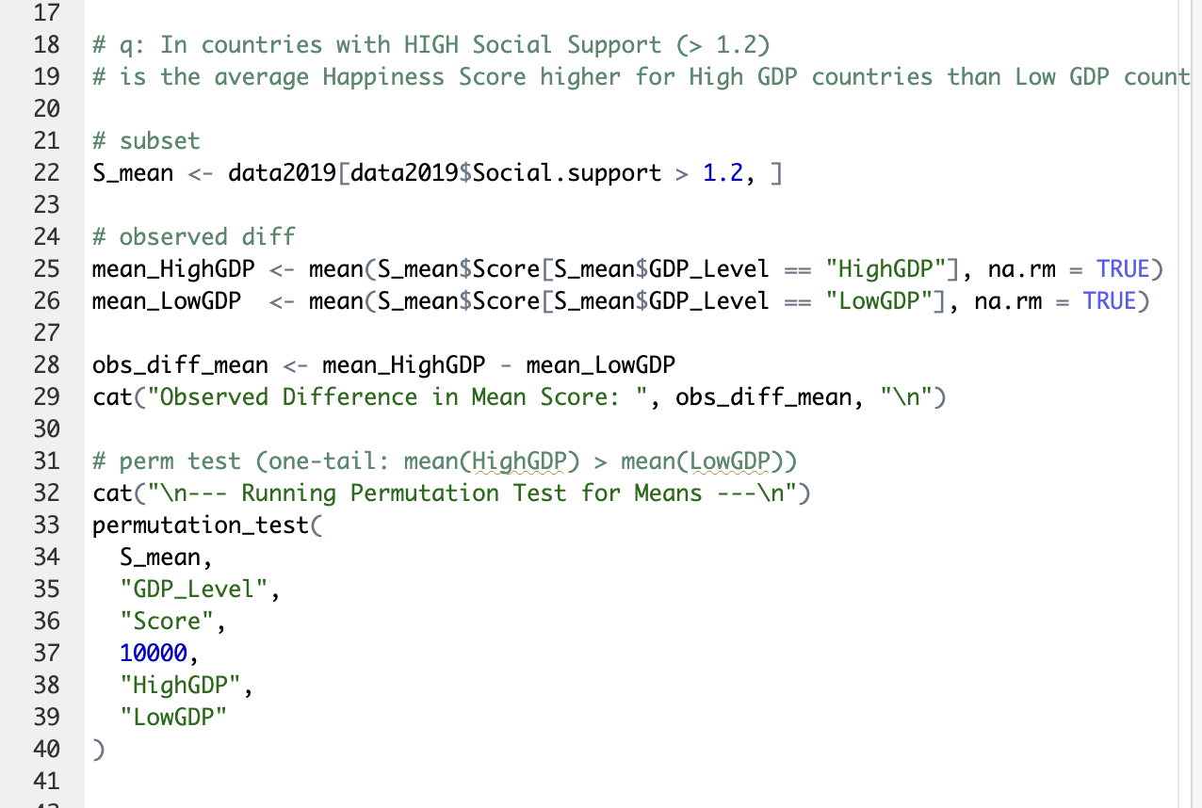
Console Output:
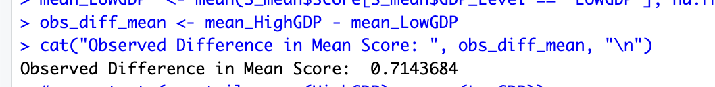
p-value: 0.00029997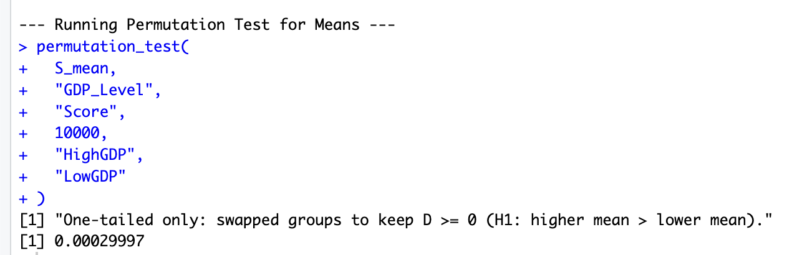
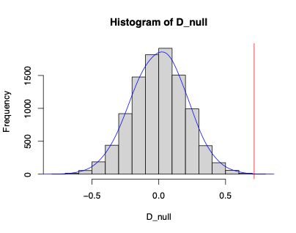
Histogram:

Interpretation: The permutation test shuffled the GDP labels 10,000 times to build a null distribution. The resulting p-value is 0.00029997. Because this p-value is less than our significance level of 0.05, we reject the null hypothesis. This means the difference in happiness scores between High GDP and Low GDP countries (within the high social support subset) is statistically significant and not just due to random chance.

Proportion Pattern
Question: In generous countries (Generosity > 0.2), is the proportion of nations with High Freedom greater in High GDP countries than in Low GDP countries?
Subset Definition: Countries where Generosity > 0.2.
Code:
R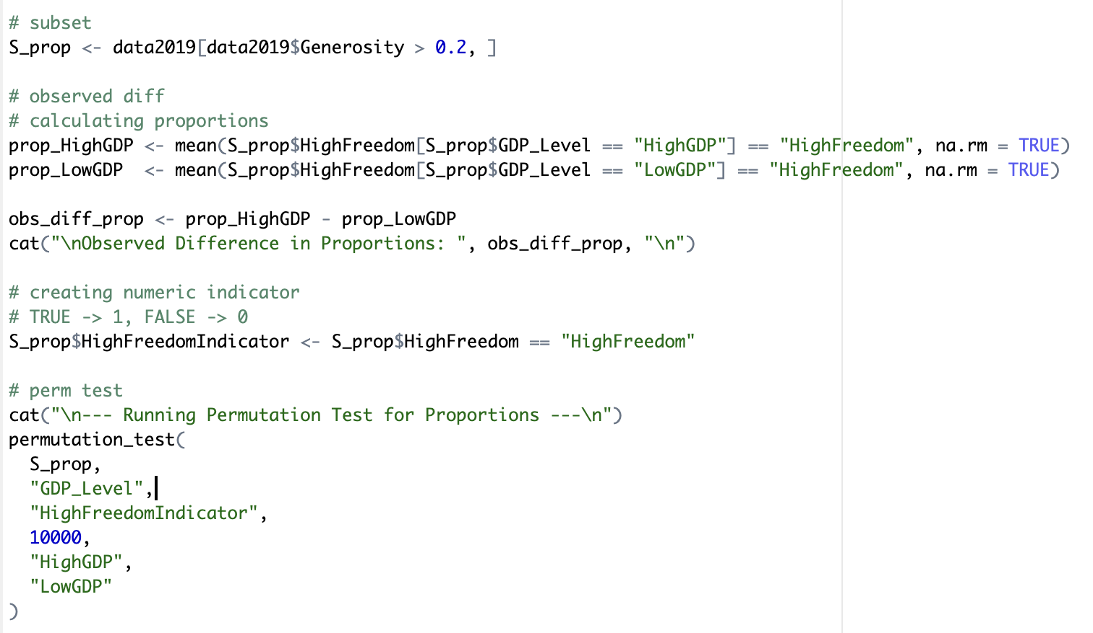
Console Output:
Observed Difference in Proportions: 0.2903226
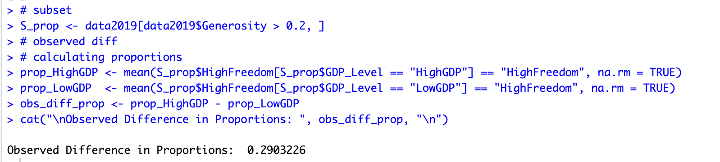
p-value: 0.01549845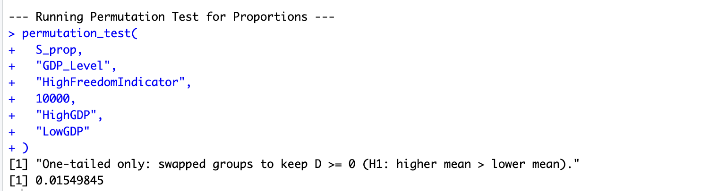
Interpretation: The permutation test shuffled the GDP labels across our High Freedom 0/1 indicator 10,000 times. The resulting p-value is 0.01549845. Because this p-value is less than 0.05, we reject the null hypothesis. This difference in proportions statistically significant and not just due to random chance.

Multiple Testing Problem
If I were to keep going through this dataset, changing the parameters like trying different cutoffs for Generosity or GDP until I found these two specific patterns. I would be falling into the multiple testing trap.
If I tested 50 different hypotheses before settling on these two. Because testing multiple hypotheses increases the Family-Wise Error Rate (FWER) and the chance of finding false positives, I have to apply the Bonferroni correction.
- New Bonferroni Coefficient:
Decision: * Mean Pattern: My p-value was 0.00029997. This is still less than 0.001, so the pattern holds.
- Proportion Pattern: My p-value was 0.01549845. This is greater than 0.001, so the pattern no longer holds.

Confidence Intervals
Code:
R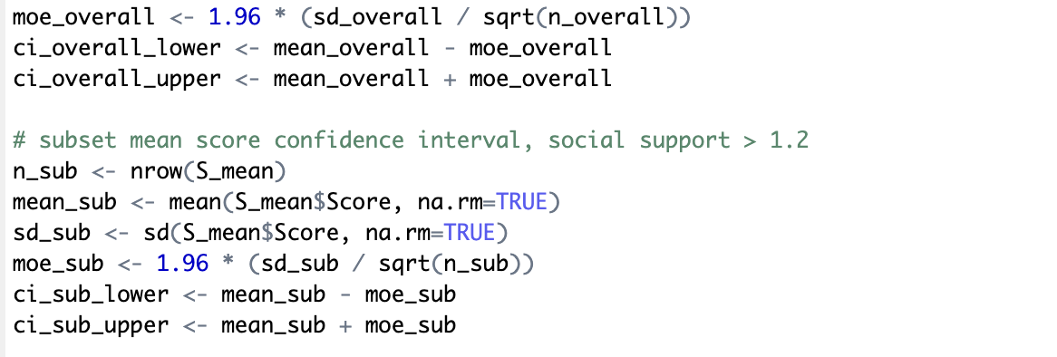
Output:
Overall Mean Score 95% CI: [5.232419, 5.581773]
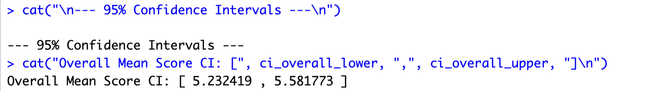
Subset Mean Score 95% CI: [5.911136, 6.232274]
Interpretation: The formula used for the 95% Confidence Interval is: Sample Mean ± 1.96 × (Sample Standard Deviation / √Sample Size).
Looking at the two intervals calculated above, they do not overlap. Because they do not overlap, this suggests that the subset of countries with high social support has a statistically significant higher mean happiness score than the global average, and we are 95% confident the true population means are different.

