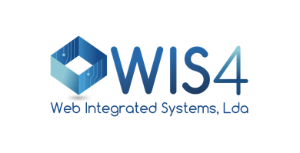

Technical Challenge

Goal

Create a PoC for an application with a document workflow.

This workflow is divided into two main flows: create a task to submit documents - only allowed to the application administrator; another flow for the task execution - only for collaborator (need to fill a description and the document upload).

Both flows need to be authenticated and need to check the authorization (specific permissions/roles).

System Architecture (simplified)

The authentication must be done in a simple form (login and password).

The architecture should be based on microservices: it needs to have a front-end application for the interfaces and a backend application for the business login e data access. The backend must be REST API compliant. The database engine to be used should be MariaDB and should have at least three tables: Users, Tasks, TaskExecution.

Regarding infrastructure, nginx should be used as webserver, MariaDB for database engine and AWS S3 for file storage (use S3 ninja as an emulator for AWS S3). All the infrastructure could be containerized (using docker) and the application must be develop using CodeIgniter (https://github.com/codeigniter4/CodeIgniter4).

The project can be delivered / shared folder (ex: dropbox). Share it with nuno.baptista@wis4.pt.

Flows

Main menu should have two options: Tasks Management and My Tasks. The Users table should be filled, and email is the key.

Task Management

* User login
* Select "Tasks Management"
* Printed all the tasks
* Select "New Task"
* Fill the form with fields: User, Task type, Description
* Press "Ok or Submit"
* all the information should be processed in the backend
* returns success/error

My Tasks

* This option is only available for the users with the right permission/role
* User login
* Select "My Tasks”
* Form with a task list
* Select a task
* Fill the form with Description, File
* Submit
* all the information is managed in the backend
* returns a success or error