Alexandra Giasi

**Design Document**

This application will attempt to address issues of summarizing natural conversations while providing users with a way to remember key details from transcribed audio recordings. The application first identifies the person standing directly in front of the user by matching the recognized face to previously recorded data, or by creating a new record. By prompt of the user, the application will record and store all desired conversations and transcribe audio recordings to text. This application will then summarize transcribed conversations and provide these summaries and other requested information on a heads-up display. The form that this project will take is an application on the Google Glass. This technology was chosen as the least obstructive method of obtaining all required information. Previous methods of obtaining the data required, such as note-taking or using a smart phone, would require the user to break eye-contact, or fiddle with a distracting device. The Google Glass will allow the user to retain the effect of having unaided interactions by using the Glass’s hands-free interface and discrete design.

End Users

The user of Mem-Friend will be able to access this program on the Google Glass. The end user will install Mem-Friend on a Google Glass and use Mem-Friend to identify persons in front of the user, cause Mem-Friend to record and transcribe conversations, and view summaries of conversations and identities on the Google Glass display.

The user of the Mem-Friend will first install the Mem-Friend onto a Google Glass. The user will open and use Mem-Friend during a meeting or conversation with one other person. To use the application, the user will first open the Mem-Friend application on the Google Glass. The user will then, using the Mem-Friend user interface, indicate to the program that he or she wants to record a conversation. After the conversation is over, the user will indicate to the Mem-Friend that it should stop recording. The user then is able to view the summary of the conversation and identity of the person on the Google Glass display upon user request. If a data entry using facial recognition already exists for a person with whom the user has met with in the past, the identity and summaries of past conversations will be displayed to the user on heads-up display upon recognition.

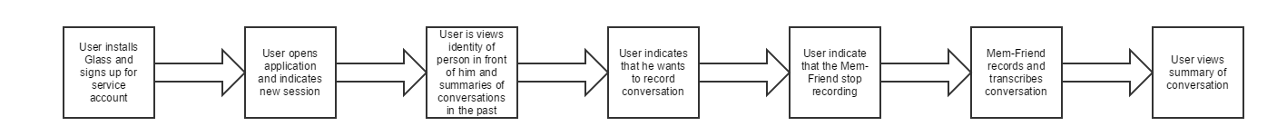

A Google Glass unit will be required by the user to access Mem-Friend. The Google Development Kit will be needed to develop an application that can access the camera and microphone. The GDK will also handle storage, speech recognition and transcription of conversations. On the back end, Google’s Mirror API will be used to develop aspects of the Mem-Friend retrieving and transferring information back and forth from the Google Glass and server. Heroku will be used as a platform for the Mem-Friend’s back-end services, such as the summarization algorithm, and data-storage and retrieval functions. Heroku Postgres will be used as the database service for the Mem-Friend, and will store facial recognition information, person identification (name), and transcribed conversations. On the front-end, the user will be presented with an option to open the Mem-Friend from the Google Glass timeline user interface.

