**Mem-Friend Functional Specification**

**Overview**

The Mem-Friend will attempt to address issues of summarizing natural conversations while providing users with a way to remember key details from transcribed audio recordings. The application first identifies the person standing directly in front of the user by matching the recognized face to previously recorded data, or by creating a new record. By prompt of the user, the application will record and store all desired conversations and transcribe audio recordings to text. This application will then summarize transcribed conversations and provide these summaries and other requested information on a heads-up display. The form that this project will take is an application on the Google Glass. This technology was chosen as the least obstructive method of obtaining all required information. Previous methods of obtaining the data required, such as note-taking or using a smart phone, would require the user to break eye-contact, or fiddle with a distracting device. The Google Glass will allow the user to retain the effect of having unaided interactions by using the Glass’s hands-free interface and discrete design.

**Scenario**

Ross is a solo practitioner who operates his own law firm. His practice mainly focuses upon drafting wills and trusts, however he also drafts other legal documents such as contracts or deeds. Every day, Ross meets with several clients to collect information before drafting each legal document. Legal documents such as wills or contracts often contain large amounts of information specific to each client, such as details of assets or amounts of money to be paid. If any of these details were forgotten or recorded improperly, a client’s assets could be lost, and Ross could get sued for malpractice.

Usually, Ross would write down these details by hand on a legal notepad during his meetings with clients. With Mem-Friend, however, Ross first would wear his pair of Google Glasses during each meeting. He enters the application located on the Google Glass menu, by voice command or by gesture, and is presented with a menu of options. He decides to pick the option to begin the meeting. The Mem-Friend will detect any face directly in front of Ross, and display the client’s name. Then, Ross is able to begin recording the meeting by swiping on the Glass’s gesture pad. To tell the Mem-Friend to stop recording, he will swipe again.

Ross has the ability to access summarized recordings of his meetings through the Google Glass itself, or through an online portal. He logs into the Mem-Friend website with a username and password, and is presented with a list of clients. After selecting the client of his choosing, he can view summaries of past conversations. One day, Ross feels like viewing the summaries of a client meeting in bed. With his Google Glasses on, he selects the Mem-Friend application from the Google Glass menu. On the Mem-Friend menu on the Google Glass, Ross selects an option to access a list of clients and view summaries of past conversations. He selects the option to view the list of clients, and selects the client he had a meeting with that day. He finds the summary of the client meeting listed under that day’s date. He then views the summary of the client meeting before falling asleep.

**Mem-Friend Google Glass Application Flowchart**

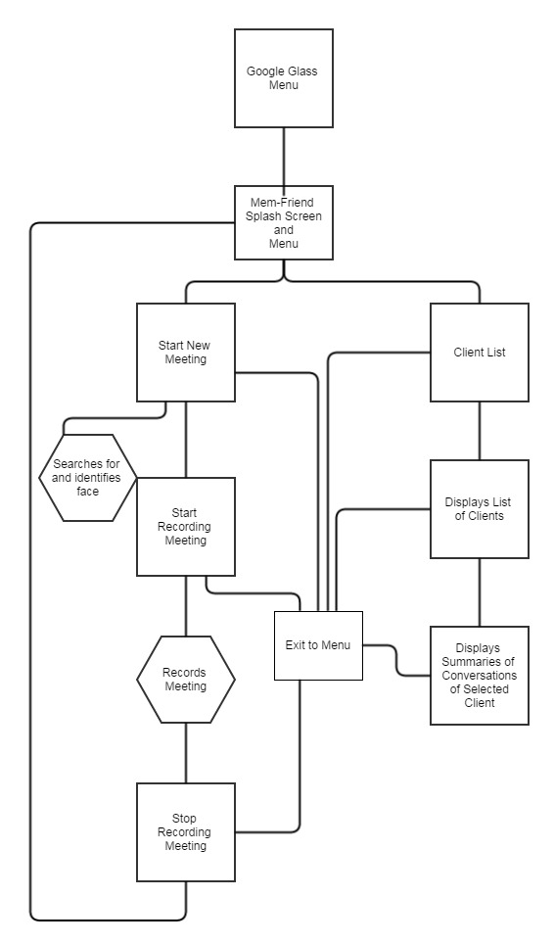

**Mem-Friend Website Flowchart**

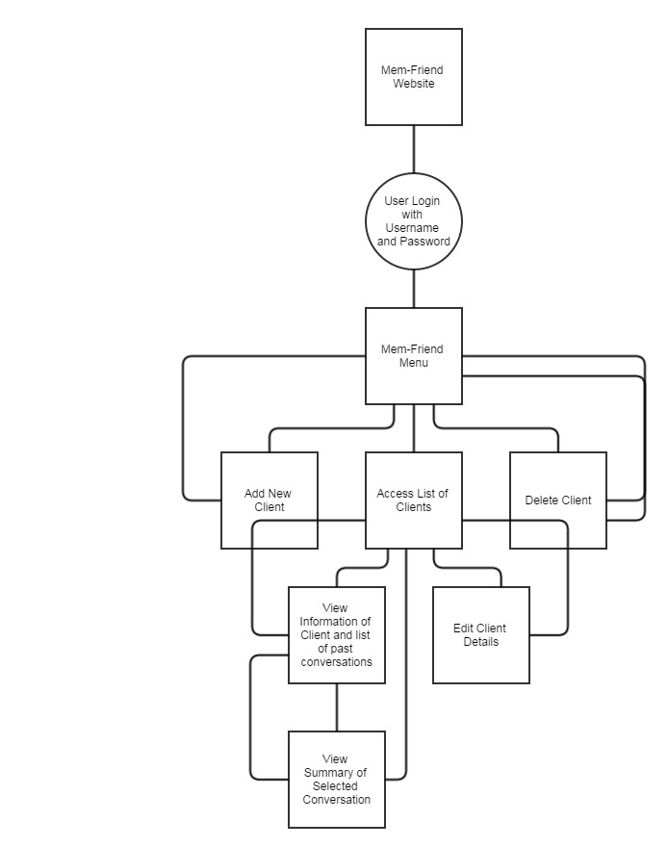

**Mem-Friend Google Glass Application Splash Screen**

From the Google Glass menu, the Mem-Friend splash screen can be accessed using the voice command “Mem-Friend” or through selecting it using gestures. The splash screen will display the name “Mem-Friend” and the user will then tap the gesture pad to move to the Mem-Friend’s main menu.

**Mem-Friend Google Glass Application Main Menu**

The Mem-Friend menu on the Google Glass consists of two options: the option to start a new meeting or to view a list of clients. The two options will be displayed one after another on two different screens, and the user will swipe the gesture pad to access the next option. To select an option, the user will tap the gesture pad.

**New Meeting User Interface**

When the user selects the new meeting option, the Mem-Friend will start searching for a face directly in front of the user. When the Mem-Friend detects a face, the name of the client will be displayed on the heads-up display. At any time, the user will be able to start recording the meeting by swiping from front to back on the gesture pad. While recording, the Mem-Friend will indicate that it is recording by a red blinking dot in one corner of the heads-up display. The user will swipe the gesture pad again to stop recording, and the Mem-Friend will indicate that it has recorded successfully by displaying the message “Recording Successful.” The user will be able to exit to the menu of the Mem-Friend at any time by swiping downwards on the gesture touchpad.

**Client List User Interface**

When the client chooses the option to view the list of clients, the client will be presented with a scrollable list of clients the Mem-Friend has data for. The user will be able to scroll up and down on the list either through swiping on the touchpad, or by tilting his head up or down. The user will be able to tap the gesture pad to select a client. The Client will then be presented with a list of summaries of past conversations, organized by date. The user will be able to select a summary to view it on a new screen. The user will be able to exit to the menu of the Mem-Friend by swiping downwards on the gesture pad.

**Mem-Friend Website**

The user will be able to navigate to the Mem-Friend website. The user will be required to register for an account and to synch his or her Google Glass with the website before use. The main page will contain forms for the user to input a username and password, or a link for the user to register for a new account. Clicking on the registration link leads the user to the registration page. The registration page will include forms for the client’s username, password, and contact information. It will also have an option to synch the user’s glass with the website through the usage of a special code. If the user inputs a wrong username or password, the website will display a message that either the username or password was entered incorrectly, and will allow the user to input new credentials using the same forms.

Once logged in, the user is presented with the main menu for the Mem-Friend website. The user has the option to view a list of clients, add a new client, or delete a client. From the list of clients, the user may edit a client’s information, and edit other information such as the name of summaries. From the list of clients, a user may select a client to view summaries of conversations by date as links. By clicking on each summary, the client may view the summary itself. Each page has an option to return to the previous menu, or the main menu of the website itself.