Austin Blackman

10/9/14

CSCI 4243

LabRat Functional Spec

Function Specifications for the LabRat Project

The LabRat application will drastically change the methods in which science labs are carried out throughout Universities as well as secondary schools. This software will enable teachers to dynamically tailor their lab materials to properly suit the set of students who will be taking the lab as well as allow students to seamlessly integrate their work into a common, more accurate representation of results. Additionally, students will find their work much more streamlined because mundane calculations will be taken care of behind the scenes. The following functional specifications will outline the use cases for both teacher and student users, as well as some intermittent user stories to drive especially crucial points home.

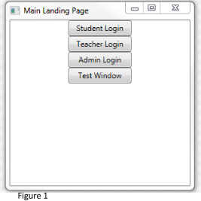

Administrator Use Cases

We can begin to analyze use cases for the LabRat application by digging into the administrator roles. The administrator’s responsibilities are limited in this design as the teachers are responsible for managing the creation and deletion of classes as well as the rosters of students for those classes. The administrator however has the capability to add and remove both student and teacher users. The administrator will create the different user accounts with provided information and then pass on relevant login information to these users. Figure 1 shows the “Admin Login” option. Clicking this button will bring up a new window for the administrator to log in (as seen in Figure 2). We will reference this login page when discussing the login pages for teacher and student users as they are virtually the same. Once a valid set of credentials has been provided, this window will be replaced by a page with options to add and remove teacher and student users. The role of the administrator is not key to the core functionality of the application however it is important to clarify how the user information is handled.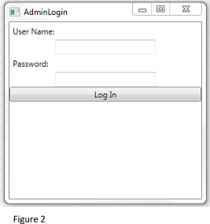

Teacher Use Cases

A teacher will being their LabRat session by logging in through “Teacher Login” option on the main landing page as seen in Figure 1. The teacher will through a similiar login process to the administrator described above, and after this point the teacher landing page will appear. The landing page provides options for the teacher to create and delete courses, as well as create lab content for the various courses. Keep in mind that the system is designed with maximum responsibilities delegated to the teacher. This means that the teacher has the ability to create and delete classes as well as manage which students are in their courses. The students will be added to the particular classes based off of their unique student identifier. While much of the teacher responsibilities are seemingly mundane, the innovative feature included for the teacher is the ability to dynamically create a lab with different modules. As seen in Figure 3, there are three type of modules which the teacher can add to their lab. 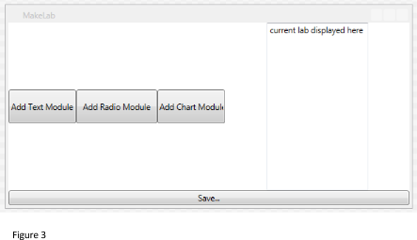

The first option is called a text module and allows the teacher to add a textblock containing their question/prompt as well as a textbox for the student to fill in their answer.

Secondly, the radio module allows the teacher to provide a question and include multiple choice answers. The radio module is highly useful for larger classes where a grader may not have the time or energy to read though a large number of text responses from a text module.

The third and final module option is the most innovative of them all. The chart module allows a teacher to set up a chart for students to input datasets collected from lab experiments. The teacher has the ability to customize the charts to allow for such options as multiple attempts on the same experiment as well as type checking to ensure uniform results. Upon creation of a chart, the teacher has the option to allow for a degree of calculations to be done automatically. For example, the teacher is able to allow the application to automatically average out the results of multiple attempts as well as provide mean, median, and mode data on multiple results for the same experiment. It is understood that as an educational and academic tool, sometimes part of the learning component is the manual calculation of such data. However, upper level science courses place much more importance on the actual nature of the experiment being completed and it is not a priority to make students perform elementary level calculations time and time again. This calculation feature is an integral part of the application as a whole.

Even more important than the calculation of aspects within a single student’s lab is the conglomeration and calculation of aggregated student data within the entire lab session. Often times students who complete labs have little to no idea if their data is correct or completely off. Utilizing the LabRat application, a teacher can decide whether or not they want to enable calculation where once a student completes a chart lab module, their data is factored into the pool of student submitted data for the same module and these averages are conveyed to all students working on that module. The students now have the ability to see how far off their data is from the rest of the class. A student now has the ability to make an educated decision as to whether or not they want to re-do a certain piece of an experiment based on how far off their data is from the norm. Additionally, the teacher has the option to input ranges of data that they deem to be “acceptable”. While the student will not be stopped from inputting data that is outside of the acceptable range, the teacher is able to make it clear that the student may run into trouble down the road if they continue with the use of out of range data. The combination of class averages and teacher provide bounds serves two purposes. The first purpose is that the students have the ability to identify and correct mistakes before they compound and become irreparable. Additionally, these tools serve to reduce the strain that is placed on the lab assistant. Lab assistants are currently highly overworked through the course of a typical science lab with students double checking their results for reference. This routine exercise can be automated using the LabRat application which will allow for the lab assistant to focus more on safety and organization of the lab setting, which are the two main priorities for someone in this position.

Once a lab is created by a teacher, it is published and will appear in the student’s workload. Teachers have instant and routine access to students work using the LabRat application. Gone are the days of piles of student work and the inevitable “but I turned that assignment in last week” excuses. The teacher also has much less work to do in terms of checking student’s math work as well as reading illegible handwriting. All of the tools of the LabRat application work to make teachers lives easier and more streamlined. The final stage in the lifecycle of a lab coincides with the end of the class. Upon the end of a class (presumably at the end of the semester), the teacher will remove all students from that class. Keep in mind that this does not mean that the class is deleted. Of course, teachers will be naturally inclined to re-use lab materials or even an entire class if the class will be repeated annually. the key dynamic aspect of the modules system means that the teacher can easily tweak and modify certain components of the labs to best fit the class that is currently being instructed.

Student Use Cases

The third and final set of use cases belong to the subjects of the application, the students themselves. A student’s life cycle with the application begins with their enrollment in a class that utilizes the LabRat application. These students will have their relevant information gathered by a teacher and submitted to an administrator to create their student accounts. The student now has a username and password to access the system on a computer loaded with the software package. A student’s landing page will show the current classes they are enrolled in with the system. Additionally, a student’s landing page will show if there are any labs in any of their classes which they have been assigned and have not completed. Clicking through any of the classes will bring up the course page for that particular class. The course page lists all of labs currently available for that class, both completed labs and incomplete/new labs.

In a typical use case for a student in the LabRat system, the student will have a Windows device with them in the lab space (given the failing popularity of Windows tablets this will be extremely cost effective). Given the fact that the LabRat application exists as a stand alone system it will be much easier for lab assistants to monitor internet activity in the classroom and to ensure that students are actually using the classroom technology in a productive way. Students have the ability to save their work upon completion of each module. This modular approach allows a student to work on pieces of the lab at a time and have a safe and redundant copy of their work. Students also have the ability to access their work on any device loaded with the software in order to reference their work for completion of lab reports and studying for tests.

There is also much more transparency between the teacher and students when using the LabRat application. Teachers can see whether or not a student has completed the lab successfully and can also see that the labs are being completed in a timely and consistent manner. This is greatly different than the current pen and paper approach to completing labs where teachers have no access to the students’ work until the student is done with the lab and is ready for grading. At this point, the student would not have access to their completed lab until the grader is finished going over their work and hands the labs back. During this time there is no provision for the student to reference the work they just completed for test preparation of lab report writing. This shortcoming is remedied with the LabRat application where the student can access and reference their work while the grader is busy grading. There is essentially zero removal from the original data source for either the teacher or the student.

A given student’s account will exist for their use beyond the single class where they started using it. In the case of a student in a STEM field major, they would likely have lab incorporated classwork for the majority of their college career. As a class is finished and identified as such by the teacher, that classes materials will cease to exist on the student’s landing page. New classes with labs will be automatically shown as a student is added to the class. The combination of dynamically adding and removing of students from classes as well as the reuse and refactoring of lab materials by the teacher allows for a highly streamlined workflow. Theoretically, a class comprised entirely of students who have pre-existing accounts could be enrolled in a class with a completely recycled lab and the only work required would be for the teacher to add each of the students to the lab. the administrator would not need to do any work and the teacher would not have to build any modules any more. Benefits such as this highlight the nature of the modular and dynamic LabRat design. All said and done, the LabRat application’s unique and innovative functionality will reinvent the way that science labs are conducted in academic institutions.