Austin Blackman

9/16/14

Senior Design

Collaborative Student Lab Manual Design Document

The Collaborative Student Lab Notebook will be used as a replacement for the standard paper lab manuals that are currently in use in science classes around the world. In addition to digitizing data for storage and access, the Collaborative Student Lab Notebook will allow students to measure their results in comparison to the results that other students are getting in addition to error margin thresholds that the teacher can assign. The Collaborative Student Lab Notebook will allow students to recognize mistakes that are made before they compound into an irreconcilable error. In addition, much of the busywork surrounding the collection of data will be eliminated. This will include the calculation of averages and standard deviations.

There are three major users in the Collaborative Student Lab Manual. These are students. admin users, and teachers. The application will be largely focused on the student user. The student will receive their username and password based on their information provided to the admin user from the teacher. The student will use this username and password to login to the system and view labs that have been assigned to them. The student will be able to select a lab to complete and work on the selection. Once a segment of the lab is completed, students will have the opportunity to “commit” their work to the database and it turn view their results in comparison to the results of students who have already completed that portion of the lab. In addition, teacher reference numbers will be available for viewing at this point. The lab will be submitted in these segments so that the lab is totally complete once the last segment is finished. The student will be able to view their completed labs for reference after completion. The teacher’s user story will begin by the creation of labs for their designated class. The teacher will be able to choose from a variety of modules to build a customized lab containing text areas, tables, and radio buttons for answering questions. The teacher will be able to deploy the lab to the students in a given class and will then be able to view the statuses of the students’ progress through the lab. The completed labs will be made available to the teacher for grading. The admin user story is simple in comparison. the admin user will be able to create teacher and student accounts. It will be left up to the teacher to create their own classes as well as remove class content as they see fit.

Student Use Cases:

* When the student logs in to complete a new lab, they will see the lab listed as an uncompleted. The student will click on the lab to work on it and fill in answers. The precondition is that the teacher has published the lab to the appropriate class and the teacher has also added the student to the class with the lab. This will ensure that the student has access to the lab that needs to be completed.
* The student can also log into the system in order to work on a lab that they have worked on previously. The student will have their completed modules saved and available for view in the lab document. The precondition will be required that the student is recognized as an active participant and the content will saved for their continued completion.
* The student will be able to log into the the system and view completed labs. Once all lab segments have been individually submitted the student will have access to the lab as a reference document. This access will continue until the end of the class where their student account and associated content will be erased as the teacher dismantles the class from their account.

Teacher Use Cases:

* To initialize a class the teacher will login using their username and password provided by the administrator. The landing page for the teacher will include a button to create a class. The teacher will be able to name the class and add student users to the class. This creation will allow the students to see that they have this new class listed under their classes.
* To create a lab document, the teacher will login to the system a button will exist on their login page in order to allow them to create content. The content creator page will allow the teacher to select pre-defined modules such as text areas, charts, and radio buttons with their own custom captions and explanations. Once a complete lab document is created, the teacher will publish the document and at this point the students will see this document listed as incomplete in their queue for this class.
* To track progress of a lab, the teacher will click on a “track progress” tab on their landing page. This page will allow them to select the lab that they would like to track and then they will see a list of all the students in the class and what modules they have completed.
* To grade completed labs, the teacher will click on a “grade labs” tab on their landing page. This page will allow them to select a lab then view all of the students who have completed the lab just like the track progress feature. This feature will allow the teacher to select a certain student and then view his/her lab as it stands. This allows the teacher to grade incomplete labs as incomplete as well as completed labs.
* To erase a course, the teacher will have access to an “erase course” button just like the previously mentioned buttons. The teacher will be able to select from a list of courses and click “erase”. This will erase all the lab documents and data associated with the documents and students will no longer see this content when they log back into their account on the system.

Administrator Use Cases:

* To add a teacher user, the administrator will login to the system and on their landing page will be an “add teacher” button. This will direct the administrator to a page where they can input the necessary teacher information such as first and last names, email address, department, username, and password. This form will create a teacher user with the proper login credentials. This username and password will be provided to the teacher for their continued use.
* The same steps will be followed in order to add a student user. The student user will be created with the same information except not including the department field. The teacher will be the one assigning students to classes so the administrator will not have to worry about this.
* To remove a teacher or student user, a corresponding button will be located on the administrator login page. The administrator will be able to search the database for username or email address in order to track down the correct user. At this point the administrator will have the opportunity to select the user and click a delete button.

Below are two diagrams of entity relationships as well as a flow diagram for the Collaborative Student Lab Notebook.

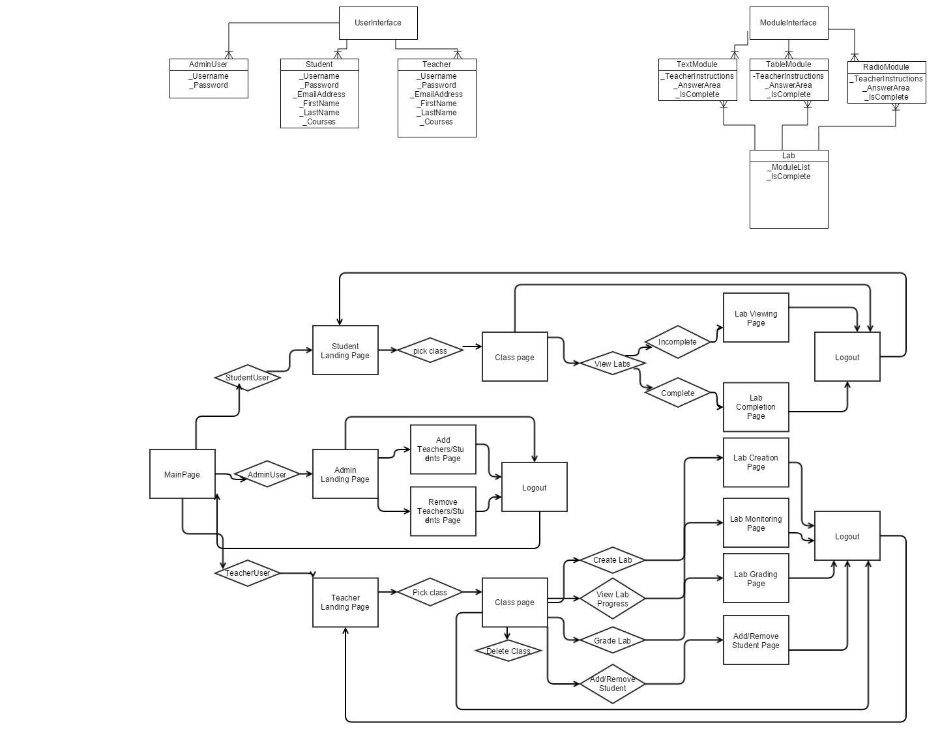

Requirements for the System:

* Users must be able to reliably login to the application and view their data.
* The content requested by the users must load reliably and with reasonable speed.
* The connection between the application and the database must be of sufficient strength to maintain continuous back and forth data transfer.
* Users must not get “stuck” in the application by entering a state where a logout is not available without loss of data.
* The database must be of sufficient size to handle the predicted course load of students along with their data.
* The database must be a design to facilitate adequate speed when querying from the application.
* Users must be able to reliably erase their data after use. User of the MongoLab tools should NOT be required except for the case of adding and removing administrator users.
* A reasonable level of confidentiality must be met. There should be reasonable measures in place to ensure that private student information is not accessable to those outside the trusted group.