Krista Bacungan
October 28, 2010
Design HW #2
Launch
Search’M will be installed via an installer executable. During this install the user has the option to choose where the application is installed. A user manual is placed in the Search’M folder. Once the application is installed and opened, there will be a tool tip popup to explain to the user the steps they must take in setting up Search’M. The only thing that must be selected during the first use of Search’M is which browser is preferred in opening articles. All other preferences can be edited at anytime and the tool tip popup as well as the user manual explains them to the user.
The configuration data will be stored in a preference file that is stored in the Search’M folder specified by the user during installation and is created the first time Search’M is opened. This preference file will store any RSS feeds that are being monitored, user interface preferences (result display), the browser to use when opening up the articles, how long the articles are to be kept in the application, how far back RSS feeds should be read once added, and other preferences. This file is retrieved everytime Search’M is opened. If no preference file is located, the system starts fresh and again displays the tool tip popups for the user to follow if needed.
Diagrams & UI
- Overview Diagram
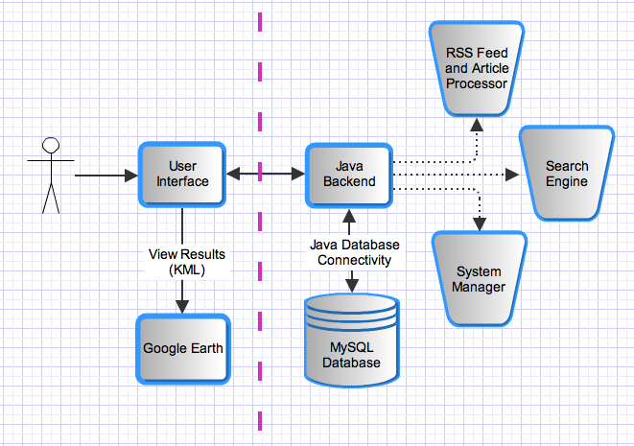
- RSS Feed/Article Control Flow
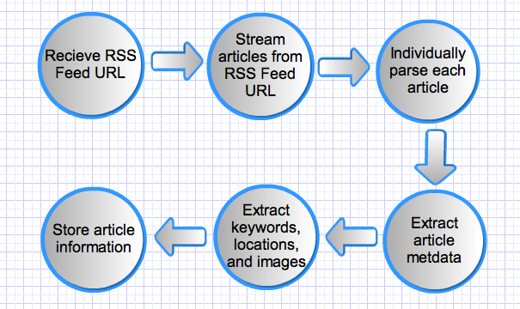
- RSS Feed/Article Data Flow Diagram
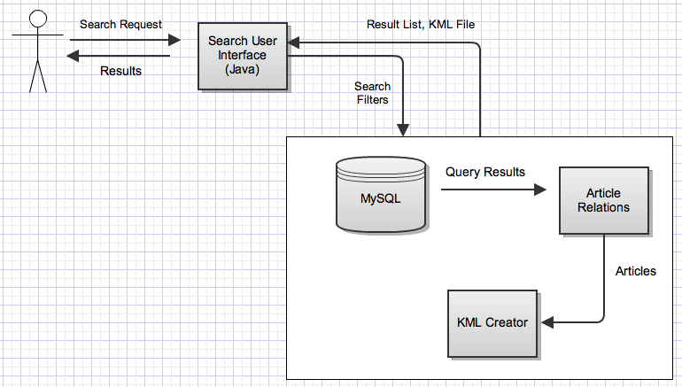
- Search Control Flow Diagram
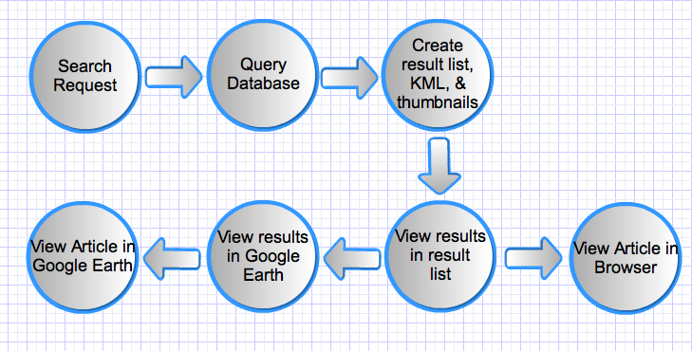
- Search Data Flow Diagram
- User Interface Mock up
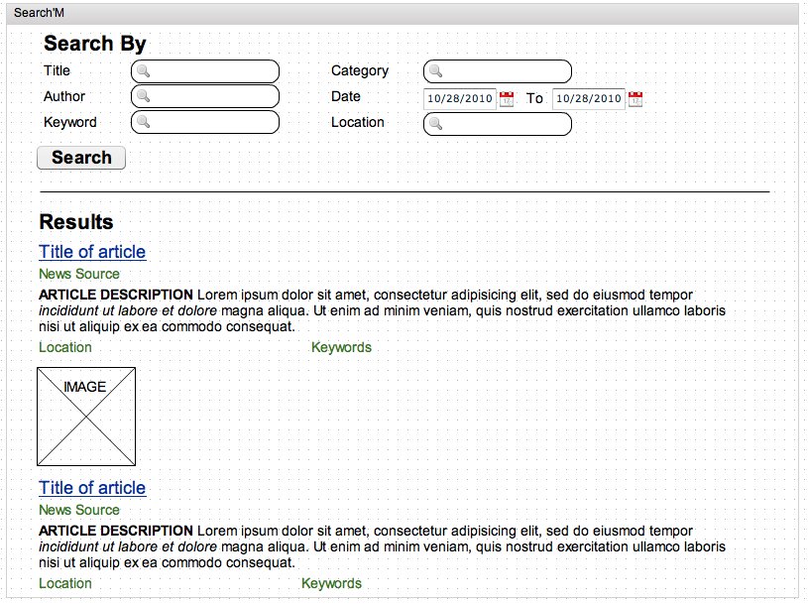
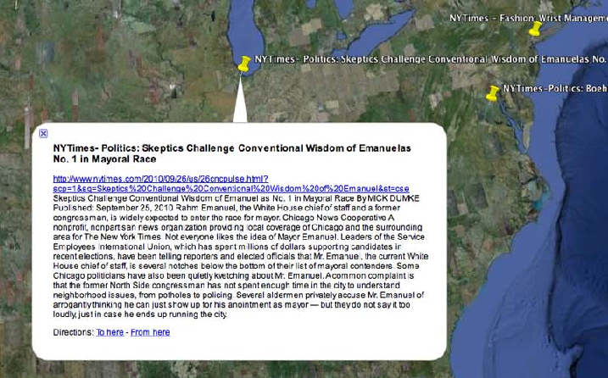
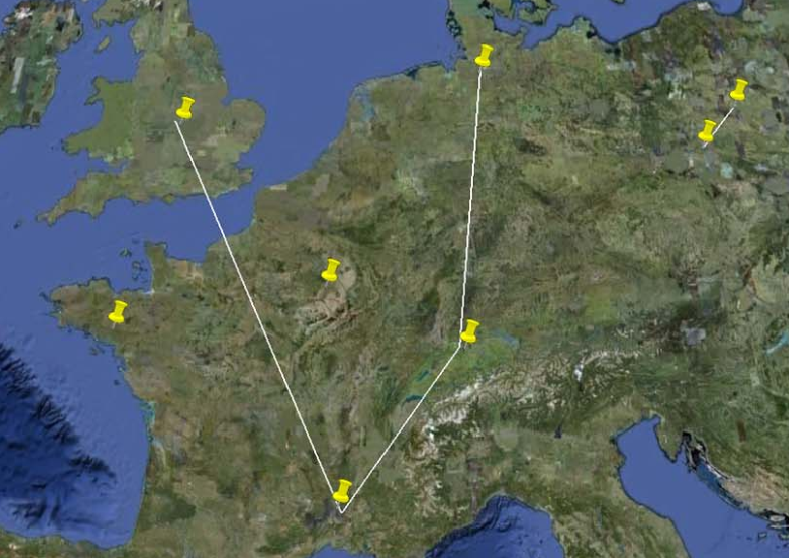
Use Case:
- Add RSS Feeds to monitor
- Search for articles through filters
  - View results in result list
  - View results in Google Earth
  - View full articles (Click on URL)
- Manage Search’M
- Use system connected/disconnected from the internetGeneral Users
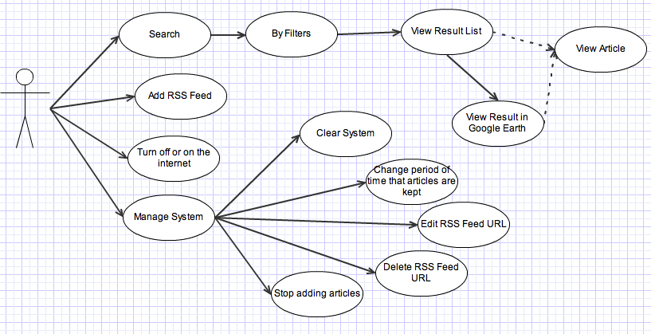
Functional Units and Data Structures

Core Requirements
- Ability to add RSS Feeds and articles
  - Parse and extract accurate information from each article
  - Extract article information in a timely matter
  - If system is disconnected from the internet do not continue to add articles
- Ability to Search
  - Many filter options for searching
  - Intelligent querying for fast results
  - User friendly and intuitive interface for searching and viewing results in Google Earth
- Managing Search’M
  - Delete, or modify RSS feed URLs
  - Clear system of all data
  - Edit how long articles stay in the system
  - Edit how far back in time should the RSS Feed read in articles
  - Start or stop adding articles to system
  - Select which browser to open articles in
- Use Search’M
  - Connected to the internet
    - All features able to run
  - Disconnected from the internet
    - All features able to run except no new articles will be added to the system
List of Functions:
- Retrieve articles from RSS Feed
  - Stream articles one at a time and read HTML (ROME API).
  - Automatically pull in articles as they are updated to the RSS feed.
- Process articles
  - Determine which sections of the HTML is the article content (Java SAX API).
  - Get article dates, authors, categories, and automated keywords from article’s metadata. (Jericho API)
  - Process the article content for keywords and locations.
  - Pick out embedded images.
    - Create thumbnails.
- Store and retrieve information from database
  - Create and design database (Java Database Connectivity, JDBC).
  - Store the article content, authors, description, thumbnail of embedded images, keywords, categories, URLs of related articles, dates, locations, and URL of the article.
  - Create efficient queries to get results for searches.
- Search
  - By title, authors, keywords, locations, dates, categories, or a combination of filters
- Create results
  - Determine relationships between articles. This is not the same as related articles which are URLs found in the article. Instead this subfunction must connect articles together based on common dates, locations, keywords, or categories.
  - Create KML to show results in Google Earth (Java SAX API).
  - Create KML to show the relating lines between articles. (Java SAX API)
Algorithms:
- Keyword Generation
  - Finding efficient and accurate keyword generation algorithms
- Determining the main location of article
  - Use of location heirachy tree
  - Created from outside sources that contain:
    - City, State/Province, Country, Continent, Longitude and Latitude
  - Store in XML
