SWE 455 Cloud Applications Engineering
Technical Project Report
Cloud-Based Volleyball Match and Set Analytics Platform

Backend | Node.js + Express.js REST API
Database | PostgreSQL (local Docker Compose) + AWS RDS (cloud)
Containerisation | Docker + Docker Compose, image: muammalzuhair/volleyball-api:latest
Cloud | AWS EC2 + AWS RDS, provisioned with Terraform
CI/CD | GitHub Actions → Docker Hub
Source Code | GitHub repository (application + Terraform infrastructure)
Date | May 2026

1. Introduction
This report documents the design, implementation, and cloud deployment of the Cloud-Based Volleyball Match and Set Analytics Platform, developed as the course project for SWE 455 Cloud Applications Engineering. The system is a RESTful backend API built with Node.js and Express.js that enables clients to manage volleyball matches, record individual sets and rallies, and retrieve detailed per-match analytics.

The application is deployed on Amazon Web Services: the API runs inside a Docker container on an AWS EC2 instance, and all persistent data is stored in AWS RDS PostgreSQL. Infrastructure provisioning is fully automated with Terraform, and a GitHub Actions pipeline handles continuous integration and delivery to Docker Hub.

This report satisfies the three submission requirements: (1) a concise technical document explaining how the system satisfies each of the 15 factors, including the system architecture diagram and full REST API documentation; (2) links to the source code repositories; and (3) the complete AI prompt log included as Appendix A.

2. Source Code Repositories
The project is hosted in a single GitHub repository containing both the application source code and the Terraform infrastructure code:

Repository | Contents
Application + Infrastructure | Node.js backend (src/, app.js), Dockerfile, docker-compose.yml, Terraform files (main.tf, variables.tf, outputs.tf), schema.sql, GitHub Actions workflow (.github/workflows/deploy.yml)
Docker Hub Image | muammalzuhair/volleyball-api:latest — publicly available pre-built image for amd64

Note: Insert the GitHub repository URL here before submission.

3. System Architecture

3.1 Architecture Diagram

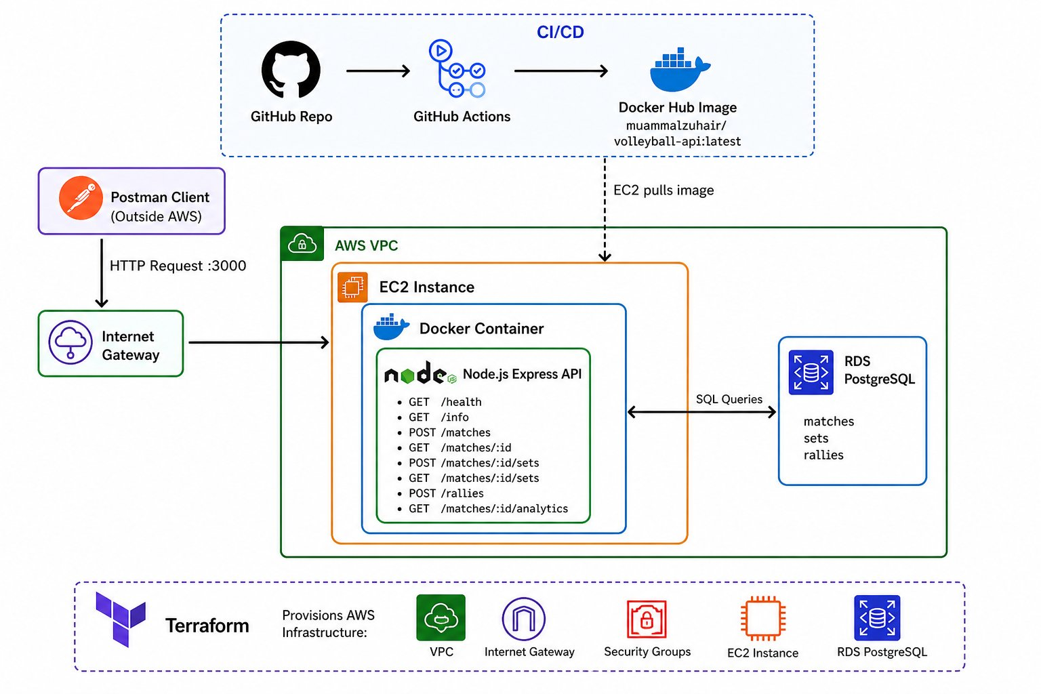

3.2 Request Flow
A client (Postman or any HTTP consumer) sends an HTTP request to the EC2 instance public IP address on port 3000. The AWS Internet Gateway routes the traffic into the VPC. The EC2 security group permits inbound TCP on port 3000 from any source (0.0.0.0/0). Docker maps the host port 3000 to the container port 3000, forwarding every request to the Express.js API process running inside the container. The API processes the request—validates input, executes business logic in the service layer, and performs SQL queries via the PostgreSQL driver—then returns a JSON response to the client. All persistent state is stored in and retrieved from the AWS RDS PostgreSQL instance, which is accessible only from the EC2 security group on port 5432.

3.3 CI/CD Flow
When a developer pushes code to the main branch, GitHub Actions triggers the deployment workflow. The workflow installs dependencies, runs validation checks, and builds the Docker image targeting the linux/amd64 platform using Docker Buildx. The built image is pushed to Docker Hub as muammalzuhair/volleyball-api:latest. The EC2 user_data bootstrap script, executed at instance launch by Terraform, pulls this image from Docker Hub and starts the container with the appropriate environment variables, connecting it to the RDS instance.

3.4 Infrastructure Components
AWS Component | Purpose
VPC | Isolated virtual network hosting all project resources
Public Subnet | Subnet with Internet Gateway routing for the EC2 instance
Internet Gateway | Allows inbound HTTP traffic from the internet to EC2 on port 3000
EC2 Instance | Runs Docker container with the Node.js Express API; Docker installed via user_data
EC2 Security Group | Allows inbound TCP 3000 (API), TCP 22 (SSH) from any source; full outbound
AWS RDS PostgreSQL | Managed relational database storing matches, sets, and rallies; accessible only from EC2 SG
DB Security Group | Allows inbound TCP 5432 only from the EC2 security group

4. 15-Factor App Compliance
The following sections demonstrate how each of the 15 factors is satisfied by the concrete implementation details of this project.

Factor 1: Codebase
The project maintains a single Git repository containing every component of the system: the Node.js/Express.js backend source (app.js, src/), the Dockerfile, Terraform infrastructure files, schema.sql, and the GitHub Actions CI/CD workflow. A single codebase maps to a single deployed application on EC2, satisfying the one-codebase-to-one-app requirement.

Factor 2: Dependencies
All Node.js dependencies are explicitly declared in package.json and installed with npm install. No dependency is assumed to exist on the host system. The Dockerfile runs npm install inside the container during image build, ensuring all required packages are bundled and isolated from the underlying host.

Factor 3: Config
All environment-specific configuration—database host, port, credentials, and the server port—is stored in environment variables (PORT, DB_HOST, DB_USER, DB_PASSWORD, DB_NAME, DB_PORT, NODE_ENV). No values are hardcoded in the source code. Terraform injects these variables into the Docker container via the EC2 user_data run command at deployment time.

Factor 4: Backing Services
PostgreSQL is treated as an attached backing service accessed purely through environment-variable-based configuration. Locally, Docker Compose provides PostgreSQL as a container. In the cloud, the app connects to AWS RDS PostgreSQL by changing only the DB_HOST variable. The application code is identical in both environments.

Factor 5: Build, Release, Run
The three stages are strictly separated. Build: GitHub Actions builds the Docker image from the Dockerfile. Release: the image is pushed to Docker Hub (muammalzuhair/volleyball-api:latest) as an immutable, versioned artifact. Run: Terraform provisions EC2 with user_data that pulls the image from Docker Hub and runs the container with the injected environment variables.

Factor 6: Processes
The Express API runs as a single stateless process. No match state, session data, or scores are held in application memory. All persistent data—matches, sets, rallies, and computed scores—lives exclusively in PostgreSQL. Any request can be handled by any container instance without shared in-process state.

Factor 7: Port Binding
Express binds to process.env.PORT, defaulting to 3000. The Dockerfile exposes port 3000, Docker maps it as 3000:3000, and the Terraform security group allows inbound TCP on port 3000. The API is entirely self-contained and exports its HTTP interface through port binding, with no dependency on an external web server.

Factor 8: Concurrency
Because the API is stateless and containerized, horizontal scaling is achieved by running additional EC2 instances or containers pointing at the same AWS RDS database. Node.js handles concurrency internally via its event-driven, non-blocking I/O model. No application changes are required to scale out.

Factor 9: Disposability
Containers and EC2 instances can be stopped, terminated, and replaced at any time without data loss, because all state is stored externally in AWS RDS. Terraform can re-provision the complete infrastructure from scratch in minutes. The container starts quickly on boot via the EC2 user_data script, achieving fast recovery.

Factor 10: Dev/Prod Parity
Both local development and cloud production use Docker and PostgreSQL. Locally, Docker Compose runs the API and PostgreSQL containers together. In production, Docker runs on EC2 and PostgreSQL runs on AWS RDS. The same containerized runtime and the same database engine in both environments minimize environment-specific defects.

Factor 11: Logs
The Express application writes all log output to stdout, following the principle of treating logs as event streams. Docker captures these streams and they can be inspected with docker logs. The EC2 user_data bootstrap script additionally writes deployment debug information—including docker ps and docker logs output—to /home/ec2-user/debug.log.

Factor 12: Admin Processes
Database schema initialization is performed by running schema.sql as a one-time admin process, separate from the running application. Infrastructure admin operations—provisioning the VPC, EC2, RDS, subnets, and security groups—are executed via Terraform commands (terraform init, terraform plan, terraform apply) independently of the application lifecycle.

Factor 13: API First
The entire system is designed around a well-defined REST API. All volleyball domain operations—creating matches, recording sets, logging rallies, querying analytics, and verifying system health—are exposed as HTTP endpoints with JSON request and response contracts. The API-first design makes the backend independently consumable by any HTTP client.

Factor 14: Telemetry
The system provides two dedicated observability endpoints: GET /health returns a simple OK confirming process liveness, and GET /info returns the runtime environment and a timestamp to verify deployment configuration. Docker container logs and the EC2 debug.log provide additional operational telemetry for debugging and monitoring.

Factor 15: Authentication and Authorization
As an academic project, authentication and authorization are not implemented in the current version. The system is deliberately designed as a REST API architecture where JWT-based bearer token validation or API key middleware can be added in a future iteration without restructuring the existing route, controller, and service layers.

5. REST API Documentation
The base URL in cloud deployment is http://<EC2_PUBLIC_IP>:3000. All endpoints that return structured data respond with Content-Type: application/json.

Method | Endpoint | Description
POST | /matches | Create a new volleyball match
GET | /matches/:id | Retrieve match details by ID
POST | /matches/:id/sets | Create a new set for a match
GET | /matches/:id/sets | Retrieve all sets for a match
POST | /rallies | Record a rally and update scores
GET | /matches/:id/analytics | Retrieve match analytics
GET | /info | Deployment verification
GET | /health | Liveness check

5.1 POST /matches
Creates a new volleyball match between two teams. Inserts a record into the matches table and returns the created match including the auto-generated ID and timestamp.

Request Body:
{"teamA": "Team A","teamB": "Team B"}

Response Example:
{"id": 1,"teamA": "Team A","teamB": "Team B","created_at": "2026-05-03T14:00:00.000Z"}

5.2 GET /matches/:id
Returns match details for the given match ID. Returns HTTP 404 with an error message if the match does not exist.

Response Example:
{"id": 1,"teamA": "Team A","teamB": "Team B","created_at": "2026-05-03T14:00:00.000Z"}

5.3 POST /matches/:id/sets
Creates a new set for the specified match. Validates that setNumber is between 1 and 5 and that no duplicate set number exists for the same match. Scores are initialized to 0.

Request Body:
{"setNumber": 1}

Response Example:
{"id": 1,"match_id": 1,"set_number": 1,"teamA_score": 0,"teamB_score": 0}

5.4 GET /matches/:id/sets
Returns all sets for a match ordered by set number, including current scores for each team.

Response Example:
[{"id": 1,"match_id": 1,"set_number": 1,"teamA_score": 25,"teamB_score": 20}]

5.5 POST /rallies
Records a rally for a match set and automatically increments the winning team's score. Validates that winner is 'A' or 'B', type is a valid enum (SPIKE, BLOCK, ACE, ERROR), and the target set exists.

Request Body:
{"matchId": 1,"setNumber": 1,"winner": "A","type": "SPIKE"}

Response Example:
{"rally": {"id": 1,"match_id": 1,"set_number": 1,"winner": "A","type": "SPIKE",
"created_at": "2026-05-03T14:00:00.000Z"},
"set": {"id": 1,"match_id": 1,"set_number": 1,"teamA_score": 1,"teamB_score": 0}}

5.6 GET /matches/:id/analytics
Returns comprehensive analytics for a match: all sets with scores, total points per team, and a breakdown of rally types (SPIKE, BLOCK, ACE, ERROR) per team. All values are computed live from the rallies table.

Response Example:
{"sets": [{"set_number": 1,"teamA_score": 25,"teamB_score": 20}],
"teamA": {"points": 25,"SPIKE": 10,"BLOCK": 3,"ACE": 2,"ERROR": 4},
"teamB": {"points": 20,"SPIKE": 8,"BLOCK": 2,"ACE": 1,"ERROR": 5}}

5.7 GET /info
Deployment verification endpoint. Returns the running environment name and current server timestamp. Used to confirm the correct Docker image is running with the expected configuration.

Response Example:
{"message": "Volleyball API running","timestamp": "2026-05-03T14:00:32.052Z","env": "development"}

5.8 GET /health
Simple liveness check. Returns the plain-text string OK with HTTP 200, confirming the API process is alive and the port binding is functioning correctly.

Response Example:
OK

6. Conclusion
The Cloud-Based Volleyball Match and Set Analytics Platform demonstrates a complete cloud-native application built to professional engineering standards. The project integrates containerisation (Docker), managed cloud infrastructure (AWS EC2 + RDS), infrastructure-as-code (Terraform), continuous integration and delivery (GitHub Actions + Docker Hub), and a well-structured REST API (Node.js + Express.js + PostgreSQL).

The system satisfies all 15 factors of the 15-Factor App methodology, from maintaining a single codebase and declaring all dependencies explicitly, to treating the database as an attached backing service, separating build/release/run stages, running stateless processes, and providing telemetry endpoints. The architecture is designed so that authentication and authorisation, horizontal auto-scaling, and a frontend client can be added as natural extensions without restructuring the existing codebase.

Appendix A: AI Prompt Log (PROMPTS.md)
The following is the complete record of prompts submitted to the AI assistant (Claude) during the development of this project. Prompts are listed in chronological order as they were appended to PROMPTS.md throughout the session.

Prompt 1 — 2026-05-03 15:46:37 +03
Set up the PROMPTS.md logging system. Every prompt must be appended to PROMPTS.md with a prompt number, timestamp, and full text. Confirm system is set up then proceed normally.

Prompt 2 — 2026-05-03 15:48:23 +03
Generate initial Node.js/Express project setup with folder structure (src/controllers, services, routes, models, config), PostgreSQL connection via environment variables, health check route GET /health, and package.json.

Prompt 3 — 2026-05-03 15:51:37 +03
Implement Match functionality: PostgreSQL matches table (id, teamA, teamB, created_at), POST /matches endpoint to create a match, GET /matches/:id to retrieve a match, with routes/controllers/services structure.

Prompt 4 — 2026-05-03 16:21:20 +03
Implement Set functionality: PostgreSQL sets table (id, match_id, set_number, teamA_score, teamB_score), POST /matches/:id/sets with validation, GET /matches/:id/sets to return all sets.

Prompt 5 — 2026-05-03 16:27:48 +03
Fix Sets API: create setRoutes.js, add POST and GET routes, ensure controller methods exist (createSet, getSets), register routes in app.js, and restart server.

Prompt 6 — 2026-05-03 16:31:13 +03
Generate Postman test scripts for POST /matches/:id/sets validating status 200, JSON response, id/match_id/set_number/teamA_score/teamB_score fields, scores equal 0, and set_number matching input.

Prompt 7 — 2026-05-03 16:32:53 +03
Implement Rally functionality: rallies table (id, match_id, set_number, winner, type, created_at), POST /rallies endpoint that inserts a rally and increments teamA_score or teamB_score based on winner.

Prompt 8 — 2026-05-03 16:36:39 +03
Implement analytics endpoint GET /matches/:id/analytics returning all sets with scores, total points per team, and rally type counts (SPIKE, BLOCK, ACE, ERROR) per team computed from the rallies table.

Prompt 9 — 2026-05-03 16:44:42 +03
Prepare PostgreSQL database setup: provide schema.sql to create all tables (matches, sets, rallies) with correct foreign keys and constraints, and instructions to run PostgreSQL locally.

Prompt 10 — 2026-05-03 16:48:06 +03
Create Docker setup: Dockerfile using node:18, .dockerignore, build and run commands (docker build, docker run -p 3000:3000), ensuring app uses environment variables for DB connection.

Prompt 11 — 2026-05-03 16:50:54 +03
Create docker-compose.yml with app (Node.js) and db (postgres:15) services, environment variables, port mappings, shared network, and volume for PostgreSQL data persistence.

Prompt 12 — 2026-05-03 16:53:21 +03
Create Terraform setup for AWS: VPC, security groups, EC2 instance with Docker installed via user_data running the API container, RDS PostgreSQL instance, and outputs for EC2 public IP and DB endpoint.

Prompt 13 — 2026-05-03 16:56:27 +03
Create GitHub Actions CI/CD pipeline: on push to main, install dependencies, build Docker image, push to Docker Hub (muammalzuhair/volleyball-api:latest) using DOCKER_USERNAME and DOCKER_PASSWORD secrets.

Prompt 14 — 2026-05-03 16:59:58 +03
Add GET /info endpoint returning JSON with message 'Volleyball API running', current timestamp, and NODE_ENV value. Register route in app.js.

Prompt 15 — 2026-05-03 17:03:59 +03
Prepare Terraform for final deployment: EC2 user_data runs container from Docker Hub image variable, passes RDS endpoint as DB_HOST, security group allows port 3000 inbound, output app_url = http://<ec2_ip>:3000.

Prompt 16 — 2026-05-03 17:09:13 +03
Provide exact step-by-step commands for Terraform deployment: prerequisites (Terraform, AWS CLI, credentials), terraform init/plan/apply, passing container_image variable, getting EC2 IP from outputs, and final curl test.

Prompt 17 — 2026-05-03 17:15:40 +03
Fix Terraform error 'source_security_group_id is not expected here': move the DB ingress rule into an aws_security_group_rule resource referencing the EC2 security group as source.

Prompt 18 — 2026-05-03 21:50:24 +03
Fix EC2 deployment: API not reachable on port 3000. Update user_data to install Docker, start service, run container with docker run -d -p 3000:3000, log docker ps and docker logs to /home/ec2-user/debug.log.

Prompt 19 — 2026-05-03 21:57:15 +03
Fix Terraform: add SSH ingress rule (port 22 from 0.0.0.0/0) to EC2 security group and attach a key_name to the aws_instance resource to enable SSH access.

Prompt 20 — 2026-05-03 22:18:33 +03
Fix Docker image architecture: rebuild image for linux/amd64 using docker buildx build --platform linux/amd64 -t muammalzuhair/volleyball-api:latest --push . instead of regular docker build (which builds arm64 on Mac).

Prompt 21 — 2026-05-03 22:51:01 +03
Generate the 15-Factor App explanation for this project, one concise explanation (2-4 lines) per factor tied to the actual implementation: Node.js backend, Docker, PostgreSQL/RDS, Terraform, GitHub Actions.

Prompt 22 — 2026-05-03 22:51:33 +03
Generate a simple architecture diagram (text/ASCII) for the system showing: Client (Postman), EC2 (Docker container running API), RDS PostgreSQL, Internet Gateway, and the request/data flow between them.

Prompt 23 — 2026-05-03 22:52:31 +03
Generate REST API documentation for all 8 endpoints: POST /matches, GET /matches/:id, POST /matches/:id/sets, GET /matches/:id/sets, POST /rallies, GET /matches/:id/analytics, GET /info, GET /health. Include method, URL, request body, response example, and description.

Prompt 24 — 2026-05-03 22:53:03 +03
Generate README.md including project description, architecture overview, tech stack, how to run locally, how to run with Docker, how to deploy with Terraform, and API endpoints summary.

