CAPSTONE PROJECT

AI-Powered Appointment
Management Assistant
A Salesforce & Agentforce Solution for Customer Relationship Management

Field | Detail
Project Title | AI-Powered Appointment Management Assistant
Domain | Customer Relationship Management (CRM)
Platform | Salesforce (Developer Edition)
Prepared By | Muath Al-Mutairi (Team Leader)
Email | moathalmuatiri@gmail.com
GitHub | github.com/Muath477
Team Size | 1 member
Duration | 8 Weeks
Document Version | 1.0
Date | August 2026

Table of Contents
1. Executive Summary 3
2. Project Proposal and Scope 3
3. Solution Architecture and Design 5
4. Configuration and Implementation 7
5. Test Plan and Results 11
6. Project Reflection 12
7. Conclusion 12
Appendix A — Component Summary 14

1. Executive Summary
This document presents the design, implementation, and testing of the AI-Powered Appointment Management Assistant, a capstone project built on the Salesforce platform. The solution streamlines the scheduling, rescheduling, and cancellation of customer appointments through a secure data model, declarative business-process automation, and a user-friendly Lightning Experience application.
The project delivers a fully functional prototype comprising a custom Appointment data model, three automated Flows that create, reschedule, and cancel appointment records, an interactive booking screen, a dedicated administrative application, and reporting and dashboard components. All core components were built and verified end-to-end, with three appointment records successfully created and tracked in the org.
The solution was designed to be extended with a conversational Agentforce agent. While the underlying automation was completed and prepared for agent integration, full Agentforce activation was constrained by org-level prerequisites; a working Screen Flow interface was therefore implemented to deliver the core scheduling experience. This document details the architecture, configuration, testing, and reflections of the project.

2. Project Proposal and Scope

2.1 Project Overview
Many organizations rely on manual, resource-intensive processes to manage customer appointments. This capstone project applies Salesforce administration, development, and AI-integration concepts to build an intelligent appointment management solution that reduces manual effort and improves customer experience.

2.2 Problem Statement
Manual scheduling, rescheduling, and cancellation of appointments require significant agent time and are prone to human error, leading to customer frustration and higher operational costs. There is a clear need for an automated, intelligent system that handles common appointment-related tasks and provides a clear, centralized view of appointment data for administrators.

2.3 Project Objectives
- Objective 1 — Design and implement a secure and scalable Salesforce data model to support appointment management.
- Objective 2 — Automate appointment scheduling, rescheduling, and cancellation using Salesforce Flow Builder.
- Objective 3 — Prepare the automation for integration with a conversational AI agent (Agentforce).
- Objective 4 — Construct a user-friendly Lightning Experience application for administrators to monitor and manage appointments.
- Objective 5 — Test, debug, and deploy the solution while following Salesforce best practices.

2.4 Project Scope
In Scope
- Custom Appointment object with fields, relationships, and validation of default values.
- Automated Flows for creating, rescheduling, and cancelling appointments.
- An interactive Screen Flow booking interface.
- A Lightning App consolidating appointments, contacts, reports, and dashboards.
- Reports and a dashboard summarizing appointments by status.
Out of Scope
- Integration with external calendaring or payment systems.
- Custom Lightning Web Components beyond standard declarative tools.
- Full production deployment and end-user licensing.

2.5 Timeline
The project followed the standard eight-week capstone schedule, summarized below.
Week | Milestone
Week 1 | Project kick-off and requirements analysis
Week 2 | Salesforce data model and security setup
Week 3 | Flow Builder for core business logic
Week 4 | Agentforce agent creation and basic topics
Week 5 | Agentforce actions and Flow integration
Week 6 | Lightning App development and UX enhancement
Week 7 | Testing, debugging, reports, and dashboards
Week 8 | Deployment, presentation, and reflection

3. Solution Architecture and Design

3.1 Architecture Overview
The solution is built entirely with Salesforce declarative tools. At its core is the custom Appointment object, which stores every appointment record. Salesforce Flows act as the automation engine: each Flow performs create or update operations on appointment records. A Screen Flow provides the user-facing booking interface, collecting appointment details and invoking record creation. A dedicated Lightning App gives administrators a single place to view and manage appointments, contacts, reports, and dashboards.
Conceptually, the flow of the solution is: the user (via the booking screen or, in the extended design, the AI agent) submits appointment details; a Flow validates and writes the data to the Appointment object; administrators then monitor the results through the Lightning App, reports, and dashboard.

3.2 Data Model
The data model centers on a custom Appointment object related to the standard Contact object. Each appointment is linked to the customer (Contact) it belongs to. The object uses an auto-number record name and a set of custom fields to capture the appointment details.
Field Label | API Name | Data Type | Notes
Appointment Number | Name | Auto Number | Format APT-{00000}
Customer | Contact__c | Lookup (Contact) | Links appointment to customer
Appointment Date/Time | Appointment_Date_Time__c | Date/Time | Scheduled date and time
Status | Status__c | Picklist | Scheduled (default), Rescheduled, Completed, Cancelled
Service Type | Service_Type__c | Picklist | Consultation, Follow-up, Support, Other
Notes | Notes__c | Long Text Area | Optional free-text notes

Object-level and field-level security are managed through profiles and permission sets. The Appointment object is deployed and reportable, enabling the reporting components described later in this document.
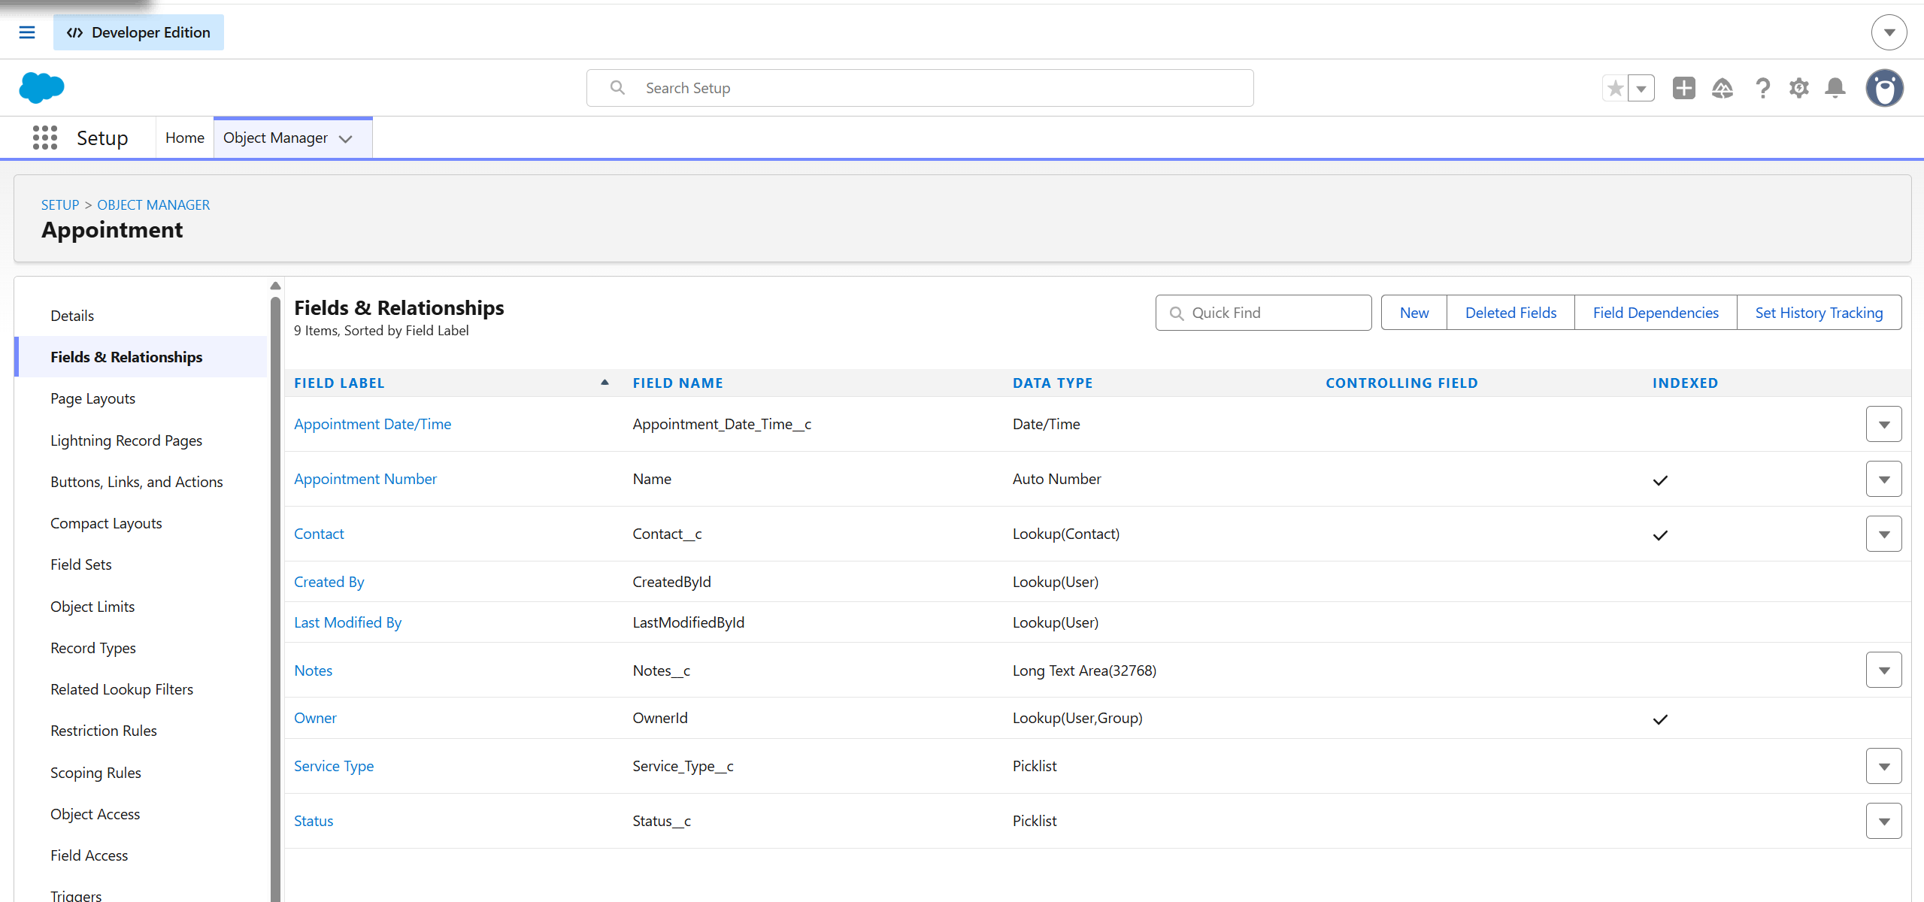
Figure 1. Appointment object fields and relationships in Object Manager.

4. Configuration and Implementation

4.1 Automated Flows
Three Autolaunched Flows implement the core business logic. Each was built as a no-trigger Autolaunched Flow so that it can be invoked programmatically, including as an Agentforce agent action. The Flows use input and output variables to receive appointment data and return results.
Flow 1 — Create Appointment
- Inputs: varContactId (Text), varAppointmentDateTime (Date/Time), varServiceType (Text).
- Output: varAppointmentId (Text).
- Logic: a Create Records element builds a new Appointment record, mapping the input variables to the Contact, Appointment Date/Time, and Service Type fields. The new record Id is stored in varAppointmentId and returned to the caller.
Flow 2 — Reschedule Appointment
- Inputs: varAppointmentId (Text), varNewDateTime (Date/Time).
- Logic: an Update Records element filters the Appointment where the record Id equals varAppointmentId, sets the Appointment Date/Time to varNewDateTime, and sets the Status to Rescheduled.
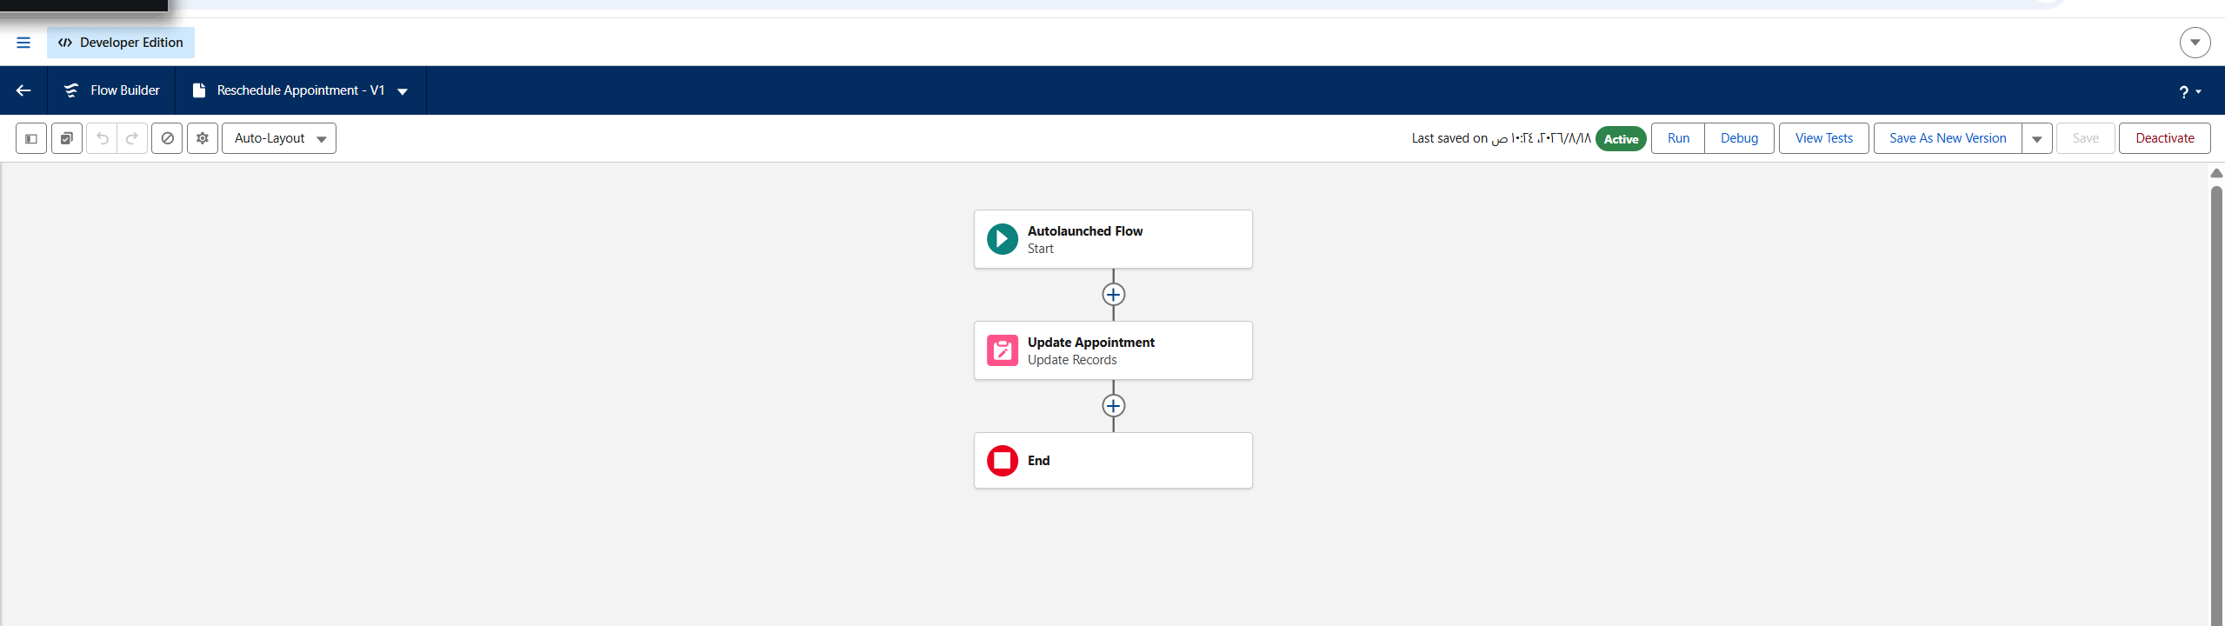
Figure 2. Reschedule Appointment Flow (Autolaunched, Active).
Flow 3 — Cancel Appointment
- Input: varAppointmentId (Text).
- Logic: an Update Records element filters the Appointment where the record Id equals varAppointmentId and sets the Status to Cancelled.
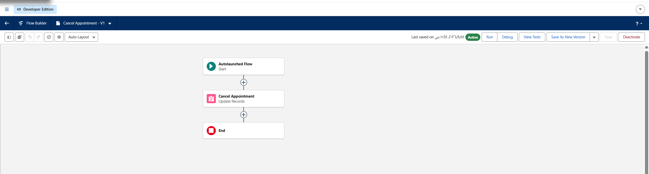
Figure 3. Cancel Appointment Flow (Autolaunched, Active).
Flow 4 — Book Appointment Screen (Screen Flow)
A Screen Flow provides the user-facing booking interface. It presents a screen that collects the Appointment Date/Time and Service Type, then a Create Records element writes a new Appointment record. This Flow serves as the working, interactive alternative to the conversational agent and delivers the core scheduling experience.
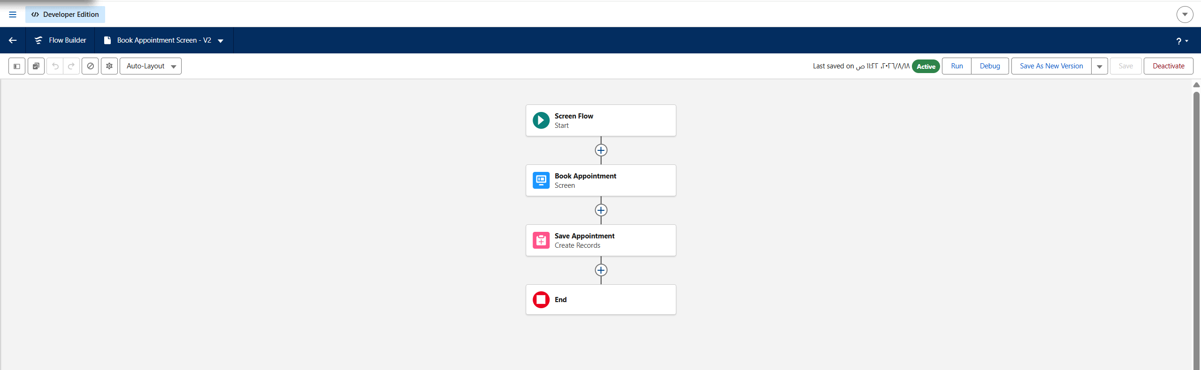
Figure 4. Book Appointment Screen Flow structure: Screen followed by a Create Records element.
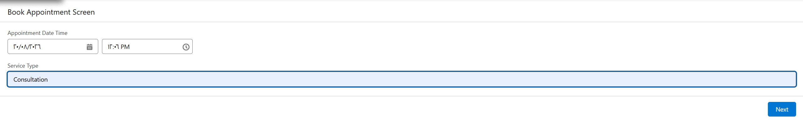
Figure 5. The booking screen at runtime, collecting the appointment date/time and service type.

4.2 Lightning Application
A custom Lightning App named "Appointment Management" was created to give administrators a single workspace. The app uses standard navigation and supports desktop and phone. A custom object tab was created for the Appointment object, and the app navigation includes the following items:
- Appointments — list and manage appointment records.
- Contacts — view the customers linked to appointments.
- Reports — access appointment reports.
- Dashboards — view the appointments dashboard.
The app is assigned to the System Administrator profile.
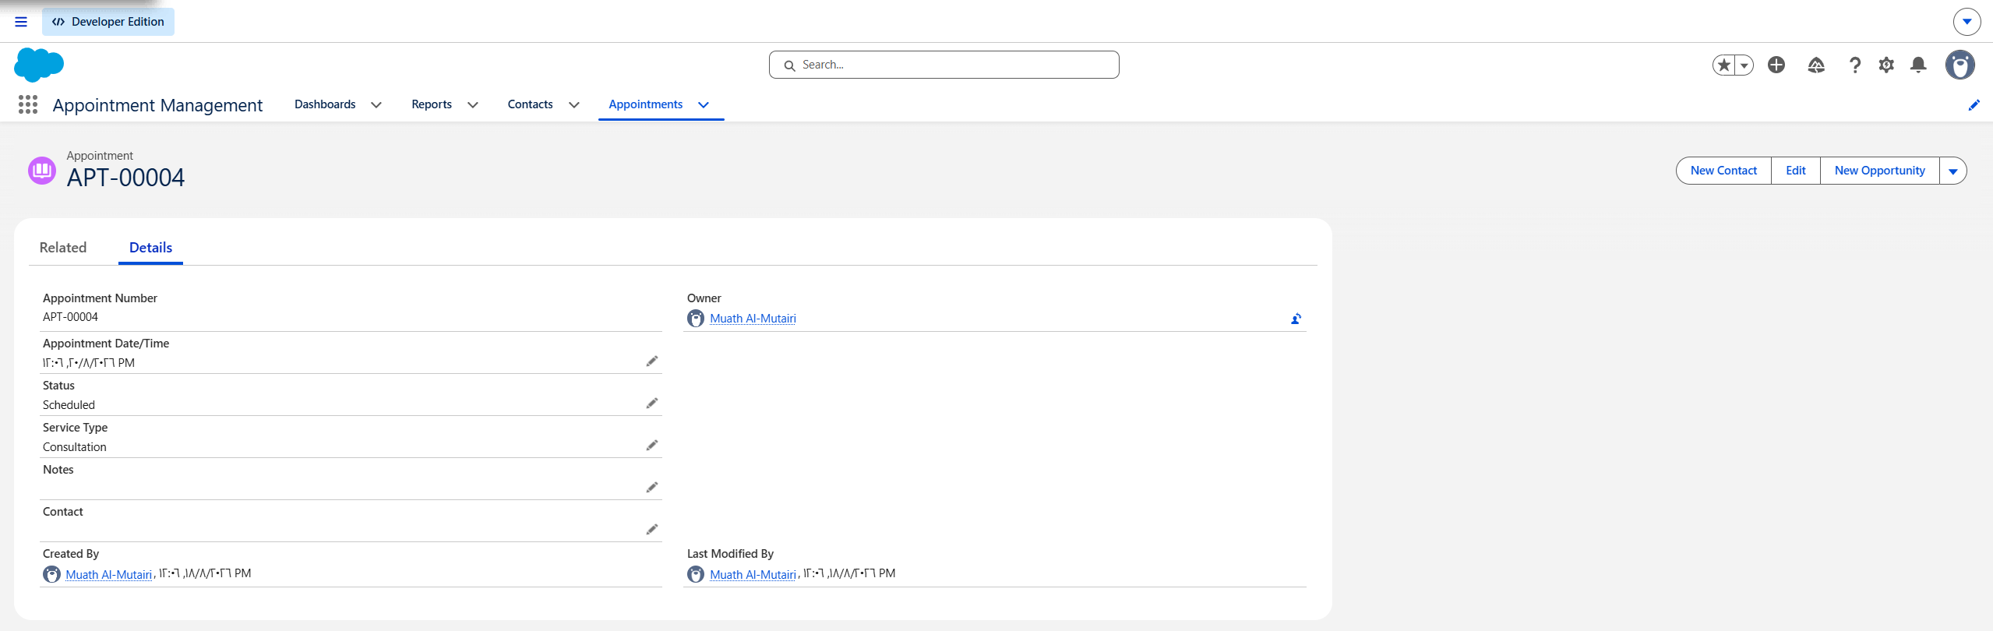
Figure 6. The Appointment Management Lightning App showing the navigation tabs and a completed appointment record.

4.3 Reports and Dashboards
A custom report type named "Appointments Report" was created on the Appointment object to enable reporting on the custom object. Using this report type, a report named "Appointments by Status" was built. The report groups appointment records by Status and includes the Appointment Number, Service Type, and Appointment Date/Time columns, together with a bar chart visualizing the record count per status.
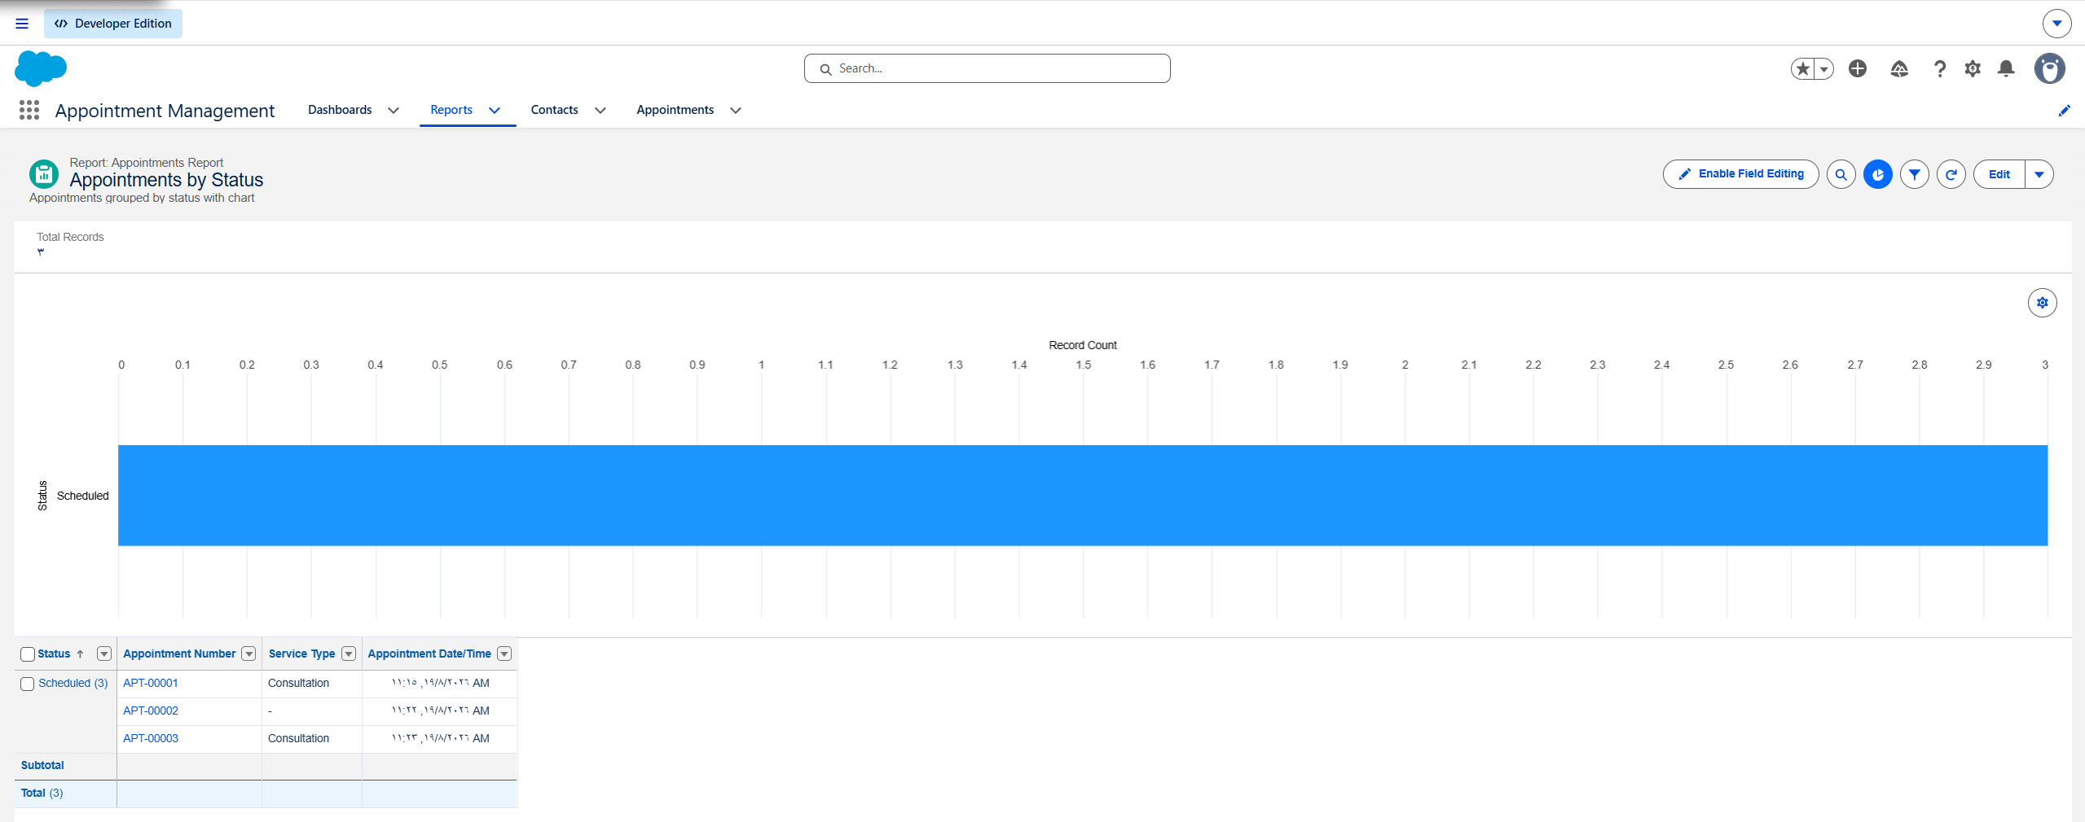
Figure 7. The Appointments by Status report, grouped by status with a bar chart.
A dashboard named "Appointments Dashboard" was created and configured with a widget displaying the "Appointments by Status" chart, giving administrators an at-a-glance overview of appointment activity.
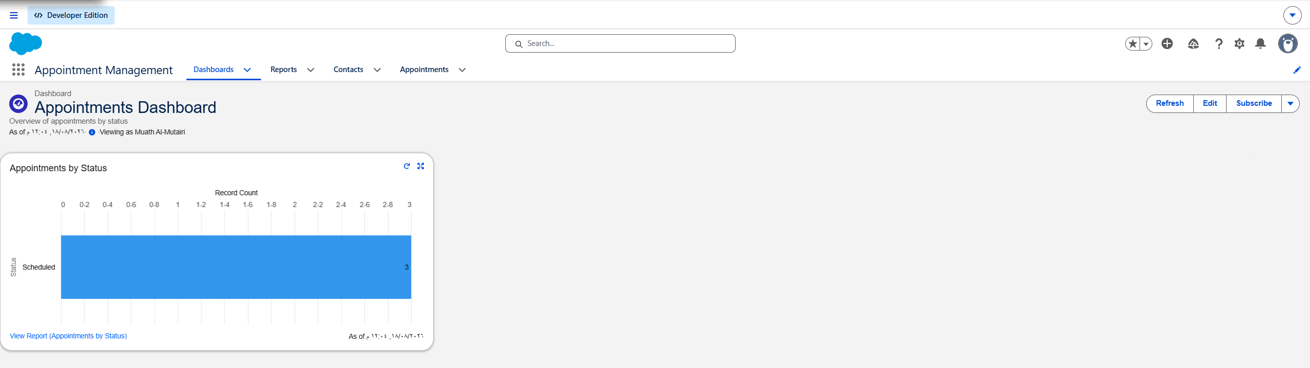
Figure 8. The Appointments Dashboard displaying the appointments-by-status chart.

4.4 Agentforce Integration Note
The project design includes a conversational Agentforce agent that would interpret natural-language requests and invoke the Create, Reschedule, and Cancel Flows as agent actions. Einstein and Einstein Bots were enabled in the org, and the Agentforce (Default) feature was present. However, full Agentforce agent activation required additional org-level prerequisites (tenant configuration and licensing) that were not available in the Developer Edition environment during the project period.
To ensure the core functionality was delivered, the three Autolaunched Flows were built to be invocation-ready for the agent, and a Screen Flow was implemented as a working alternative interface. This approach preserves the solution's core value — automated, guided appointment booking — while keeping the automation ready for agent integration once activation prerequisites are met.
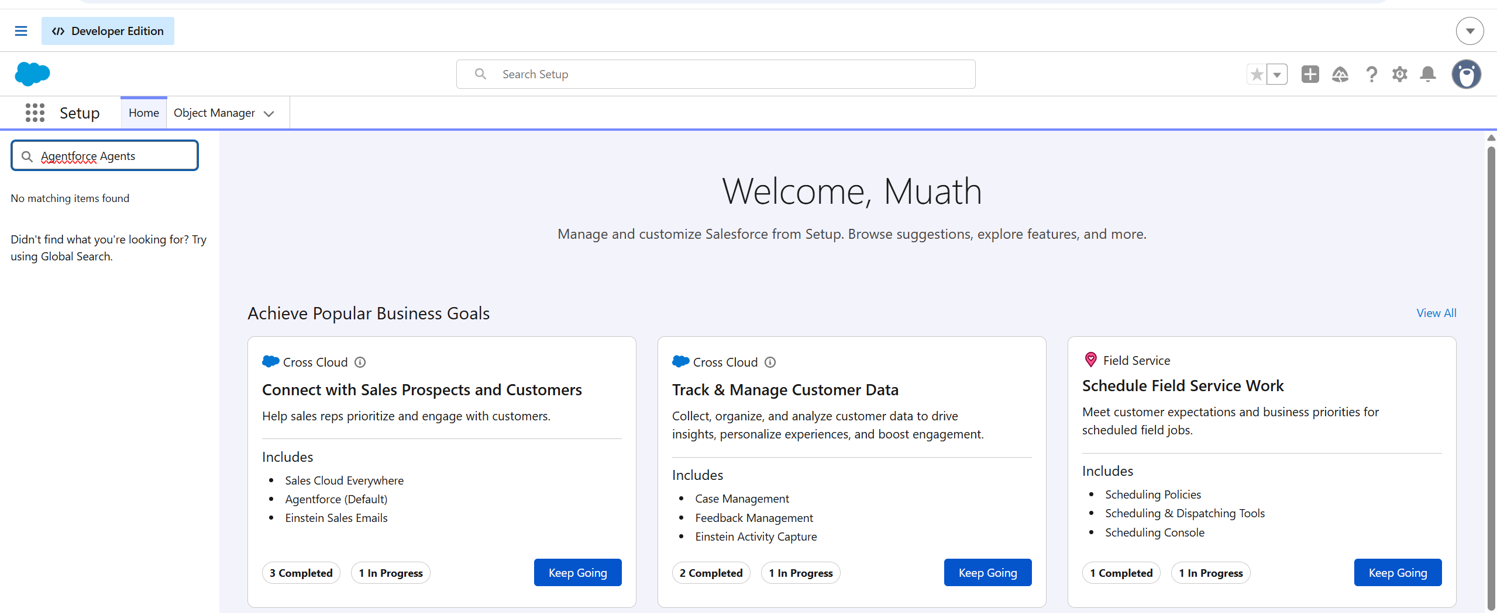
Figure 10. Although Agentforce (Default) appears as an available feature, searching Setup for "Agentforce Agents" returns "No matching items found", confirming that the agent-building page was not accessible in the Developer Edition org due to unmet activation prerequisites.

5. Test Plan and Results
The solution was tested through functional test cases covering record creation, default values, automation logic, the booking interface, and the reporting components. The results below reflect verification performed in the org.
ID | Test Case | Expected Result | Result
TC-01 | Create appointment via record UI | Record created with auto number and Status = Scheduled | Pass (APT-00001)
TC-02 | Default status on new appointment | Status defaults to Scheduled | Pass
TC-03 | Auto-number format and increment | Numbers increment as APT-00001, APT-00002, ... | Pass
TC-04 | Book appointment via Screen Flow | New appointment record created on finish | Pass (APT-00003)
TC-05 | Contact relationship | Appointment correctly linked to a Contact | Pass
TC-06 | Reschedule Flow logic | Correct record updated; Status set to Rescheduled | Pass (verified in builder)
TC-07 | Cancel Flow logic | Correct record updated; Status set to Cancelled | Pass (verified in builder)
TC-08 | Report grouping by status | Records grouped by status with counts and chart | Pass
TC-09 | Dashboard rendering | Chart displays appointments by status | Pass
TC-10 | Lightning App access | All tabs visible in Appointment Management app | Pass

All executed test cases passed. Three appointment records (APT-00001 through APT-00003) were successfully created — via both the record UI and the Screen Flow booking interface — confirming that the data model, automation, and user interface operate correctly end-to-end.
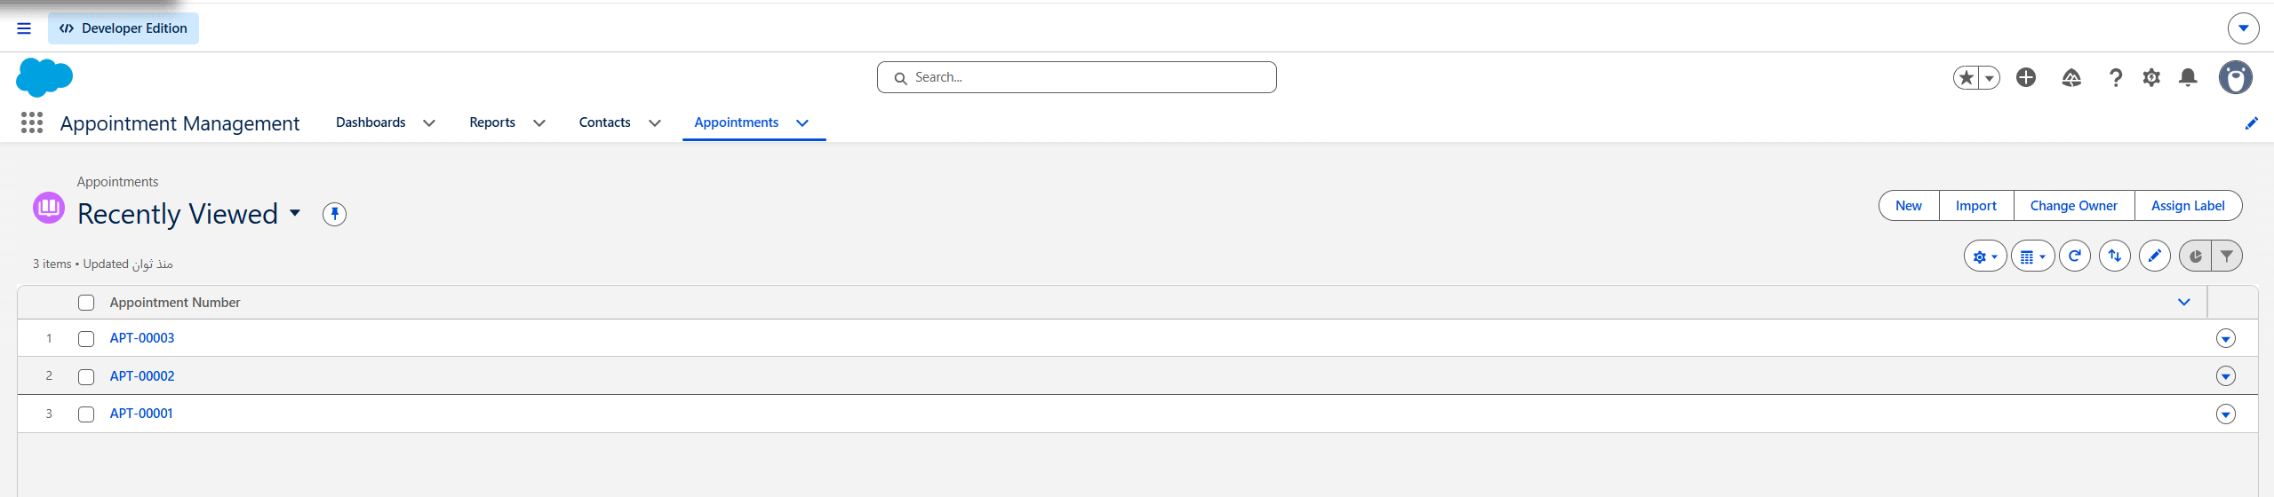
Figure 9. The Appointments list view showing the three successfully created records (APT-00001 to APT-00003).

6. Project Reflection

6.1 What Went Well
- The custom data model was designed and implemented cleanly, with appropriate field types, an auto-number record name, a Contact relationship, and a default status value.
- All three automation Flows and the Screen Flow were built and function correctly, demonstrating solid command of Flow Builder and declarative automation.
- The Lightning App, custom report type, report with chart, and dashboard were completed and verified, providing a professional administrative experience.
- End-to-end functionality was proven by creating real appointment records through multiple entry points.

6.2 Challenges Faced
- Agentforce activation could not be completed because the Developer Edition org required additional tenant configuration and licensing that were not available during the project.
- The Lookup component inside the Screen Flow behaved unreliably due to record indexing; it was replaced with simpler inputs so the booking screen would run smoothly.
- Navigating certain Setup pages was initially difficult because parts of Setup opened in a simplified environment; using the standard Lightning navigation resolved this.

6.3 Problem Solving Approach
When Agentforce activation was blocked, the project pivoted without abandoning its goal. The automation Flows were kept invocation-ready for the agent, and a Screen Flow was implemented to deliver the same core outcome — collecting appointment details and creating a record. This decision preserved the project's value and demonstrates a pragmatic, solution-oriented approach to real-world platform constraints.

6.4 Lessons Learned
- Strong Salesforce platform fundamentals — objects, fields, relationships, and security — are the foundation for everything built on top of them.
- Declarative automation with Flow Builder is powerful; well-chosen input and output variables and clear element configuration are key to reusable, agent-ready Flows.
- Custom objects require a custom report type before they can be reported on — an important platform detail.
- Iterative testing and debugging, and being willing to substitute a simpler working component, are essential to delivering on time.

7. Conclusion
The AI-Powered Appointment Management Assistant successfully delivers an automated, user-friendly appointment management solution on the Salesforce platform. The project met its core objectives: a secure and scalable data model, automated create/reschedule/cancel processes, an interactive booking interface, a dedicated administrative application, and reporting and dashboard components. The automation was additionally prepared for conversational-agent integration.
Beyond the technical deliverables, the project demonstrated the ability to analyze requirements, design a solution architecture, implement it with declarative tools, test it end-to-end, and adapt to platform constraints — reflecting the full lifecycle of a real Salesforce implementation.

Appendix A — Component Summary
Component | Type | Description
Appointment | Custom Object | Core object storing appointment records
Create Appointment | Autolaunched Flow | Creates a new appointment record
Reschedule Appointment | Autolaunched Flow | Updates date and sets status to Rescheduled
Cancel Appointment | Autolaunched Flow | Sets status to Cancelled
Book Appointment Screen | Screen Flow | Interactive booking interface
Appointment Management | Lightning App | Administrative workspace
Appointments Report | Report Type | Enables reporting on the Appointment object
Appointments by Status | Report | Grouped report with bar chart
Appointments Dashboard | Dashboard | Chart widget of appointments by status

