**ProGuard:**

**ProGuard** is a Java class file shrinker, optimizer, obfuscator, and preverifier. In the shrinking step it removes the unused classes, methods, fields and attributes. In the optimization step it optimizes the bytecode of the methods. The obfuscation step renames the remaining classes, fields, and methods using meaningless names. All of These steps make the code harder to reverse engineer. The final preverification step adds preverification information to the classes, which is required for Java Micro Edition and for Java 6 and higher. Each of these steps are optional, they may not all be used. Furthermore, ProGuard can be used to list dead code in an application.

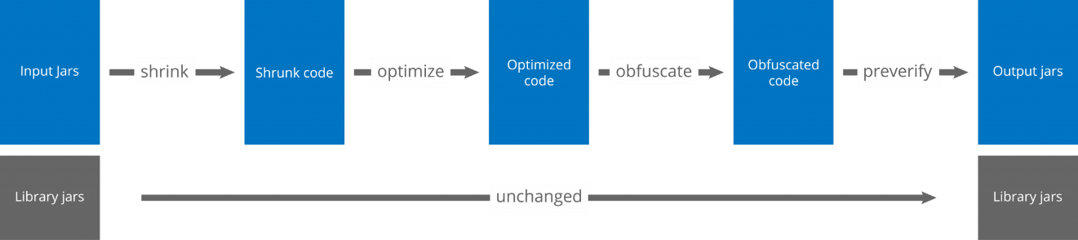

ProGuard process

ProGuard first reads the **input jars** (or zips, apks, or directories). It then subsequently shrinks, optimizes, obfuscates, and preverifies them. ProGuard writes the processed results to one or more **output jars** (or zips, apks, or directories). The input may contain resource files, whose names and contents can optionally be updated to reflect the obfuscated class names.

https://www.guardsquare.com/en/proguard/manual/introduction