* **Watermarking** :
* Static watermarking:

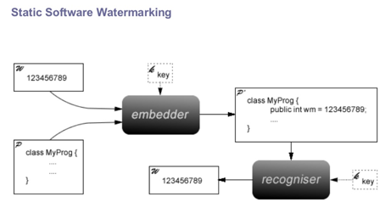

It’s a technique that adds obfuscation to program code .

1 - adding redundant syntax to the program in which makes it more complex to understand (spaghetti code) , but doesn’t change the logic, in addition, an ambiguous part of code could be added to prove the ownership of the author (it’s like a puzzle , solving it leads to a surprise).

2- reordering the program blocks to make the program flow more complex to understand, but doesn’t change the logic, in addition false branches could be added.

3- renaming the variable names to make it more ambiguous.

4 – “Essential” parts of the program are steganographically encoded into the media. If the watermarked image is attacked, the embedded code will crash.

* Dynamic watermarking:

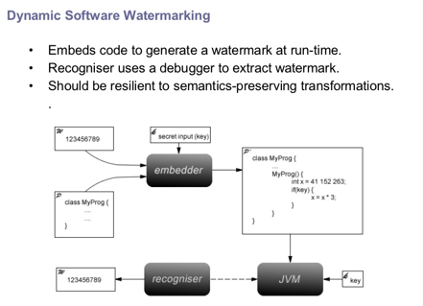

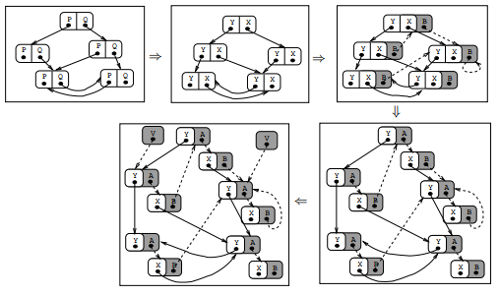

The obfuscation depends on the input (i.e. false branches are not static )

It changes the program flow depending on the program input at the run time unlike the static , but keeping the same logic .