Pandas Slicing Worksheet

$$df=pd.read_csv('elections.csv^{'})$$

print(df)

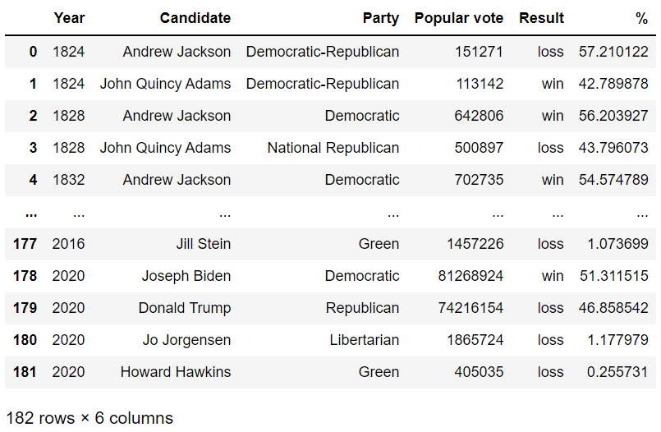

# Using loc

1. Extract all rows for the candidate 'Andrew Jackson' and display the columns 'Year', 'Popular vote', and 'Result'.  
   Solution:
2. 2. Use `loc` to extract all rows where the candidate's `Party` is 'Democratic' and display the 'Year', 'Candidate', and 'Result'.  
   Solution:
3. 3. Extract rows where the `Popular vote` is greater than 600000 and display the 'Candidate' and 'Party' columns.  
   Solution:
4. 4. Use `loc` to find all candidates who won the election and display their 'Year' and 'Candidate'.  
   Solution:
5. 5. Extract the 'Year', 'Candidate', and 'Percentage' for candidates from the 'National Republican' party using `loc`.  
   Solution:

# Using iloc

1. Retrieve the first 5 rows and display only the first 3 columns using `iloc`.  
   Solution:
2. Use `iloc` to extract the 3rd to 7th rows and display all columns.  
   Solution:
3. Use `iloc` to retrieve the last 5 rows and display only the 'Year' and 'Candidate' columns.  
   Solution:
4. Extract rows from index 2 to 6 and display the 'Popular vote' and 'Percentage' columns using `iloc`.  
   Solution:
5. Use `iloc` to display the first 10 rows but only show the 'Party' and 'Result' columns.  
   Solution:

# Using []

1. Display only the `Party` and `Result` columns for candidates whose `Popular vote` is greater than 500,000.  
   Solution:
2. Extract all rows where the `Year` is greater than 1900 and display the 'Candidate' and 'Popular vote' columns.  
   Solution:
3. Extract the 'Year' and 'Percentage' for candidates whose percentage is greater than 50.  
   Solution:
4. Display only the rows where the 'Result' is 'loss' and show the 'Candidate' and 'Popular vote' columns.  
   Solution:
5. Extract rows where the 'Party' is 'Democratic-Republican' and display all columns.  
   Solution:

# Combined usage of loc, iloc, and []

1. Using `loc`, filter rows where the candidate's `Party` is 'Democratic' and display the first 5 rows of 'Year', 'Candidate', and 'Percentage'.  
   Solution:
2. Using `iloc`, extract the first 5 rows and display 'Candidate' and 'Party' where the candidate's percentage is above 55.  
   Solution:
3. Use square brackets to filter rows where the `Popular vote` is less than 200000 and display all columns.  
   Solution:
4. Using `loc`, filter out rows where the candidate's `Result` is 'loss' and display the 'Year' and 'Candidate' columns.  
   Solution:
5. Use `iloc` to retrieve rows from index 5 to 10 and show the 'Popular vote' and 'Result' columns.  
   Solution: