SMART UNIVERSITY COMPLAINT PORTAL WITH AI CHATBOT

Table of Contents

- Introduction
- Project Objectives
- System Users Overview
- Functional Requirements
- Non-Functional Requirements
- ERD Diagram
- Use Case Diagram
- Usage Scenarios
- Methodology (Agile Scrum)
- Test Cases
- Tools & Technologies

- Introduction:
Efficient communication between students and university administration is key for a good academic environment. However, the traditional systems for handling complaints in universities often have problems. They can be slow, lack clear updates, have complicated steps, and are hard to access outside office hours. These problems can lead to student frustration, a loss of trust in the system, and general unhappiness.
To solve these issues, this project proposes a Smart University Complaint Portal. This is a complete website that also includes an Artificial Intelligence (AI) chatbot. The goal is to improve how complaints are managed and how students get support.
The portal is a single, online place where students can submit complaints, see their real-time progress, and add necessary documents. The AI chatbot acts as the first helper. It can understand questions asked in normal language and give instant answers for common issues, like library timings or fee details. For more complex problems that need a person to solve, the system will automatically create a formal complaint ticket. It will sort the ticket into the right category (like Academics or Hostel), decide its priority, and send it to the correct department.
The system has three main types of users with different access: Students, Department Staff, and System Administrators.
- Students get a simple dashboard to submit complaints, track status, get notifications, and give feedback.
- Department Staff can manage the complaints sent to them, talk to students for details, update the resolution status, and organize their work.
- Administrators control the whole system, manage user accounts and departments, update the AI chatbot's knowledge, and create reports to help the university make better decisions.
The portal is built with PHP and MySQL for the backend, and uses HTML5, CSS3, JavaScript, and Bootstrap for a frontend that works well on phones and computers. It is designed to be secure and able to grow. Important features include a clear step-by-step process for each complaint, tools for internal communication, a feedback system after a complaint is solved, and detailed reports that show complaint data visually for the university leaders.
In summary, the Smart University Complaint Portal is more than just a website for complaints. It is an intelligent system that mixes AI automation with organized human handling. By making resolutions faster, increasing transparency, and providing useful insights, the system aims to increase student satisfaction, make admin work smoother, and create a more responsive and efficient university environment. This project is a major move towards updating how universities manage complaints and using data to make continuous improvements.

- Project Objectives:
The primary objective of this project is to design and implement a Smart University Complaint Portal that transforms the traditional complaint handling system into a more efficient, transparent, and accessible digital platform. This system addresses the common challenges faced by universities, such as delayed responses, lack of clarity in complaint processing, and limited access to administrative support outside working hours.
- Instant Student Assistance through AI Chatbot:
One of the key goals is to provide students with immediate support at any time of the day through an integrated AI chatbot. This intelligent agent can understand natural language queries and respond to frequently asked questions, such as library timings, fee structures, exam schedules, or hostel-related information. By handling routine inquiries automatically, the chatbot ensures 24/7 availability, reduces dependency on human staff, and improves the overall user experience for students.
- Efficient Handling of Complex Complaints:
Not all student issues can be resolved automatically. For complex, sensitive, or department-specific complaints, the system is designed to seamlessly escalate the issue by generating a formal complaint ticket. These tickets are automatically categorized and prioritized based on predefined rules and routed to the relevant department, such as Academics, Finance, Examinations, or Hostel. This ensures that administrative staff can focus on issues requiring human attention, increasing overall operational efficiency.
- Transparency and Real-Time Tracking:
A significant objective is to provide complete transparency in complaint management. Students can track the status of their complaints in real-time, from submission to resolution. Notifications and updates keep them informed, which builds trust in the institution and reduces anxiety or frustration associated with delayed responses.
- Administrative Efficiency and Reporting:
For department staff and administrators, the portal provides user-friendly tools to manage complaints efficiently. Staff can view, update, and communicate regarding complaints, while administrators can oversee the entire workflow, manage user roles, and generate detailed reports. These reports, enriched with visual insights, allow university authorities to analyze patterns, identify recurring issues, and make data-driven decisions to improve processes.
- Enhanced Communication and Accountability:
Overall, the project aims to enhance communication between students and university administration, reduce resolution times, and strengthen institutional accountability. By integrating AI automation with structured human intervention, the system fosters a more responsive, transparent, and student-centric academic environment.

System Users Overview
The Smart University Complaint Portal is designed to serve multiple user roles, each with distinct responsibilities, access privileges, and interactions with the system. These roles ensure that complaints are handled efficiently, tracked transparently, and resolved promptly. The primary system users include Students, Super Administrators, Complaint Department Staff, and the AI Chatbot System. Each role plays a crucial part in creating a well-coordinated, responsive, and accountable complaint management ecosystem.

1. Student
Students are the primary beneficiaries of the portal, as they are the ones who experience university services directly and may encounter issues that need redressal. The system empowers students to submit grievances, track their progress, and receive support quickly, creating a more transparent and responsive academic environment.
Key Functionalities for Students:
- Registration and Login
- AI Chatbot Interaction
- Formal Complaint Submission
- Complaint Status Tracking
- View Communication History
- Feedback and Ratings
- Profile Management

2. Super Administrator
The Super Administrator is the highest authority in the system, responsible for overall management, configuration, and oversight. This user ensures that the portal operates efficiently, securely, and in compliance with university policies.
Key Functionalities for Super Administrator:
- Secure Login
- User Account Management
- Department and Category Management
- System Configuration
- AI Chatbot Management
- Analytical Reporting
- Audit Trail Monitoring
- Complaint Assignment

3. Complaint Department Staff
Department Staff are the operational users responsible for processing and resolving complaints assigned to their specific department. They act as the bridge between students and the administrative system.
Key Functionalities for Department Staff:
- Secure Login
- Complaint Dashboard
- Complaint Management
- Student Communication
- Resolution and Closure
- Department Reporting
- Internal Collaboration

4. AI Chatbot System (Automated User)
The AI Chatbot is an automated, intelligent agent that serves as the first point of contact for students, significantly improving the speed and efficiency of the complaint management process.
Key Functionalities for the AI Chatbot:
- Instant Response
- Natural Language Understanding
- Complaint Escalation
- Interactive Guidance.
- Learning and Improvement

Functional Requirements
The Smart University Complaint Portal is developed to provide tailored functionalities for three main types of users—Students, Department Staff, and Administrators—ensuring efficient complaint management, AI-assisted support, and transparent reporting. Each feature is designed to improve communication, reduce resolution time, and enhance the overall academic environment.

A. Student-Facing Features
- Student Registration & Login:
  - Students can register securely using a university-verified authentication system, such as their official roll number or email address.
  - The login system ensures that only authorized students can access the portal, protecting sensitive complaint information.
  - Passwords are securely stored using hashing and salting techniques, enhancing system security.
  - Example: A new student registers using their university email, receives a verification link, and sets a secure password to log in.
- Edit/Update Profile:
  - Students can view their profile information, including name, contact details, department, and enrollment information.
  - They can update any changes, such as a new phone number or email address, to ensure that notifications reach them promptly.
  - Example: A student moves to a new hostel and updates their contact number to receive complaint status updates.
- AI Chatbot Interface:
  - The integrated AI chatbot allows students to interact in natural language, providing instant responses to common queries.
  - Example queries include:
    - “What are the library timings?”
    - “When is the exam form submission deadline?”
    - “How can I request a hostel maintenance service?”
  - The chatbot helps reduce administrative workload by handling routine questions automatically, available 24/7.
- Formal Complaint Submission:
  - Students can submit formal complaints by selecting the appropriate category or department (e.g., Academics, Hostel, Finance, Examinations).
  - They can provide a detailed description of the issue and attach supporting documents like screenshots, photos, or PDFs.
  - Example: A student notices a broken chair in the hostel room and submits a complaint under the “Hostel” category with an image attachment.

- Complaint Status Tracking:
  - Students have access to a dashboard showing all complaints they submitted.
  - Each complaint displays its current status (Pending, In-Progress, Resolved), allowing students to track progress in real-time.
  - Example: A student sees that their finance-related query has been escalated to the Finance department and is currently marked “In-Progress.”
- View Complaint History & Communication:
  - Students can access a detailed history of each complaint, including updates, staff responses, and internal notes.
  - This ensures transparency and helps students understand how their complaint is being addressed.
  - Example: The student can see that the hostel staff scheduled maintenance for a broken bed and communicated the date via the portal.
- Submit Feedback:
  - Once a complaint is resolved, students can submit ratings and feedback on the resolution process.
  - This helps the university evaluate staff performance and improve service quality.
  - Example: A student gives a 5-star rating and comments, “Prompt resolution and clear communication.”
- User Logout:
  - Students can securely log out of the system, ensuring that their account remains protected from unauthorized access.

B. Department Staff-Facing Features
- Staff Login:
  - Department staff log in using secure credentials, with access limited to their specific role and assigned department.
  - Role-based access ensures data confidentiality and prevents unauthorized operations.
- Dashboard & Complaint Assignment:
  - Staff view a centralized dashboard listing all complaints assigned to their department.
  - Complaints are categorized by priority and status, helping staff focus on urgent issues first.
  - Example: An urgent hostel maintenance complaint is highlighted in red, while general academic inquiries are in yellow.
- Manage Complaints:
  - Staff can accept, reassign, update status, and add internal notes to complaints.
  - Example: If a complaint about examination fees mistakenly reaches the hostel department, staff can reassign it to the Finance department.
- Communicate with Students:
  - Staff can send messages or clarification requests directly to students within the portal, avoiding external emails or calls.
  - Example: Staff may ask for additional information or attachments to process a complaint accurately.
- Mark Complaint as Resolved:
  - Staff have the authority to close a complaint after providing a final resolution summary.
  - Students are notified of the resolution automatically.
- Department Analytics:
  - Staff can view statistics on complaint handling, such as total complaints received, resolved, pending, and average resolution time.
  - These metrics help departments identify performance bottlenecks.
- Staff Logout:
  - Staff can log out securely, ensuring the safety of complaint data.

C. Administrator-Facing Features
- Admin Login:
  - The administrator logs in using the highest level of secure credentials, allowing full access to the system.
- User Management:
  - Admin can add, edit, deactivate, or delete student and staff accounts.
  - Ensures that only authorized users can access the portal.
- Department Management:
  - Admin can create new complaint categories or departments, modify existing ones, or deactivate obsolete ones.
  - Example: Adding a new category “IT Support” for network or software-related issues.
- AI Chatbot Knowledge Base Management:
  - Admin can review chat logs, update FAQs, and train the AI chatbot with new query-response pairs to improve accuracy and relevance.
  - Example: Adding responses for “How to apply for a hostel room transfer?”
- Generate Comprehensive Reports:
  - Admin can generate department-wise, category-wise, and trend-based reports.
  - Reports include complaint resolution times, student feedback ratings, and complaint volumes over time.
  - These reports help monitor efficiency and make data-driven decisions.
- System Logs & Audit Trail:
  - Admin can track all system activities, ensuring accountability, security, and compliance.
- Admin Logout:
  - Provides secure logout functionality to prevent unauthorized access.

Non-Functional Requirements
The Smart University Complaint Portal is designed not only to provide functional features but also to meet critical non-functional requirements that ensure the system is efficient, secure, reliable, and user-friendly. These requirements define the overall quality attributes of the system and are essential for long-term usability and performance.

1. Usability
- The system must have an intuitive and user-friendly interface so that students, staff, and administrators can use it with minimal training.
- Navigation should be simple and consistent, with clearly labeled menus, buttons, and forms.
- The AI chatbot interaction should feel natural and conversational, mimicking human communication to reduce user effort in finding answers.
- Example: A first-year student should be able to log in, submit a complaint, and interact with the chatbot without needing guidance or instruction manuals.

2. Performance
- The portal should load all pages within 3 seconds under normal operating conditions to ensure smooth user experience.
- The AI chatbot must provide responses to common queries within 2 seconds to simulate real-time interaction.
- The system must handle multiple concurrent users (students and staff accessing at the same time) without significant slowdown or performance degradation.
- Example: During peak hours, such as exam form submissions, hundreds of students may log in simultaneously. The system must continue to respond efficiently without errors or delays.

3. Security
- Passwords must be stored securely using hashing and salting to prevent unauthorized access.
- The system must protect against common web vulnerabilities, including SQL Injection and Cross-Site Scripting (XSS) attacks.
- Role-Based Access Control (RBAC) should ensure that students, staff, and administrators can only access features permitted for their role.
- All data transmission must be encrypted using HTTPS/SSL to protect sensitive information such as personal details and complaint data.
- Example: A student submitting a financial complaint should be assured that the information is securely stored and cannot be accessed by unauthorized personnel.

4. Reliability & Availability
- The portal must maintain at least 99% uptime during operational hours, ensuring continuous access for students and staff.
- In case of server downtime, there should be graceful error handling and informative messages to keep users aware of the situation.
- Example: Even during system maintenance or updates, students should be notified, and critical operations like complaint submission should remain functional if possible.

5. Scalability
- The system must support a growing number of users and complaints over time without affecting performance.
- Backend infrastructure should be designed to optimize database queries, manage large datasets efficiently, and implement caching for faster response times.
- Example: The university may expand to include thousands of new students every year. The system should accommodate this growth without requiring major redesigns.

6. Maintainability
- The codebase must be modular, clean, and well-documented, allowing developers to easily fix bugs, add new features, or enhance existing functionalities in the future.
- Standard coding practices and consistent naming conventions should be used throughout the system.
- Example: If the university wants to integrate a mobile application version or add new AI chatbot features, the existing system should support these enhancements without extensive rework.

7. Portability
- The web portal should be fully functional across major web browsers, including Chrome, Firefox, Edge, and Safari, ensuring broad accessibility.
- The responsive design must allow seamless usage on desktops, laptops, tablets, and mobile devices.
- Example: A student using a mobile device in the hostel should be able to submit a complaint or track its status just as easily as a student using a desktop computer in the library.

8. Additional Considerations
- Interoperability: The system should be capable of integrating with other university systems, such as student information systems or email notification services.
- Auditability: Every action, including complaint submissions, status updates, and staff communications, should be logged to provide a full audit trail for accountability.
- Adaptability: The system should be able to adapt to changing policies or departmental structures, such as introducing new complaint categories or modifying workflow rules.

By addressing these non-functional requirements, the Smart University Complaint Portal ensures that it is not only feature-rich but also robust, secure, scalable, and easy to use, meeting the long-term needs of both students and university administration.

- ERD Diagram:

An ERD (Entity Relationship Diagram) is the backbone of your database. While a Use Case Diagram shows actions, the ERD shows data. It defines the tables, the specific information (attributes) they hold, and how they relate to one another (one-to-one, one-to-many).
For your Complaint Management System, the ERD would likely look like this:

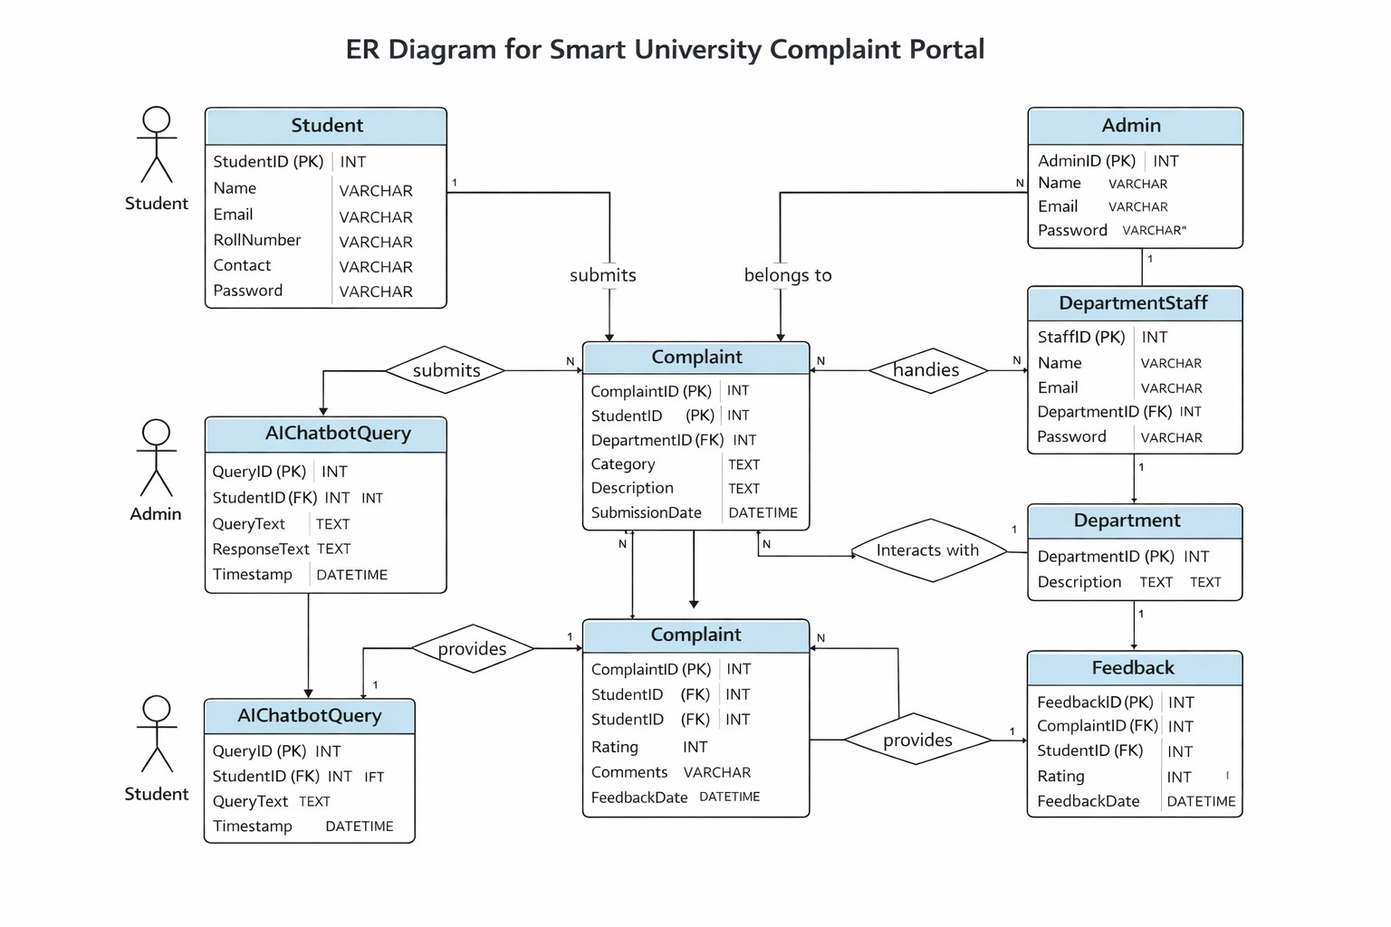

1. Key Entities & Attributes
- Student: StudentID (PK), RollNo, Name, Email, Password, DepartmentID (FK).
- Department: DepartmentID (PK), DeptName, HeadOfDept.
- Staff: StaffID (PK), Name, Email, Role, DepartmentID (FK).
- Complaint: ComplaintID (PK), Title, Description, Category, Status, CreatedDate, StudentID (FK), DeptID (FK), AssignedStaffID (FK).
- Feedback: FeedbackID (PK), Rating, Comments, ComplaintID (FK).
- ChatbotLog: LogID (PK), Query, Response, Timestamp, StudentID (FK).

2. Core Relationships
To make the system functional, the tables must "talk" to each other:
- Student to Complaint (1:N): One student can file many complaints, but each complaint belongs to one student.
- Department to Staff (1:N): One department has many staff members.
- Department to Complaint (1:N): One department handles many complaints routed to it.
- Complaint to Feedback (1:1): Each complaint typically receives one final feedback entry upon resolution.
- Staff to Complaint (1:N): One staff member can be assigned to work on many different complaints.

3. Cardinality Symbols
In your diagram, you will see specific symbols at the ends of the lines:
- || (One and only one): e.g., A complaint must have exactly one sender.
- 0< (Zero or many): e.g., A new student might have zero complaints, or they might have many.

- Use Case Diagram:

Think of a Use Case Diagram as a high-level blueprint of your system. It doesn’t focus on how things happen (the logic) but rather what happens and who is involved. It’s the simplest way to visualize the functional requirements of your project.

Core Components:
Every Use Case Diagram is built from four primary elements:

- Actors (Stick Figures): These are the users or external systems that interact with your platform. In your project, the Actors are the Student, Department Staff, and Admin.

- Use Cases (Ovals): These represent the specific functions or "goals" the system performs, such as "Submit Complaint" or "Generate Report."

- System Boundary (Rectangle): A box drawn around the use cases to represent the scope of your application. Actors stay outside the box; use cases stay inside.

- Relationships (Lines): Solid lines that connect an actor to a use case, showing they have the authority to perform that action.

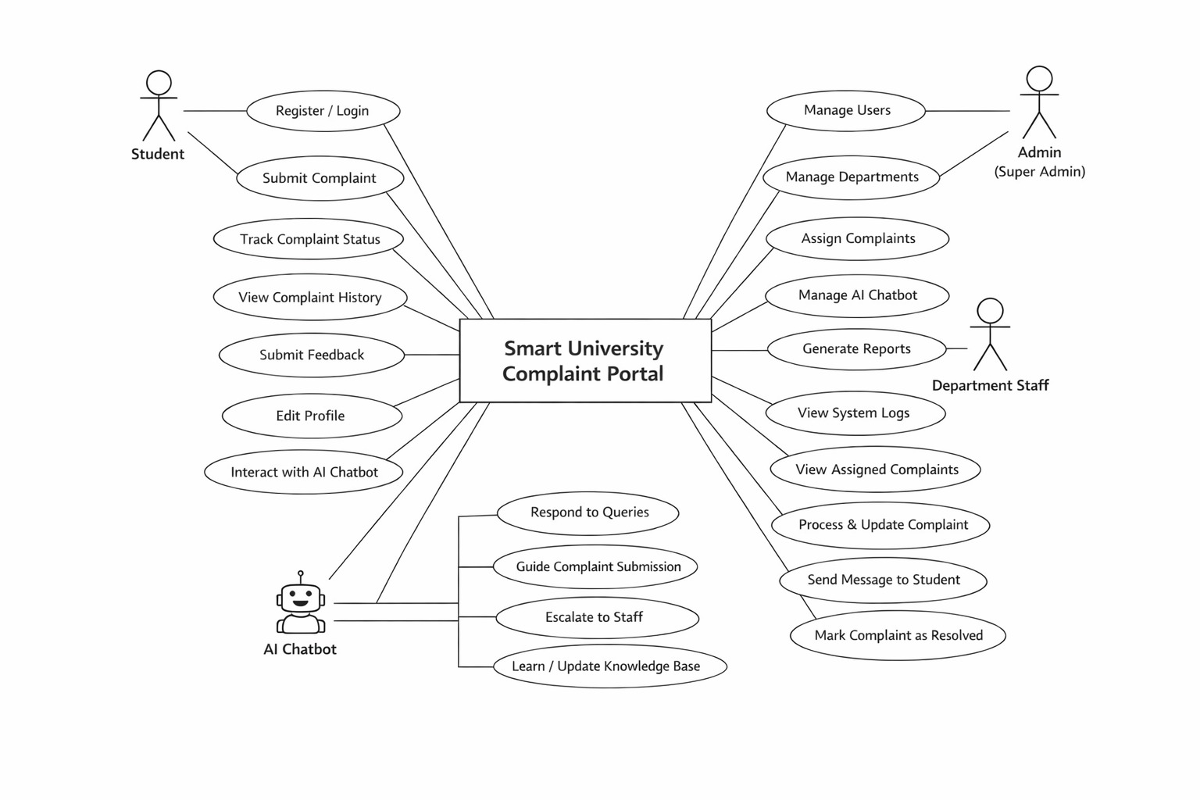

Usage Scenarios for Smart University Complaint Portal

Usage Scenarios for Students
Field | Details
Actor | Student
Description | Allows a new student to create an account in the system.
Pre-Conditions | None
Actions | 1. Navigate to registration page. 2. Enter roll number, email, password, and personal details. 3. Submit form for verification.
Alternative Paths | If email or roll number already exists, the system shows an error message.
Post-Conditions | Account created, verification email sent, student can log in.
Exceptions | Form validation errors (e.g., weak password), database connection failure.
Author | [Your Name/ID]

Field | Details
Actor | Student
Description | Allows a registered student to access their personal complaint dashboard.
Pre-Conditions | Student must be registered in the system.
Actions | 1. Enter roll number/email and password. 2. Click the login button.
Alternative Paths | If the password is incorrect, the system shows an error message.
Post-Conditions | Student dashboard is displayed.
Exceptions | Invalid credentials, account disabled/locked.
Author | [Your Name/ID]

Field | Details
Actor | Student
Description | Provides immediate AI-powered answers to student queries to reduce ticket volume.
Pre-Conditions | Student must be logged in.
Actions | 1. Type query in chatbot interface. 2. System processes and returns response. 3. Student asks follow-up questions or chooses to escalate.
Alternative Paths | If the chatbot cannot resolve the issue, it suggests creating a formal complaint.
Post-Conditions | Query resolved or escalated to a formal complaint ticket.
Exceptions | AI service unavailable, unclear/unsupported query language.
Author | [Your Name/ID]

Field | Details
Actor | Student
Description | Creates a formal complaint ticket for administrative action and tracking.
Pre-Conditions | Student must be logged in.
Actions | 1. Select complaint category. 2. Enter detailed description. 3. Upload supporting documents (optional). 4. Submit complaint.
Alternative Paths | If required fields are missing, the system shows validation errors.
Post-Conditions | Complaint ticket created, unique reference number generated.
Exceptions | File upload failure (size/format), database error.
Author | [Your Name/ID]

Field | Details
Actor | Student
Description | Allows the student to monitor the real-time progress of their submitted complaints.
Pre-Conditions | Student logged in; at least one complaint must exist.
Actions | 1. View complaint dashboard. 2. Click on a specific complaint. 3. View status timeline, comments, and updates.
Alternative Paths | If no complaints exist, the system shows an "Empty State" message.
Post-Conditions | Detailed complaint status and history are displayed.
Exceptions | Complaint record not found, unauthorized access attempt.
Author | [Your Name/ID]

Field | Details
Actor | Student
Description | Collects student satisfaction data once a complaint has been marked as resolved.
Pre-Conditions | Complaint marked as "Resolved"; feedback not yet submitted.
Actions | 1. System prompts for feedback. 2. Rate satisfaction (1-5 stars). 3. Add comments (optional). 4. Submit feedback.
Alternative Paths | Student chooses to skip feedback (if the system allows optional closing).
Post-Conditions | Feedback recorded in analytics, complaint status updated to "Fully Closed."
Exceptions | Invalid rating value, database write error.
Author | [Your Name/ID]

Usage Scenarios for Staff

Field | Details
Actor | Department Staff
Description | Authenticates a department staff member to allow access to the administrative backend.
Pre-Conditions | Staff account must exist and be set to "Active" status.
Actions | 1. Enter username and password. 2. Click the login button.
Alternative Paths | If credentials are incorrect, the system displays an authentication error.
Post-Conditions | Staff dashboard is displayed with relevant departmental access.
Exceptions | Account disabled by admin, multiple failed login attempts leading to temporary lockout.
Author | [Your Name/ID]

Field | Details
Actor | Department Staff
Description | Shows all complaints specifically assigned to the staff member's department for review.
Pre-Conditions | Staff member is logged into the system.
Actions | 1. Login to the portal. 2. Dashboard automatically displays assigned complaints. 3. Use filter/sort options by priority or date.
Alternative Paths | If no complaints are currently assigned, the system shows an "Empty State" message.
Post-Conditions | Filtered list of departmental complaints is displayed.
Exceptions | Database connection error, permission denied (role mismatch).
Author | [Your Name/ID]

Field | Details
Actor | Department Staff
Description | Allows staff to move a complaint through various resolution stages (In Progress, On Hold, Resolved).
Pre-Conditions | Complaint must be assigned to the staff's department.
Actions | 1. Open specific complaint details. 2. Update status dropdown. 3. Add internal notes for auditing. 4. Save changes.
Alternative Paths | Staff determines the issue belongs elsewhere and reassigns it to another department.
Post-Conditions | Status updated in DB, audit trail logged, and student is notified of the change.
Exceptions | Invalid status transition (e.g., trying to "Reopen" without permission), permission error.
Author | [Your Name/ID]

Field | Details
Actor | Department Staff
Description | Enables direct, logged communication between staff and the student regarding a specific ticket.
Pre-Conditions | Complaint exists and staff has active permissions to manage it.
Actions | 1. Open the complaint ticket. 2. Compose a message in the communication panel. 3. Click "Send Message."
Alternative Paths | Staff uses a pre-defined "Template Response" for common issues to save time.
Post-Conditions | Message is recorded in the ticket history and the student receives a notification.
Exceptions | Student account has been deactivated, SMTP/Message service failure.
Author | [Your Name/ID]

Field | Details
Actor | Department Staff
Description | Creates analytical reports (PDF/Excel) to track departmental performance and resolution times.
Pre-Conditions | Staff is logged in with reporting privileges.
Actions | 1. Navigate to the Reports section. 2. Select report type (e.g., "Resolution Time") and date range. 3. Click "Generate Report." 4. View on-screen or download file.
Alternative Paths | If no data exists for the selected date range, the system notifies the user.
Post-Conditions | Report is generated and made available for download/viewing.
Exceptions | Server-side report generation error, insufficient data to calculate metrics.
Author | [Your Name/ID]

Usage Scenarios for Admin

Field | Details
Actor | Admin
Description | Authenticates the super administrator for full system access.
Pre-Conditions | Admin account exists and is active.
Actions | 1. Enter admin credentials. 2. Click login button.
Alternative Paths | Two-factor authentication (2FA) verification if enabled for the account.
Post-Conditions | Full Admin Control Panel is displayed.
Exceptions | Security lockout after multiple failed attempts; database connection failure.
Author | [Your Name/ID]

Field | Details
Actor | Admin
Description | Allows the administrator to create, update, or deactivate accounts for students and staff.
Pre-Conditions | Admin must be logged in.
Actions | 1. Navigate to "User Management." 2. View all users. 3. Add, edit, or deactivate specific accounts.
Alternative Paths | Bulk import user data using a CSV file.
Post-Conditions | User account records are updated in the system.
Exceptions | User not found; constraint violation (e.g., trying to delete a user with active tickets).
Author | [Your Name/ID]

Field | Details
Actor | Admin
Description | Configures departments (e.g., IT, Finance, Registrar) and assigns staff to them.
Pre-Conditions | Admin must be logged in.
Actions | 1. Navigate to "Department Management." 2. Create, edit, or delete departments. 3. Assign or reassign staff members to specific units.
Alternative Paths | Creating a department hierarchy (parent/child departments).
Post-Conditions | Departmental configuration and routing rules are updated.
Exceptions | Active complaints assigned to a department prevent its deletion.
Author | [Your Name/ID]

Field | Details
Actor | Admin
Description | Maintains the AI knowledge base and monitors chatbot performance.
Pre-Conditions | Admin must be logged in.
Actions | 1. View chatbot interaction logs. 2. Add or update FAQ responses. 3. Trigger model training. 4. Test responses in a sandbox.
Alternative Paths | Import/Export training data via JSON or CSV files.
Post-Conditions | Chatbot knowledge base updated; model performance improved.
Exceptions | Training data format errors; AI service (API) unavailable.
Author | [Your Name/ID]

Field | Details
Actor | Admin
Description | Provides high-level analytics on system performance and complaint trends.
Pre-Conditions | Admin must be logged in.
Actions | 1. Select report type (e.g., system-wide resolution rate). 2. Apply date or department filters. 3. Click "Generate Report." 4. Export as PDF or Excel.
Alternative Paths | Set up a schedule for automated report generation and email delivery.
Post-Conditions | Global system report generated and stored/downloaded.
Exceptions | Large data processing timeout; export format/library error.
Author | [Your Name/ID]

Field | Details
Actor | Student / Staff / Admin
Description | Safely terminates the user's active session and prevents unauthorized access.
Pre-Conditions | User is currently logged into the system.
Actions | 1. Click the "Logout" button/link. 2. System confirms the action. 3. Redirect to the login/landing page.
Alternative Paths | N/A
Post-Conditions | Session token invalidated; user can no longer access protected pages.
Exceptions | Session not terminated properly due to local cache or server error.
Author | [Your Name/ID]

Adopted Methodology: Agile Scrum

For the development of the Smart University Complaint Portal, the Agile Scrum methodology has been chosen due to its flexibility, iterative nature, and suitability for projects involving multiple users and evolving requirements. Agile Scrum allows the project to be divided into small, manageable sprints, each delivering a functional increment of the system, rather than waiting until the very end to see results. This ensures continuous progress, early feedback, and adaptability.

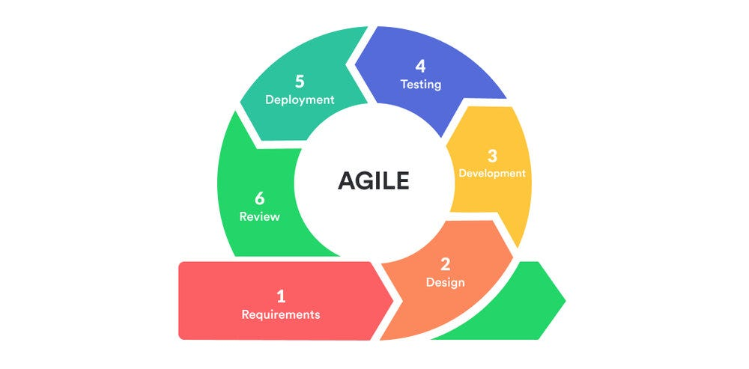

Key Features of Agile Scrum in This Project
- Iterative and Incremental Development:
  - The project is divided into short development cycles called Sprints, typically lasting 2–3 weeks.
  - Each sprint delivers a potentially shippable product, which can be tested and reviewed by stakeholders.
  - This allows the system to adapt to changes, such as new student or admin requirements, without disrupting the whole project.
- Defined Roles:
  - Scrum Master: Ensures the Scrum process is followed and removes obstacles for the team.
  - Product Owner: Represents stakeholders (students, staff, university authorities) and prioritizes requirements.
  - Development Team: Developers, testers, and designers who implement the system.
- Structured Ceremonies:
  - Sprint Planning: Define goals and tasks for the sprint.
  - Daily Stand-ups: Short daily meetings to track progress and resolve issues.
  - Sprint Review: Demonstrate completed work to stakeholders for feedback.
  - Sprint Retrospective: Analyze what went well and what can improve for the next sprint.
- Artifacts Used:
  - Product Backlog: A prioritized list of all features and tasks.
  - Sprint Backlog: Tasks chosen for the current sprint.
  - Increment: Working system version produced at the end of each sprint.

Project Development Phases (Sprints)
The portal will be developed in five main phases:
- Sprint 0 – Foundation & Planning:
Initial setup, requirement finalization, and system architecture design.
- Sprint 1 – Core Student Module:
Registration, login, and basic complaint submission features for students.
- Sprint 2 – Department Staff Module:
Complaint management dashboard, status updates, communication workflow.
- Sprint 3 – AI Chatbot Integration:
Natural language processing, instant query responses, and automated ticket creation.
- Sprint 4 – Admin & Reporting Module:
Administrative controls, department and user management, and analytical reporting tools.
- Sprint 5 – Testing & Deployment:
System testing, bug fixing, security audit, and final deployment for production use.

Reasons for Choosing Agile Scrum
- Handles Evolving Requirements:
University systems often need adjustments based on feedback from students, staff, and administrators. Agile allows changes after each sprint without delaying the entire project.
- Risk Reduction:
Integrating an AI chatbot is technically challenging. Short sprint cycles help identify and resolve technical issues early, reducing the risk of major delays.
- Continuous Stakeholder Engagement:
Frequent sprint reviews ensure student representatives and staff can provide input, improving the relevance and usability of the portal.
- Modular Development:
Each component—Student Module, Staff Panel, AI Chatbot, Admin Console—can be developed independently in sprints and then integrated, making the project manageable.
- Academic Project Constraints:
Agile Scrum fits fixed timelines of a final year project, as progress is visible through sprint reviews, burn-down charts, and milestones, making supervision easier.
- Quality Assurance:
Continuous testing during sprints ensures early detection of bugs, especially important for a system handling sensitive student data.
This methodology aligns perfectly with the needs of a multi-user, AI-integrated complaint system, guaranteeing a robust and responsive solution for the university.

Test Cases
Test cases are essential for ensuring the quality, reliability, and security of the Smart University Complaint Portal. They verify that each module performs as expected under different conditions. The test cases for this project are divided by system modules: Admin, Student, Department Staff, AI Chatbot, and Integration/Security.

Admin Module Test Cases
The admin module is the core management module of the system. Admin users have the highest level of access and are responsible for managing users, departments, complaints, AI chatbot knowledge, and generating system reports. The test cases ensure that all admin functionalities are secure, accurate, and responsive.
Test Case ID | Feature Tested | Test Steps | Expected Result
TC-A-01 | Admin Login (Success) | 1. Navigate to admin login page. 2. Enter valid username & password. 3. Click "Login". | Admin authenticated, redirected to control panel dashboard.
TC-A-02 | Admin Login (Failure) | 1. Navigate to admin login. 2. Enter invalid credentials. 3. Click "Login". | Error message "Invalid username or password" displayed, access denied.
TC-A-03 | Manage Users (Add Staff) | 1. Login as admin. 2. Go to "User Management". 3. Click "Add Staff". 4. Fill details & save. | New staff account created, email sent, appears in staff list.
TC-A-04 | Manage Departments (Create) | 1. Login as admin. 2. Go to "Department Management". 3. Click "Add Department". 4. Enter name & description. 5. Save. | Department created, visible for complaint assignment.
TC-A-05 | Manage Departments (Edit) | 1. Login as admin. 2. Select department. 3. Edit details. 4. Save. | Department information updated successfully.
TC-A-06 | Assign Complaint | 1. Login as admin. 2. View complaints. 3. Select unassigned complaint. 4. Assign department. | Complaint status changes to "Assigned", relevant staff notified.
TC-A-07 | Generate System Report | 1. Login as admin. 2. Go to "Analytics & Reports". 3. Select "Monthly Complaint Summary". 4. Click "Generate Report". | Comprehensive report displayed with functional export option.
TC-A-08 | Chatbot Knowledge Base | 1. Login as admin. 2. Navigate to "AI Chatbot Management". 3. Add new FAQ. 4. Save. | New FAQ added, reflected in real-time chatbot responses.

Explanation:
These test cases ensure the admin can securely manage the system, including users, departments, complaints, and AI functionality. It also validates that reports are generated accurately and the system reacts correctly to invalid inputs (e.g., login failures).

Student Module Test Cases
The Student module focuses on complaint submission, tracking, and interaction with the AI chatbot. Test cases validate that the student-facing interface is intuitive and all workflows are functioning correctly.
Test Case ID | Feature Tested | Test Steps | Expected Result
TC-S-01 | Student Registration | 1. Navigate to registration page. 2. Fill in all required fields. 3. Submit form. | Account created in database and verification email sent to the user.
TC-S-02 | Student Login (Success) | 1. Navigate to login page. 2. Enter registered credentials. 3. Click "Login". | Dashboard displayed showing a summary of active/resolved complaints.
TC-S-03 | Submit New Complaint | 1. Login → Click "Submit Complaint". 2. Select category & enter description. 3. Attach file (optional) and Submit. | Complaint created; unique ID assigned; visible in "My Complaints".
TC-S-04 | Track Complaint Status | 1. Login → Go to "My Complaints". 2. Click on a specific complaint ID. | Displays current status (e.g., Pending, In Progress), timeline, and logs.
TC-S-05 | View Complaint History | 1. Login. 2. Navigate to "Complaint History" section. | System lists all past and present complaints with their current statuses.
TC-S-06 | Submit Feedback | 1. Login → Open a "Resolved" complaint. 2. Provide rating/comments and Submit. | Feedback recorded in system; ticket status updated to "Closed".
TC-S-07 | Update Profile | 1. Login → Go to "My Profile". 2. Update personal details and click "Save". | Profile information updated successfully in the user database.
TC-S-08 | Change Password | 1. Login → Security Settings. 2. Enter current & new password → Click "Change". | Password updated; user is logged out to re-authenticate with new credentials.
Explanation:
These test cases validate that student can register, login, submit complaints, track progress, and provide feedback. They also verify profile management and account security functions like password changes.

Department Staff Module Test Cases
Department staff handle complaint resolution and communication. These test cases ensure that assigned complaints are correctly processed and students are properly updated.
Test Case ID | Feature Tested | Test Steps | Expected Result
TC-D-01 | Staff Login | 1. Navigate to staff login portal. 2. Enter credentials. 3. Click "Login". | Staff authenticated; dashboard displays summary of assigned departmental complaints.
TC-D-02 | View Assigned Complaints | 1. Login. 2. Access the main dashboard. | System displays a filtered list of complaints specific to the staff's department.
TC-D-03 | Accept Complaint | 1. Open a "Pending" complaint. 2. Click "Accept". | Status updates to "In Progress"; ticket is officially assigned to the logged-in staff member.
TC-D-04 | Update Complaint Status | 1. Open an active complaint. 2. Change status (e.g., On-Hold). 3. Save changes. | Status is updated in the database; student receives an automated notification.
TC-D-05 | Send Message to Student | 1. Open complaint ticket. 2. Type message in the chat panel. 3. Click "Send". | Message is logged in the communication history; student is notified.
TC-D-06 | Mark Complaint Resolved | 1. Open complaint. 2. Select "Mark Resolved". 3. Enter resolution summary and submit. | Status changes to "Resolved"; student is prompted to provide feedback/rating.
TC-D-07 | Generate Dept. Report | 1. Go to Reports section. 2. Select report type (e.g., "Monthly Performance"). 3. Click "Generate". | Department-specific metrics (resolution time, volume) are displayed/exported.
TC-D-08 | Reassign Complaint | 1. Open complaint. 2. Click "Reassign". 3. Select another staff member and confirm. | Ownership of the ticket is transferred; both staff members receive notifications.
Explanation:
These ensure workflow efficiency, correct status updates, internal collaboration, and direct student communication within the portal.

AI Chatbot Module Test Cases
The AI Chatbot module handles instant query responses and escalates unresolved issues.
Test Case ID | Feature Tested | Test Steps | Expected Result
TC-C-01 | Basic Response | 1. Open chatbot interface. 2. Type "Library hours?". | Chatbot retrieves and returns accurate operational hours.
TC-C-02 | Context Handling | 1. Ask "When is semester break?". 2. Follow up with "And after that?". | Chatbot remembers the topic and provides the "Post-break" schedule.
TC-C-03 | Escalation | 1. Report a complex/serious grievance. 2. Detect failure to resolve via AI. | Chatbot provides a direct link/suggestion to "Submit Formal Complaint."
TC-C-04 | Unclear Query | 1. Send a vague or jumbled message (e.g., "Help now"). | Chatbot responds by politely asking for clarification or specific keywords.
TC-C-05 | Knowledge Base Search | 1. Admin adds a new FAQ. 2. Student asks a question related to that FAQ. | Chatbot successfully retrieves the newly updated information.
TC-C-06 | Multi-turn Conv. | 1. Initiate a multi-step query (e.g., how to apply for a refund). | Chatbot maintains the conversation flow through all necessary steps.
TC-C-07 | Fallback Mechanism | 1. Ask a question outside the knowledge domain. | Chatbot triggers fallback response (e.g., "I'm not sure, please contact Admin").
Explanation:
These test cases ensure AI accuracy, conversational flow, and escalation for unresolved issues, making the system intelligent and student-friendly.

Integration & Security Test Cases
Integration and security test cases ensure safe and reliable operation across all modules.
Test Case ID | Feature Tested | Test Steps | Expected Result
TC-I-01 | Role-Based Access | 1. Log in as a Student. 2. Manually enter a URL for the Admin dashboard. | Access denied; system redirects user to the Student dashboard.
TC-I-02 | File Upload Validation | 1. Go to "Submit Complaint". 2. Try to upload a .exe or restricted file type. | File rejected; system displays error (e.g., "Unsupported file format").
TC-I-03 | Session Timeout | 1. Log in and remain idle for 30 minutes. 2. Attempt to refresh or perform an action. | Session is automatically terminated; user is redirected to the login page.
TC-I-04 | Email Notifications | 1. Staff marks a complaint as "Resolved". 2. Check the inbox of the student who filed the ticket. | Automated email received containing the resolution details and feedback link.
TC-I-05 | Database Integrity | 1. Navigate to "Manage Departments". 2. Attempt to delete a department that has active tickets. | System prevents deletion; displays warning regarding active dependencies.
TC-I-06 | XSS Prevention | 1. Enter <script>alert('Hacked')</script> in a complaint description. 2. Submit and view the complaint. | Input is sanitized; script is rendered as harmless plain text without executing.
Explanation:
These test cases verify security, session management, file validation, notifications, and database integrity, protecting both students and university data.

11. Tools & Technologies:

- Frontend Development: HTML5 – For semantic structure and content

- CSS3 – For styling and visual presentation

- Bootstrap 5 – For responsive, mobile-first design

- JavaScript – For client-side interactivity

- jQuery – For simplified DOM manipulation and AJAX

- Chart.js – For data visualization in reports

- Backend Development: PHP 8.x – Server-side scripting and business logic

- Composer – PHP dependency management

- PHPMailer – For email notification system

- Database: MySQL 8.x – Relational database management

- phpMyAdmin – Database administration interface

- AI Chatbot Integration: Botpress – Open-source conversational AI platform

- Natural Language Processing (NLP) – For intent recognition

- Custom Knowledge Base – University-specific FAQ training

- Design & Prototyping: Figma/Adobe XD – UI/UX design and wireframing

- Draw.io – System architecture and flowchart diagrams

- Development Environment: XAMPP/WAMP – Local server stack (Apache, MySQL, PHP)

- VS Code – Primary code editor with PHP extensions

- Git & GitHub – Version control and collaboration

- Testing & Deployment: Postman – API testing and documentation

- Browser Developer Tools – Frontend debugging

- FileZilla – FTP client for deployment (if needed)

- Documentation & Reporting: Microsoft Word – Project documentation

- Microsoft PowerPoint – Presentation slides

- TCPDF/FPDF – PDF report generation in PHP

- Security Tools: bcrypt – Password hashing in PHP

- HTTPS/SSL – Secure data transmission

- Input Sanitization Libraries – XSS and SQL injection prevention
THE END !

