**Task 03**

From previous class, we have learned about creating components and the use of JSX as well as props.

**RECALL**

**Components**

* You can think of components as blueprints.
* Whatever a function component returns is rendered as a **React element.**
* React elements let you describe what you want to see on the screen.

**JSX**

* **JSX,** a syntax that lets you write elements inside JavaScript.
* **JSX** is JavaScript, you can use variables inside it.
* You can think of curly braces as creating a portal into JS functionality in your **JSX**!

**Props**

* **Props** is short for “properties”. **Props** let you customize React components.
* Most of React Native’s Core Components can be customized with **props**, too

Today we are going to learn about state.

**State**

* **State** is like a component’s personal data storage.
* **State** is useful for handling data that changes over time or that comes from user interaction.
* **State** gives your **components** memory

1. We are going to continue exploring this part about React Fundamentals, specifically **State**

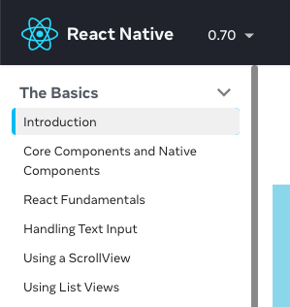



1. Continue with the previous app you created or create a new one
2. Modify the example from the website under **State** subsection
3. Modify the Cat component with the following features:
   * A text displaying “My name is xxx, and I am awake. Day 0”
   * A button with a label “Let me sleep”.
   * When the button is clicked, the label will change to, “Wake me up” and the text will display “My name is xxx, and I am sleeping. Day 1”
   * When the button is clicked again, the label will change to, “Let me sleep” and the text will display “My name is xxx, and I am awake. Day 2”
4. **Create a report by providing the screenshots of all the tasks you have followed from 1 until 4 and submit in iTaleem. Only one group member submit the report in iTaleem.**
5. **Write only group members who attended and participated for today’s class.**