PHASE-5 CAPSTONE PROJECT-
MEDICARE (DOMAIN: HEALTHCARE)

Project Objective & Background:

To develop a dynamic and responsive web application for online ordering of medicines through Medicare Application. Medicare is a company that supplies medicines and a couple of other healthcare essentials at an affordable price. It was established in 2012 in Delhi, India.

Developer Details:

Name: MUBASHIR P

Github link:

https://github.com/Mub19/Medicare

Product Features:

- Medicare application is made specifically to the required business needs. It is completely flexible and scalable to the business demands and growth.

- The whole application is a Single Page Application that is more efficient in terms of processing and provides a seamless user experience.

- The application web pages are responsive and secure.

- The application has one Administrator. The Admin Portal features are:

  - The admin can login with username and password in admin portal.

  - The admin can add or remove medicine details.

  - Edit medicine details like name, price etc., to keep the product information updated with current prices.

  - Enable or disable the medicines.

- The application has a User portal. The User Portal features are:

  - Sign up and login with username and password.

  - The User can maintain the record of activities.

  - Search for products based on the search keyword.
- Apply filters and sort result based on different categories.

- Add the product to cart and customize the purchase at the end.

- Experience a seamless payment experience.

- Receive an order summary once the payment is successful.

Core Concepts Used and Project Architecture:
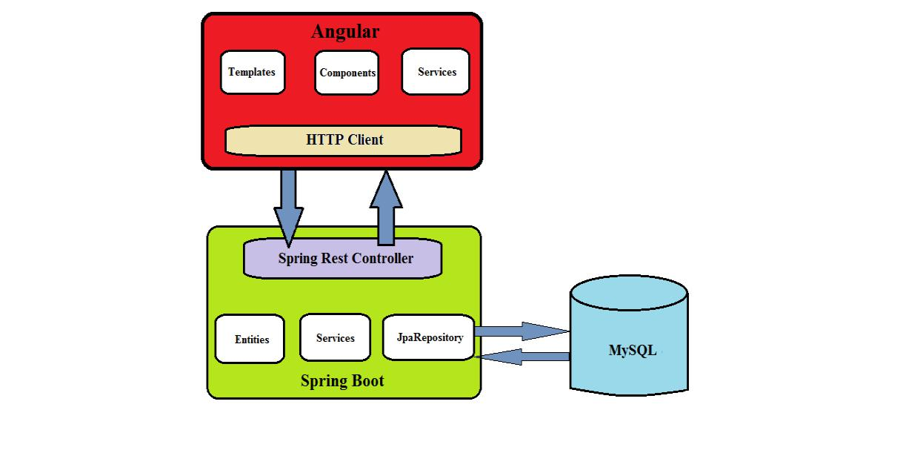

- Angular framework for frontend UI’s.

- Spring boot framework for backend .

- MySQL Database for storing all the data.

- HTML, Bootstrap 4.

- Typescript.

- Spring Security and JWT Authentication.

- Spring Data Jpa, Spring Web.

Sprint Planning and Task Achieved:

Number of sprint planned = 4.

Sprint 1:

- Planned to develop backend code for project. Generated Spring boot project from http://start.spring.io.

- Planned to develop the rest api’s to create Admin and User. Used spring security and Jwt authentication to achieve this task.

- Planned to develop api’s for admin portal to add, update, delete, enable or disable products.

- Successfully developed and tested the admin portal rest api’s using Postman software.

- Planned to develop frontend code for project. Generated Angular project using angular cli.

- Planned to develop login ui for admin and user portal. Successfully developed the ui’s for admin and user.

- Planned to develop admin dashboard that enables admin to perform the required functionalities. Successfully developed the admin dashboard.

Sprint 2:

- Planned to develop home page of the application. Successfully developed the home ui of the application.

- Planned to develop Sign up ui for users. Developed successfully.

- Planned to develop ui for search product based on keyword, show product based on category. Successfully developed the ui’s for user portal feature.
- Planned to develop user home ui. Developed successfully.

Sprint 3:

- Planned to develop add to cart feature ui in user portal. Developed successfully.

- Planned to develop rest api’s to create an order and to view orders by user. Successfully developed and tested the user order api’s using postman software.

- Planned to develop create a new order ui in user portal. Developed successfully.

- Planned to develop ui’s for order summary, show all orders in user and admin portal. Developed successfully.

Sprint 4:

- Planned to test the complete web application by giving the required inputs in respective fields.

- Successfully tested all the admin portal features and user portal features.

- The Web application is responsive, secure and all features are working as per the given requirements.

