Functional and formal verification of digital design

Transmitter Buffer

Waveform:

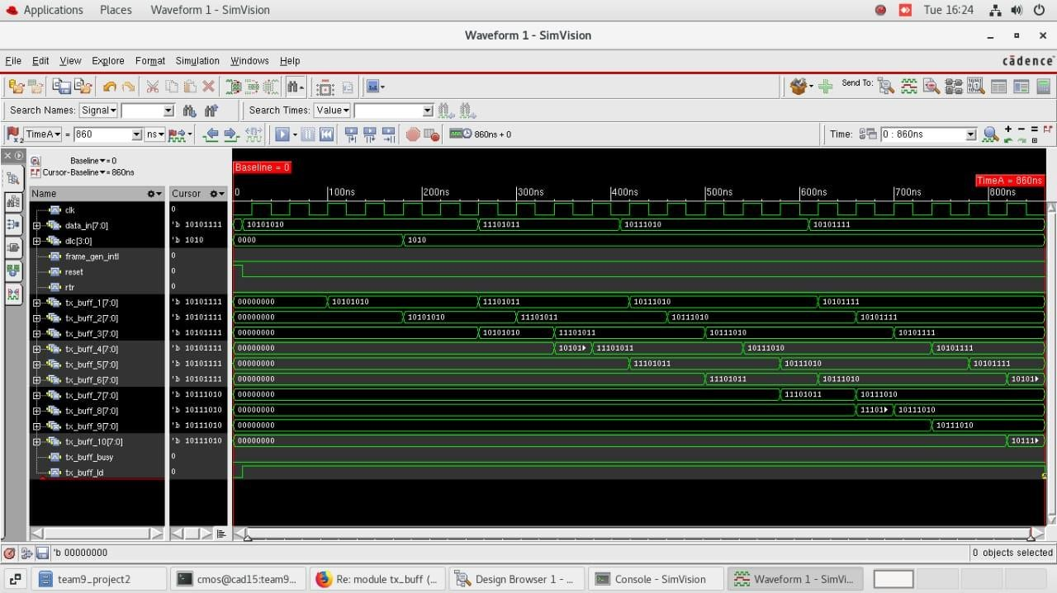

IMC Analysis: code coverage

