

SCHOOL OF ADVANCED TECHOLOGY ENGINEERING AND SCIENCES

DEPARTMENT OF COMPUTER SCIENCE

ADVANCED SYSTEM ANALYSIS AND DESIGN

COURSE CODE: CS456

TOPIC/TITTLE:

MULTIMEDIA AND DESIGN-GENERATIVE ARTIFICIAL INTELLIGENCE (AI) TOOL DEVELOPMENT PROJECT

DATE: (22nd , April 2024)

LECTURER: (MR. FRANCIS AVEVOR)

GROUP 8

**MOHAMMED MUBAREK ADS21B00260Y**

**MAHAMA HAWA ADS21A00097Y**

**OLIHIDE HENRY LOLADE ADS19A00047Y**

**ONYINYECHI BROWN VALENTINA ADS15A00038Y**

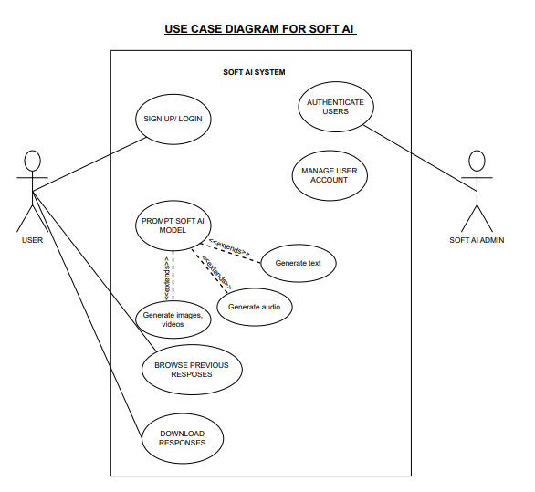

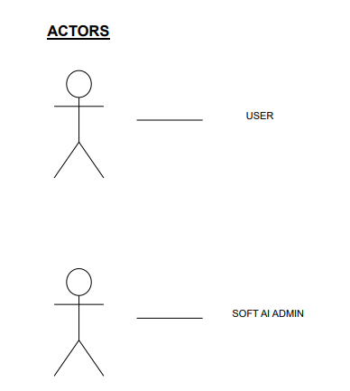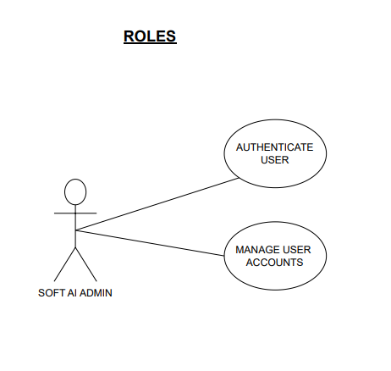

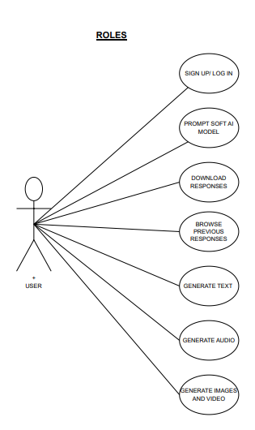

**SEQUENCE DIAGRAM**

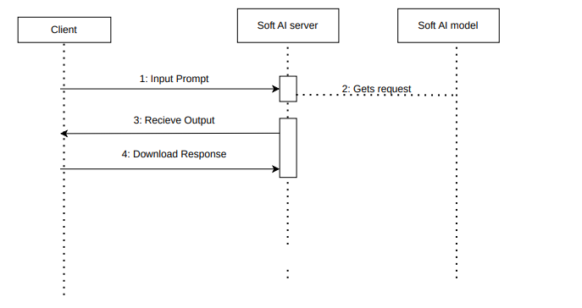

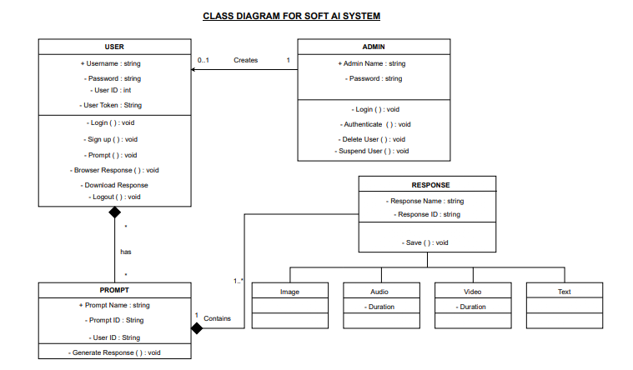

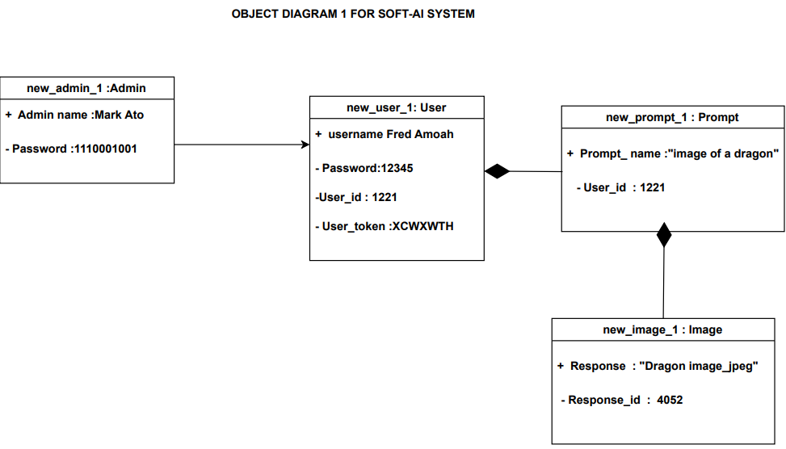

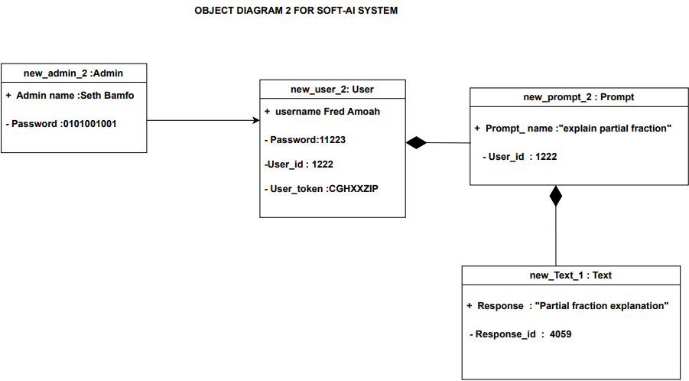

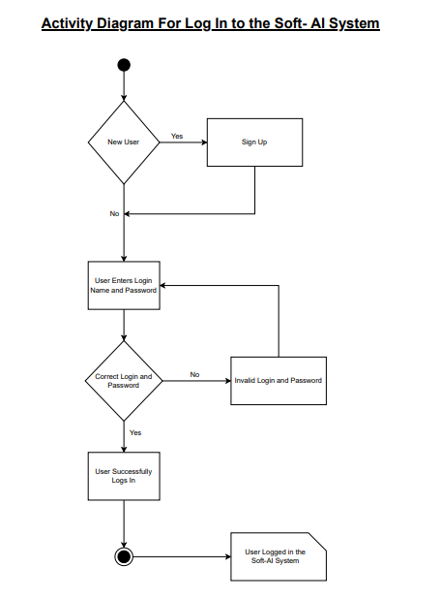

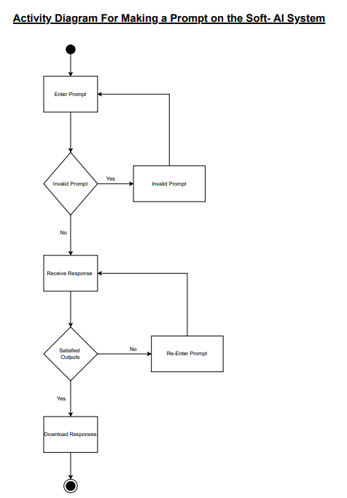

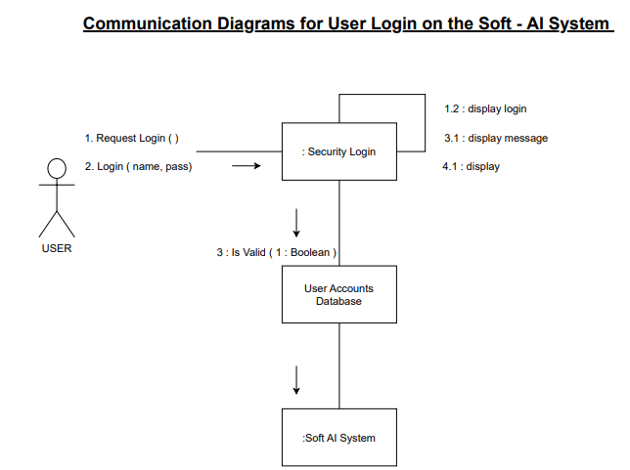

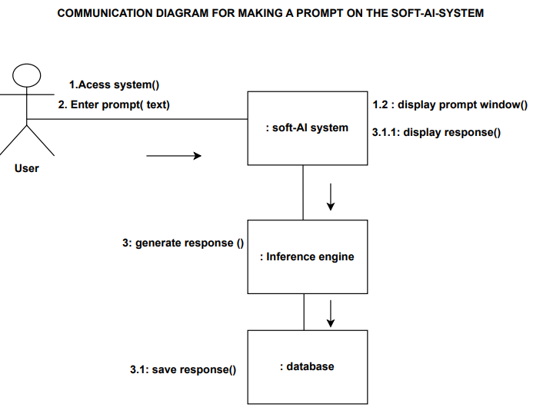

|  |  |  |  |  |  |  |
| --- | --- | --- | --- | --- | --- | --- |
| CONTENT PERFORMANCE REPORT | | | | | | |
| **Date** | **Content type** | **Platform** | **Engagement Rate** | **Click-Through Rate** | **Conversion Rate** | **Audience**  **Demographics** |
| **99-99-9999** | **AAAAAAA** | **AAAAAA** | **9999** | **9999** | **9999** | **Age:9999**  **Gender: AAAA** |
| **99-99-9999** | **AAAAAAA** | **AAAAAA** | **9999** | **9999** | **9999** | **Age: 9999**  **Gender: AAAA** |

|  |  |  |  |  |  |
| --- | --- | --- | --- | --- | --- |
| **REPORTS THAT SHOULD BE GENERATED BY THE IMMINENT SYSTEM**  USER ACTIVITY REPORT | | | | | |
| **User ID** | **Date** | **Projects Created** | **Time Spent (hours)** | **Frequency of Use** | **Feature Utilization (%)** |
| **9999** | **99-99-9999** | **9999** | **99-99** | **AAAAA** | **Text: 99-99**  **Design:9999** |
| **9999** | **99-99-9999** | **9999** | **99-99** | **AAAAA** | **Text: 9999 Design: 9999** |

|  |  |  |  |  |  |
| --- | --- | --- | --- | --- | --- |
| QUALITY ASSURANCE REPORT | | | | | |
| **Date** | **Content Type** | **Error Rate** | **consistency Score** | **Sentiment analysis** | **User Feedback Ratings** |
| **99-99-9999** | **AAAA** | **9999** | **9999** | **AAAAA** | **9999** |
| **99-99-9999** | **AAAA** | **9999** | **9999** | **AAAAA** | **9999** |

|  |  |  |  |
| --- | --- | --- | --- |
| RESOURCE UTILISATION REPORT | | | |
| **Date** | **Computing Resource Used** | **Storage Space Used** | **Licensing Cost** |
| **99-99-9999** | **AAAAAA** | **AAAA** | **9999** |
| **99-99-9999** | **AAAAAA** | **AAAA** | **9999** |

|  |  |  |  |  |
| --- | --- | --- | --- | --- |
| TREND ANALYSIS REPORT | | | | |
| **Date** | **Popular Topics** | **Emerging Keyword** | **Competitor Strategies** | **Audience Preferences** |
| **99-99-9999** | **AAAAAA** | **AAAAAA** | **AAAAAA** | **AAAAA** |
| **99-99-9999** | **AAAAA** | **AAAAAA** | **AAAAA** | **AAAAAA** |

**THE TESTING STRATEGIES**

Following the successful development of our soft -AI system, the most quintessential thing to do find out if there is any default or error present in the software so they are eliminated and thus increase the quality of our for the Soft AI project, a comprehensive testing approach is crucial to ensure the reliability, functionality, and performance of the system. We adopt several testing strategies, including but not limited to the following:

**Unit Testing**

By virtue of this strategy, we test the individual units or components of the Soft AI system, such as text generation algorithms, voice synthesis modules, video editing functionalities, and design rendering components. It would involve us writing automated unit tests to verify the correctness of each unit's behavior and ensure that changes to the code do not introduce new bugs.

**Integration testing**

Again, we would focus on testing how different units or components of the Soft AI system interact with each other, adopting Various integration testing techniques such as top-down, bottom-up, and incremental integration testing to ensure that the integrated system functions as intended.

**System testing**

Finally, we test the entire Soft AI system as a whole to verify that it meets the specified requirements and functions correctly in its intended environment. This testing phase would validate all system functionalities, including text generation, voice synthesis, video editing, and design rendering, across different platforms and environments.

|  |  |
| --- | --- |
| **Test Criteria** | **Test Data** |
| Text generation | Sample text prompt |
| Text to speech and voice synthesis | Text phrases or sentences |
| Design generation | Design specifications |
| Security | Harmful input, Invalid user credentials |

**SOFTWARE TOOLS**

Here in this section of our study is where we talk about the software tools, for building the front-end and backend of the Soft-AI system.

For the front end of Soft-AI, the React-JavaScript would be an excellent choice. React is a popular JavaScript library for building user interfaces, known for its component-based architecture and efficient rendering and hence can give the User interface of Soft-AI a lively look.

**Justification**

There exist several auspicious reasons for which we select React as the front-end tool for our imminent system. Foremost, React’s component-based architecture allows for the creation of reusable UI components, making it easier to manage complex user interfaces. Each component encapsulates its own logic and state, promoting modularity and maintainability. React utilizes a virtual DOM to optimize DOM manipulation and improve performance. By only updating the parts of the DOM that have changed, react minimizes unnecessary re-renders and enhances the overall user experience. Further, React's JSX syntax enables us to write HTML-like code directly within JavaScript, enhancing readability and productivity. JSX facilitates the creation of dynamic and interactive UI elements without sacrificing the benefits of JavaScript. React has a vast ecosystem of libraries, tools, and community support, making it easy to integrate with other technologies and extend its functionality. Pursuant to this, we can leverage libraries like React Router for routing and Redux for state management, and hence enhancing Soft-AI’s capabilities. Another plausible reason is, the fact that React promotes a declarative programming paradigm, where we the developers describe the desired UI state and React takes care of updating the DOM (Document object modelling) to match

Similarly, for the back-end programming, we would use of Laravel (PHP) for the server, Postgres SQL for the database and then Python with TensorFlow for training and building the generative model. be suitable. Laravel is a PHP framework known for its elegant syntax, robust features, and developer-friendly environment. It provides a comprehensive set of tools and libraries for building scalable and maintainable web applications. It is a full stack framework; thus, it can be used for both front end and backend development, however we would only use its backend functionality for our Soft-AI system.

PostgreSQL is a powerful, open source object-relational database system with over 35 years of active development that has earned it a strong reputation for reliability, feature robustness, and performance.

Python is a versatile programming language widely used in machine learning, data science, and web development. TensorFlow is a popular open-source python-based machine learning framework developed by Google. We would therefore, use TensorFlow for building the machine learning model of our system.

**Justification**

Laravel offers built-in features like routing, authentication, and ORM (Object-Relational Mapping), streamlining the development process and reducing time-to-market. Its expressive syntax and rich ecosystem make it ideal for implementing the back-end logic of a very complex project like Soft-AI. Python's simplicity, readability, and extensive libraries make it well-suited for implementing machine learning algorithms and handling complex data processing tasks. Concurrently, Postgres SQL as our backend database ensures we have a firm infrastructure for storing and retrieving data for soft-AI system. TensorFlow, being a powerful and scalable framework, provides tools for building, training, and deploying machine learning models, such as the CNNs that will be used in the Soft-AI tool/system.

Utilizing AWS (Amazon Web Services) cloud server for hosting the back-end infrastructure offers scalability, reliability, and security. This choice of hosting, provides us with a wide range of services, including EC2 for virtual servers, RDS for managed databases, and S3 for storage. AWS offers flexible pricing options and a global network of data centers, ensuring high availability and performance for the Soft-AI tool/system.

**MAINTENANCE**

For the proposed Soft AI system, there are various types of maintenance techniques that we could adopt to ensure its reliability, efficiency, and security while meeting user needs. They entail:

**Corrective Maintenance:**

This type of maintenance would be essential for addressing any malfunctions, bugs, or errors encountered in the Soft AI system after it's operational. Corrective maintenance would involve promptly identifying and fixing any issues that arise during the system's usage, ensuring smooth functionality for users. Examples include fixing errors in text generation, voice synthesis, video editing, or design rendering functionalities.

**Preventative Maintenance:**

Preventative maintenance for the Soft AI system would involve anticipating and addressing potential issues before they impact the system's performance or user experience. It could include regular updates and patches to address vulnerabilities, optimize performance, and ensure compatibility with evolving technologies. This type of maintenance would help prevent minor issues from developing into more significant problems and enhance the longevity of the system.

**Perfective Maintenance:**

Perfective maintenance would focus on enhancing and evolving the Soft AI system to meet the changing needs and expectations of users. It would involve adding new features, improving existing functionalities, and refining algorithms to keep the system competitive and relevant in the market. Examples include adding new text generation models, improving voice synthesis capabilities, enhancing video editing tools, or introducing advanced design features.

**Adaptive Maintenance:**

Adaptive maintenance would ensure that the Soft AI system remains compatible and functional in the face of evolving technologies, laws, and regulations. This type of maintenance would involve adjusting accommodate changes in operating systems, cloud storage platforms, hardware requirements, or regulatory standards. Examples include updating the system to support new operating system versions, integrating with emerging cloud services, or ensuring compliance with data protection regulations.