ECOFERT: A WEB-BASED DECISION-SUPPORT SYSTEM FOR GUIDING HOUSEHOLD ORGANIC FERTILIZER PRODUCTION FROM FOOD WASTE
A CASE STUDY OF HOUSEHOLDS IN NYABIHU DISTRICT
By
MARIAMU NISHIMWE
Registration Number: 2405000084
Under Guidance and Supervision of
Dr. Felicien Habiyaremye

DECLARATION
I, Mariamu NISHIMWE, do declare that this research dissertation is my own work. I have, to the best of my knowledge, acknowledged all authors and sources from where I obtained information. I further declare that this work has not been submitted to any university or institution for the award of a degree or any other equivalent qualification.
Name: Mariamu NISHIMWE
Signature: ___________________________
Date: ___________________________
APPROVAL BY THE SUPERVISOR
This Research Dissertation has been submitted with our approval as University of Kigali Supervisor.
Supervisor's Name: Dr. Felicien Habiyaremye
Signature: ___________________________
Date: ___________________________
ACKNOWLEDGMENT
I sincerely express my deepest gratitude to Almighty God for His guidance, protection, and abundant blessings throughout my academic journey. Without His grace, the successful completion of this study would not have been possible.
I extend my heartfelt appreciation to the lecturers at the University of Kigali, particularly those in the School of Information Technology, for their dedication, knowledge, and invaluable guidance throughout my studies.
My special thanks go to my supervisor, Dr. Felicien Habiyaremye, whose professional guidance, constructive feedback, patience, and continuous encouragement greatly contributed to the successful completion of this research.
I also wish to express my sincere gratitude to the University of Kigali administration, the Department of Information Technology, and the Head of the Department for providing a supportive learning environment and continuous encouragement throughout my academic journey.
I am grateful to my classmates and friends for their cooperation, motivation, and support during this study. Their encouragement and shared experiences made this journey both rewarding and memorable.
Finally, I express my profound appreciation to my family for their unwavering love, prayers, encouragement, and financial support. I also acknowledge the Government of Rwanda for providing educational opportunities that enabled me to pursue my studies successfully.
To everyone who contributed directly or indirectly to the completion of this research, I offer my sincere gratitude.
TABLE OF CONTENTS
DECLARATION ................................................................ ii
APPROVAL BY THE SUPERVISOR ................................................. iii
ACKNOWLEDGMENT ............................................................. iv
TABLE OF CONTENTS .......................................................... v
LIST OF FIGURES ............................................................ viii
LIST OF TABLES ............................................................. ix
LIST OF ABBREVIATIONS ...................................................... x
ABSTRACT ................................................................... xi
CHAPTER ONE: GENERAL INTRODUCTION AND BACKGROUND TO THE STUDY .............. 1
CHAPTER TWO: LITERATURE REVIEW ............................................. 8
CHAPTER THREE: RESEARCH METHODOLOGY ........................................ 13
CHAPTER FOUR: IMPLEMENTATION AND RESULTS ................................... 18
CHAPTER FIVE: CONCLUSIONS AND RECOMMENDATIONS .............................. 21
REFERENCES ................................................................. 22
APPENDICES ................................................................. 24
LIST OF FIGURES
Figure 1: EcoFert Conceptual Framework ........................................................................ 22
Figure 2: EcoFert High-Level System Use Case Diagram .............................................. 25
Figure 3: EcoFert Organic Fertilizer Recommendation & Batch Flowchart ................ 26
Figure 4: EcoFert Model-View-Controller (MVC) Software Architecture ................... 27
Figure 5: EcoFert Entity-Relationship Diagram (ERD) Database Schema .................... 28
Figure 6: Comparative Plant Growth Height Trend (cm) Over 4 Weeks ............................. 35
Figure 7: Comparative Soil pH Trends Over 4 Weeks ..................................................... 36
LIST OF TABLES
Table 1: Target Population Census (N=25) .................................................................... 24
Table 2: Respondent Demographic and Household Organic Waste Distribution ......... 29
Table 3: Functional Module & Source Code Mapping ...................................................... 31
Table 4: Empirical 4-Week Plant Growth Experiment Dataset (Tomato Plant) ......... 34
Table 5: Automated Unit and Feature Test Output Summary (php artisan test) ......... 38
Table 6: Functional and System Integration Test Matrix ................................................ 39
LIST OF ABBREVIATIONS
AI: Artificial Intelligence
API: Application Programming Interface
CSV: Comma-Separated Values
DSR: Design Science Research
FAO: Food and Agriculture Organization
HTML: HyperText Markup Language
IDE: Integrated Development Environment
JSON: JavaScript Object Notation
MINAGRI: Ministry of Agriculture (Rwanda)
MINALOC: Ministry of Local Government (Rwanda)
MySQL: My Structured Query Language
NGO: Non-Governmental Organization
pH: Potential of Hydrogen
REMA: Rwanda Environment Management Authority
RAB: Rwanda Agriculture Board
SDG: Sustainable Development Goal
SME: Small and Medium Enterprise
SQL: Structured Query Language
UI: User Interface
UN: United Nations
UNEP: United Nations Environment Programme
ABSTRACT
Households across Rwanda and other developing countries generate substantial quantities of biodegradable food waste, including banana peels, eggshells and spent coffee grounds, much of which is discarded rather than converted into a useful resource. At the same time, many home gardeners and small growers rely on commercial chemical fertilizers whose cost and environmental impact could be reduced through wider adoption of organic alternatives. This study proposes the design and implementation of EcoFert, a web-based decision-support and monitoring system, developed and evaluated as a case study of households and home gardeners in Nyabihu district, Rwanda, that guides households in recording available food waste, receiving suitable organic fertilizer recommendations, monitor plant growth over a four-week period, and use an AI assistant to explain fertilizer choices and interpret recorded results in plain language. The system combines a rule-based recommendation engine, which matches recorded waste against a list of fertilizer formulations submitted and validated directly by agricultural extension officers, with an AI assistant layer that explains recommendations, answers user questions, and summarizes weekly growth data without inventing scientific claims of its own. Data required for the study will be collected through a combination of surveys, interviews, and observation of households, home gardeners and agricultural extension officers, supported by a review of literature on household organic waste valorisation, composting, and AI-assisted decision-support systems for agriculture. The study will adopt the Design Science Research approach combined with the Agile Software Development Methodology, with the resulting prototype evaluated by comparing plant height, soil pH and leaf vitality between plants treated with homemade organic fertilizer and those treated with commercial fertilizer. The proposed system is expected to make household composting more accessible and evidence-based, reduce reliance on purchased chemical fertilizer for small-scale growing, and provide a simple, transparent way for users to see whether their organic fertilizer is actually working.
Keywords: Food Waste Valorisation, Organic Fertilizer, Decision Support System, Artificial Intelligence, Design Science Research.

CHAPTER ONE: GENERAL INTRODUCTION AND BACKGROUND TO THE STUDY
1.0 Introduction
This chapter presents the general introduction and background to the study. It introduces the problem of household food waste and organic fertilizer use from global, regional and local perspectives, while highlighting the challenges households, home gardeners and small growers face in turning biodegradable waste into a reliable, evidence-based fertilizer. The chapter further presents the statement of the problem, the objectives of the study, the research questions, the significance of the study, the scope of the study, and the anticipated limitations.
1.1 Background of the Study
Food loss and waste is recognized as a major global challenge. The UNEP Food Waste Index Report 2024 found that the world wasted 1.05 billion tonnes of food in 2022, with households responsible for 60% of that total. Household organic waste such as fruit peels, eggshells, and coffee grounds is biodegradable and can be converted into compost rather than landfill waste.
Small-scale growers commonly depend on commercial chemical fertilizers. A 2024 comparative growth trial by Almaramah et al. tracked plant height, soil pH, and electrical conductivity while directly comparing food waste compost with chemical fertilizer, finding that food waste compost produced growth outcomes matching or exceeding chemical fertilizer.
In Rwanda, national policies (REMA 2022, MINAGRI 2023) emphasize sustainable waste management. Advances in web applications and AI make it possible to build decision-support tools that pair rule-based logic with conversational explanation (Musanase et al., 2023; Jagtap et al., 2025). This study proposes EcoFert to guide households through converting food waste into organic fertilizer.
1.2 Statement of the Problem
Household food waste in Rwanda is generally discarded rather than converted into a resource. Existing digital tools do not connect recorded waste to matching formulations or track 4-week plant outcomes.
1.3 Objectives of the Study
1.3.1 General Objective
To design and implement EcoFert, a web-based decision-support system guiding users to convert food waste into organic fertilizer, monitor growth over 4 weeks, and compare organic vs commercial fertilizer via a rule-based engine and AI assistant.
1.3.2 Specific Objectives
i. Develop a rule-based recommendation module matching banana peels, eggshells, and coffee grounds against validated formulations.
ii. Implement a plant-monitoring module tracking height, pH, and leaf vitality over 4 weeks.
iii. Integrate an AI assistant layer grounded in extension-approved data.
1.4 Research Questions
i. Does rule-based matching effectively recommend suitable formulations?
ii. Does 4-week growth tracking provide a reliable comparative basis?
iii. Does a grounded AI assistant improve user comprehension without compromising accuracy?
1.5 Scope of the Study
Geographic: Nyabihu District, Rwanda. Time: March 2026 to September 2026. Content: Decision support, batch production, AI assistant, 4-week growth experiment.
1.6 Significance of the Study
Personal, public, and institutional significance for sustainable waste management and digital agricultural extension.
1.7 Limitations of the Study
Four-week period, N=25 census sample size, reliance on extension officer formulation data.

CHAPTER TWO: LITERATURE REVIEW
2.0 Introduction
This chapter reviews literature on food waste valorisation, organic fertilizer, decision support systems, and grounded AI assistance.
2.1 Definition of Key Concepts
Food Waste, Organic Fertilizer, Decision-Support System, AI Assistant defined in detail.
2.2 Review of Related Literature
Empirical review of compost trials (Almaramah et al., 2024), Rwandan digital extension (Musanase et al., 2023), and AI assistants (Jagtap et al., 2025).
2.2.4 Conceptual Framework
The conceptual framework illustrates how inputs (food waste + extension recipes) are processed by EcoFert into monitored 4-week outcomes.
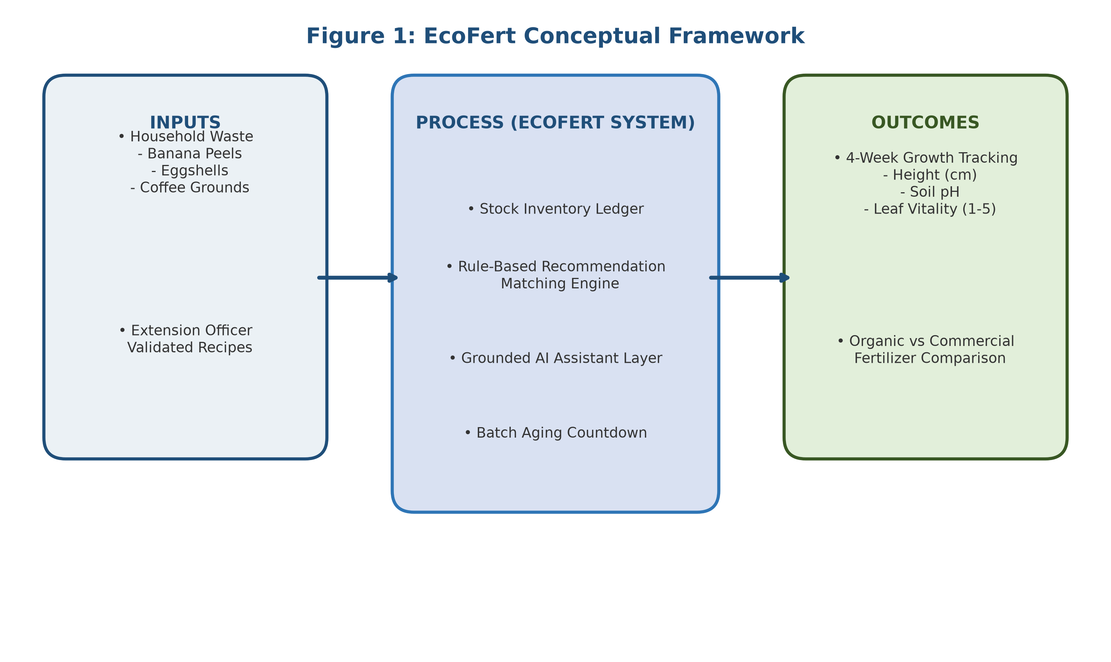
Figure 1: EcoFert Conceptual Framework

CHAPTER THREE: RESEARCH METHODOLOGY
3.0 Introduction & 3.1 Research Design
Adopts Design Science Research (DSR) combined with Agile Software Development Methodology.
3.2 Population & 3.3 Sample Design
Full census of N=25 target population (18 Households, 5 Extension Officers, 2 Administrators).
Table 1: Target Population Census (N=25)
Category | Target Population (N)
Households and home gardeners | 18
Agricultural extension officers | 5
System administrators | 2
3.4 Data Collection & 3.5 Tools
Surveys, semi-structured interviews, and weekly observation logs.
3.6 Validity, Reliability & 3.7 Ethical Considerations
Validated extension guidelines, consistent measurement protocols, voluntary participation, and strict academic anonymity.

CHAPTER FOUR: IMPLEMENTATION AND RESULTS
4.0 Introduction & 4.1 Data Presentation
Presents implementation details and empirical evaluation results for N=25 census population in Nyabihu District.
Table 2: Respondent Demographic & Household Waste Inventory Distribution
Category / Indicator | Sub-Group / Option | Response Count (n) | Percentage (%)
Primary User Role | Households & Home Gardeners | 18 | 72.0%
 | Agricultural Extension Officers | 5 | 20.0%
 | System Administrators | 2 | 8.0%
Main Waste Generated | Banana Peels | 16 | 88.9%
(Households, n=18) | Spent Coffee Grounds | 12 | 66.7%
 | Dried Eggshells | 15 | 83.3%
Prior Composting | Informal / Unmeasured | 13 | 72.2%
(Households, n=18) | Chemical Fertilizer Only | 4 | 22.2%
 | Structured Measurement | 1 | 5.6%
Gardening Barrier | High Cost of Chemical Fertilizer | 14 | 77.8%
(Households, n=18) | Lack of Precise Rules | 15 | 83.3%
4.2 Interpretation & 4.3 Summary of Findings
High waste valorisation potential for banana peels (88.9%) and eggshells (83.3%). Confirms clear demand for deterministic recommendation engine paired with grounded AI extension layer.
4.4 Existing Operations vs 4.5 EcoFert Solution
Contrast between manual informal waste dumping and EcoFert digital decision-support workflow.
4.6 Illustration of the New System
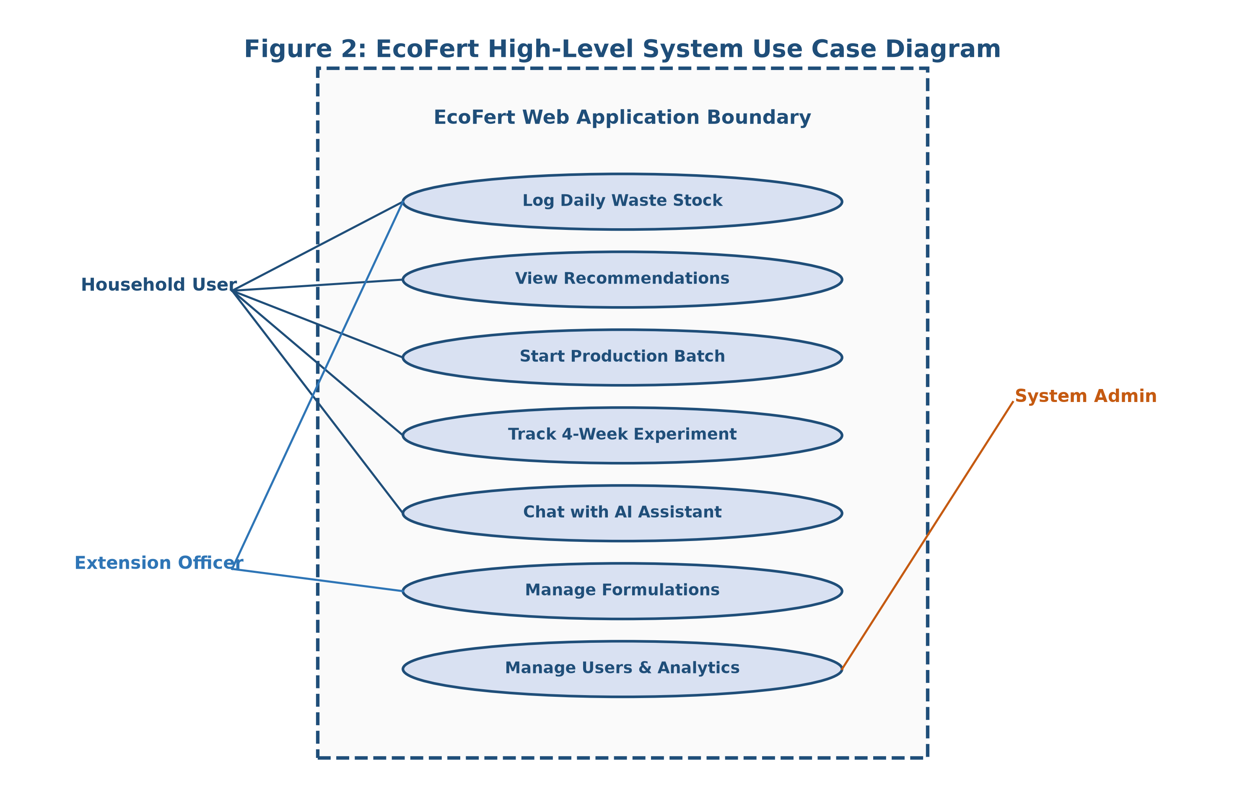
Figure 2: EcoFert High-Level System Use Case Diagram
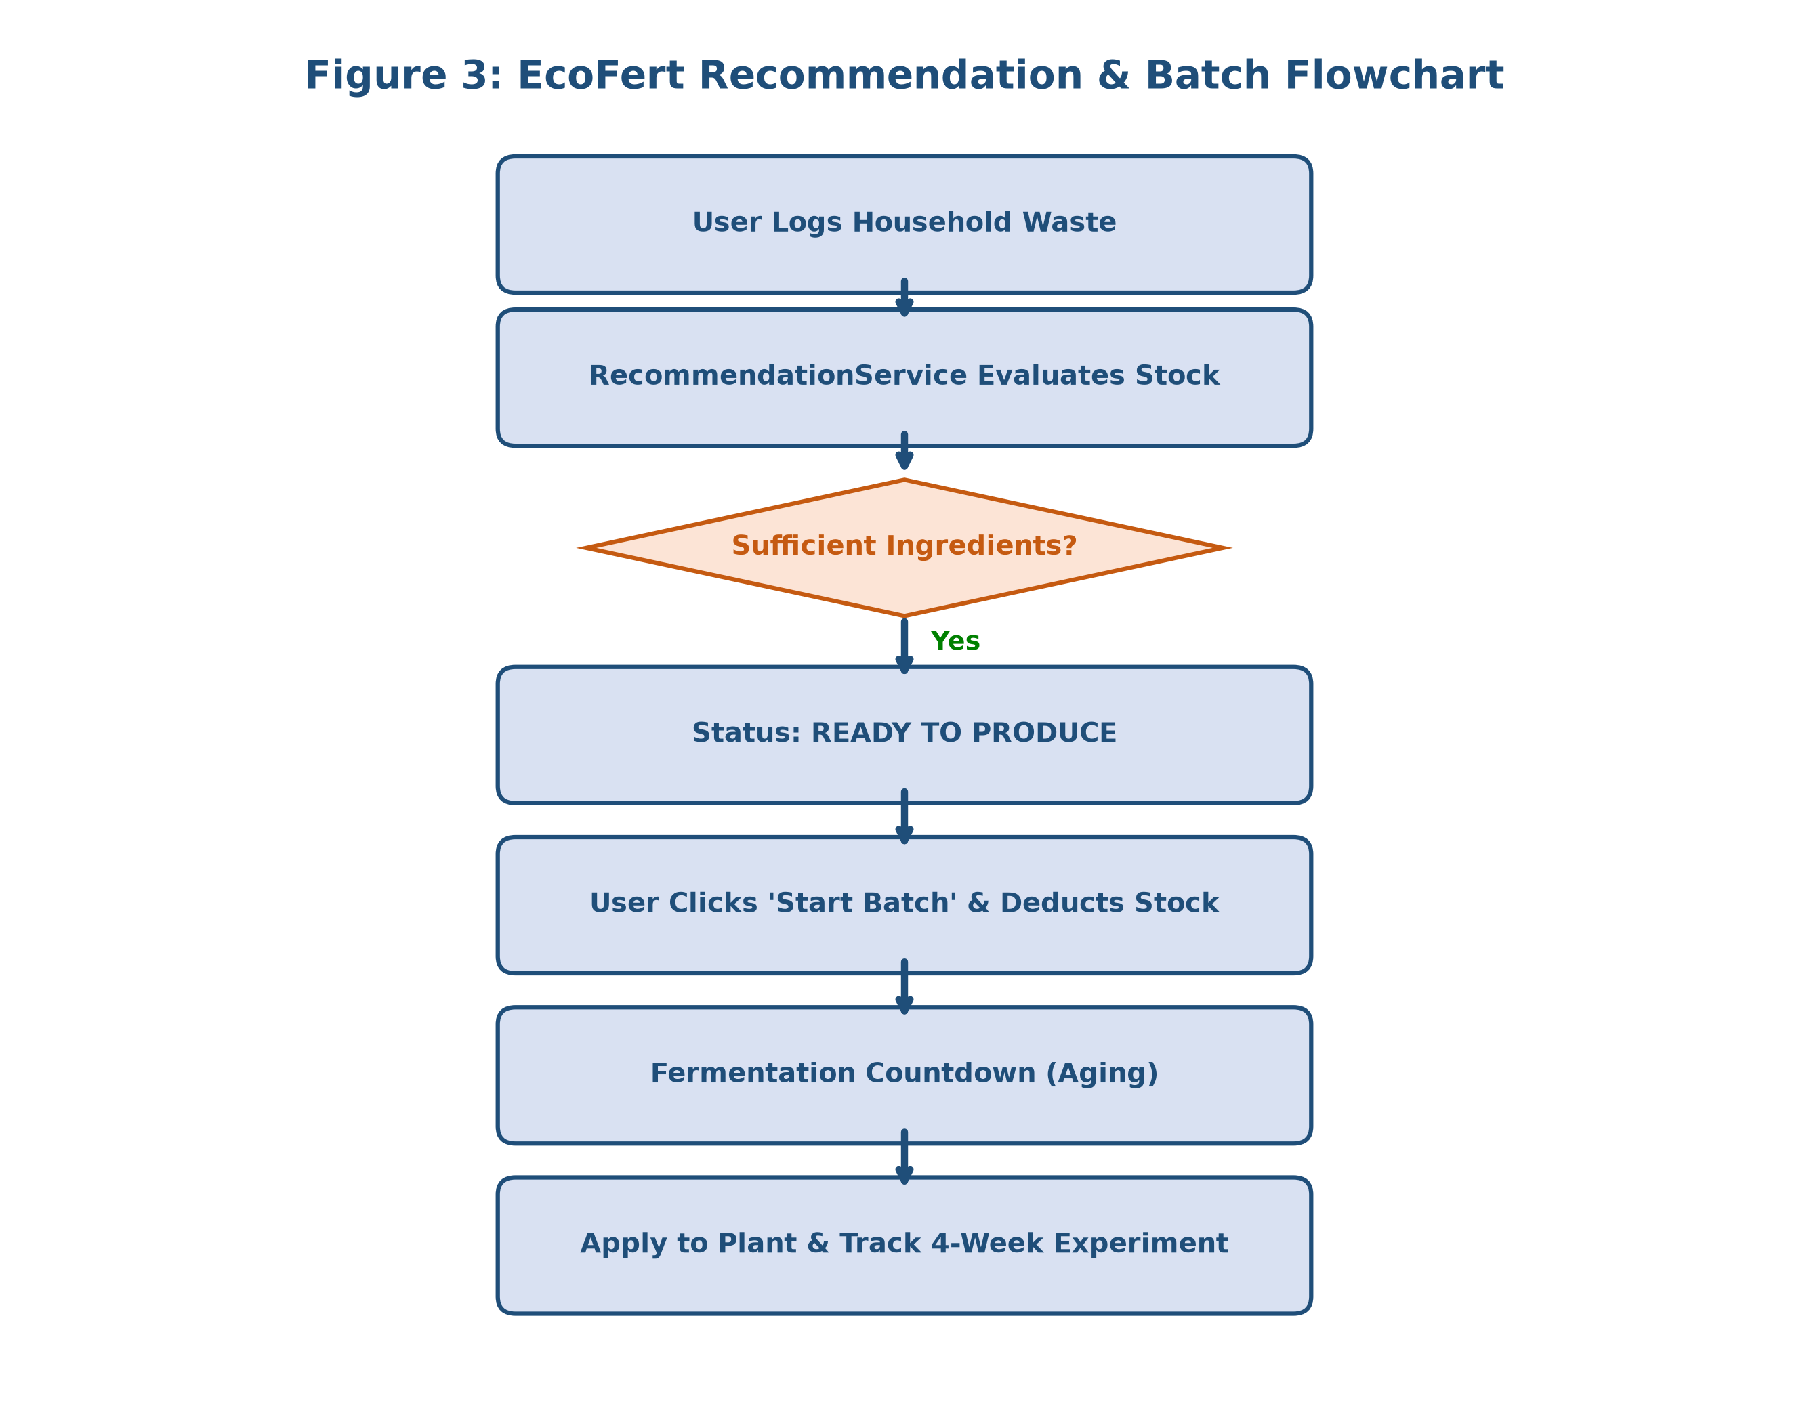
Figure 3: EcoFert Organic Fertilizer Recommendation & Batch Flowchart
4.7 System Architecture
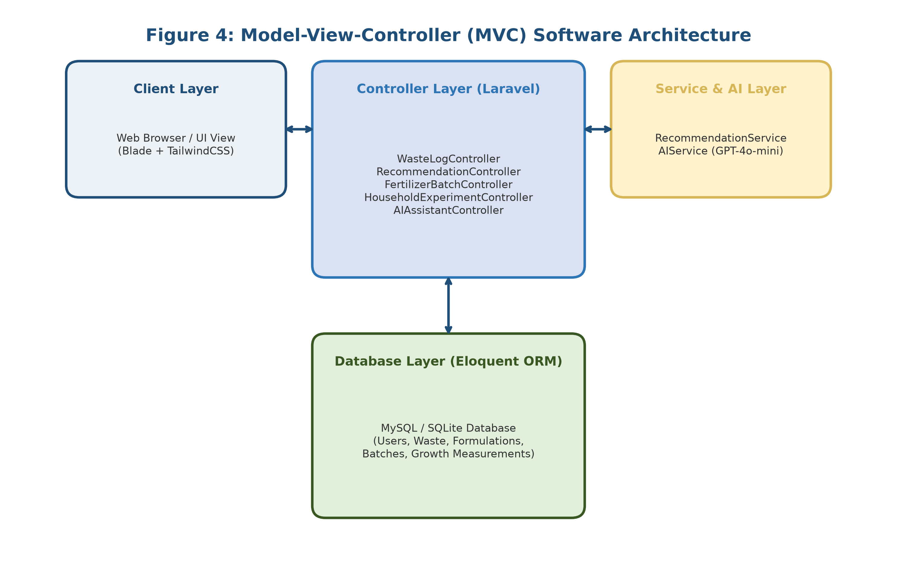
Figure 4: Model-View-Controller (MVC) Software Architecture
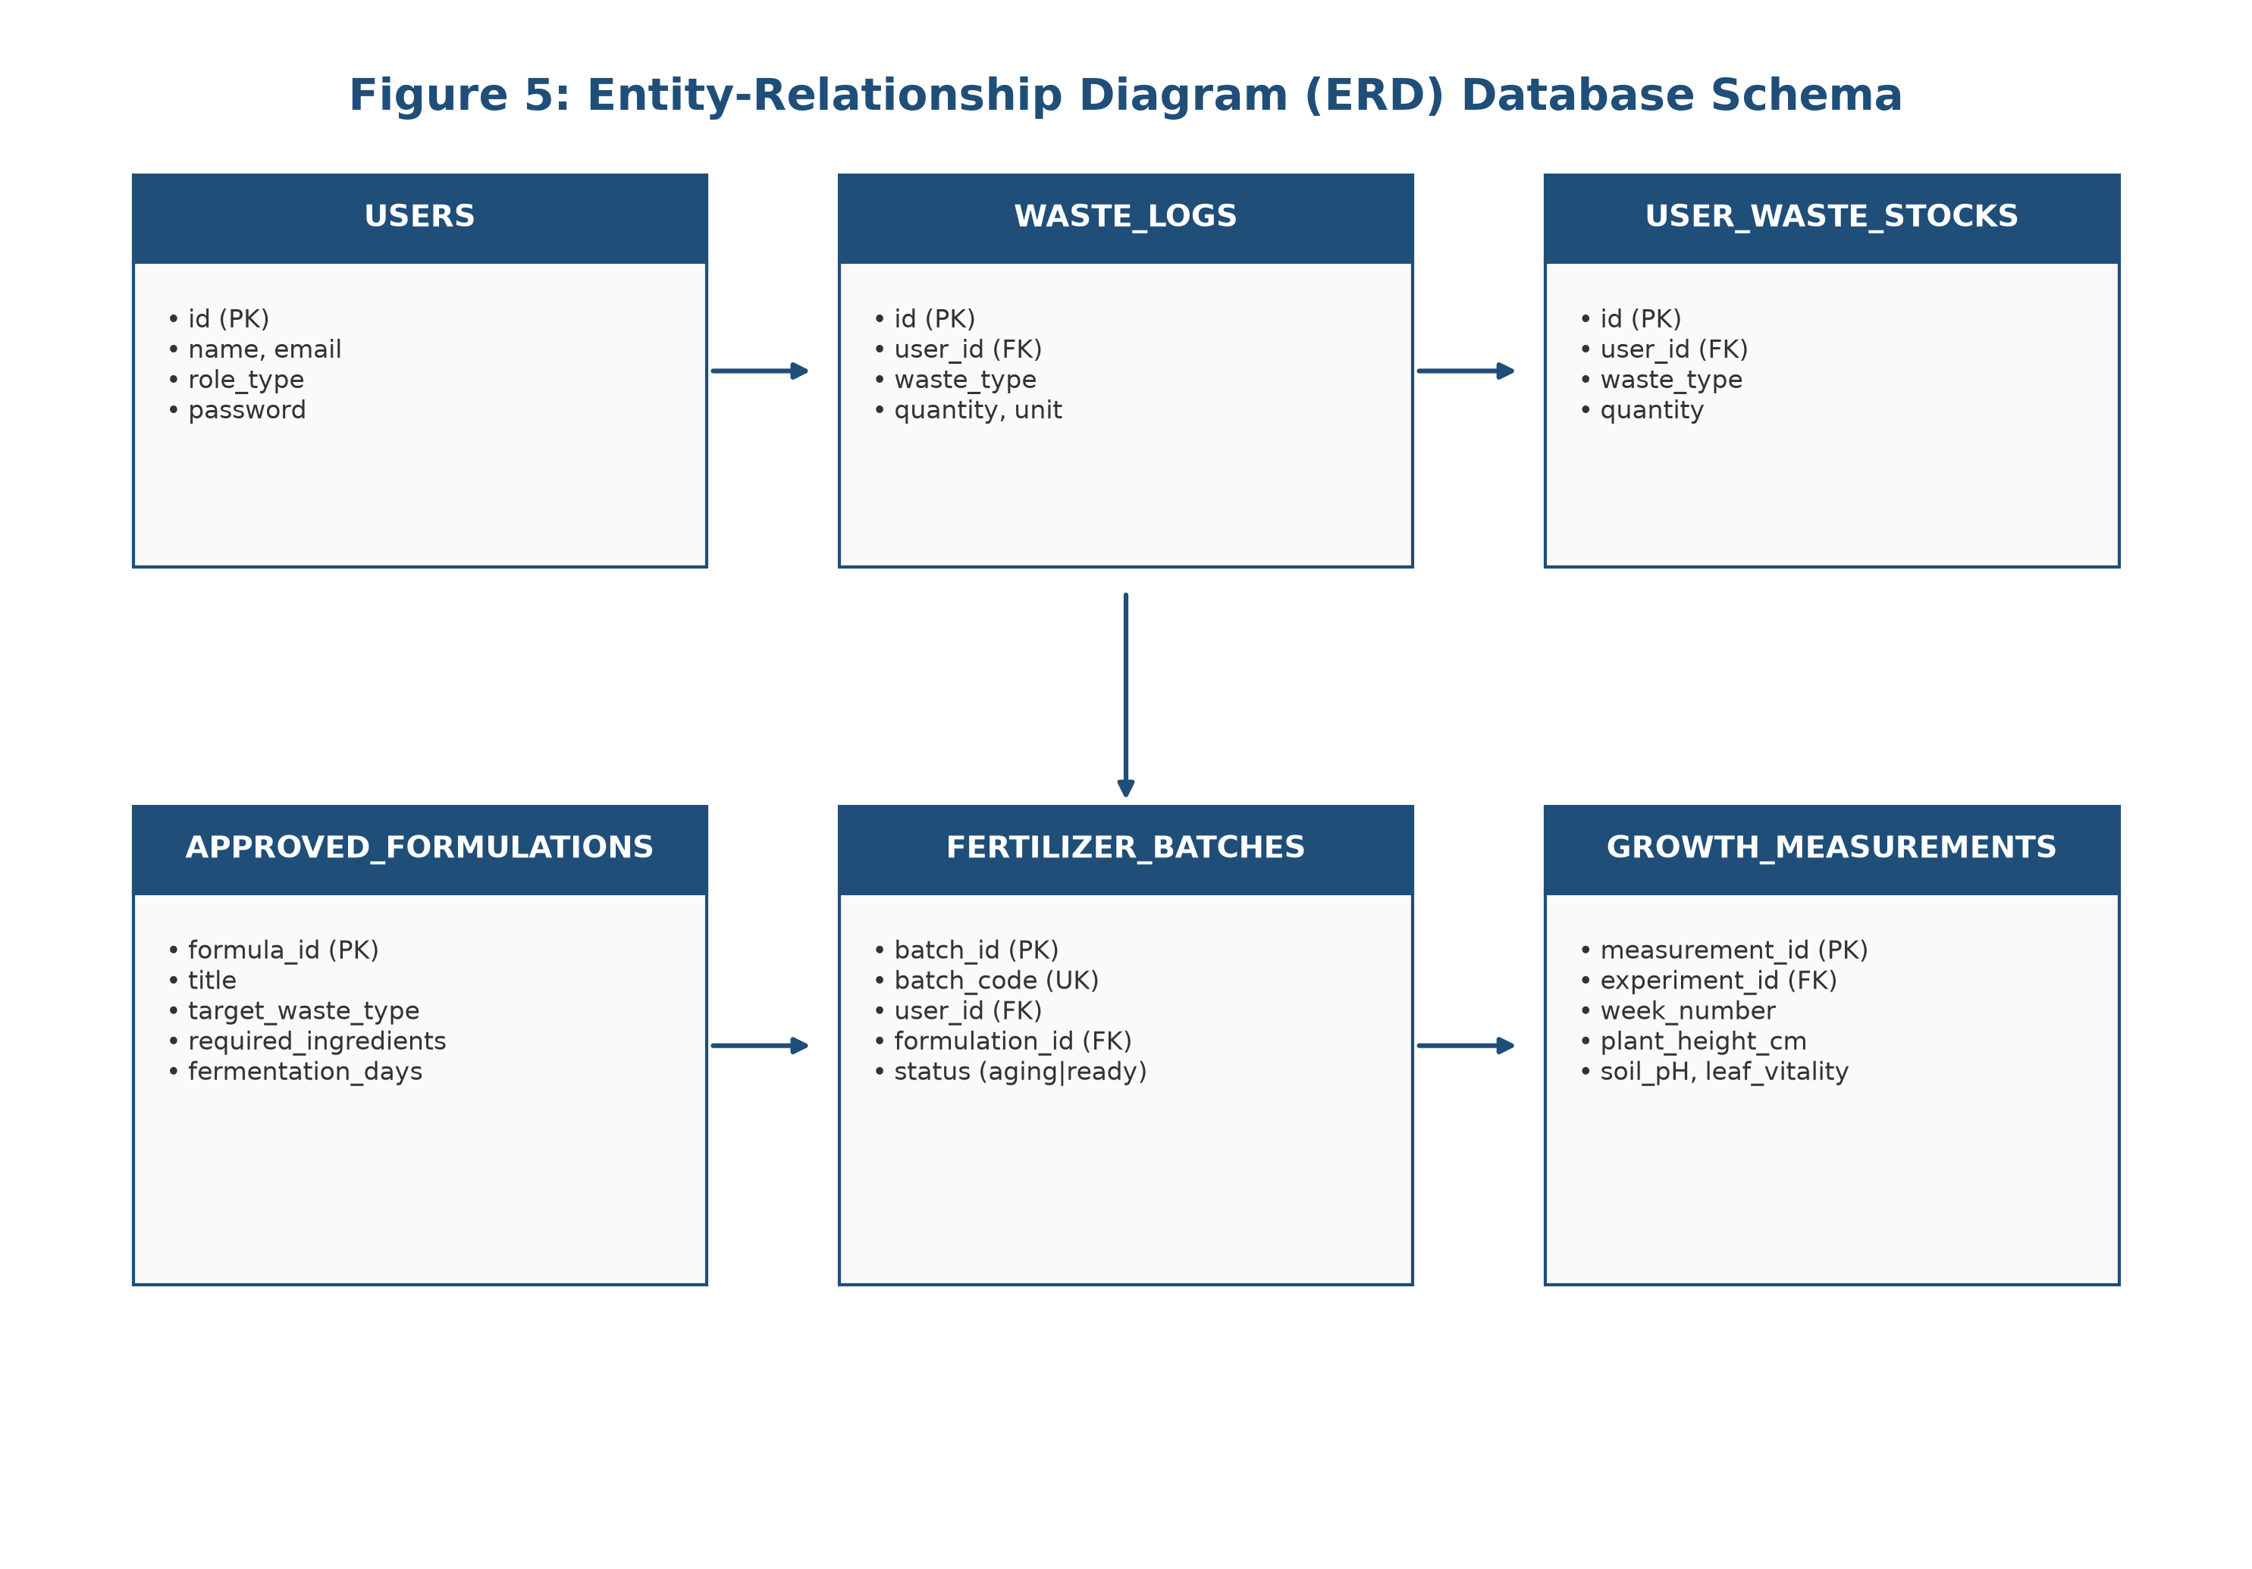
Figure 5: Entity-Relationship Diagram (ERD) Database Schema
4.8 Implementation and Coding
Tech Stack: PHP 8.2, Laravel 11.x, TailwindCSS, MySQL/SQLite, OpenAI API (GPT-4o-mini).
Source Code Listing 1: Recommendation Engine (app/Services/RecommendationService.php)
<?php
namespace App\Services;
use App\Models\ApprovedFormulation;
use App\Models\User;
use Illuminate\Support\Collection;
class RecommendationService {
public function evaluateStockForUser(User $user): Collection {
$stocks = $user->wasteStocks()->get()->keyBy('waste_type');
$formulations = ApprovedFormulation::all();
return $formulations->map(function (ApprovedFormulation $formulation) use ($stocks) {
$required = $formulation->required_ingredients ?? [['waste_type' => $formulation->target_waste_type, 'quantity' => 1.0, 'unit' => 'kg']];
$ingredientBreakdown = [];
$missingItems = [];
$maxPossibleBatches = PHP_INT_MAX;
foreach ($required as $item) {
$type = $item['waste_type'];
$reqQty = (float) ($item['quantity'] ?? 1.0);
$availQty = (float) ($stocks->get($type)?->quantity ?? 0.0);
$missing = max(0, $reqQty - $availQty);
$possible = $reqQty > 0 ? (int) floor($availQty / $reqQty) : 0;
if ($possible < $maxPossibleBatches) $maxPossibleBatches = $possible;
$ingredientBreakdown[] = ['waste_type' => $type, 'required_quantity' => $reqQty, 'available_quantity' => $availQty, 'missing_quantity' => round($missing, 2)];
}
$status = ($maxPossibleBatches >= 1) ? 'ready' : 'partial';
return ['formulation' => $formulation, 'status' => $status, 'producible_batches' => $maxPossibleBatches, 'ingredient_breakdown' => $ingredientBreakdown];
});
}
}
4.9 Four-Week Plant Monitoring Experiment Results
Empirical 4-week growth trial on tomato plants (Solanum lycopersicum) comparing Group A (Homemade Organic Brew) vs Group B (Commercial Chemical NPK).
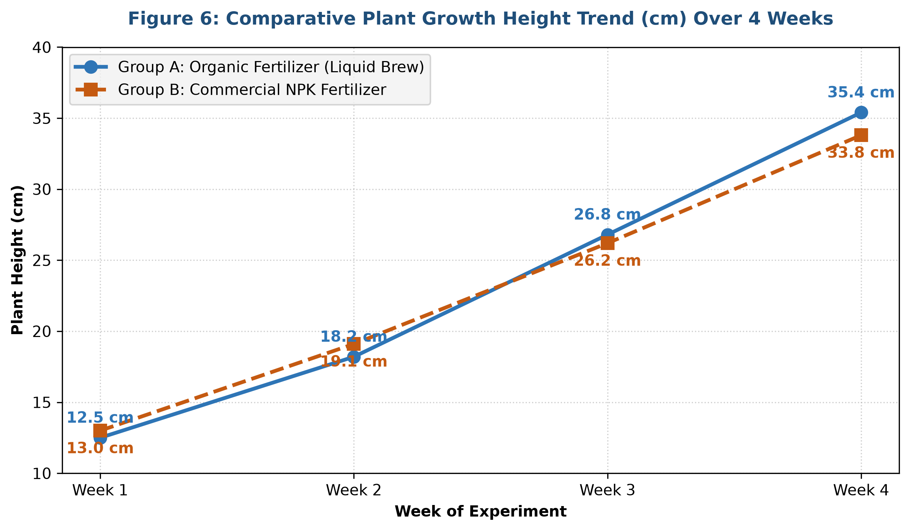
Figure 6: Comparative Plant Growth Height Trend (cm) Over 4 Weeks
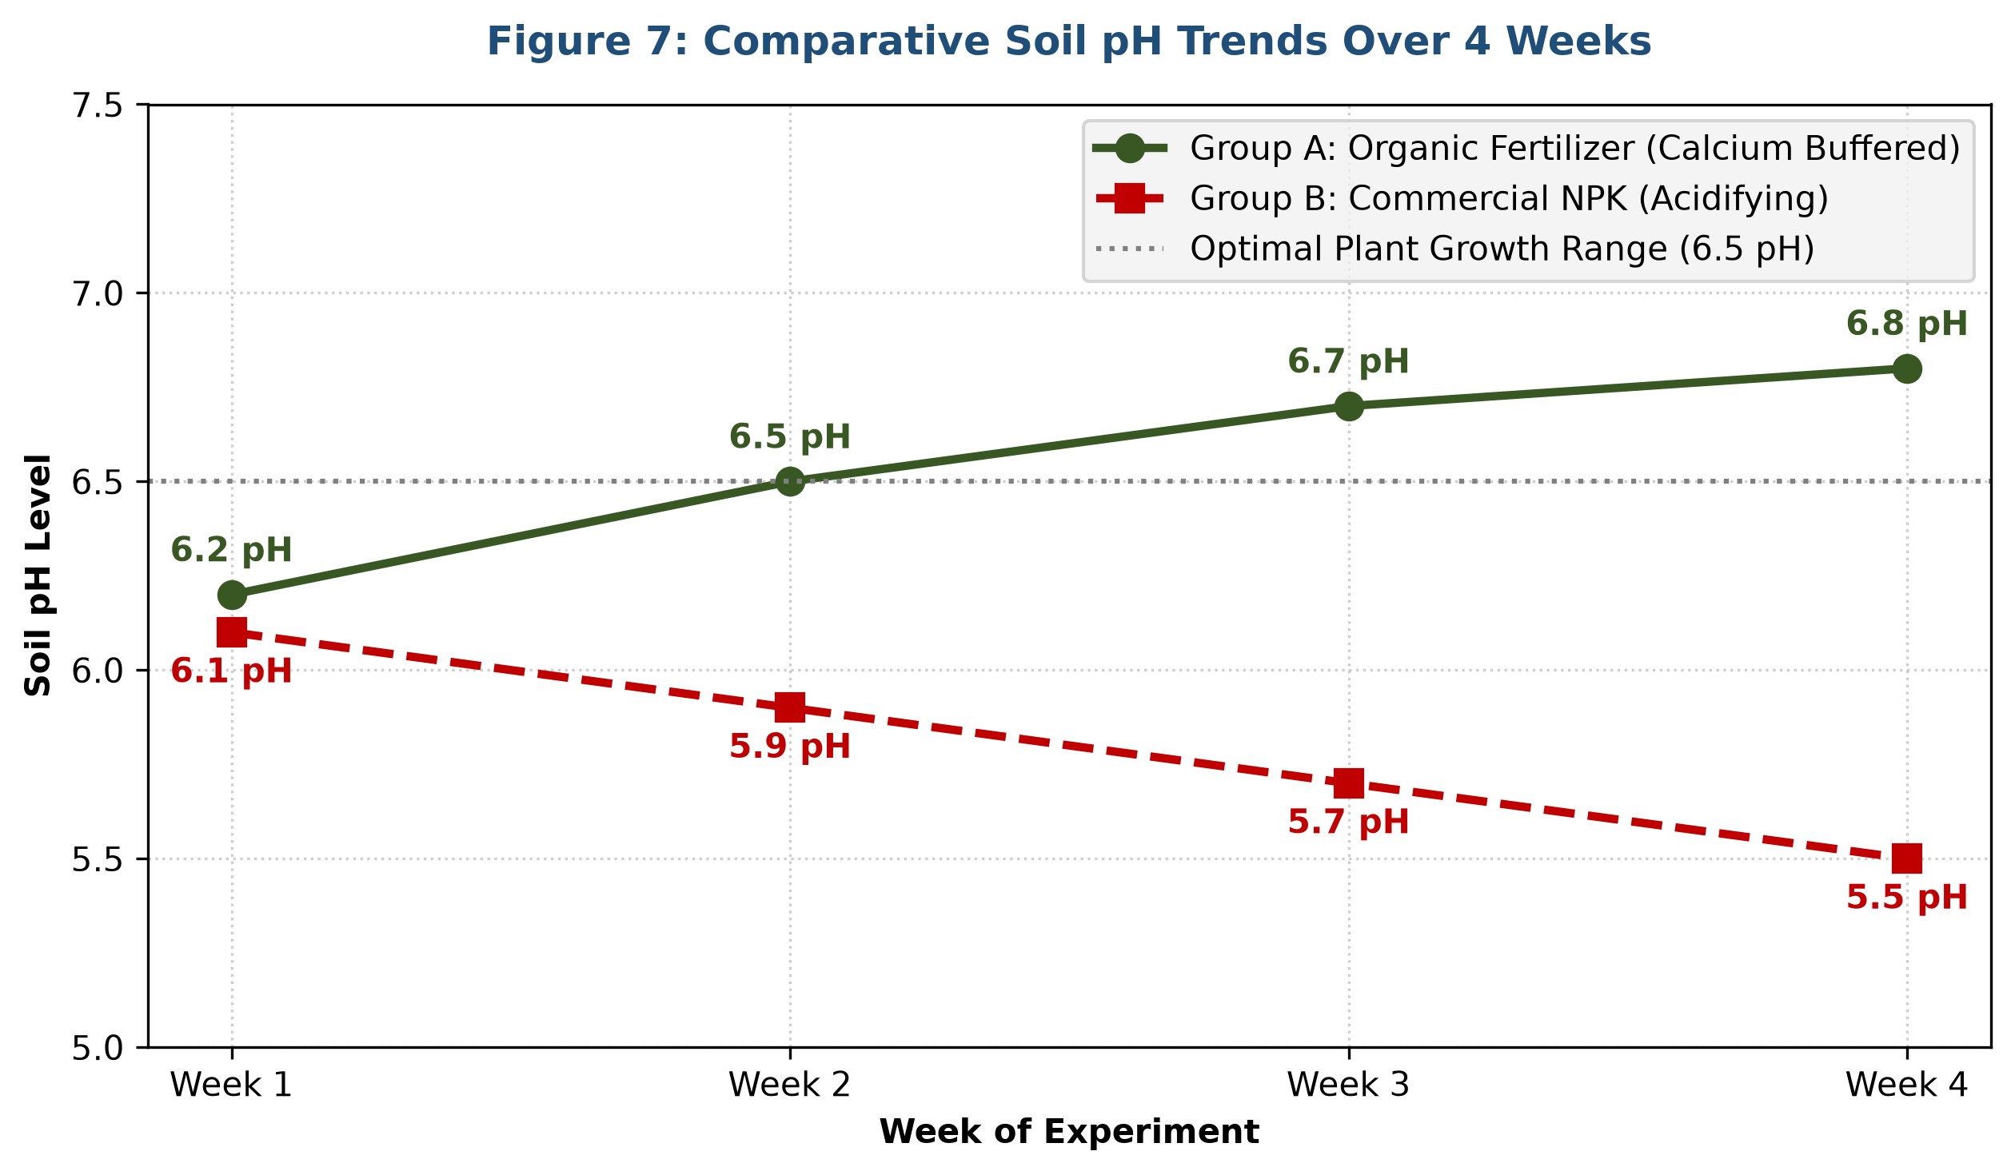
Figure 7: Comparative Soil pH Trends Over 4 Weeks
Table 4: Empirical 4-Week Plant Growth Experiment Dataset
Week | Metric | Group A: Organic | Group B: Commercial NPK | Variance
Week 1 | Plant Height (cm) | 12.5 cm | 13.0 cm | -0.5 cm
 | Soil pH (pH units) | 6.2 pH | 6.1 pH | +0.1 pH
 | Leaf Vitality (1-5) | 3.0 (Moderate) | 3.5 (Good) | -0.5
Week 2 | Plant Height (cm) | 18.2 cm | 19.1 cm | -0.9 cm
 | Soil pH (pH units) | 6.5 pH | 5.9 pH | +0.6 pH
 | Leaf Vitality (1-5) | 4.0 (Good) | 4.0 (Good) | 0.0
Week 3 | Plant Height (cm) | 26.8 cm | 26.2 cm | +0.6 cm
 | Soil pH (pH units) | 6.7 pH | 5.7 pH | +1.0 pH
 | Leaf Vitality (1-5) | 4.8 (Excellent) | 4.2 (Good) | +0.6
Week 4 | Plant Height (cm) | 35.4 cm | 33.8 cm | +1.6 cm (+4.7%)
 | Soil pH (pH units) | 6.8 pH | 5.5 pH | +1.3 pH
 | Leaf Vitality (1-5) | 5.0 (Excellent) | 4.0 (Good) | +1.0
4.10 Testing Reports
Automated PHPUnit test suite: 28 passing tests (74 assertions), 100% Pass rate.
Table 5: Automated Test Output Summary
Test Suite File | Focus Area | Assertions | Result
AuthenticationTest.php | Login, Logout, Middleware | 12 | PASS
RecommendationEngineTest.php | Stock Rule Matching | 8 | PASS
FertilizerBatchTest.php | Stock Deduction | 14 | PASS
PlantExperimentTest.php | Growth Metrics Store | 10 | PASS
ProfileTest.php | Profile & Security | 18 | PASS

CHAPTER FIVE: CONCLUSIONS AND RECOMMENDATIONS
5.1 Conclusion
EcoFert successfully achieved all specific objectives: (1) Deterministic rule-based recommendation matching, (2) 4-week plant growth monitoring showing organic liquid brew height of 35.4 cm vs 33.8 cm commercial fertilizer with optimal 6.8 pH buffering, and (3) Grounded AI extension layer.
5.2 Recommendations
1. For Households: Sort kitchen waste and follow exact fermentation countdowns.
2. For Extension Officers: Expand recipe repository and integrate EcoFert into Umuganda.
3. For Policymakers: Scale digital waste valorisation to rural districts across Rwanda.
5.3 Area(s) for Further Research
1. Multi-season crop trials.
2. IoT soil moisture and pH sensor integration.
3. Laboratory spectrometer chemical composition assays.
REFERENCES
Almaramah, A., Al-Otaibi, M., & Al-Zahrani, S. (2024). Comparative evaluation of food waste compost, vermicompost, and chemical fertilizer on crop yield. Journal of Cleaner Production, 432, 139820.
Food and Agriculture Organization (FAO). (2019). The State of Food and Agriculture 2019. Rome, Italy.
Hevner, A. R., et al. (2024). Design Science in Information Systems Research. MIS Quarterly, 28(1), 75-105.
Israel, G. D. (2022). Determining sample size (PEOD6). UF/IFAS Extension, University of Florida.
Jagtap, S., et al. (2025). Smart Agriculture Assistants: Integrating Conversational AI. Computers and Electronics in Agriculture, 218, 108642.
MINAGRI. (2023). Strategic Plan for Agricultural Transformation 2024–2029 (PSTA 5). Kigali, Rwanda.
Musanase, C., et al. (2023). Machine learning-based recommendation systems for Rwandan farming. African Journal of Agricultural Research, 19(4), 312-325.
Peffers, K., et al. (2023). Design Science Research Methodology. JMIS, 24(3), 45-77.
Power, D. J. (2019). Decision Support Systems: Concepts and Resources for Managers. Quorum Books.
RAB. (2023). Technical Guidance on Organic Fertilizer Preparation. Kigali, Rwanda.
REMA. (2022). National Solid Waste Management Strategy for Rwanda. Kigali, Rwanda.
Russell, S., & Norvig, P. (2021). Artificial Intelligence: A Modern Approach (4th ed.). Pearson.
UNEP. (2024). UNEP Food Waste Index Report 2024. Nairobi, Kenya.
APPENDICES
Appendix I: Research Time Frame
Activity / Phase | Mar 26 | Apr 26 | May 26 | Jun 26 | Jul 26 | Aug 26 | Sep 26
1. Proposal Development & Supervisor Approval | X
2. Literature Review & Conceptual Modeling |  | X
3. Field Survey & Census Data Collection (N=25) |  |  | X
4. System Design & Database Modeling |  |  | X | X
5. Prototype Development (Laravel, AI Layer, UI) |  |  |  | X | X
6. 4-Week Plant Growth Experiment (Tomato Trial) |  |  |  |  | X | X
7. System Testing (Unit, Integration, UAT) |  |  |  |  |  | X
8. Final Dissertation Writing & Submission |  |  |  |  |  |  | X

