**Data Definition Language**

**(Functions)**

**NOTE:** The Process of creating and dropping tables is defined in the screenshots, we are using PHP Laravel Artisan Commands to create tables and drop them.

e.g

php artisan make:migration create_users_table  
  
The following command will create a class which will have two methods  
The up() and The down(), up() method is to create the table whereas down() method is to delete table.

-----------------------------------------------------------------------------------------------------------

**PurchasedMedicine Table**

PHP Command

(php artisan make:migration create_PurchasedMedicine_table)

Create Table Query

CREATE TABLE PurchasedMedicines (

id BIGINT UNSIGNED AUTO_INCREMENT PRIMARY KEY,

product VARCHAR(255) NOT NULL,

category_id BIGINT UNSIGNED NULL,

supplier_id BIGINT UNSIGNED NULL,

cost_price DECIMAL(8, 2) NULL,

quantity VARCHAR(255) NOT NULL,

expiry_date VARCHAR(255) NULL,

image VARCHAR(255) NULL,

created_at TIMESTAMP NULL,

updated_at TIMESTAMP NULL,

FOREIGN KEY (category_id) REFERENCES MedicineCategory(id) ON DELETE CASCADE,

FOREIGN KEY (supplier_id) REFERENCES suppliers(id) ON DELETE CASCADE

);

Drop Table Query

DROP TABLE IF EXISTS PurchasedMedicines;

ScreenShots PHP File

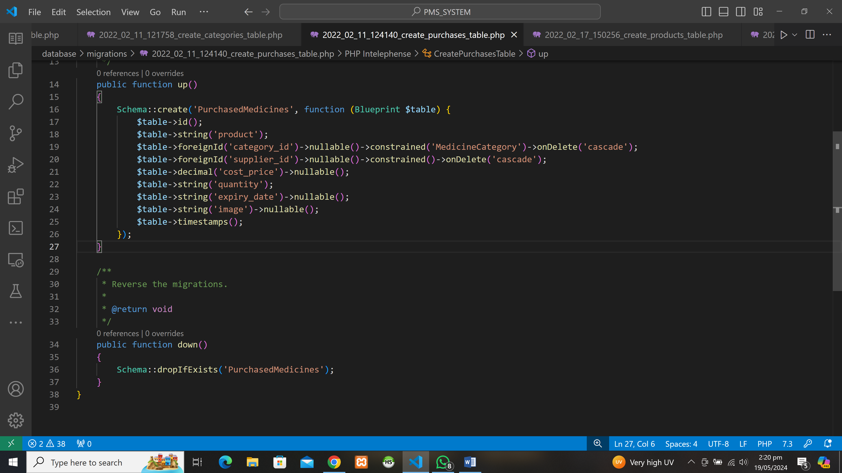

**Medicine Table**

PHP Command

(php artisan make:migration create_Medicine_table)

Create Table Query

CREATE TABLE Medicines (

id BIGINT UNSIGNED AUTO_INCREMENT PRIMARY KEY,

purchase_id BIGINT UNSIGNED NULL,

price DECIMAL(8, 2) NOT NULL,

discount DECIMAL(8, 2) DEFAULT 0,

description TEXT NULL,

deleted_at TIMESTAMP NULL,

created_at TIMESTAMP NULL,

updated_at TIMESTAMP NULL,

FOREIGN KEY (purchase_id) REFERENCES PurchasedMedicines(id) ON DELETE CASCADE

);

Drop Table Query

DROP TABLE IF EXISTS Medicines;

ScreeShot PHP File

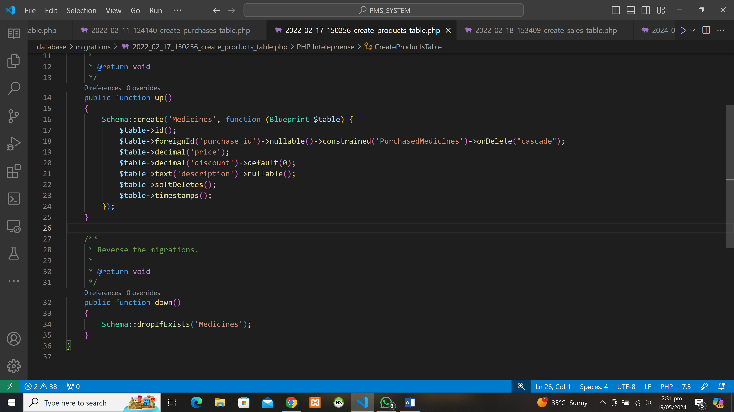

**Suppliers Table**

PHP Command

(php artisan make:migration create_Suppliers_table)

Create Table Query

CREATE TABLE suppliers (

id BIGINT UNSIGNED AUTO_INCREMENT PRIMARY KEY,

name VARCHAR(255) NOT NULL,

email VARCHAR(255) NULL,

phone VARCHAR(255) NULL,

company VARCHAR(255) NULL,

address VARCHAR(255) NULL,

product VARCHAR(255) NULL,

comment TEXT NULL,

created_at TIMESTAMP NULL,

updated_at TIMESTAMP NULL

);

Drop Table Query

DROP TABLE IF EXISTS suppliers;

ScreenShot PHP File

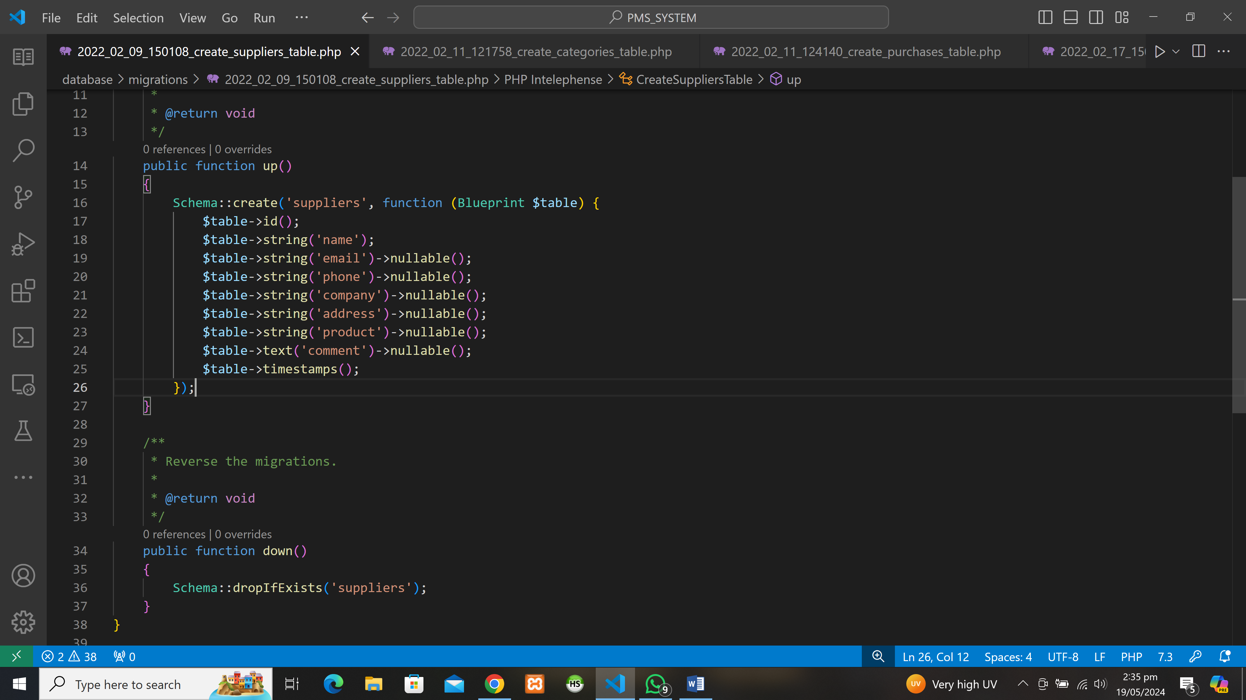

**MedicineCategory Table**

PHP Command

(php artisan make:migration create_MedicineCategory_table)

Create Table Query

CREATE TABLE MedicineCategory (

id BIGINT UNSIGNED AUTO_INCREMENT PRIMARY KEY,

name VARCHAR(255) NOT NULL,

created_at TIMESTAMP NULL,

updated_at TIMESTAMP NULL

);

Drop Table Query

DROP TABLE IF EXISTS MedicineCategory;

ScreenShot PHP File

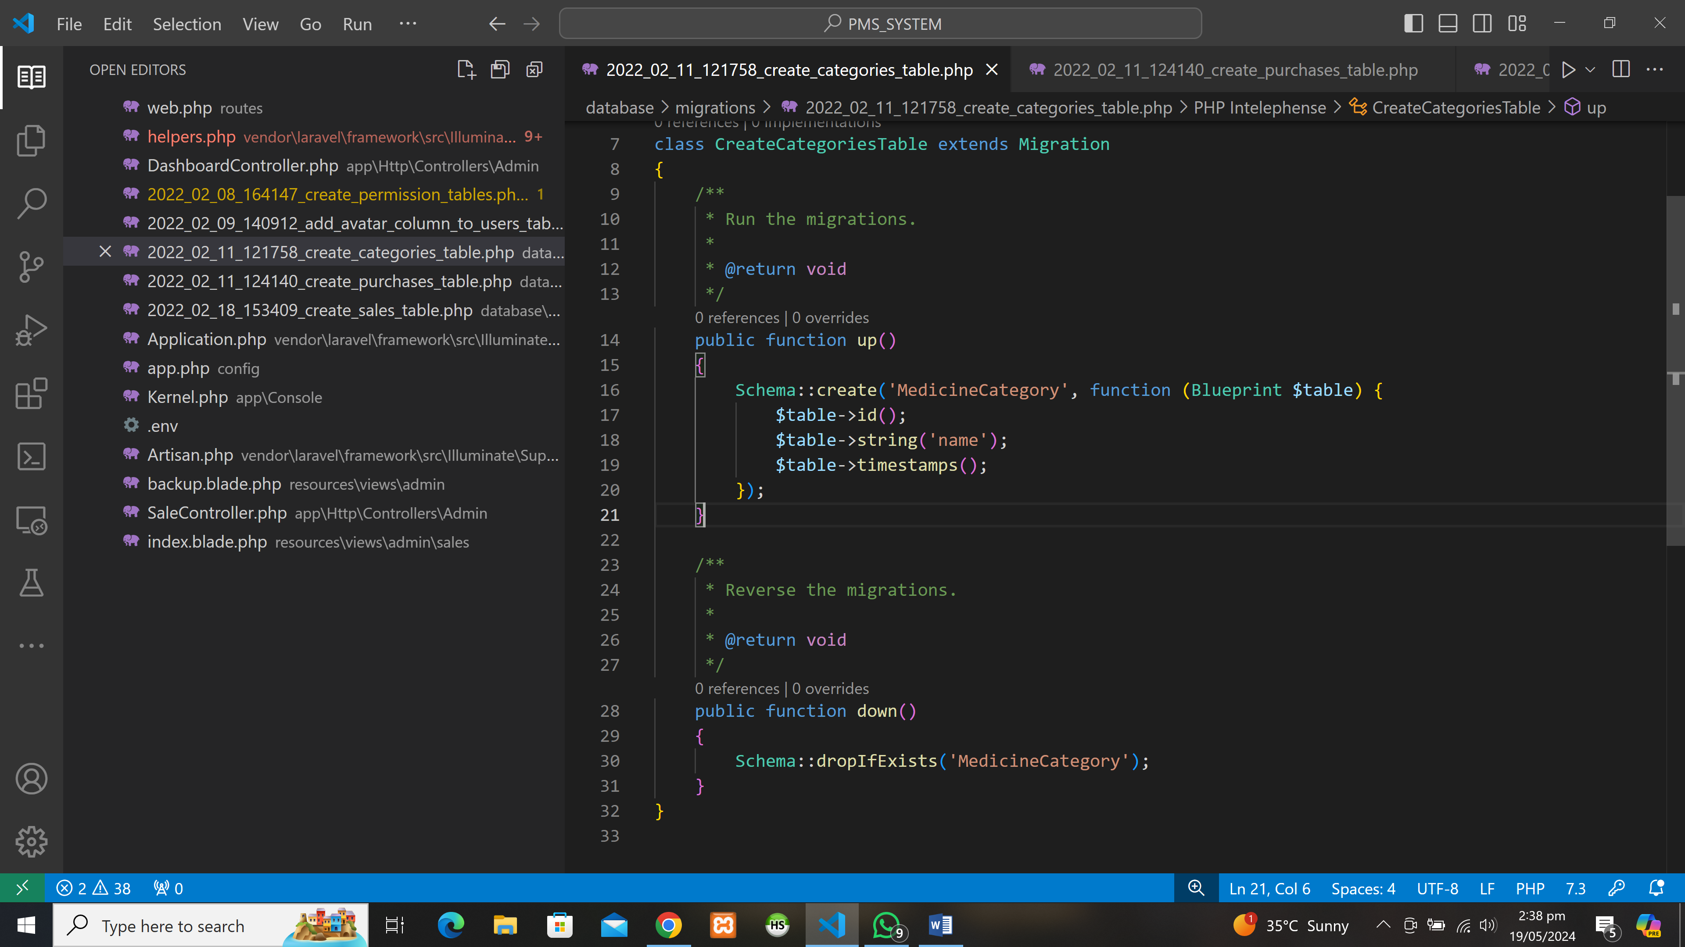

**Sales Table**

Create Table Query

CREATE TABLE sales (

id BIGINT UNSIGNED AUTO_INCREMENT PRIMARY KEY,

details LONGTEXT NOT NULL,

total_price DECIMAL(8, 2) NOT NULL,

deleted_at TIMESTAMP NULL,

created_at TIMESTAMP NULL,

updated_at TIMESTAMP NULL

);

Drop Table Query

DROP TABLE IF EXISTS sales;

ScreenShot PHP File

