[Unit Converter 2.0]

Table of Contents

Disclaimer……………………………………………………………...03

License………………………………………………………………....04

About Company………………………………………………………05

Architecture and Design………………………………………….06

System Behavior……………………………………………………..07

Logical View…………………………………………………………..08

Process View………………………………………………………….08

Physical View………………………………………………………...09

User Guide……………………………………………………………..10

Contribution……………………………………………………………11

Reference……………………………………………………………….11

Version: <1.0>
Modifier: <Stevenharradine>
Date: Sep 6,2015
Description of Change: <Original Product was Developed>
______________________________________________________
Version: <2.0>
Modifier: <Asad, Mubashar And Bilal>
Date: May 27, 2016
Description of Change: <New Conversion Units were added>

Disclaimer By Author
Copyright (c) 2015, Steven Harradine <>
Permission to use, copy, modify, and/or distribute this software for any
purpose with or without fee is hereby granted, provided that the above
copyright notice and this permission notice appear in all copies.
THE SOFTWARE IS PROVIDED "AS IS" AND THE AUTHOR DISCLAIMS ALL WARRANTIES
WITH REGARD TO THIS SOFTWARE INCLUDING ALL IMPLIED WARRANTIES OF
MERCHANTABILITY AND FITNESS. IN NO EVENT SHALL THE AUTHOR BE LIABLE FOR
ANY SPECIAL, DIRECT, INDIRECT, OR CONSEQUENTIAL DAMAGES OR ANY DAMAGES
WHATSOEVER RESULTING FROM LOSS OF USE, DATA OR PROFITS, WHETHER IN AN
ACTION OF CONTRACT, NEGLIGENCE OR OTHER TORTIOUS ACTION, ARISING OUT OF
OR IN CONNECTION WITH THE USE OR PERFORMANCE OF THIS SOFTWARE.

License:

The MIT License (MIT)
Copyright (c) 2016, Asadullah, Bilal Ramzan, Mubashar Ahmad
Permission is hereby granted, free of charge, to any person obtaining a copy of this software and associated documentation files (the "Software"), to deal in the Software without restriction, including without limitation the rights to use, copy, modify, merge, publish, distribute, sublicense, and/or sell copies of the Software, and to permit persons to whom the Software is furnished to do so, subject to the following conditions:
The above copyright notice and this permission notice shall be included in all copies or substantial portions of the Software.
THE SOFTWARE IS PROVIDED "AS IS", WITHOUT WARRANTY OF ANY KIND, EXPRESS OR IMPLIED, INCLUDING BUT NOT LIMITED TO THE WARRANTIES OF MERCHANTABILITY, FITNESS FOR A PARTICULAR PURPOSE AND NONINFRINGEMENT. IN NO EVENT SHALL THE AUTHORS OR COPYRIGHT HOLDERS BE LIABLE FOR ANY CLAIM, DAMAGES OR OTHER LIABILITY, WHETHER IN AN ACTION OF CONTRACT, TORT OR OTHERWISE, ARISING FROM, OUT OF OR IN CONNECTION WITH THE SOFTWARE OR THE USE OR OTHER DEALINGS IN THE SOFTWARE.

Company Goals:
Open Core / Split Open Source Development:
Open core is a business model for the monetization of commercially-produced open source software. The open core model primarily involves offering a "core" or feature-limited version of a software product as free and open-source software, while offering "commercial" versions or add-ons as proprietary software.
This Business Model allows users to edit code according to desire and they can also sell or distribute the modified version but they will also have to provide the source code along with the add-ons. This way our contribution to this society that is our software will remain accessible to all but at the same time people could generate revenue with it also.
Introduction

Architecture and Design
The program includes more than 33 units in 7 categories, including length, area, speed, mass, time, temperature, data transfer.

The program provides a solution for anyone whose activities require them to work with quantities measured in different units. The user-friendly, intuitive interface will enable even first-time users to rapidly perform all their necessary conversions.

Design Goals
There is no absolute measure for distinguishing between good and bad design. The value of a design depends on our priorities. For example, depending on the circumstances, an efficient design might be better than a maintainable one, or vise versa..

The design priorities for the Unit Converter 2.0 application are:
- The design minimizes complexity and development effort.
- The design allows other Programmers to modify this software easily.

System Behavior
This Software can be run on any computer which is compatible to run the Codeblocks, as codeblocks or any other compiler is essential for this software to work. This code takes mere few kilobyte of space in a computer.

Logical View
.

High-Level Design (Architecture)
The high-level view or architecture consists of 3 major components:

- Input.
- Formula to calculate the Conversion.
- Output.

Example:
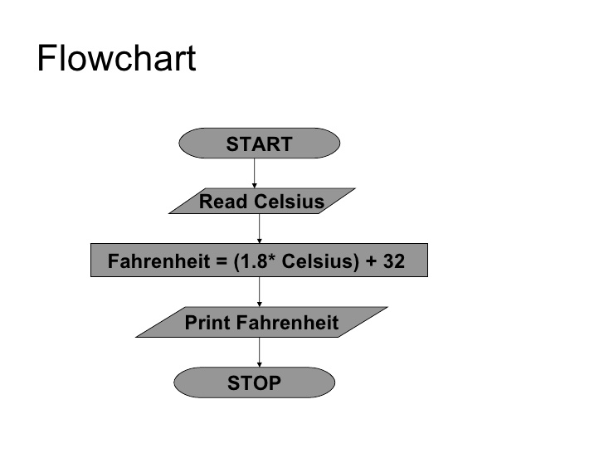

System Architecture
.>

Process View

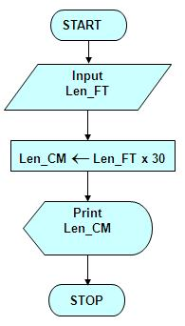
As shown above the user is asked to input his choice of conversion, in above example the user chooses to convert Feet into Centimeters. He inputs value in centimeters and then in the next step the formula applied converts the value in feet and in the next step the result is printed.

Physical View

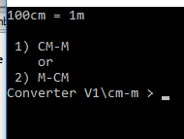

User Guide:
When the user runs the program he will see following main menu. Then he would have to choose the category of conversion.

Main Menu:

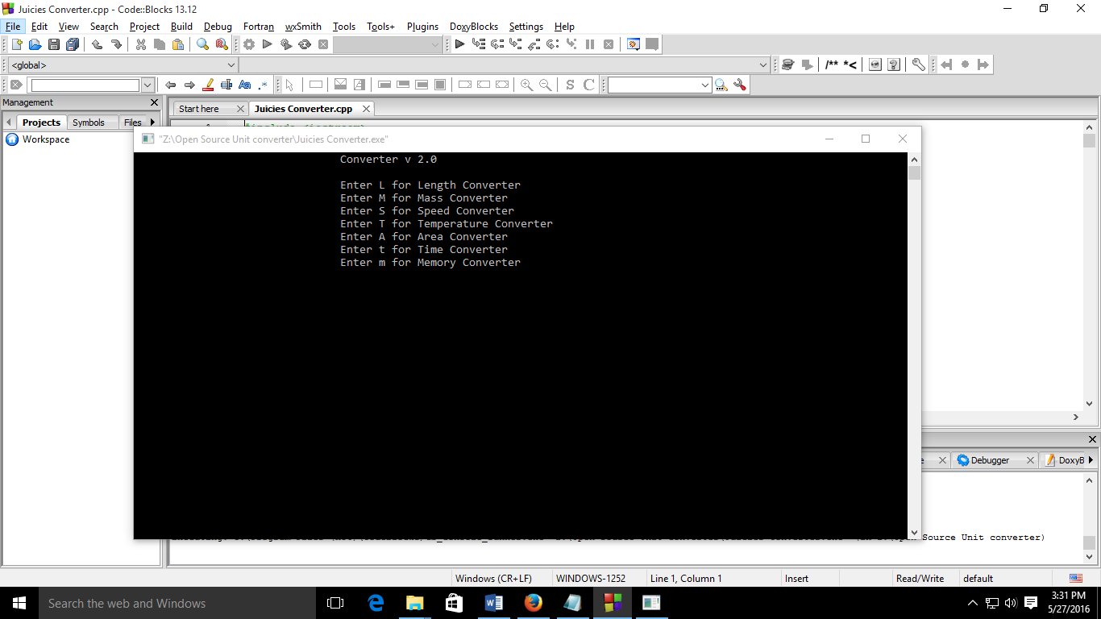

After Choosing he will be directed to the sub menu. Example is given below:

Sub_Menu:

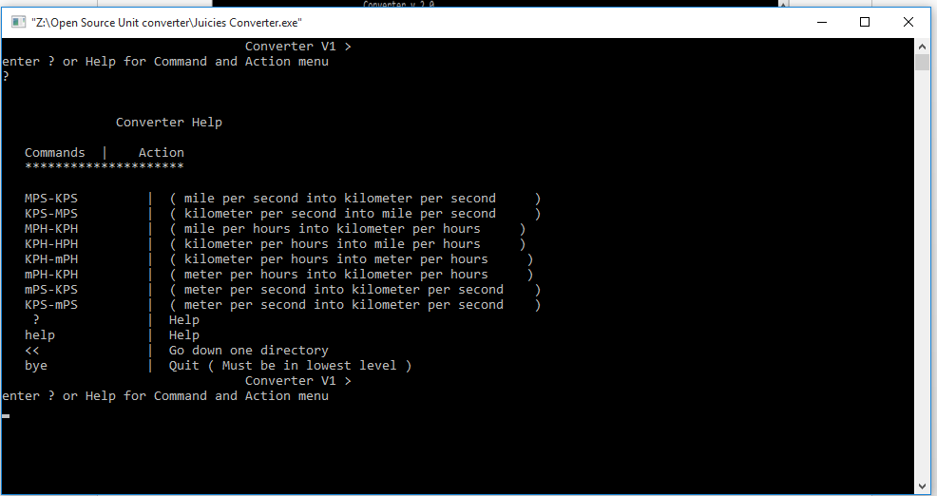

Contribution
Users can also contribute to our software by giving us feedback of our software and telling us the bugs and error in it so we can try our best to solve them.
You can contact us on:
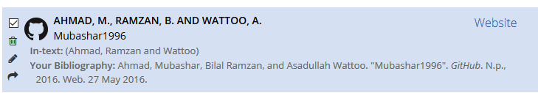

https://github.com/Mubashar1996

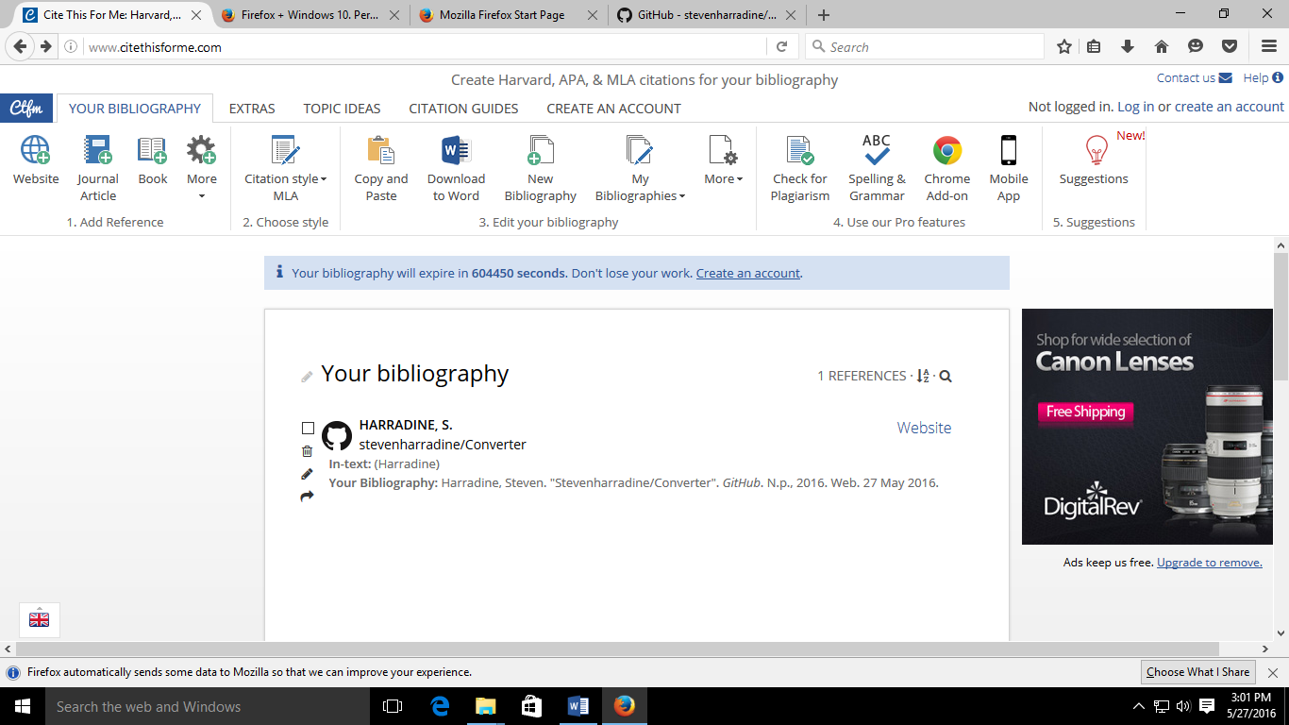

https://github.com/stevenharradine/Converter

+

