Muhammad Mubashir Islam – 23i-0834 Muhammad Qasim – 23i-0552 Zia-ul-Baqa – 23i-0606 CS-D
Software Engineering – Project, Deliverable # 3
Bug Report
Bug Id | BUG-001
Title | Invalid Values in Input Fields of Manage Users
Priority | High
Severity | Major
Status | Not Fixed
Evidence | 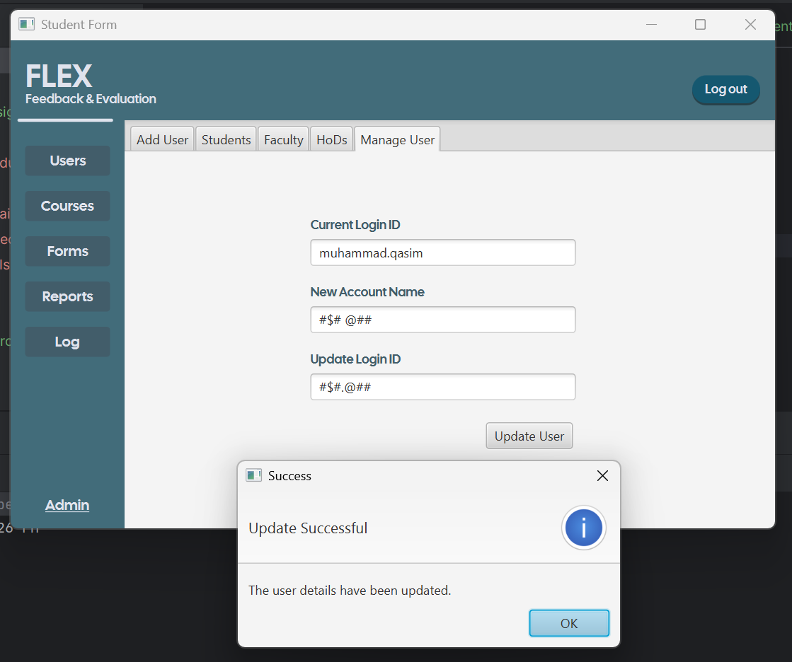

Bug Id | BUG-002
Title | Invalid Input Values in Add Course
Priority | High
Severity | Major
Status | Not Fixed
Evidence | 

Bug Id | BUG-003
Title | Invalid Input Values in Review Page
Priority | Critical
Severity | Major
Status | Not Fixed
Evidence | 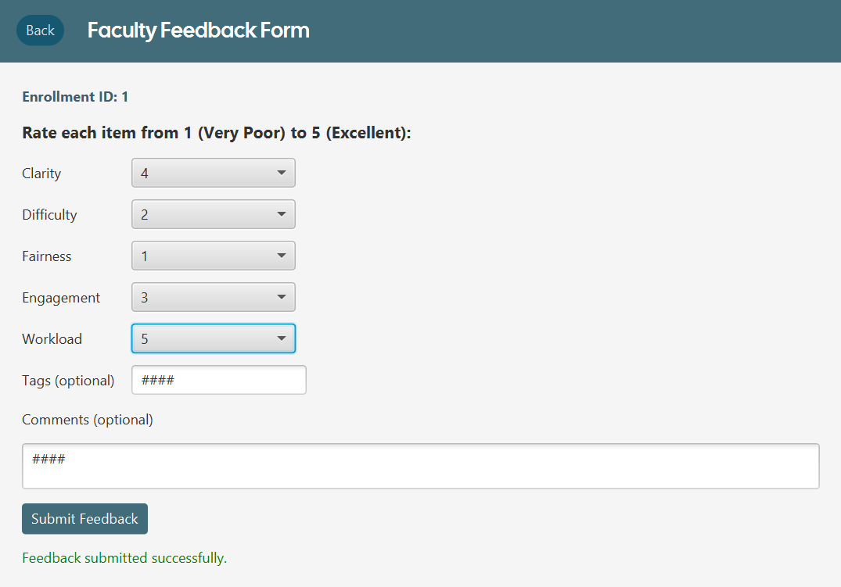

Bug Id | BUG-004
Title | Invalid Input Values Accepted in Add Form
Priority | Critical
Severity | Major
Status | Not Fixed
Evidence | 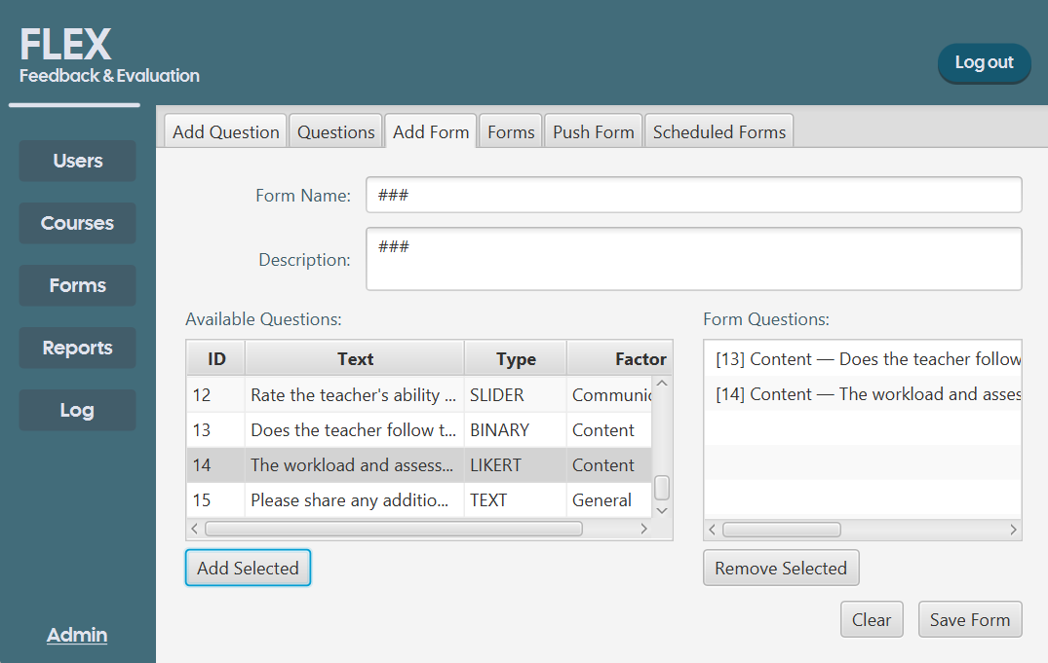

Bug Id | BUG-005
Title | Invalid Input Values Accepted in Feedback Form Text Boxes
Priority | Critical
Severity | Major
Status | Not Fixed
Evidence | 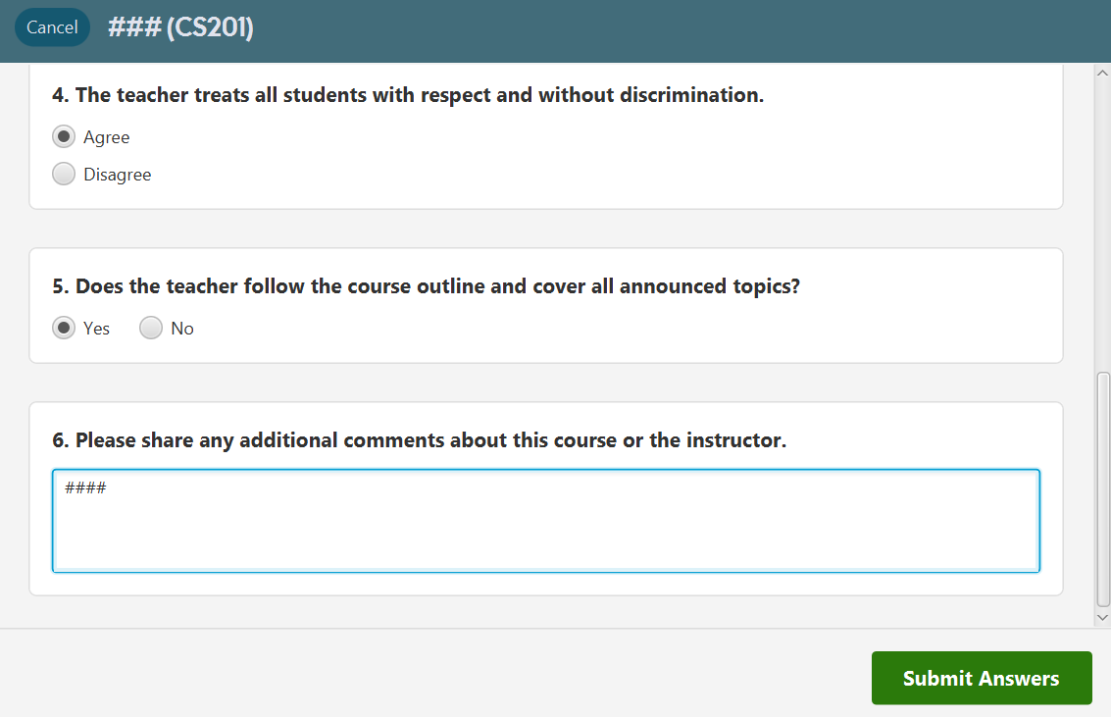

Bug Id | BUG-006
Title | Duplicate Submission of Feedback Forms
Priority | Critical
Severity | Major
Status | Fixed
Evidence

Bug Id | BUG-007
Title | Duplicate Options in Add Question (Likert Type)
Priority | Medium
Severity | Major
Status | Not Fixed
Evidence | 