Name : Muhammad Mubashir Shafique
CMS-ID: 023-24-0235
BSCS(05)
Section : G
Subject : Web Engineering Lab
Lab 04 CSS Layout

Class Activity D — Mobile-First Breakpoints:
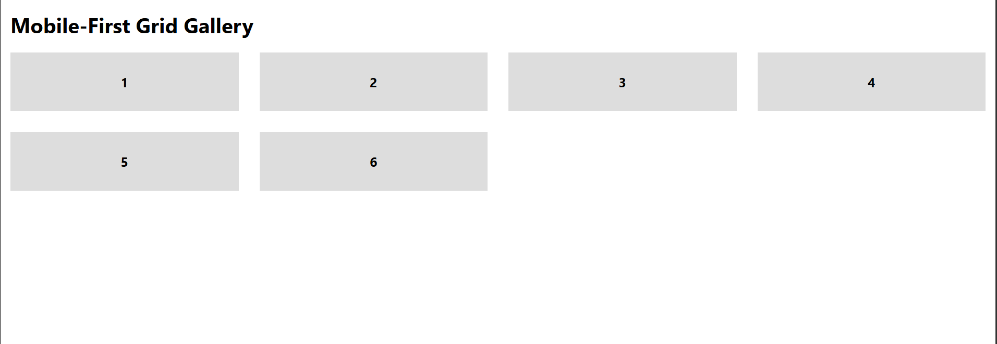

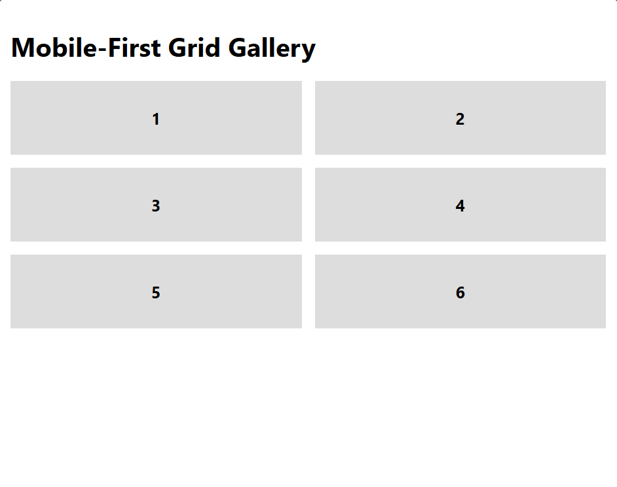

Class Activity E — Three Comparisons:
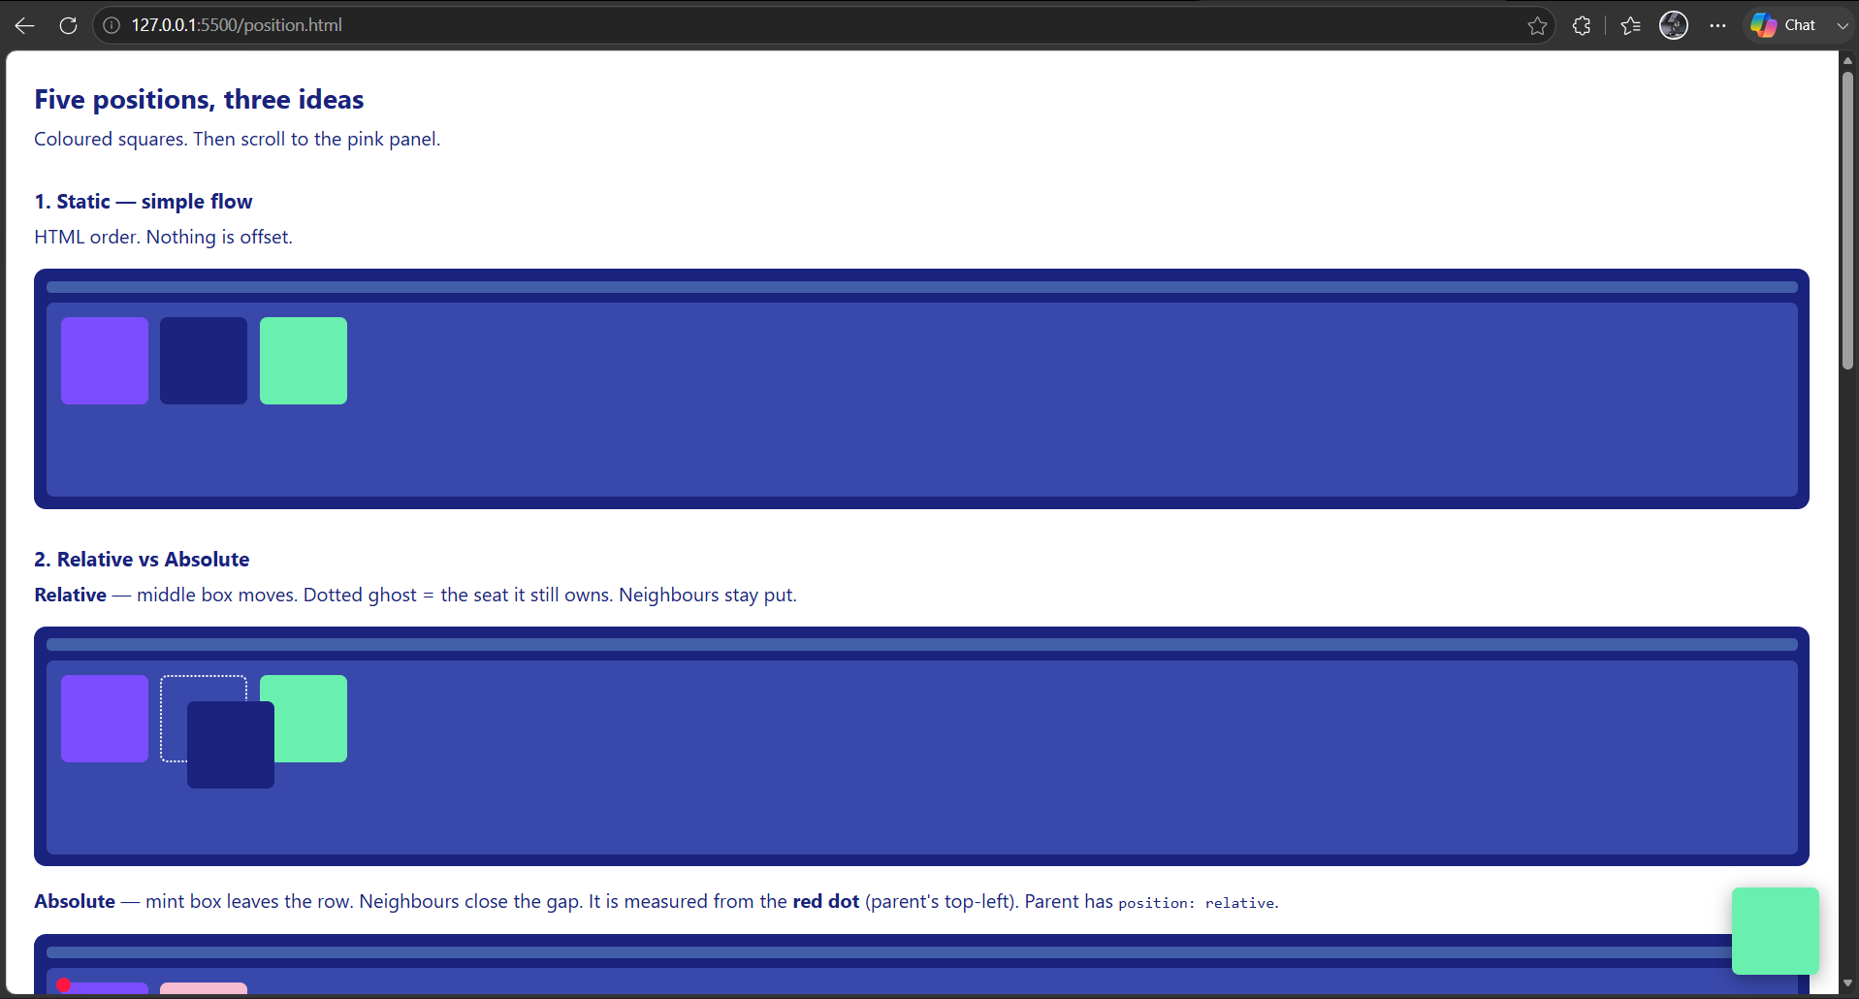

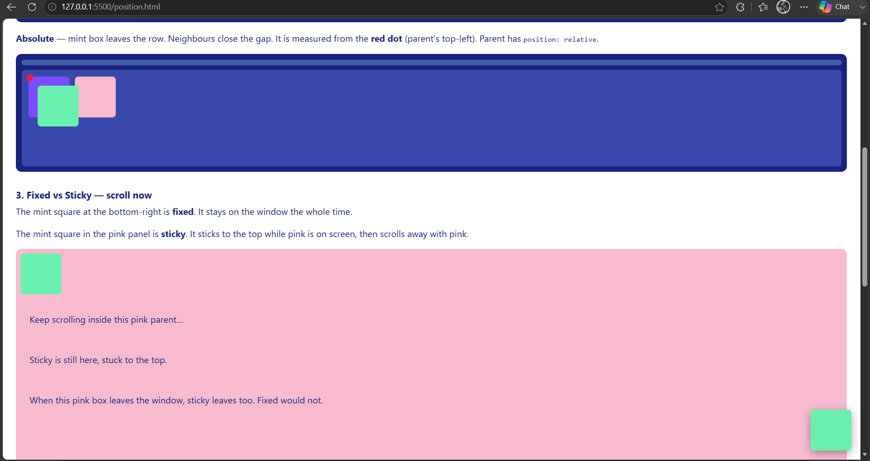

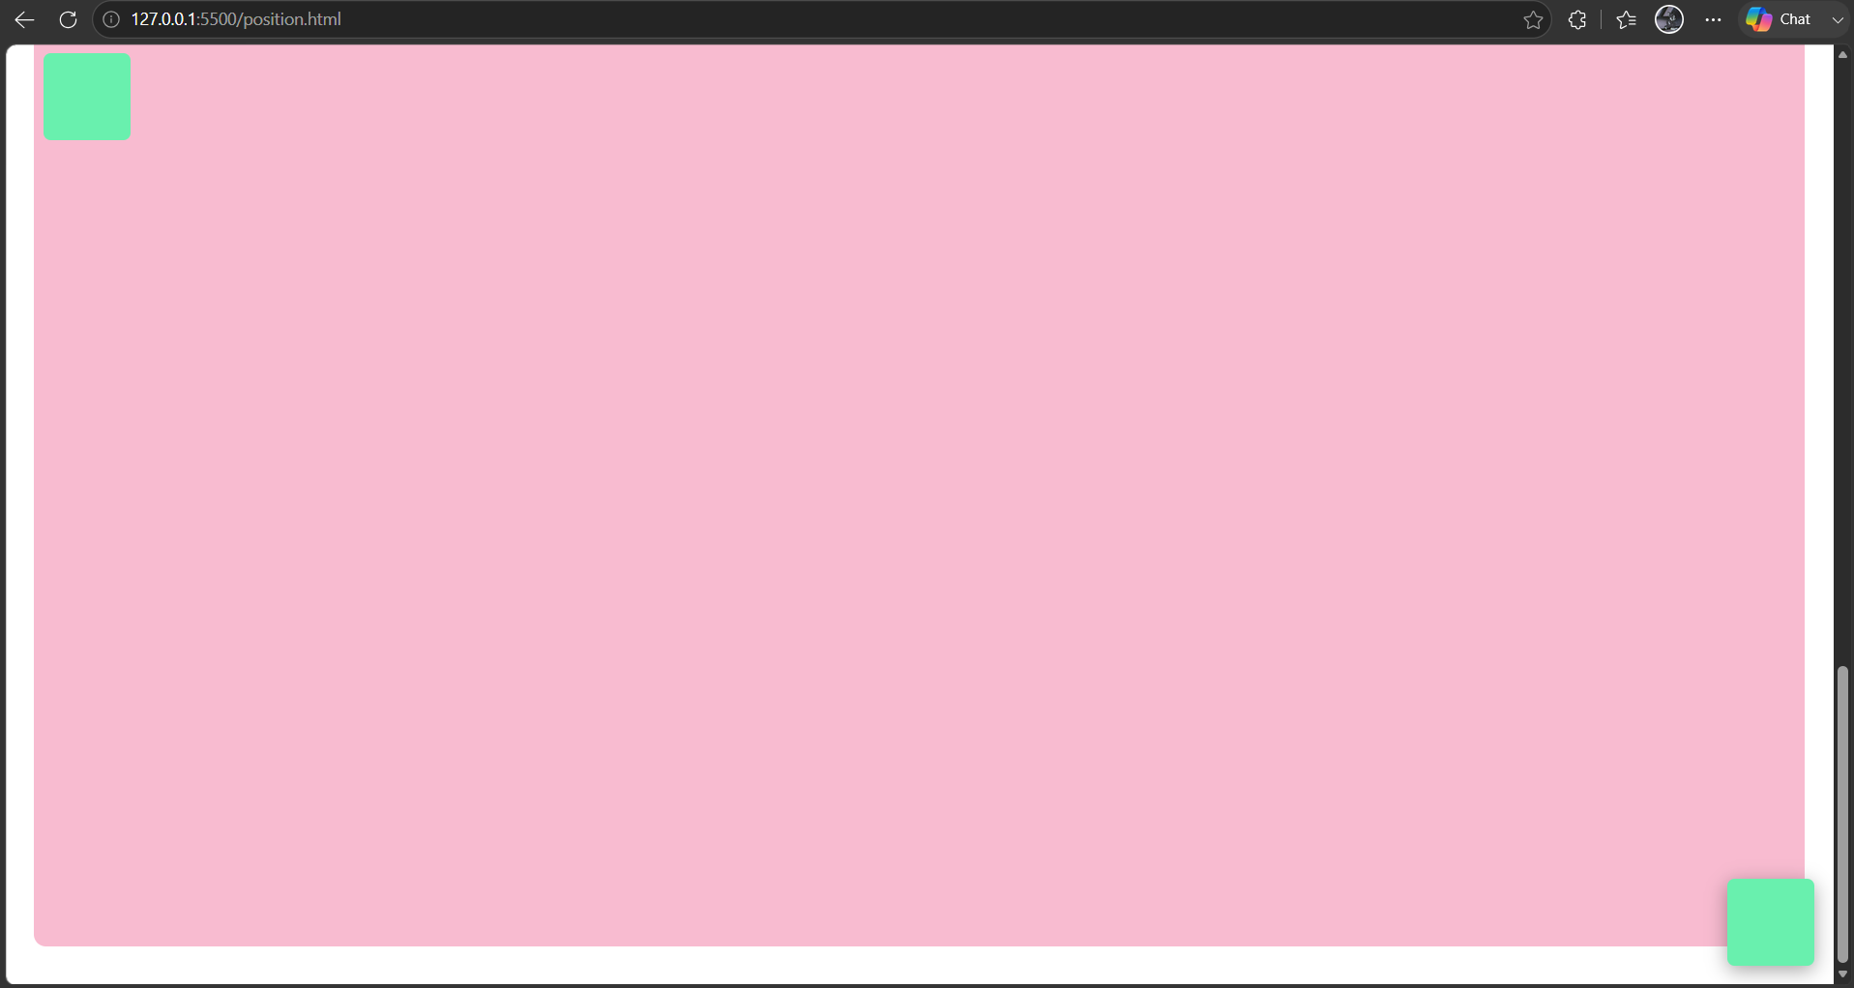

Homework Task 1 — Flexbox Froggy + Grid Garden:
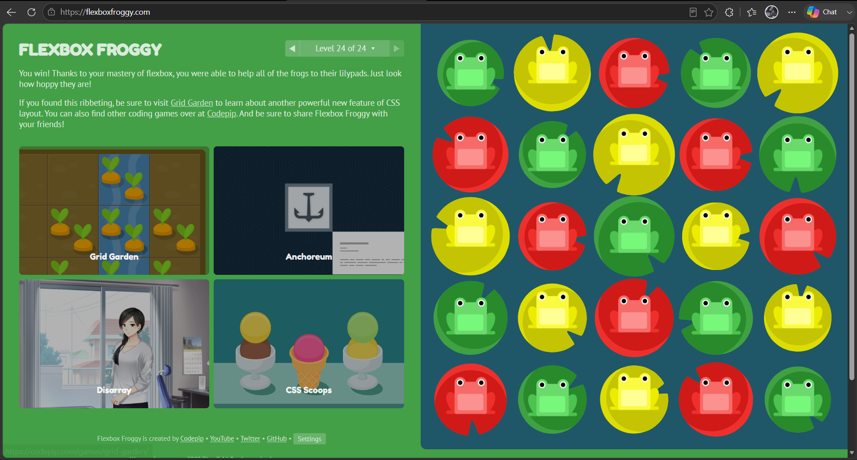

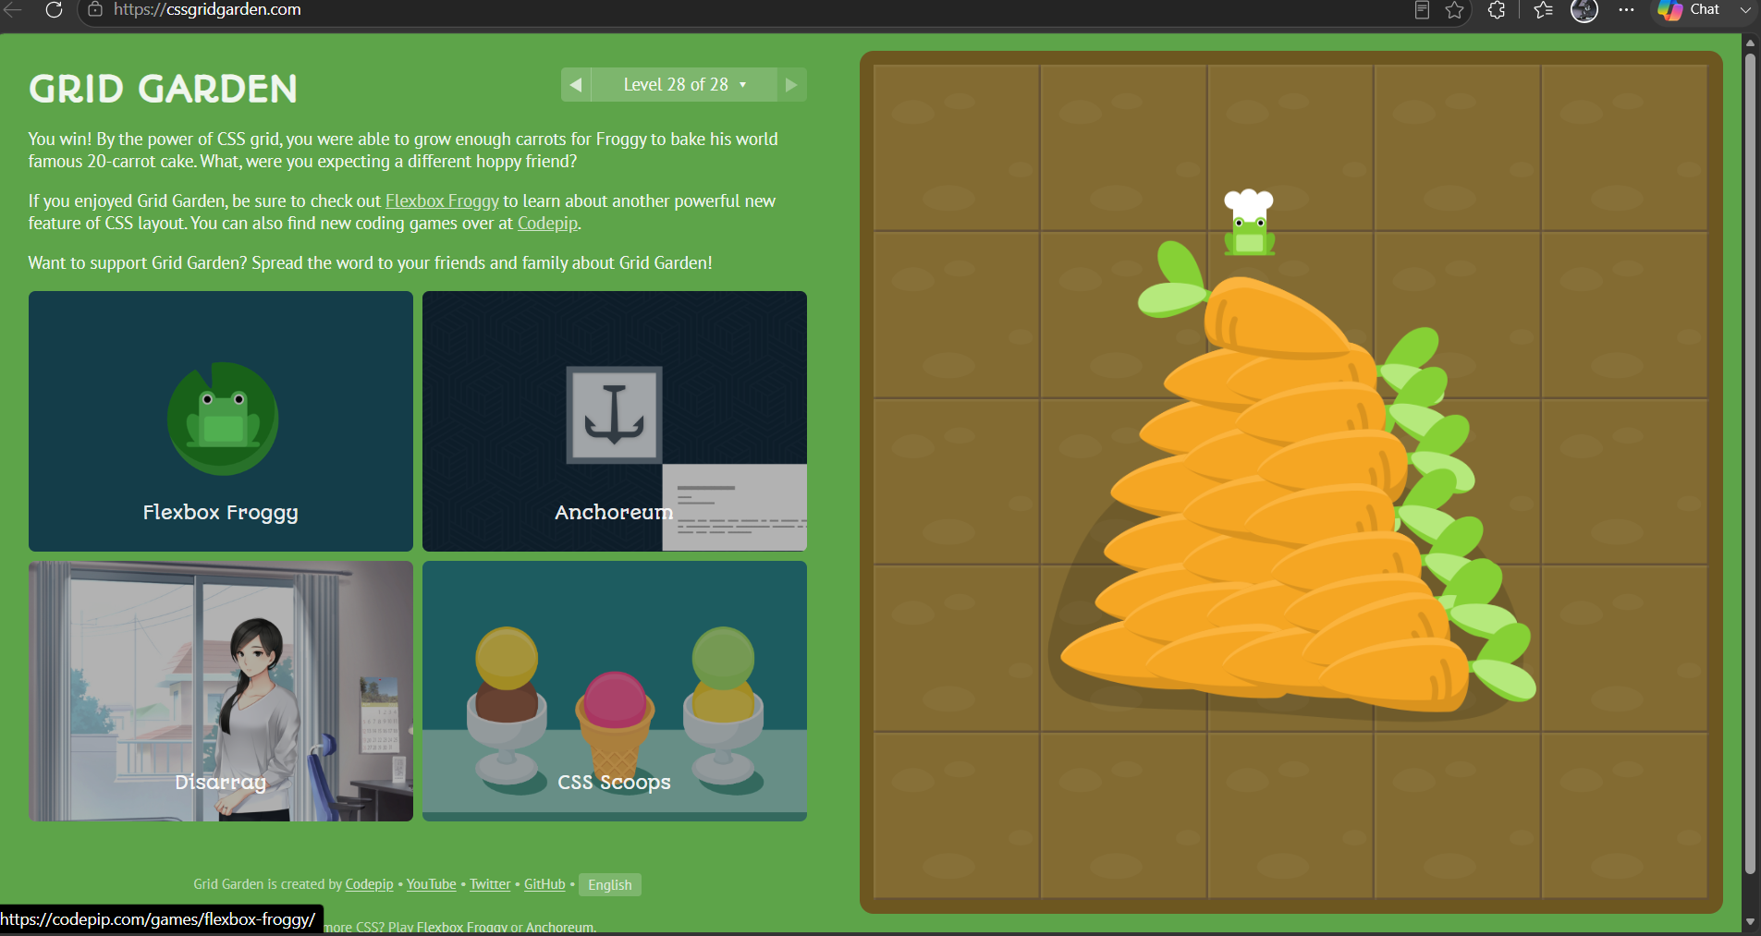

Homework Task 2 — Grey-Box Layout Clone:
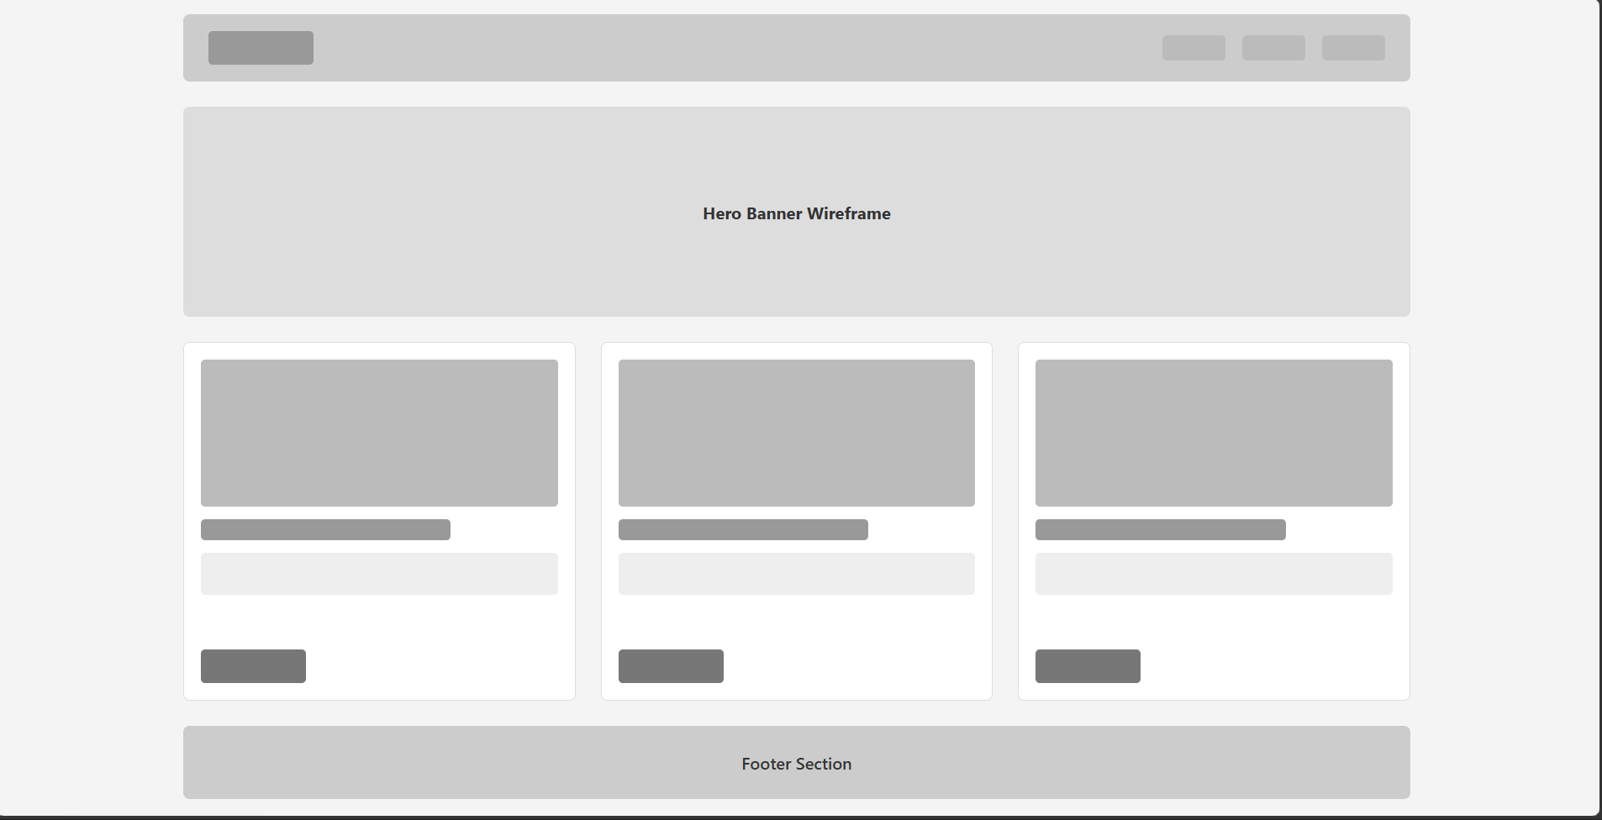

Homework Task 3 — Make the Profile Responsive :
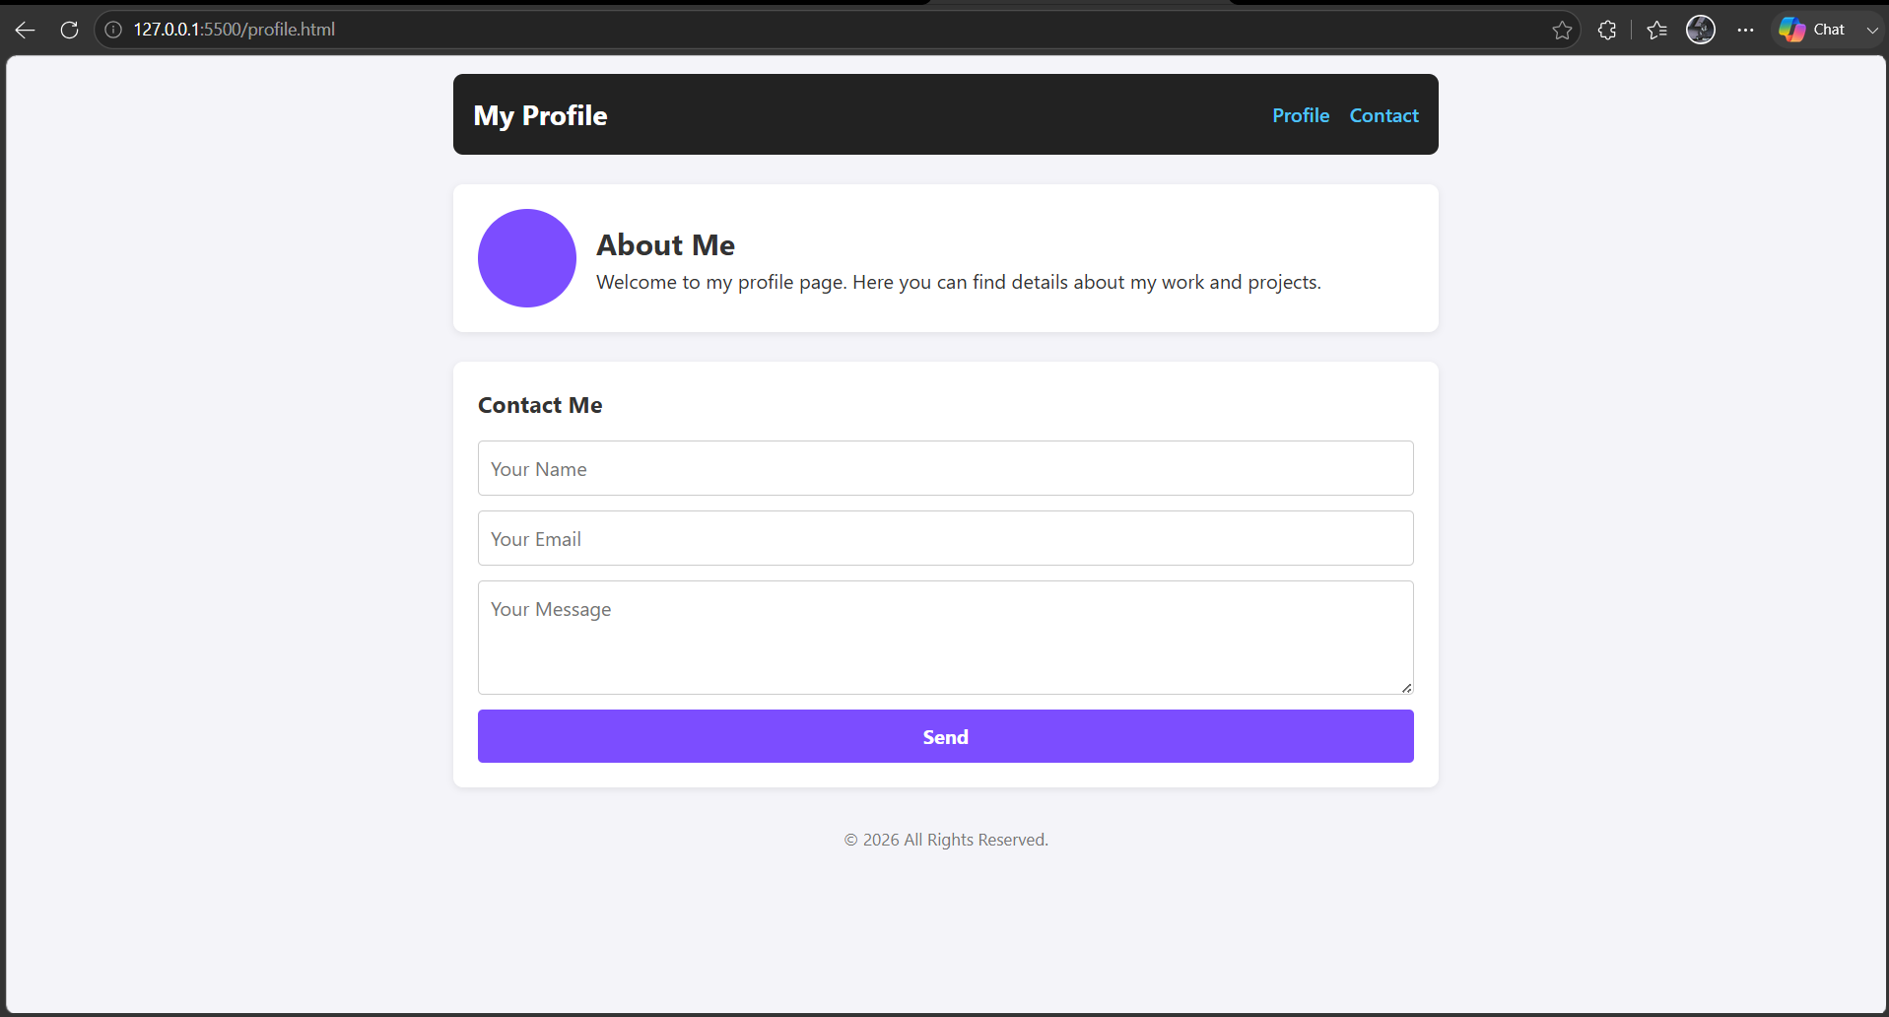

Homework Task 4 — Break and Fix (Annotated):
