Name : Muhammad Mubashir Shafique
CMS-ID:023-24-0235
BSCS(05)
Section : G
Course : Web Engineering Lab
Class activity
Warm-up (5 min)

- How many requests appeared?
Ans : 41 requests

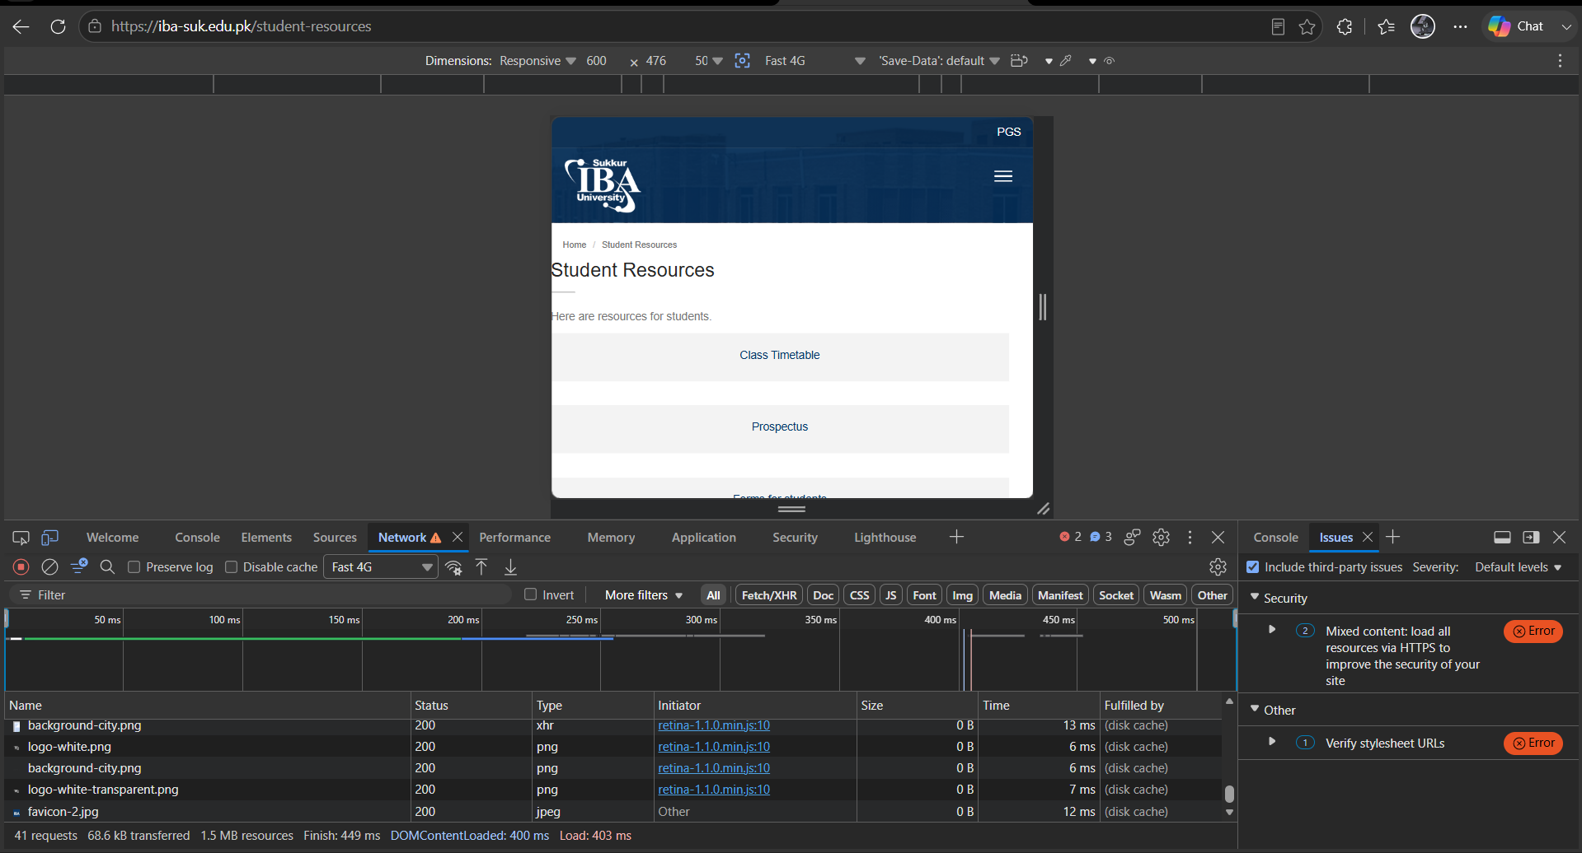

2. Can you find one that says 200?

Ans: YES

Class activity A
draw the client server diagram with pen and paper(5 min)
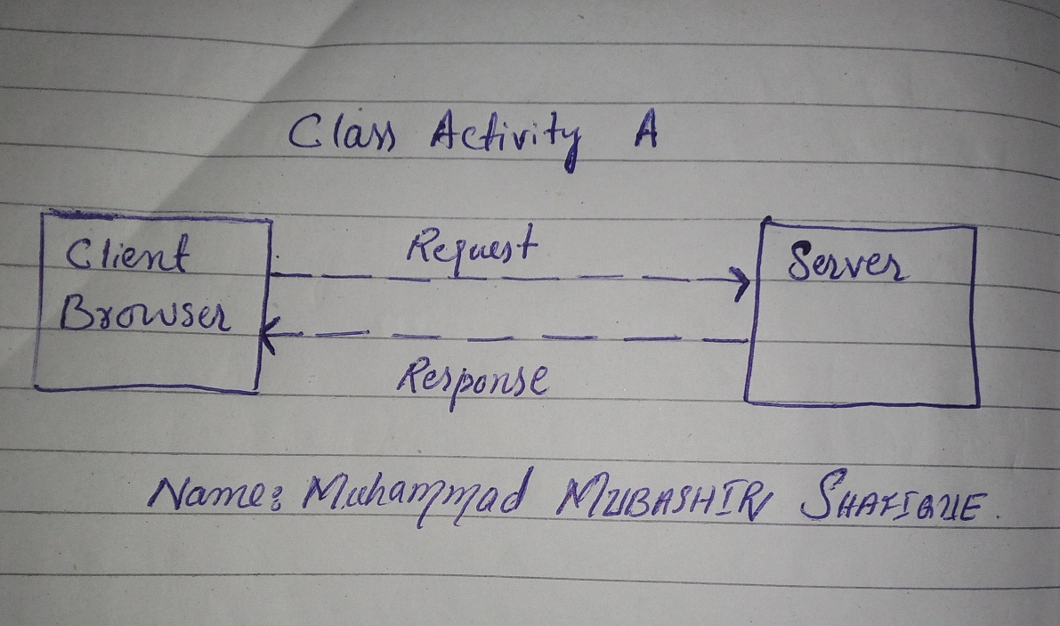

Class Activity B — URL Teardown

Complete URL Example:
https://www.daraz.pk:443/catalog/?q=laptop#reviews

URL Parts Breakdown:
• Protocol: https (Secure communication protocol)
• Host: www.daraz.pk (Domain / Website name)
• Port: 443 (Default port number for HTTPS)
• Path: /catalog/ (Path to the resource or folder on the server)
• Query: ?q=laptop (Search parameters or input data)
• Fragment: #reviews (Specific section or anchor on the page)

Search Change Observation:
• Changing the search from "laptop" to "mobile" (?q=mobile) modifies only the Query component of the URL.

Class Activity C — HTTP Status Code Activity

HTTP Status Code Families and Meanings:

• 2xx (Success) — 200 OK:
Meaning: The request has succeeded. The client has requested data, and the server successfully delivered the requested resource.

• 3xx (Redirection) — 301 Moved Permanently:
Meaning: The requested URL has been assigned a new permanent URI. The browser is automatically redirected to the new location.

• 4xx (Client Error) — 404 Not Found:
Meaning: The server cannot find the requested resource. This usually happens when a URL is mistyped or the page has been deleted.

• 5xx (Server Error) — 500 Internal Server Error:
Meaning: The server encountered an unexpected condition that prevented it from fulfilling the request due to a backend issue.

Screen Shots :
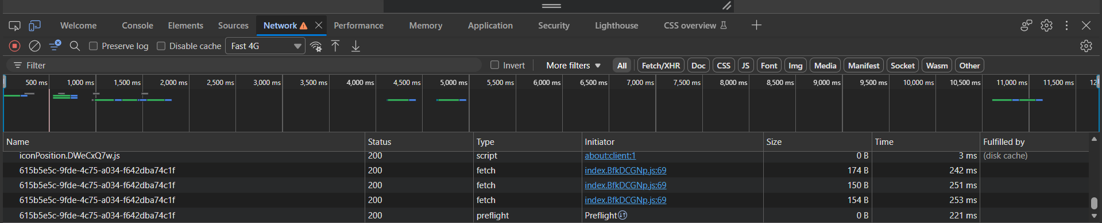

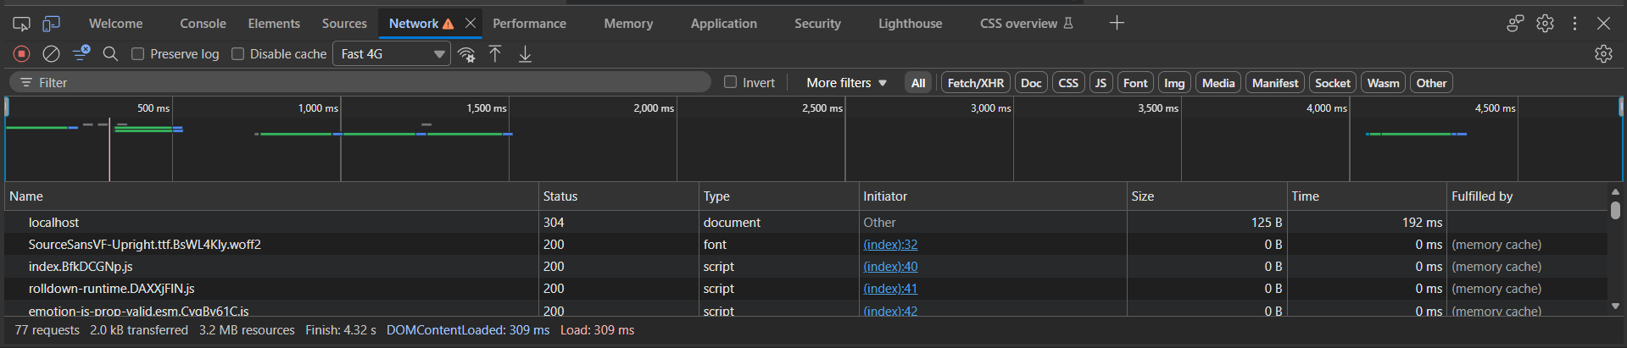

Class activity D — Tools Installation & Setup Activity

