Name: Muhammad Mubashir Shafique
CMS-ID:023-24-0235
BSCS(05)
Section : G
Web Engineering Lab

Task 1 — Prove the toolchain

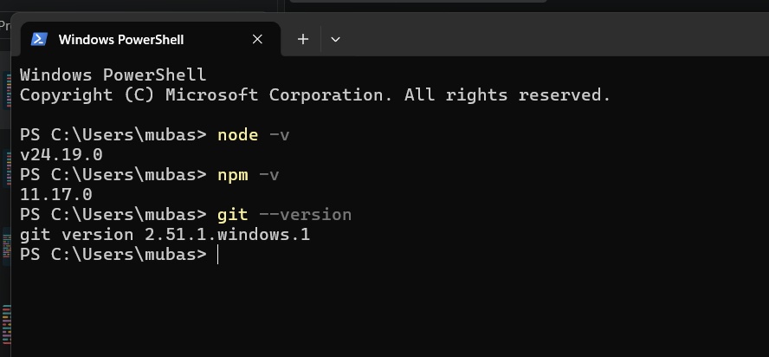

Task 2 — Network detective (hands-on)

- Website Tested:
https://iba-suk.edu.pk/student-resources

- How many requests did the page make?
Ans :
The page made 42 requests (totaling 1.5 MB of resources).
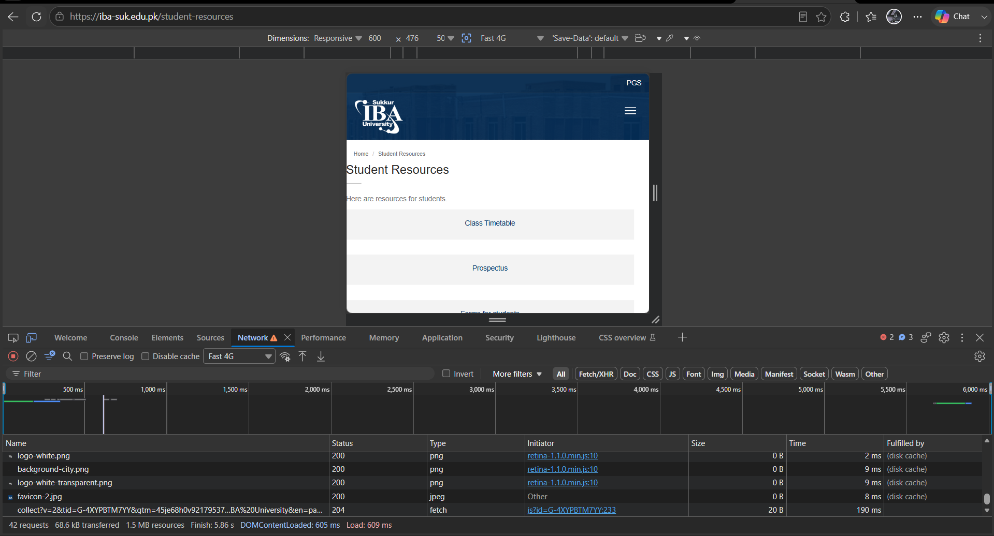

- What is the largest file, and what type is it?
Ans:
The largest transferred file is student-resources with a size of 68.6 kB, and its type is Document (HTML).
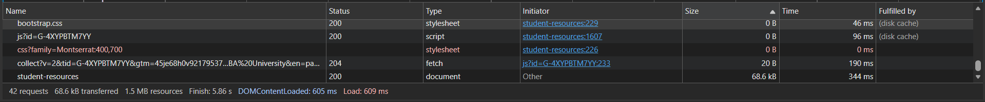

- Find one request that is not 200. What status is it, and what do you think happened?
Ans:
  - Request Name: collect?v=2&tid=G-4XYPBTM7YY...
  - Status Code: 204 (No Content)
  - Explanation: This is a Google Analytics tracking request. A 204 No Content status means the server successfully received and processed the tracking data, but it did not need to send any body content or page back in return.

