Name : Muhammad Mubashir Shafique
CMS-ID: 023-24-0235
BSCS(05)
Section : G
Subject : Web Engineering Lab

week-03-css-fundamentals

Warm-up (5 min):
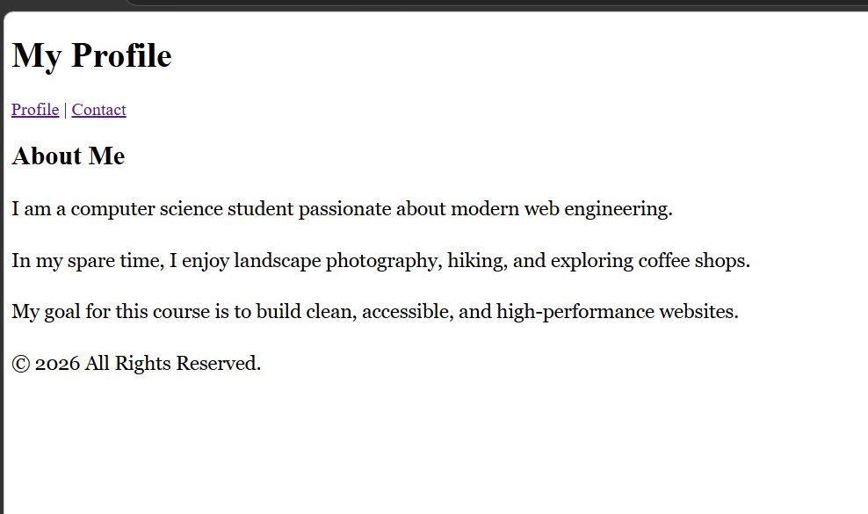

Explanation:
- The <link rel="stylesheet" href="styles.css" /> tag points directly to the external style sheet located in the same directory.
- The element selector p targets every <p> element across the document, applying Georgia font with a fallback to serif, setting font size to 1.125rem (18px default equivalent), and expanding line height to 1.6 for optimal readability.

Class Activity A — External Stylesheet Only (5 min):
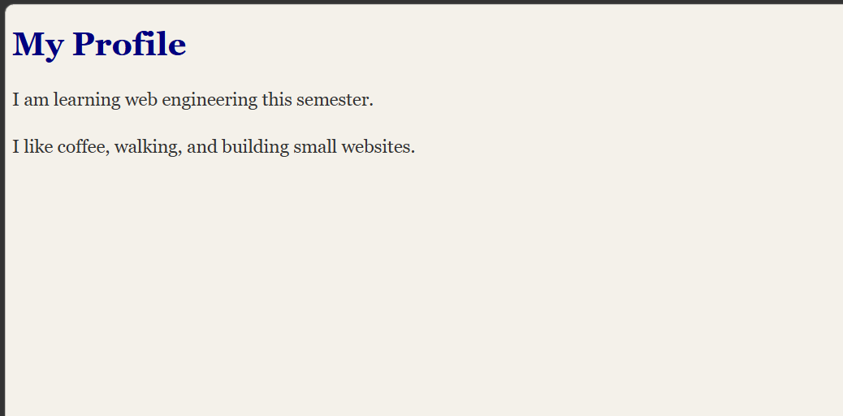

Explanation
- Separation of concerns: visual presentation is completely decoupled from markup structure.
- Removing style="" eliminates tight coupling, avoids bloated HTML, and enables site-wide reusability from a single CSS file.

Class Activity B — See the Four Layers (10 min):
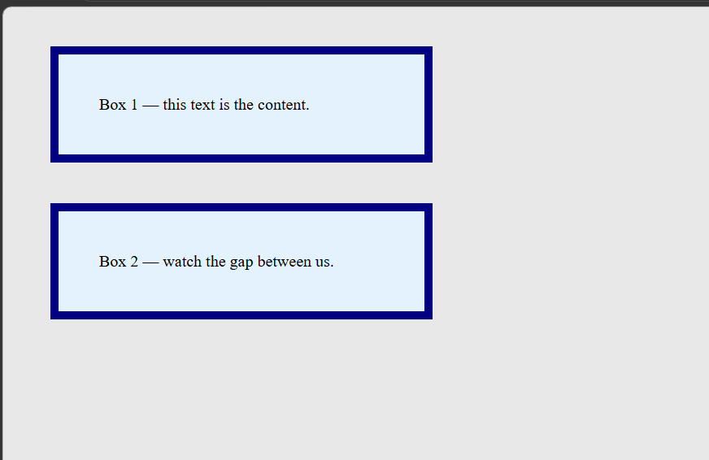

Explanation
- Content: The actual text string inside .box, restricted to a width of 280px.
- Padding (40px): Internal breathing room between the content text and the outer border; retains the blue card background (#e3f2fd).
- Border (8px solid navy): The structural visual boundary wrapping around the padded area.
- Margin (40px): External space pushing neighboring elements away; exposes the underlying grey page canvas (#e8e8e8). Vertical margins between adjacent block elements collapse into the maximum single margin value (40px, not 80px).

Class Activity C — Selector Scavenger Hunt (15 min):
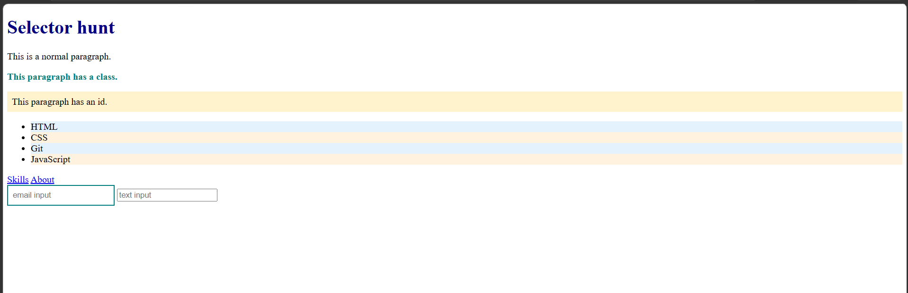

Class ACTIVITY C
1. Tag (h1)
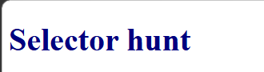

Explanation: Targets only the <h1> element, setting color to navy and font size to 2rem. Unmatched heading or body elements remain unchanged.

2. Class (.note)


Explanation: Targets elements with class="note". Only the second paragraph turns bold teal; the default and ID paragraphs are unaffected.
3. ID (#alert)
Explanation: Targets the unique element carrying id="alert". Applies a light-yellow warning background (#fff3cd) with 8px internal padding.
4. Attribute (input[type="email"])
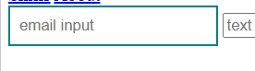
Explanation: Targets only <input> elements whose type attribute strictly equals "email". Leaves standard type="text" fields unstyled.
5. Hover (a:hover)

Explanation: Triggers dynamically when a user hovers over an anchor element, changing link color to crimson and adding an underline.
6. Odd (li:nth-child(odd))
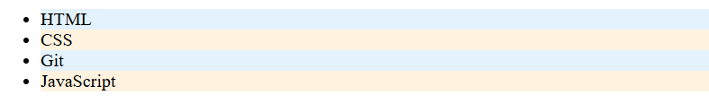Explanation: Targets the 1st (HTML) and 3rd (Git) sibling <li> items, styling their background with light blue (#e3f2fd).
7. Even (li:nth-child(even))
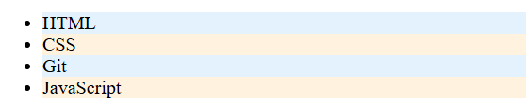
Explanation: Targets the 2nd (CSS) and 4th (JavaScript) sibling <li> items, styling their background with light orange (#fff3e0).

Class activity D:

Screenshot #1: All 4 rules active
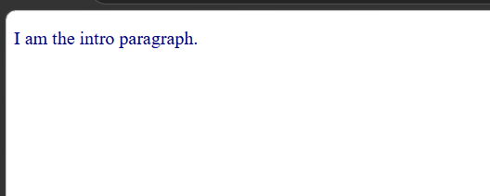

Screenshot #2: Comment out #main p
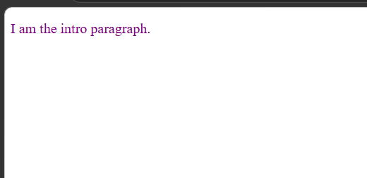

Screenshot #3: Comment out p.intro
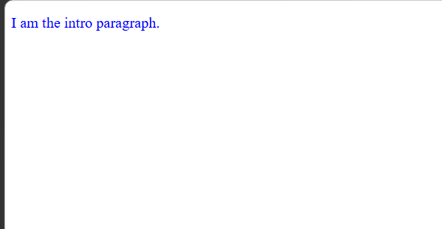

Screenshot #4: Source order test (equal specificity)
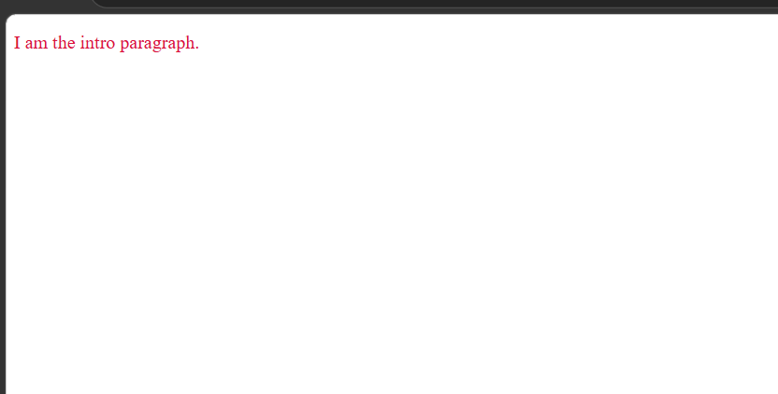

Screenshot #5: Inline style test
