**Task 01**

i)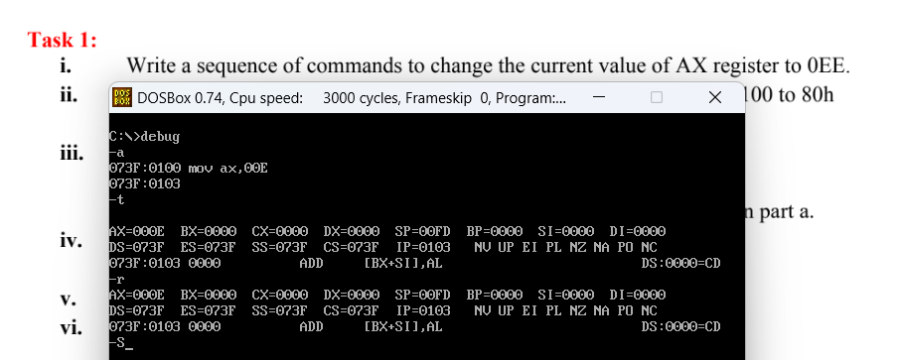ii)

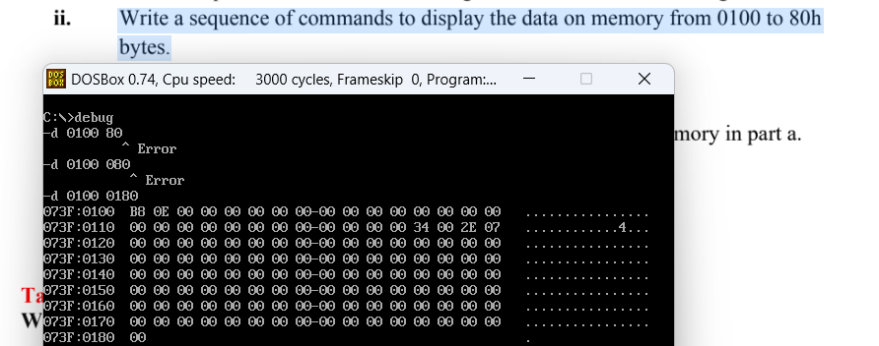

iii)

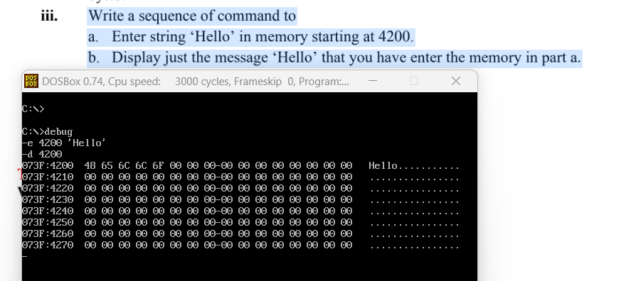

iv) This command will disassemble and display the assembly instructions from the memory location CS:0100 to CS:01DF. 1E0 is the ending offset plus one within the code segment where disassembly ends.

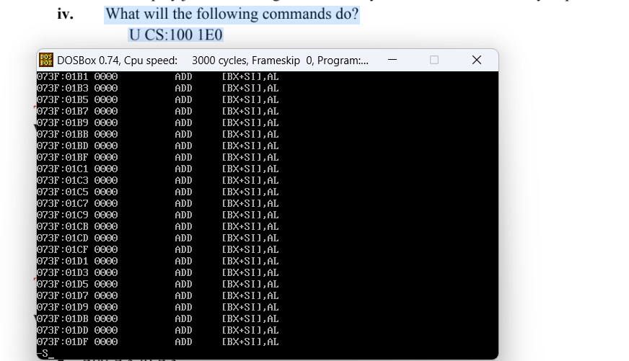

**TASK 02**

1. Must do trace “t” after command

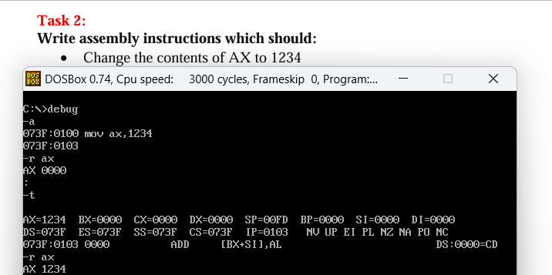

1. Enter a again for commands

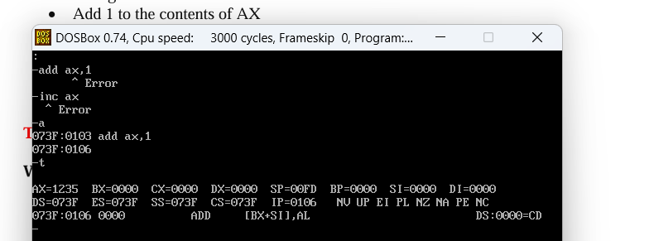

iii)“mov dx,ax” is the command

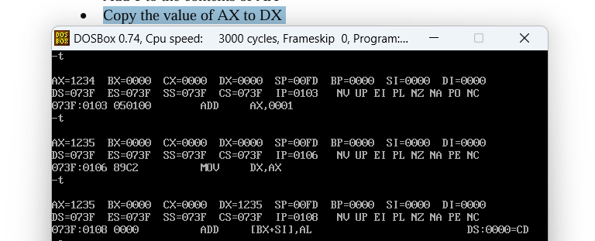

iv)

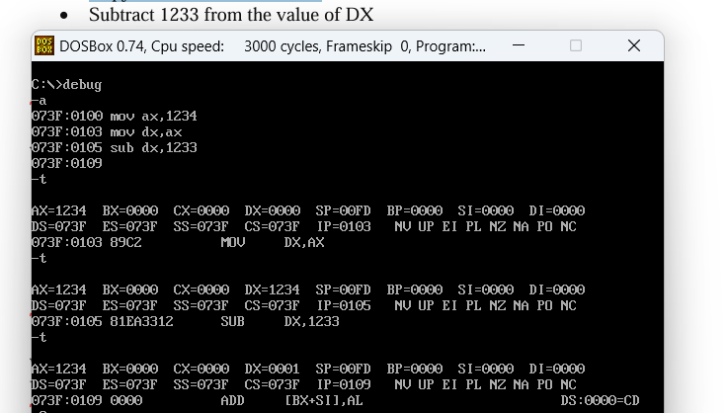

v/vi) a mistake it should be “mov bh,dl”

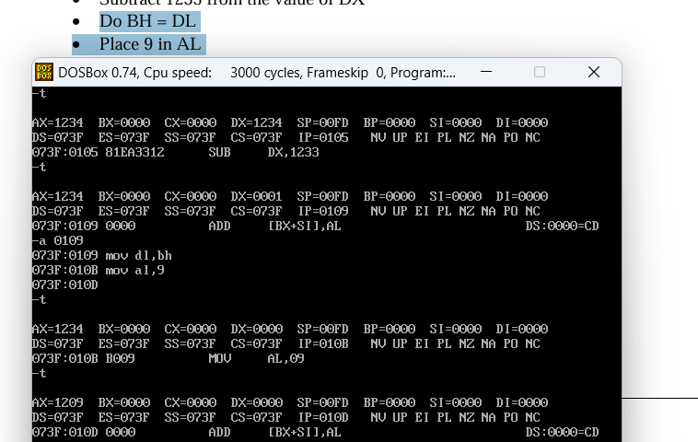

**TASK 03**

**All)**

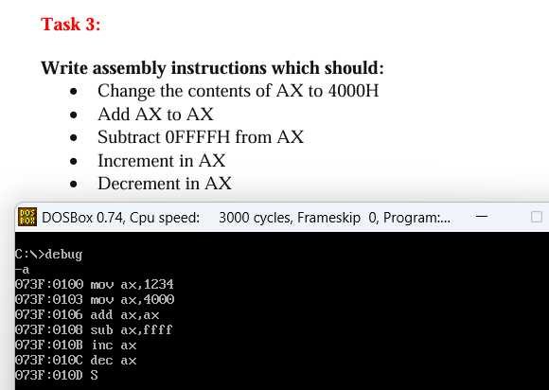

Traced program:

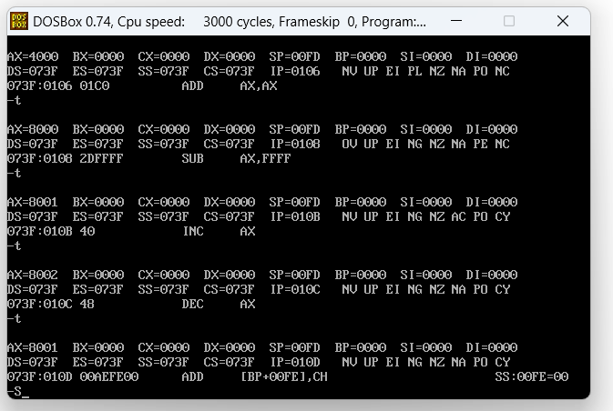

**TASK 4**

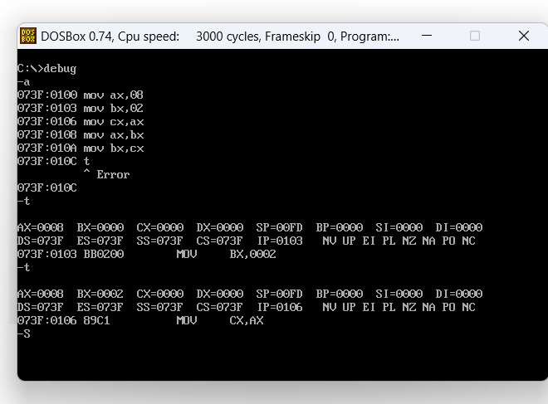

**Cont.**

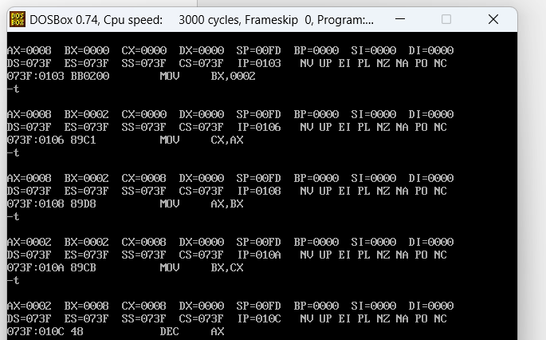

**TASK 05**

**i)**

**ZF** NZ (reset)

**SF** NG(set)

**CF** NC(reset)

**OF** NV(Reset)

**ii)**

**ZF** ZR (set)

**SF** PL (reset)

**CF** NC(reset)

**OF** NV(Reset)

**iii)**

**ZF** ZR (set)

**SF** PL (reset)

**CF** NC(reset)

**OF** NV(Reset)

**iv)**

**ZF** NZ (reset)

**SF** NG (set)

**CF** CY(set)

**OF** NV(Reset)

Additional practical:

ax has 1234 changing al,00 will replace ax with 1200

