**Puma.com**

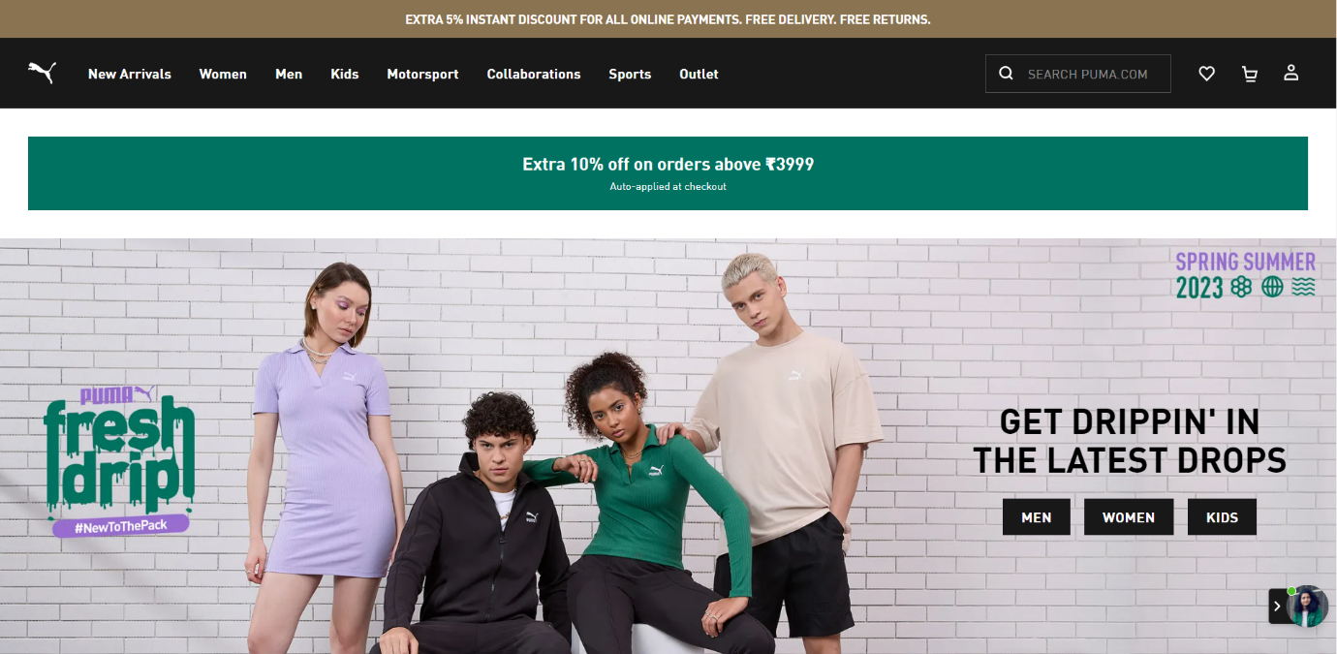

**OVERVIEW:**

Its an E-commerce website for athletic and casual footwear,apparel and accessories for men,women and kids.

1. **HOME PAGE:**

* **Header-**
* Logo.
* Discount and offer highlightes.
* Navigation(New arrivals,Men,Women,Kids,Sports).
* Search bar
* Icons(Whishlist,Cart,Menu for account and registration).
* **Body-**
* Various sections for clothes, shoes etc. with their price and ratings.
* Recommendations.
* **Footer-**
* Support.
* About us.
* Social networks.
* Copyright.

1. **REGISTRATION FORM:**

* Full name & Last name.
* Phone no.
* Email.
* Password.

1. **MAIN PAGE:**

* Filters-(Category, Product type, Price, Gender, Size, Color, Discount, Activity).
* Image of the chosen product with details like-(Name, Price, Discount% (if any)).
* On clicking the image, it can be seen from differernt angles, zoom in, zoom out.
* Product description-(Name, price, size chart, delivery options, size and fit, material and care, specifications, ratings and reviews).

1. **PAYMENT GATEWAY:**

* Address selection.
* Payment method- UPI/ CREDIT OR DEBIT CARD/ NET BANKING/ WALLET/ COD.

1. **TECHNOLOGIES USED:**

* **Front-End-**
* Html.
* Css.
* Bootstrap.
* React.
* **Dynamic-**
* Javascript.
* Ci/Cd with AWS.
* Login and logout(oauth and jwt).
* **Database-**
* Mongodb.
* Json data.
* **Code compilers-**
* Visual studio code.
* Git bash.
* Git hub.
* Node js.