American International University-Bangladesh · Department of Computer Science & Engineering
CSC4161 · Advanced Programming in Web Technology
Project Report
STRESSFORGE
An architecture stress-testing REST API and web application
Group information
Group | Individual submission (one student)
Section | D
Semester | Fall 2026–2027
Submitted to | Sultanul Arifeen Hamim, Lecturer, Faculty, Department of Computer Science
Submission date | 19 November 2026 (presentation day)
Presentation | Thursday 19 November 2026, 11:00 AM to 1:00 PM, 20 minutes per group

Group members, contribution and AI usage
SL | Student ID | Name | Section | Contribution | AI usage
1 | 22-49838-3 | Mubassir Ebne Mohsin | D | Requirements, database design and migrations, authentication and sessions, roles and permissions, simulation engine integration, designs and runs, reports and sharing, Support system, notifications, optional email, Admin tools, web application, tests, documentation. | 40%

AI usage is the share of the student's own work (code, diagrams, report text) that was drafted or generated with an AI tool, as the student's own estimate. AI assistants used: Claude Code (Anthropic) and Codex (OpenAI), as coding assistants for implementation, tests, diagrams, screenshots and report drafting. All generated code was read, run and tested; the test results in Chapter 7 are from commands run on the final code. The student must be able to explain every module.

Tools, technologies and tech stack this software is built on
Area | Tools and technologies
Backend | NestJS 11.2.7, TypeScript 5.9.3, Node.js 22 or later, Express, TypeORM 0.3.31 with pg 8.23.1, Zod 4.6.7 with nestjs-zod, JWT (@nestjs/jwt) and argon2 0.44.0, @nestjs/throttler, Helmet, cookie-parser, Swagger / OpenAPI 3.1, Bull 4.16.5, nodemailer 10.4.0, Node worker_threads
Web client | Next.js 16.4.2 (App Router, Turbopack), React 19.3.0, TanStack React Query 5.104.5, pdf-lib 1.17.1, Tailwind CSS 4, next-themes, sonner, cmdk, openapi-typescript
Data and infrastructure | PostgreSQL 16, Redis 7, Docker and Docker Compose, Mailtrap (email sandbox, development only)
Testing and quality | Jest 30.5.2, supertest 7.3.1, node:test with jsdom, Playwright 1.64.1 (Chrome), ESLint, Prettier
Development tools | pnpm, Git and GitHub, Swagger UI (API demo), psql, Chrome
AI assistants | Claude Code (Anthropic) and Codex (OpenAI)
Contents
1. Background Study 3
1.1 Project overview and objectives 3
1.2 Problem domain 3
1.3 Existing solutions 3
1.4 Technology study 4
1.5 Key concepts 5
2. Requirement Analysis 6
2.1 Functional requirements 6
2.2 Non-functional requirements 7
2.3 Constraints and assumptions 8
3. Use Case Diagram and ER Diagram 9
3.1 Actors 9
3.2 Use case diagram 10
3.3 Use case descriptions 10
3.4 ER diagrams 12
3.5 Relationships 14
3.6 Keys and constraints 15
4. Database Normalization 18
4.1 Unnormalized form (UNF) 18
4.2 First normal form (1NF) 18
4.3 Second normal form (2NF) 18
4.4 Third normal form (3NF) 19
4.5 How the sample maps to the real tables 19
4.6 A deliberate denormalisation: the graph and the result are documents 19
5. List of APIs 21
5.1 Response format 21
5.2 Endpoints 22
5.3 Requirement coverage 26
5.4 Roles and permissions 27
6. Screenshots of Functionality 29
7. Implementation Highlights 43
7.1 A strict request contract 43
7.2 Creating a report inside a transaction 43
7.3 Permissions read from the database on every call 44
7.4 Timing-safe login 44
7.5 One exception filter for every error 44
7.6 Optional email that cannot hurt a request 44
7.7 Verification 45
8. Conclusion and References 46

1. Background Study

1.1 Project overview and objectives
STRESSFORGE is a web application and REST API for learning how a system architecture behaves under load. A person draws a design (components such as clients, load balancers, app servers, caches, databases and queues, joined by connections), sets the traffic it must survive, and runs a mathematical model that predicts latency, errors and utilisation. The result says whether the design passes, is strained or fails, names the bottleneck, finds the load at which the design stops meeting its target, and suggests fixes that the server checks by running the model again. Every number is a model estimate, not a measurement of real infrastructure, and the application says so on every result.
Besides the simulator the system contains what a multi-user service needs: accounts with five roles, saved designs with immutable revisions, read-only share links, a printable report, reviewer feedback, instructor challenges, a problem-report (Support) system, an in-app notification bell, optional email, and Admin tools. The project has four checkable objectives:
- Provide REST endpoints, with the right verbs and status codes, for accounts, designs and their revisions, runs, notes, shares, reviews, challenges, Support reports and notifications (115 endpoints, Chapter 5).
- Keep multi-table changes correct by running them inside database transactions, with row-level locking and optimistic concurrency where two people could change the same data (Chapter 7).
- Restrict every operation by role: JWT authentication, one permission table checked by a global guard, and roles read from the database on every call (Section 5.4).
- Validate every input at the edge with strict schemas, return one consistent error shape, and keep an append-only history of role changes and Support activity (Chapters 5 and 7).
Scope. The project delivers a NestJS backend and a Next.js web client; the guide does not require a frontend, and the API can be exercised through Swagger UI alone (Chapter 6 does exactly that). Out of scope: real traffic generation against deployed systems, production monitoring, automatic cloud provisioning and simultaneous collaborative editing.

1.2 Problem domain
An architecture diagram shows which components are connected, but not which one will be overloaded first. Students and beginning developers often add servers without finding the real constraint: a second app server does not help if the database is the bottleneck. Load-testing a real system answers the question, but needs a deployed system, scripts and money. Three problems follow:
- A diagram carries no numbers, so two designs cannot be compared objectively.
- Trying a change (more copies, a cache, a read replica) in reality means building and paying for it first.
- A result without its inputs is not reproducible: nobody can tell which traffic, which design revision and which model version produced it.
STRESSFORGE addresses these with a deterministic model that anyone can re-run, saves every design change as an immutable revision, stores the inputs of every run with its result, and marks a result out of date when the design has changed since (a SHA-256 fingerprint of the inputs is compared).

1.3 Existing solutions
The comparison is by category of tool, because the point is what each approach can and cannot answer for a learner.
Approach | Strengths | Gaps for this purpose
Diagramming tools (for example draw.io, Excalidraw) | Free-form drawing, widely known, easy sharing | No load model: a diagram never says what will break first
Load-testing tools (for example k6, Apache JMeter) | Real measurements of a real system | Need a running, deployed system and test scripts; cost and set-up time; not usable at design time
Cloud pricing calculators and architecture centres | Cost estimates and reference diagrams | Cost, not latency or failure behaviour under a given traffic
Textbook queueing formulas by hand | Exact, explainable | Slow to apply to a whole graph, no persistence, no comparison between versions
STRESSFORGE (this project) | Draw, set traffic, get a predicted verdict, bottleneck and verified fixes in seconds; every run is saved with its inputs | A model, not a measurement; no real traffic; no real cloud provisioning

1.4 Technology study
Versions are taken from the package.json files of the two packages (backend and web) at the time of writing.
Technology | Role in STRESSFORGE | Why it was chosen
NestJS 11.2.7 (TypeScript 5.9.3, Node.js 22 or later) | Backend framework | Modules, dependency injection, guards, pipes, interceptors and filters are built in and map directly onto the course topics
PostgreSQL 16 | Relational database, the system of record | ACID transactions, row locking, advisory locks, CHECK and unique constraints, triggers, jsonb for frozen documents
TypeORM 0.3.31 with pg 8.23.1 | ORM, migrations and driver | Entities, migrations and a DataSource with transactions; most business queries are parameterised SQL inside transactions for exact control
Redis 7 (ioredis 5.11.1, redis 5.12.1) | Rate-limit counters, token revocation, AI quota | Fast shared counters that survive restarts and work across instances
Bull 4.16.5 (@nestjs/bull 11.0.5) | Job queue for the optional email outbox | Redis-backed repeating jobs with retries
JWT (@nestjs/jwt 11.0.2) and argon2 0.44.0 | Access tokens and password hashing | Stateless short-lived access tokens; argon2 is a slow, memory-hard password hash
Zod 4.6.7 with nestjs-zod 5.5.0 | Validation of every request, response and engine input | One strict schema is both the runtime check and the TypeScript type; unknown fields are rejected
@nestjs/throttler 6.7.1 | Rate limiting | Per-client limits with Redis storage
@nestjs/swagger 11.4.7 (OpenAPI 3.1) | Interactive API documentation at /docs | Generated from the schemas, with bearer authentication for the demo
Helmet 8.3.0, cookie-parser 1.4.7 | Security headers, cookie reading | Standard Express hardening
nodemailer 10.4.0 | SMTP client for the optional email feature | Small and well known; Mailtrap sandbox for development
Node worker_threads | Runs the simulation engine off the main thread | A heavy graph cannot block other requests; runs have a hard time limit
Next.js 16.4.2, React 19.3.0 | Web client | File-based routes, production build
TanStack React Query 5.104.5 | Server-state cache in the web client | Caching, refetching, polling of runs and notifications
pdf-lib 1.17.1 | PDF report built in the browser | Pure JavaScript, no server round trip
Jest 30.5.2, supertest 7.3.1 | Backend unit and end-to-end tests | End-to-end tests run against a real PostgreSQL test database
Playwright 1.64.1 | Browser journeys against a production build | Real clicks in Chrome, light and dark themes
Docker Compose | Starts PostgreSQL and Redis for development | Same services on every machine

1.5 Key concepts

Authentication and sessions
- POST /v1/auth/login checks the email and password (argon2 verify) and returns a short-lived access token (JWT, 900 seconds by default) in the response body; the browser keeps it in memory only.
- The same response sets a refresh token in an httpOnly cookie named sf_refresh, restricted to the path /v1/auth, SameSite=Lax and Secure in production, so page scripts cannot read it and the rest of the API never receives it.
- Every request sends Authorization: Bearer <access token>. The global AuthGuard verifies the signature and expiry and checks Redis for a revoked token id, a blocked user, or a session ended by a password change. A missing or bad token gives 401.
- When the access token expires the client calls POST /v1/auth/refresh. The refresh token is rotated: each use returns a new one. Presenting an already-used refresh token is treated as theft and revokes the whole token family.
- Permissions are not taken from the token. The PermissionGuard reads the account's roles from the user_roles table on every protected call, so a revoked role stops working at once. A missing permission gives 403.

Why transactions matter here
Creating a Support report changes several tables: the ticket row, the activity log row, and the notifications for Support staff. If the notification insert failed after the ticket had been saved, a report would exist that nobody was told about. A transaction makes the group atomic: all changes are saved, or none. Section 7.2 shows the code, and Figure 6.11 shows a test that forces a failure in the middle of a transaction and proves nothing was left behind.

Optimistic concurrency and idempotency
Two browser tabs can edit the same design. Each save names the revision it started from (expectedRevision); if the stored revision moved on, the server answers 409 Conflict with the current revision instead of overwriting the other tab's work (Figure 6.8). Run requests carry a requestId, so a double click or a network retry returns the first run instead of starting a second one.

2. Requirement Analysis

2.1 Functional requirements
Each requirement names the module that implements it. Priority is High for the core loop, Medium for supporting features and Low for convenience.
ID | Requirement | Priority | Module
Accounts and sessions
FR-01 | A visitor can register with an email, a display name and a password of 8 to 128 characters with at least one letter and one digit. The email is stored in lower case and is unique. New accounts have the User role. | High | Auth
FR-02 | A user can log in and receives a short-lived access token and a refresh cookie. | High | Auth
FR-03 | The refresh token is rotated on every use; reuse of an old one revokes the whole token family. | High | Auth
FR-04 | A user can log out; changing the password ends every earlier session. | High | Auth
FR-05 | A suspended account cannot sign in and its tokens stop working. | High | Roles
FR-06 | A signed-in user can read their own profile and roles, and change their display name. | Medium | Auth, Account
FR-07 | A user can export everything they own as JSON and delete their own account after typing a confirmation. Their designs are removed; their Support reports and challenge feedback are kept anonymised. | Medium | Account
Designs and simulation
FR-08 | A user can create a design from a blank canvas, one of six templates, a validated import (at most 65,536 bytes) or a text description. | High | Designs
FR-09 | A design has at most 50 components of 12 types and at most 200 connections; the server validates the graph and reports each problem with a code. | High | Designs, Simulation
FR-10 | A save names the revision it started from; a stale save is refused with 409 and the current revision. | High | Designs
FR-11 | Every save creates an immutable version. A user can list versions, compare two, and restore an old one (which creates a new version). | High | Designs
FR-12 | A user can list own designs with paging, search, filters and sorting, and can duplicate, archive, unarchive and delete a design. | Medium | Designs
FR-13 | A user can attach notes of kind decision or assumption (1 to 2,000 characters) to a design, optionally pinned to a component. | Medium | Designs
FR-14 | A user can run a stress test. The call is asynchronous (202 Accepted); the user polls the run and gets a verdict (pass, strained, fail), p50, p95 and p99 latency, error rate, per-component utilisation and the bottleneck. | High | Designs, Simulation
FR-15 | A run request carries a requestId; repeating it returns the same run. | High | Designs
FR-16 | A user can search for the breaking load (Limits), run a load ladder at 2x, 5x and 10x, ask a what-if question, and get up to three fix suggestions that the server has verified by re-running the model. | High | Designs, Simulation
FR-17 | A user can preview an unsaved graph live; previews have their own rate-limit bucket. | Medium | Simulation
Reports, sharing and review
FR-18 | A user can open a report for a design (a consistent snapshot of the design, one revision and its latest run) and download it as a PDF built in the browser. | High | Designs, Web
FR-19 | A user can create a read-only share link (the token is shown once and only its hash is stored) that expires after 7, 30 (default) or 90 days or never, list links and revoke a link. Anyone with a valid link can open the shared view without signing in. | High | Designs
FR-20 | A design owner can grant one named Reviewer access to one revision, revoke it, and read and answer the comment thread. | Medium | Reviews
FR-21 | A Reviewer can list designs shared with them, read the shared revision and add, edit and remove their own comments. | Medium | Reviews
Learning
FR-22 | Anyone can list and read published challenges. A signed-in user can start an attempt, submit it (202 Accepted) and see their progress. | Medium | Challenges
FR-23 | An Instructor can create, edit, publish, archive and duplicate challenges, read submissions to them and give feedback. | Medium | Challenges
Support, notifications and email
FR-24 | A user can send a problem report (category, title 3 to 120 and body 10 to 4,000 characters, an allow-listed technical context). At most 5 reports an hour and 20 a day per account; an open report with the same title is refused with 409 unless the user confirms. | High | Support
FR-25 | A user can list their own reports, read their thread (internal notes are never shown) and reply; a resolved report can be continued for 14 days. | High | Support
FR-26 | Support staff can list and search the inbox, read a report, mark it read, reply, add internal notes, set status and priority, assign it, use saved replies (personal or team) and merge or unmerge duplicate reports. | High | Support
FR-27 | A user sees notifications for Support replies and status changes (staff also for new reports, assignments and reporter replies), can mark them read, and can mute each kind. | Medium | Notifications
FR-28 | When enabled, the reporter also receives an email for a Support reply or a status change. The email never contains report text. | Medium | Mails
Administration
FR-29 | An Admin can search accounts, grant and revoke the Instructor, Reviewer, Support and Admin roles, and suspend and restore accounts. The last Admin cannot be removed or suspended and nobody can suspend themselves. | High | Roles
FR-30 | Every role change and suspension is written to an append-only audit log that an Admin can read. | High | Roles
FR-31 | An Admin can view a live dashboard of aggregate counts and export a snapshot as CSV or JSON. The dashboard never reads design content or the Support inbox. | Medium | Roles
Platform
FR-32 | All successful responses use the envelope { data } (lists add meta), all failures use { error: { code, message, details } }, and lists are paged. | High | Common
FR-33 | Optional AI features (describe a system in words, what-if sentence, fix filter) are off by default and only fill a strict form; all numbers and graphs come from the engine. | Low | AI
FR-34 | A public health endpoint reports whether PostgreSQL and Redis answer. | Medium | Health

2.2 Non-functional requirements
Each target is a number that can be checked. The last column says how.
ID | Category | Requirement | How it is checked
NFR-01 | Security | Passwords are stored only as argon2 hashes; a login for an unknown email still runs a dummy hash so timing does not reveal which emails exist. JWT secrets and lifetimes come from the environment (access token 900 s, refresh token 7 days by default). | Inspect the users table and the configuration; unit tests of the auth service
NFR-02 | Security | Every route except 8 public ones requires a valid token. 39 routes also require a role permission; roles are read from the database on every call. | Probe of all 115 routes (Section 5.2): 8 answered without a token, 39 answered 403 to an ordinary user
NFR-03 | Security | Request bodies are limited to 100 kb (160 kb for design import); text fields have maximum lengths; unknown fields are rejected with 422. | Swagger 422 test (Figure 6.7); contract tests
NFR-04 | Performance | A saved run is stopped after 5 seconds and a live preview after 2 seconds; at most 4 runs wait in the admission queue. | Executor settings in simulation-executor.ts; worker tests
NFR-05 | Rate limiting | 120 requests a minute per client by default, 10 a minute for register, login and refresh, 5 problem reports an hour and 20 a day per account. | Throttler configuration; Support end-to-end tests
NFR-06 | Data integrity | Multi-table writes run in transactions. The schema has 34 foreign keys and 63 CHECK constraints, plus triggers that make the audit tables append-only. | Schema dump (Chapter 3); forced-failure test (Figure 6.11)
NFR-07 | Concurrency | A design save names its revision and a stale save is refused with 409; concurrent writes to the same record (saved-reply edits, merges) cannot both succeed; two simultaneous requests cannot both exceed a per-account limit. | Figure 6.8; concurrency tests in support-extras.e2e-spec.ts (simultaneous merges, edits and creates)
NFR-08 | Privacy | Admin cannot read design content or the Support inbox; internal Support notes are never returned to the reporter; emails contain no report text. | Permission table; end-to-end tests in the roles, support and mails specs
NFR-09 | Auditability | Role changes and Support activity are stored in append-only tables; an UPDATE or DELETE on them fails in the database. | Triggers role_audit_no_change and support_activity_no_change; tests
NFR-10 | Usability | Every endpoint is documented in Swagger (115 operations). An invalid request names each failing field. | Swagger review (Chapter 6); 422 body in Figure 6.7
NFR-11 | Maintainability | One NestJS module per feature, one strict schema per operation; lint and type checks pass. | ESLint and tsc on the changed files; 63 unit-test suites and 33 end-to-end suites
NFR-12 | Portability | The schema is built only from migrations (21 of them) and every setting comes from environment variables validated at start-up. | Migrations on an empty database (Figure 6.15)
NFR-13 | Scalability | The API keeps no session state in memory: tokens are self-contained, counters and revocations live in Redis, data lives in PostgreSQL. The simulation admission queue is per instance. | Design review

2.3 Constraints and assumptions
- The model is a mathematical estimate. It is never presented as a measurement of real infrastructure.
- PostgreSQL and Redis run locally through Docker Compose; no paid cloud service is needed.
- Email is optional, off by default and sent only to a Mailtrap sandbox inbox during development and the demo.
- AI features are optional and off by default; the simulator remains the only source of numbers.
- The scope is a single organisation: one database, no multi-tenant isolation.

3. Use Case Diagram and ER Diagram

3.1 Actors
Actor | Description | Main permissions
User | Every account (the implicit base role) | Create and run own designs, notes, shares, reports and PDFs; send problem reports; read notifications; take challenges; export or delete the account
Instructor | Granted by an Admin | Create, edit, publish, archive and duplicate challenges; read submissions to them; give feedback
Reviewer | Granted by an Admin | Read designs that owners shared with them (one frozen revision) and comment
Support | Granted by an Admin | Read and answer problem reports, write internal notes, set status and priority, assign, saved replies, merge duplicates. Never sees designs
Admin | First one created by a server command, others by an Admin | Manage accounts and roles, suspend and restore, read the audit log, see aggregate dashboard numbers. Never reads design content or the Support inbox
Email service | Secondary actor (SMTP server, optional) | Receives the mails the system sends to reporters
AI provider | Secondary actor (hosted model, optional) | Fills a strict form for three narrow tasks; never produces numbers

Roles are not inherited: an Admin does not gain Instructor, Reviewer or Support powers, and no role reads another person's private design. Section 5.4 gives the permission table.

3.2 Use case diagram
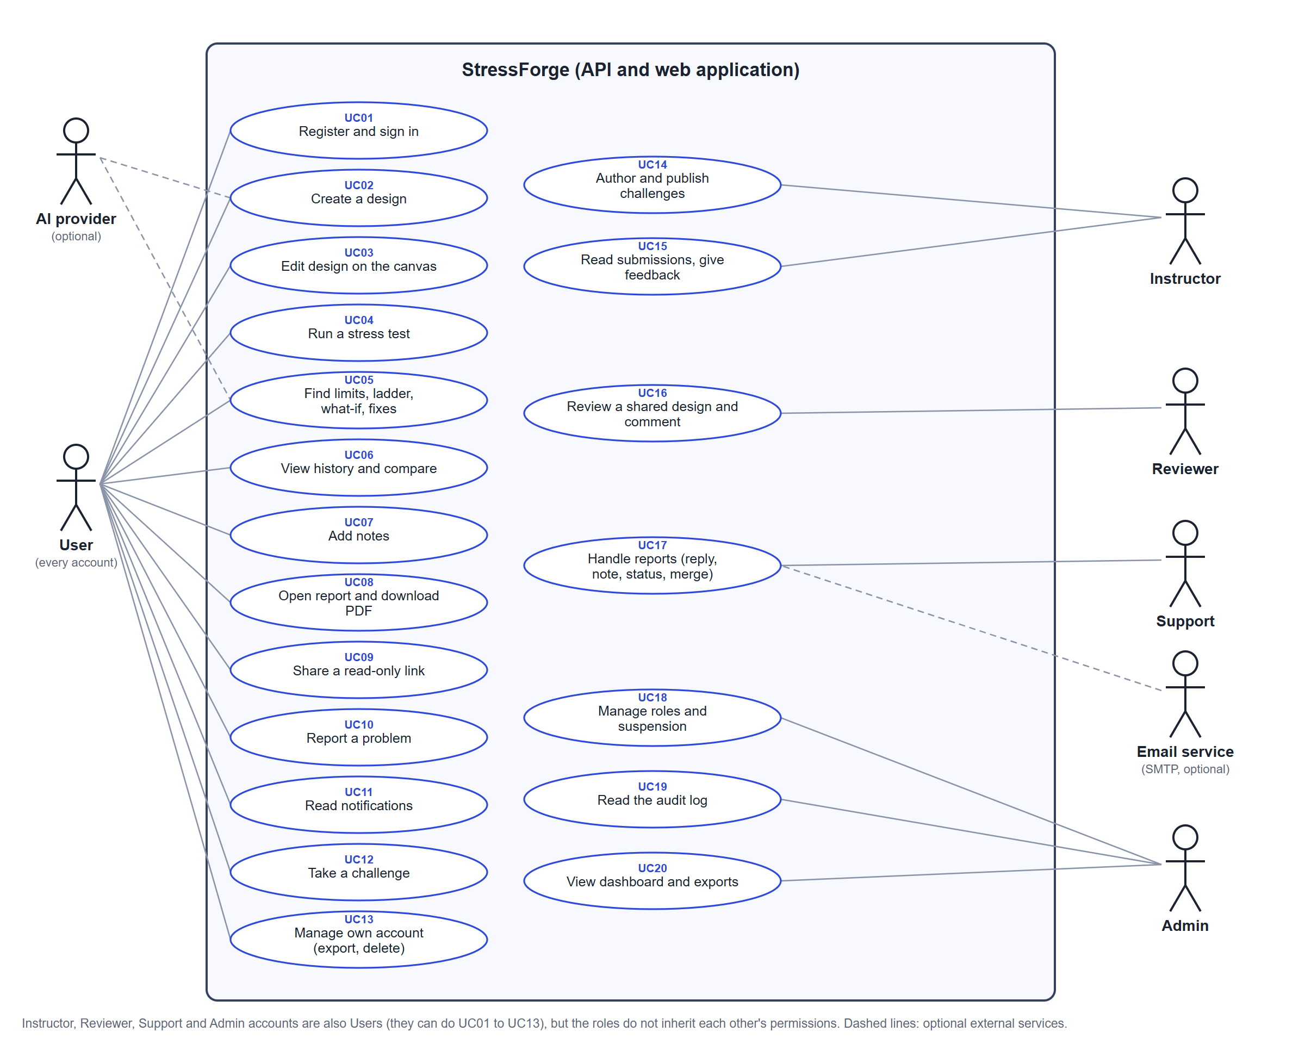
Figure 3.1: Use case diagram of STRESSFORGE

3.3 Use case descriptions

UC04 Run a stress test
Field | Description
Actor | User (primary)
Preconditions | The user is signed in and owns the design. The design has a saved revision.
Main flow | 1. The client sends POST /v1/designs/{id}/simulate with the revision it believes is saved (expectedRevision) and a fresh requestId.  2. The server checks ownership. If the same requestId was already accepted, it returns that run instead of starting another.  3. It checks that the revision is still current and that the account has no other calculation pending.  4. It validates the graph (components, connections, entry point, cycles, unreachable parts) and reserves a slot in the executor.  5. In one transaction it locks the design row, re-checks the revision and inserts a design_runs row with status pending, the input fingerprint and the engine version.  6. It answers 202 Accepted with a status URL; the model runs in a worker thread with a 5 second limit.  7. The client polls GET /v1/designs/{id}/runs/{runId} until the status is completed or failed, then shows the verdict, percentiles, utilisation and bottleneck.
Alternative flows | A1. The revision is stale: 409 with REVISION_MISMATCH and the current revision.  A2. The same requestId is reused for different inputs: 409 with REQUEST_ID_REUSED.  A3. The graph is invalid: 422 with the list of problems.  A4. Another calculation is pending for the account, or capacity is exhausted: 429 (retry with the same requestId).  A5. The calculation service is unavailable or the admission window expired: 503.  A6. The server restarts while a run is pending: the run is marked failed (interrupted) at the next recovery pass.
Postcondition | Either one run row exists with its inputs and (when finished) its result, or nothing was stored.

UC10 and UC17 Report a problem and receive a reply
Field | Description
Actors | User (reporter), Support (staff), Email service (secondary)
Preconditions | The reporter is signed in. A Support account exists.
Main flow | 1. The reporter sends POST /v1/support/reports (category, title, body, optional expected result, allow-listed context).  2. The server validates the body against the strict schema and, in one transaction, takes a per-account advisory lock, counts the account's reports (limits 5 an hour and 20 a day), refuses an open report with the same title unless confirmed, inserts the ticket, writes the activity row and creates the notifications for Support staff. It answers 201.  3. A Support agent lists the inbox, opens the report and replies (POST /v1/support/inbox/{id}/messages).  4. The server stores the message, writes the activity row and creates a support_reply notification for the reporter in the same transaction.  5. The reporter's bell shows the notification. If email is enabled, a background job later sends a short email (report number and a link, never the text of the report) and records the outcome in notification_emails.
Alternative flows | A1. More than 5 reports in an hour or 20 in a day: 429 with retryAfterSeconds.  A2. An open report with the same title exists: 409 DUPLICATE_OPEN, unless the request sets confirmDuplicate.  A3. The reporter opens someone else's report id: 404 (another person's report looks the same as a missing one).  A4. A staff-only route is called by an ordinary user: 403.  A5. The mail server is unavailable: the email is retried up to three times and then marked failed; the Support action is never affected.
Postcondition | The ticket, its activity row and the notifications exist together, or none of them do.

UC18 Manage roles and suspension
Field | Description
Actor | Admin
Preconditions | The Admin is signed in and holds the Admin role in the database.
Main flow | 1. The Admin searches an account (GET /v1/admin/users?q=).  2. The Admin grants a role (POST /v1/admin/users/{id}/roles) or suspends the account.  3. In one transaction the server writes user_roles (or the suspension) and appends a row to role_audit.  4. The next request from that account sees the new roles, because roles are read from the database on every call.
Alternative flows | A1. The caller lacks the permission: 403.  A2. The last Admin would be removed or suspended, or an Admin suspends themselves: 409 (LAST_ADMIN or SELF).  A3. The target account does not exist: 404.
Postcondition | The role change and its audit row exist together. The audit table cannot be edited or deleted from (database trigger).

3.4 ER diagrams
The database has 24 application tables (plus the migrations bookkeeping table), 34 foreign keys, 63 CHECK constraints and 3 triggers. The diagrams are drawn from the schema of a database built by running all 21 migrations on an empty database, so keys and cardinalities match the real schema. Crow's foot notation: a bar is "one", a circle is "optional", a fork is "many". Primary keys are marked PK and foreign keys FK; "(null)" marks a nullable column. Only the important columns are shown.
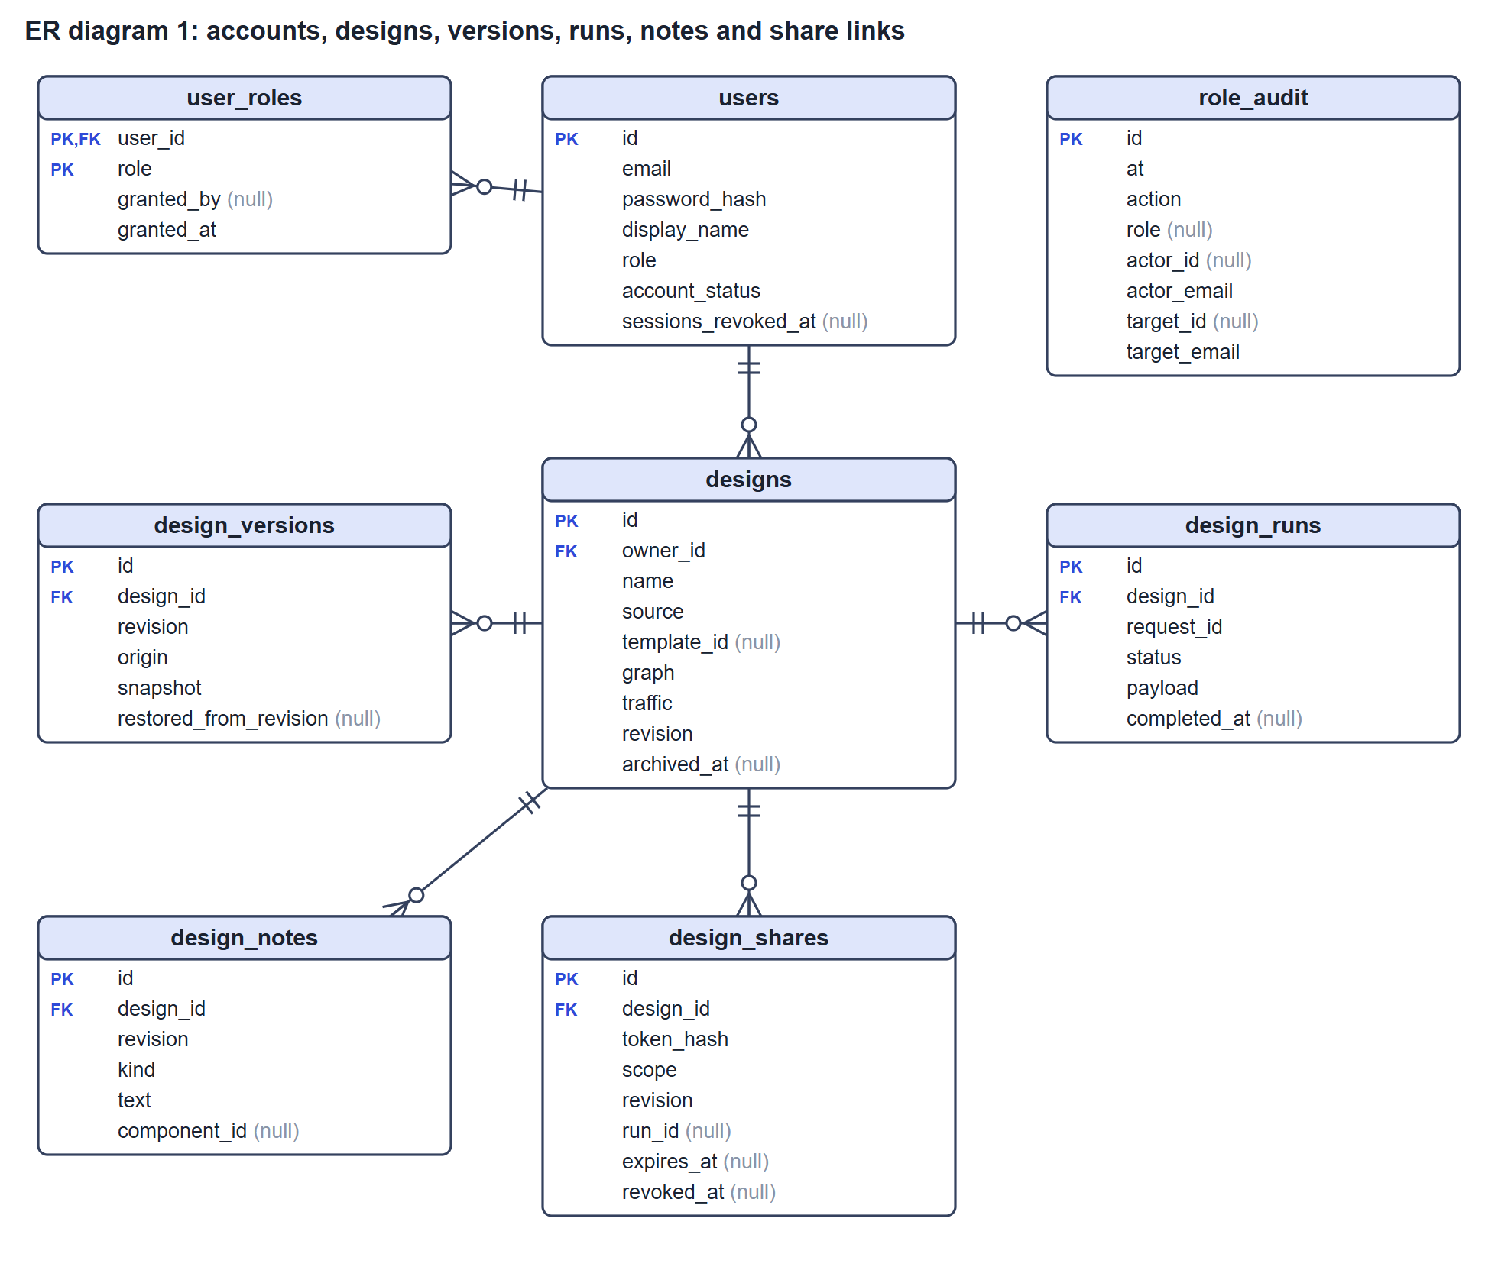
Figure 3.2: ER diagram 1, accounts, roles, designs, versions, runs, notes and share links
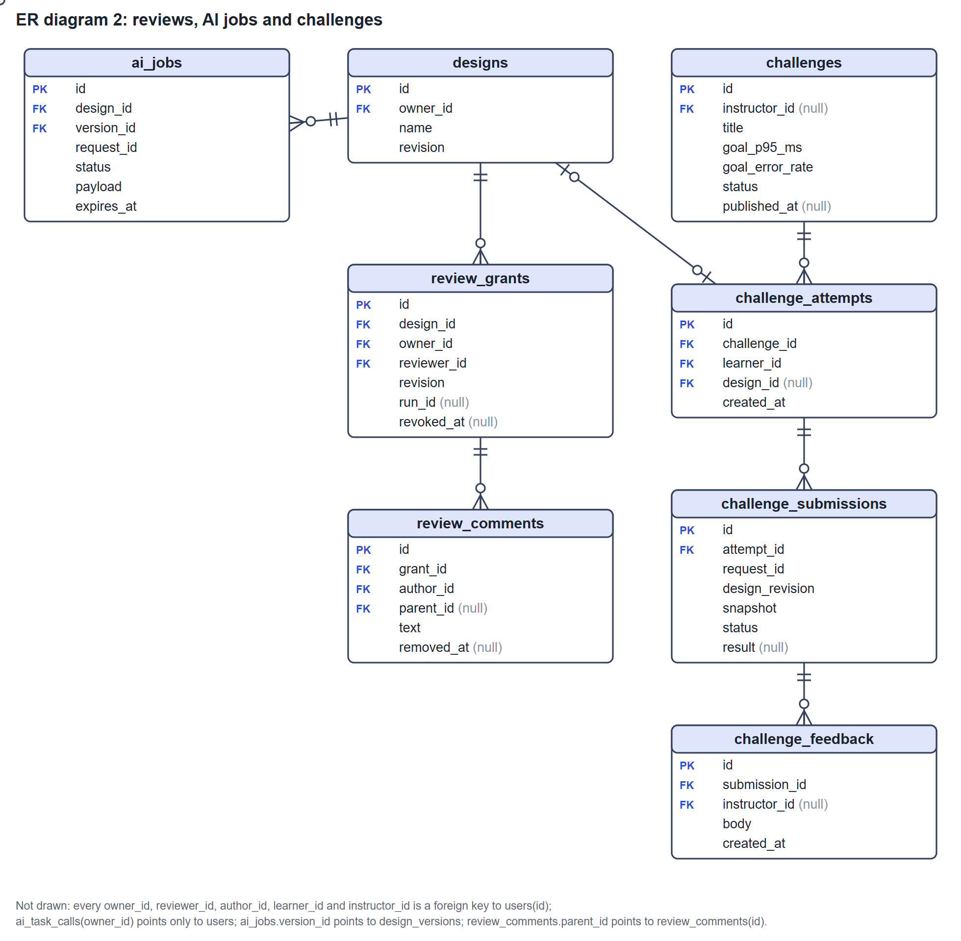
Figure 3.3: ER diagram 2, review grants and comments, AI jobs and challenges
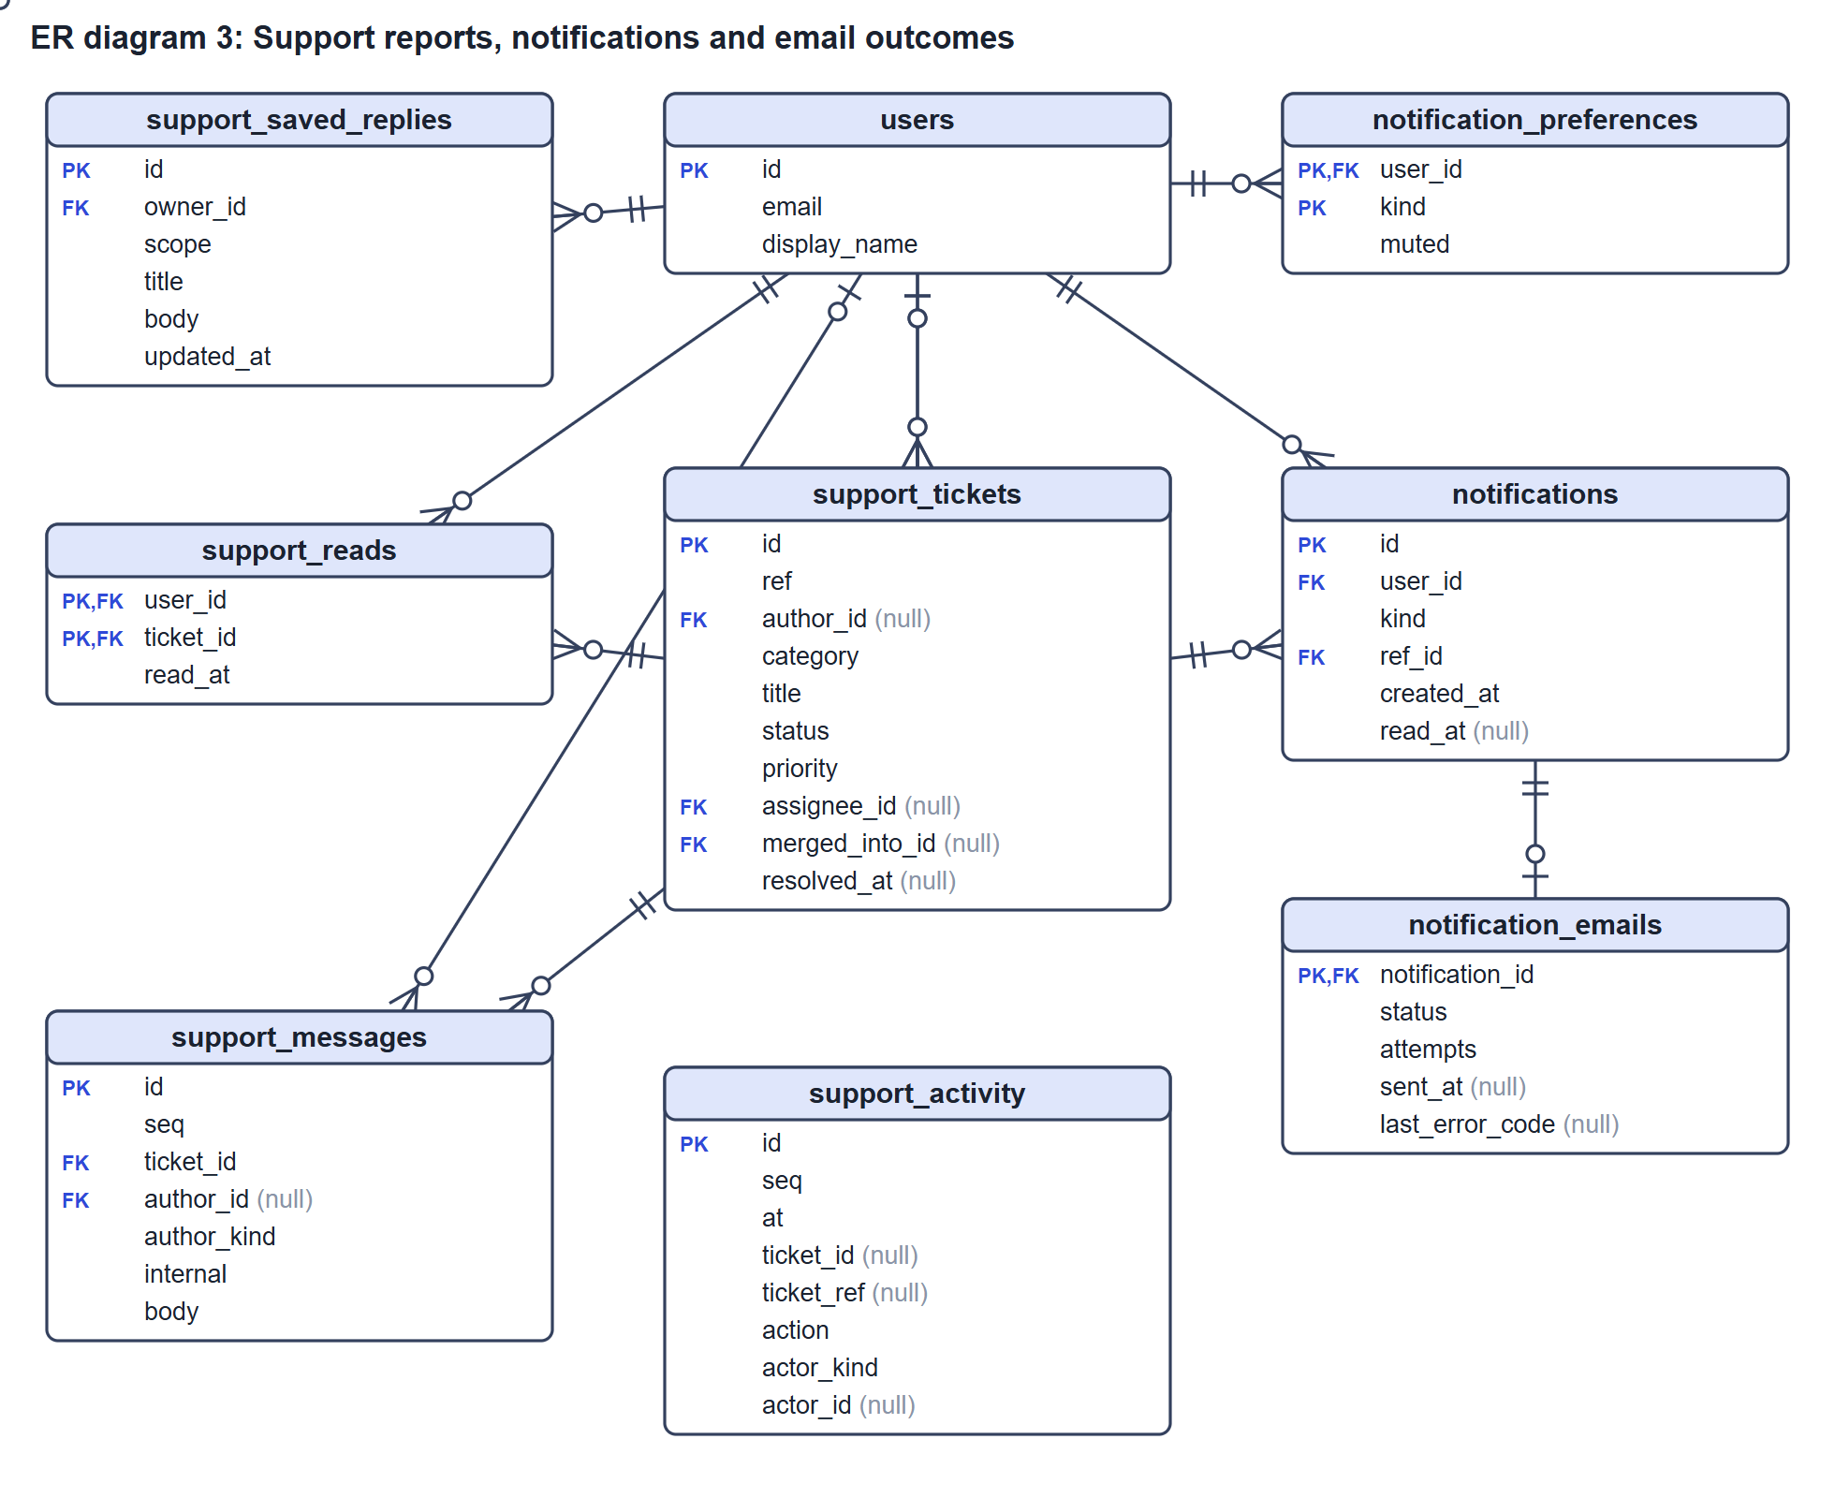
Figure 3.4: ER diagram 3, Support reports, notifications and email outcomes
Two tables have no foreign keys on purpose. role_audit and support_activity are append-only histories that must outlive the accounts and tickets they describe, so they store ids and e-mail text without a foreign key. A database trigger refuses UPDATE and DELETE on both.

3.5 Relationships
Generated from the 34 foreign keys. Cardinality reads parent : child; 0..1 on the parent side means the foreign key column may be null. On delete is what the database does to child rows when the parent row is deleted: CASCADE removes them, SET NULL keeps them anonymised, RESTRICT or NO ACTION refuses the deletion.
Relationship | Cardinality | Implemented by | On delete
Challenge attempt has submissions | 1 : 0..N | challenge_submissions.attempt_id | CASCADE
Submission has feedback entries | 1 : 0..N | challenge_feedback.submission_id | CASCADE
Challenge has attempts | 1 : 0..N | challenge_attempts.challenge_id | RESTRICT
Design version has AI jobs | 1 : 0..N | ai_jobs.version_id | NO ACTION
Design has AI jobs | 1 : 0..N | ai_jobs.design_id | CASCADE
Design has attempts | 0..1 : 0..1 | challenge_attempts.design_id | SET NULL
Design has notes | 1 : 0..N | design_notes.design_id | CASCADE
Design has runs | 1 : 0..N | design_runs.design_id | CASCADE
Design has share links | 1 : 0..N | design_shares.design_id | CASCADE
Design has versions | 1 : 0..N | design_versions.design_id | CASCADE
Design has review grants | 1 : 0..N | review_grants.design_id | CASCADE
Notification has email outcomes | 1 : 0..1 | notification_emails.notification_id | CASCADE
Review comment has replies comments | 0..1 : 0..N | review_comments.parent_id | CASCADE
Review grant has comments | 1 : 0..N | review_comments.grant_id | CASCADE
Support report has notifications | 1 : 0..N | notifications.ref_id | CASCADE
Support report has messages | 1 : 0..N | support_messages.ticket_id | CASCADE
Support report has read marks | 1 : 0..N | support_reads.ticket_id | CASCADE
Support report has replies Support reports | 0..1 : 0..N | support_tickets.merged_into_id | SET NULL
User has AI task calls | 1 : 0..N | ai_task_calls.owner_id | CASCADE
User has attempts | 1 : 0..N | challenge_attempts.learner_id | CASCADE
User has feedback entries | 0..1 : 0..N | challenge_feedback.instructor_id | SET NULL
User has challenges | 0..1 : 0..N | challenges.instructor_id | CASCADE
User has designs | 1 : 0..N | designs.owner_id | CASCADE
User has preferences | 1 : 0..N | notification_preferences.user_id | CASCADE
User has notifications | 1 : 0..N | notifications.user_id | CASCADE
User has comments | 1 : 0..N | review_comments.author_id | CASCADE
User has review grants | 1 : 0..N | review_grants.owner_id | CASCADE
User has review grants | 1 : 0..N | review_grants.reviewer_id | CASCADE
User has messages | 0..1 : 0..N | support_messages.author_id | SET NULL
User has read marks | 1 : 0..N | support_reads.user_id | CASCADE
User has saved replies | 1 : 0..N | support_saved_replies.owner_id | CASCADE
User has Support reports | 0..1 : 0..N | support_tickets.assignee_id | SET NULL
User has Support reports | 0..1 : 0..N | support_tickets.author_id | SET NULL
User has role assignments | 1 : 0..N | user_roles.user_id | CASCADE

3.6 Keys and constraints
Primary keys, unique constraints and CHECK constraints per table, taken from the same schema dump. CHECK constraints are the database's own validation, a second wall behind the request schemas.
Table | Constraints
ai_jobs | PK id  Unique design_id + request_id  Check status IN (pending, completed, failed, cancelled, interrupted)
ai_task_calls | PK id  Check completion_tokens >= 0; input_hash ~ '^[a-f0-9]{64}$'; input_length >= 0; latency_ms >= 0; prompt_tokens >= 0; task IN (describe, whatif, fixes); total_tokens >= 0
challenge_attempts | PK id  Unique challenge_id + learner_id; design_id
challenge_feedback | PK id  Check (char_length(body) >= 1) AND (char_length(body) <= 2000)
challenge_submissions | PK id  Unique attempt_id + request_id  Check design_revision > 0; status IN (pending, completed, failed, interrupted)
challenges | PK id  Check ((status = 'draft') AND (published_at IS NULL) AND (archived_at IS NULL)) OR ((status = 'published') AND (published_at IS NOT NULL) AND (archived_at IS NULL)) OR ((status = 'archived') AND (archived_at IS NOT NULL)); (goal_error_rate >= 0) AND (goal_error_rate <= 1); (goal_p95_ms >= 1) AND (goal_p95_ms <= 60000); status IN (draft, published, archived); char_length(summary) >= 1; char_length(title) >= 1
design_notes | PK id  Check kind IN (decision, assumption); revision > 0; (char_length(text) >= 1) AND (char_length(text) <= 2000)
design_runs | PK id  Unique design_id + request_id  Check status IN (pending, completed, failed)
design_shares | PK id  Check open_count >= 0; revision > 0; scope IN (design, design_report); char_length(token_hash) = 64
design_versions | PK id  Unique design_id + revision  Check origin IN (baseline, create, edit, restore); restored_from_revision > 0; revision > 0
designs | PK id  Check revision > 0; schema_version = 1; source IN (blank, template, import, scripted, ai)
notification_emails | PK notification_id  Check (attempts >= 0) AND (attempts <= 10); status IN (retry, sent, failed, skipped)
notification_preferences | PK user_id, kind  Check kind IN (support_reply, report_status, support_new_report, support_assigned, reporter_reply)
notifications | PK id  Check kind IN (support_reply, report_status, support_new_report, support_assigned, reporter_reply)
review_comments | PK id  Check ((removed_at IS NULL) AND (char_length(text) >= 1)) OR ((removed_at IS NOT NULL) AND (text = ''))
review_grants | PK id  Check owner_id <> reviewer_id; revision > 0
role_audit | PK id  Check action IN (grant, revoke, bootstrap, suspend, restore); role IN (instructor, reviewer, support, admin)
support_activity | PK id  Check action IN (create, reply, note, status, priority, assign, reopen, merge, unmerge, saved_create, saved_update, saved_delete); actor_kind IN (user, support); ((ticket_id IS NOT NULL) AND (ticket_ref IS NOT NULL)) OR action IN (saved_create, saved_update, saved_delete)
support_messages | PK id  Check author_kind IN (user, support); (char_length(body) >= 1) AND (char_length(body) <= 4000); (NOT internal) OR (author_kind = 'support')
support_reads | PK user_id, ticket_id
support_saved_replies | PK id  Check (char_length(body) >= 1) AND (char_length(body) <= 4000); scope IN (personal, team); (char_length(title) >= 3) AND (char_length(title) <= 120)
support_tickets | PK id  Unique ref  Check (merged_into_id IS NULL) OR (status = 'resolved'); (merged_into_id IS NULL) OR (merged_into_id <> id); (char_length(body) >= 10) AND (char_length(body) <= 4000); category IN (bug, wrong_result, account, performance, idea, other); (status = 'resolved') = (resolved_at IS NOT NULL); jsonb_typeof(context) = 'object'; (expected IS NULL) OR (char_length(expected) <= 2000); priority IN (low, normal, high, urgent); status IN (open, in_progress, waiting, resolved); char_length(title) >= 3
user_roles | PK user_id, role  Check role IN (instructor, reviewer, support, admin)
users | PK id  Unique email  Check email = lower(email); role IN (user, admin); account_status IN (active, suspended)

Triggers and indexes of note
Item | Purpose
Trigger role_audit_no_change | Refuses UPDATE and DELETE on role_audit (append-only history)
Trigger support_activity_no_change | Refuses UPDATE and DELETE on support_activity
Trigger support_merge_guard | Prevents a report from being merged into itself, into a merged report or in a cycle
Unique uq_users_email, check ck_users_email_lowercase | One account per email, stored in lower case
Unique design_versions (design_id, revision) | One immutable version per revision number
Unique design_runs (design_id, request_id) | Idempotency of run requests
Unique challenge_attempts (challenge_id, learner_id) | One attempt per learner per challenge
Partial unique index ai_jobs_one_pending | At most one pending AI job at a time
67 indexes in total | Owner lists, cursor paging on (created_at, id), idempotency keys and partial indexes for open reports

4. Database Normalization
Before the application existed, run results could have been kept in a sheet like the one below: one row per test run, with the owner and the design copied into every row. The two sample rows and the table below are invented for this explanation; the normalised relations at the end correspond to real tables.

4.1 Unnormalized form (UNF)
Run | Owner | Owner e-mail | Design | Components | RPS | Verdict | Bottleneck | Notes
R-101 | U-07 Nadia Karim | nadia@mail.com | D-3 Shop MVP | Users; App servers; Postgres | 300 | pass | none | baseline
R-102 | U-07 Nadia Karim | nadia@mail.com | D-3 Shop MVP | Users; App servers; Postgres | 900 | fail | Postgres | decision: keep one database; assumption: reads are 80%
R-103 | U-09 Imran Hossain | imran@mail.com | D-5 Blog | Users; CDN; App servers | 500 | pass | none

Problems: the Components and Notes cells hold several values; the owner's name and e-mail are repeated on every run of the same person; the design name is repeated on every run of the same design; and the Bottleneck cell is meaningless for a passing run.

4.2 First normal form (1NF)
1NF requires atomic values and no repeating groups. Each component gets its own row, so the row is identified by the composite key (Run, Component). Notes move to their own relation, keyed by (Design, NoteNo).
Run | Component | Owner | Owner e-mail | Design | Design name | RPS | Verdict | Bottleneck
R-101 | Users | U-07 Nadia Karim | nadia@mail.com | D-3 | Shop MVP | 300 | pass | none
R-101 | App servers | U-07 Nadia Karim | nadia@mail.com | D-3 | Shop MVP | 300 | pass | none
R-101 | Postgres | U-07 Nadia Karim | nadia@mail.com | D-3 | Shop MVP | 300 | pass | none
R-102 | Users | U-07 Nadia Karim | nadia@mail.com | D-3 | Shop MVP | 900 | fail | Postgres
R-102 | App servers | U-07 Nadia Karim | nadia@mail.com | D-3 | Shop MVP | 900 | fail | Postgres
R-102 | Postgres | U-07 Nadia Karim | nadia@mail.com | D-3 | Shop MVP | 900 | fail | Postgres
R-103 | Users | U-09 Imran Hossain | imran@mail.com | D-5 | Blog | 500 | pass | none
R-103 | CDN | U-09 Imran Hossain | imran@mail.com | D-5 | Blog | 500 | pass | none
R-103 | App servers | U-09 Imran Hossain | imran@mail.com | D-5 | Blog | 500 | pass | none

Primary key: (Run, Component). Notes: design_note(Design, NoteNo, Kind, Text) with primary key (Design, NoteNo).

4.3 Second normal form (2NF)
2NF removes partial dependencies: a non-key column that depends on only part of a composite key. Every attribute except Component (owner, design, RPS, verdict, bottleneck) depends on Run alone, not on Component. Those columns move to a relation keyed by Run, and the link between runs and components stays on its own.
run(Run PK, Owner, OwnerEmail, Design, DesignName, RPS, Verdict, Bottleneck)
run_component(Run FK, Component) PK (Run, Component)

Every non-key column in run now depends on the whole key. Redundancy remains: the owner's details are still repeated for every run of that person, and the design name for every run of that design.

4.4 Third normal form (3NF)
3NF removes transitive dependencies: a non-key column that depends on another non-key column. Three appear in run:
- Run → Design → DesignName, Owner: the design's name and owner belong to the design, not to the run.
- Design → Owner → OwnerName, OwnerEmail (through the owner): the person's name and e-mail belong to the person.
- Verdict and Bottleneck describe one run's result; they stay with the run, but their exact numbers (percentiles, utilisation per component) are a variable-size result, which is kept as a single stored document (see 4.6).
Resulting relations:
owner(Owner PK, Name, Email UNIQUE)
design(Design PK, Owner FK, Name)
run(Run PK, Design FK, RPS, Verdict, Bottleneck)
run_component(Run FK, Component) PK (Run, Component)
design_note(Design FK, NoteNo, Kind, Text) PK (Design, NoteNo)

In each relation every determinant is a candidate key (Owner, Email, Design, Run, or the composite keys of the two link relations), so the design is also in Boyce-Codd normal form.

4.5 How the sample maps to the real tables
Sample relation | Real table | Key columns | Notes
owner | users | id PK, email UNIQUE, display_name, password_hash | Email stored lower-case (CHECK); roles split into user_roles
design | designs | id PK, owner_id FK to users | Holds the current draft graph and traffic as jsonb, plus revision
design versions | design_versions | id PK, UNIQUE (design_id, revision) | Immutable snapshot of each saved revision
run | design_runs | id PK, design_id FK, UNIQUE (design_id, request_id) | Status columns plus the result in payload
design_note | design_notes | id PK, design_id FK | Kind limited to decision or assumption; optional component_id
run_component | inside design_versions.snapshot and designs.graph | n/a | Deliberately not a table (see 4.6)

4.6 A deliberate denormalisation: the graph and the result are documents
The components and connections of a design, and the detailed result of a run, are stored as jsonb documents (designs.graph, design_versions.snapshot, design_runs.payload) instead of rows in a run_component table. Strictly, a document is not first normal form. This was chosen on purpose.

- A graph is edited, validated and saved as one unit. The strict schema (at most 50 components and 200 connections, 12 component types, identifiers checked) validates the whole document on every write, and the engine always reads it whole.
- A saved revision and a run must be frozen. If components lived in shared rows, a later change to the model or to the component list could silently alter an old result. A document per revision keeps each result tied to exactly the inputs that produced it (the fingerprint is a SHA-256 of that canonical document).
- Components are never queried on their own across designs, so no query needs a component table or its joins.
- The price is that PostgreSQL cannot enforce, say, that a connection points at an existing component. That rule is enforced by the schema and by the graph validation, and is tested.
Everything that is queried across rows (who owns what, which revision, which run belongs to which design, who may see it) is relational, keyed and constrained as described in Chapter 3.

5. List of APIs
Base URL: http://localhost:5001/v1 (the Swagger UI is at /docs). All routes exchange JSON. The tables list all 115 endpoints: 49 GET, 53 POST, 8 PATCH and 5 DELETE. The list is generated from the controllers and was checked against the live OpenAPI document served by the running API: both contain exactly the same 115 operations.
Access is one of: Public (no token needed), Signed in (any valid access token; ownership is then checked inside each service, and another person's resource is answered as not found), or a role with the permission name the global PermissionGuard demands. The last column is the result of a real probe: every route was called once without a token and once with an ordinary user's token (a fresh, throw-away account on a test database), with placeholder ids and an empty body. 401 / 422 therefore reads: no token gives 401, and a signed-in ordinary user gets past the guards and is stopped by validation. 401 / 403 means the route needs a role permission. A public route answers something other than 401 without a token.
Probe summary. 115 routes probed: 8 are public, 39 answered 403 to an ordinary user (they need a role permission), and the other 68 require sign-in only. Every one of the 39 permission routes in the code answered 403 and no other route did, so the declared permissions and the observed behaviour agree. POST /v1/auth/refresh is declared public (it needs no access token) but answers 401 without the refresh cookie.

5.1 Response format
Successful responses use one envelope; lists add meta. Errors are produced by one global exception filter. These bodies are real responses of the same requests shown in Figures 6.2, 6.5, 6.7, 6.8 and 6.9 (identifiers and times differ from run to run).
POST /v1/auth/register -> 201 Created
{
"data": {
"accessToken": "eyJhbGciOiJIUzI1NiIs...",
"expiresIn": 900,
"user": { "id": "574bdcd8-654a-4047-bff4-5f4a661ad920",
"email": "register-demo-...@example.test",
"displayName": "Register Demo", "role": "user",
"createdAt": "2026-11-09T07:37:08.760Z" }
}
}

GET /v1/designs?page=1&pageSize=2 -> 200 OK
{ "data": [ { "id": "...", "name": "Shop MVP C", "revision": 1, "nodeCount": 3,
"edgeCount": 2, "latestRun": null }, ... ],
"meta": { "page": 1, "pageSize": 2, "total": 3 } }

{ "error": {
"code": "VALIDATION_FAILED",
"message": "Validation failed",
"details": { "fields": [
{ "path": "name", "message": "Too small: expected string to have >=1 characters" },
{ "path": "", "message": "Unrecognized key: \"unexpectedField\"" } ] } } } // 422

{ "error": { "code": "CONFLICT",
"message": "The saved design changed. Your draft has been retained.",
"details": { "reason": "REVISION_MISMATCH", "currentRevision": 1 } } } // 409

{ "error": { "code": "FORBIDDEN", "message": "You do not have permission to do that" } } // 403

Status | Used when
200 / 201 / 202 / 204 | Succeeded / created / accepted for asynchronous work (runs, submissions) / succeeded with no body (deletes, logout)
401 | Token missing, invalid, expired (SESSION_EXPIRED) or revoked; wrong login credentials
403 | Valid token but the role lacks the permission, or the account is suspended
404 | Resource not found, or it belongs to someone else (the two look the same on purpose)
409 | Stale revision, reused request id, an open report with the same title, a unique value that already exists, the last Admin
422 | Validation failed: a field is wrong, too long or unknown; the graph is invalid; a body is too large or malformed
429 | Rate limit, report limit, or a calculation already pending for the account
500 / 503 | Unexpected error (generic message, details only in the server log) / a required service such as PostgreSQL, Redis or the calculation service is unavailable

5.2 Endpoints

Auth (6)
Method | Endpoint | Description | Access | No token / user
POST | /v1/auth/register | Register an account (role User) | Public | 422 / 422
POST | /v1/auth/login | Log in; returns an access token and sets the refresh cookie | Public | 422 / 422
POST | /v1/auth/refresh | Rotate the refresh token and issue a new access token | Public (refresh cookie) | 401 / 401
POST | /v1/auth/logout | Log out and revoke the tokens | Public | 204 / 204
POST | /v1/auth/password | Change the password; ends all earlier sessions | Signed in | 401 / 422
GET | /v1/auth/me | Profile of the signed-in user | Signed in | 401 / 200

Account (4)
Method | Endpoint | Description | Access | No token / user
PATCH | /v1/account/profile | Change own display name | Signed in | 401 / 422
GET | /v1/account/export | Export everything the account owns as JSON | Signed in | 401 / 200
POST | /v1/account/delete | Delete own account after a typed confirmation (204) | Signed in | 401 / 422
GET | /v1/account/roles | Roles of the signed-in account | Signed in | 401 / 200

Starter data and library (5)
Method | Endpoint | Description | Access | No token / user
GET | /v1/templates | The six starter templates | Signed in | 401 / 200
GET | /v1/simulation/catalog | The 12 component types and their defaults | Signed in | 401 / 200
GET | /v1/dashboard | The signed-in user's dashboard data | Signed in | 401 / 200
GET | /v1/library/designs | List own designs: search, filters, sorting, paging | Signed in | 401 / 200
GET | /v1/health | Liveness: PostgreSQL and Redis answer | Public | 200 / 200

Designs, versions, notes and runs (26)
Method | Endpoint | Description | Access | No token / user
POST | /v1/designs/prepare | Build a draft from a text description or an import without saving it | Signed in | 401 / 422
POST | /v1/designs | Create a design (blank, template, import or description) | Signed in | 401 / 422
GET | /v1/designs | List own designs (page, pageSize) | Signed in | 401 / 200
GET | /v1/designs/:id | Read one own design | Signed in | 401 / 404
GET | /v1/designs/:id/versions | List the immutable versions | Signed in | 401 / 404
GET | /v1/designs/:id/report | Report data: design, one revision and its latest run | Signed in | 401 / 404
GET | /v1/designs/:id/compare | Compare two revisions | Signed in | 401 / 404
GET | /v1/designs/:id/runs | List runs of a design | Signed in | 401 / 404
POST | /v1/designs/:id/versions/:revision/restore | Restore an old version as a new version | Signed in | 401 / 422
POST | /v1/designs/:id/duplicate | Duplicate a design | Signed in | 401 / 404
POST | /v1/designs/:id/archive | Archive a design (reversible) | Signed in | 401 / 404
POST | /v1/designs/:id/unarchive | Restore an archived design | Signed in | 401 / 404
GET | /v1/designs/:id/notes | List notes | Signed in | 401 / 404
POST | /v1/designs/:id/notes | Add a decision or assumption note | Signed in | 401 / 422
PATCH | /v1/designs/:id/notes/:noteId | Edit a note | Signed in | 401 / 422
DELETE | /v1/designs/:id/notes/:noteId | Delete a note (204) | Signed in | 401 / 404
PATCH | /v1/designs/:id | Save a draft; requires expectedRevision (409 if stale) | Signed in | 401 / 422
DELETE | /v1/designs/:id | Delete a design and everything under it (204) | Signed in | 401 / 404
POST | /v1/designs/:id/validate | Validate the graph and list problems | Signed in | 401 / 422
POST | /v1/designs/:id/simulate | Run a stress test (202 Accepted, asynchronous) | Signed in | 401 / 422
POST | /v1/designs/:id/fixes | Suggest up to three server-verified fixes | Signed in | 401 / 422
POST | /v1/designs/:id/ladder | Run the load ladder at 2x, 5x and 10x | Signed in | 401 / 422
POST | /v1/designs/:id/what-if | Ask a what-if question on a copy of the draft | Signed in | 401 / 422
POST | /v1/designs/:id/limits | Search for the breaking load (202 Accepted) | Signed in | 401 / 422
GET | /v1/designs/:id/runs/:runId | Read one run (poll until completed or failed) | Signed in | 401 / 404
POST | /v1/simulation/preview | Live preview of an unsaved graph (own rate-limit bucket) | Signed in | 401 / 422

Share links (4)
Method | Endpoint | Description | Access | No token / user
POST | /v1/designs/:id/shares | Create a read-only share link (token shown once) | Signed in | 401 / 422
GET | /v1/designs/:id/shares | List share links | Signed in | 401 / 404
POST | /v1/designs/:id/shares/:shareId/revoke | Revoke a share link | Signed in | 401 / 404
POST | /v1/shares/open | Open a shared view with a token (no sign-in) | Public | 404 / 404

Reviews (11)
Method | Endpoint | Description | Access | No token / user
POST | /v1/designs/:id/reviews | Grant a Reviewer access to one revision | Signed in | 401 / 422
GET | /v1/designs/:id/reviews | List review grants of a design | Signed in | 401 / 404
POST | /v1/designs/:id/reviews/:grantId/revoke | Revoke a review grant | Signed in | 401 / 404
GET | /v1/designs/:id/reviews/:grantId/comments | Owner reads the comment thread | Signed in | 401 / 404
POST | /v1/designs/:id/reviews/:grantId/comments | Owner replies in the thread | Signed in | 401 / 422
GET | /v1/reviews/shared-with-me | Reviewer lists designs shared with them | Reviewer (REVIEW_READ) | 401 / 403
GET | /v1/reviews/:id | Reviewer reads the shared revision | Reviewer (REVIEW_READ) | 401 / 403
GET | /v1/reviews/:id/comments | Reviewer reads the thread | Reviewer (REVIEW_READ) | 401 / 403
POST | /v1/reviews/:id/comments | Reviewer adds a comment | Reviewer (REVIEW_READ) | 401 / 403
PATCH | /v1/reviews/:id/comments/:commentId | Reviewer edits own comment | Reviewer (REVIEW_READ) | 401 / 403
DELETE | /v1/reviews/:id/comments/:commentId | Reviewer removes own comment | Reviewer (REVIEW_READ) | 401 / 403

Challenges (16)
Method | Endpoint | Description | Access | No token / user
POST | /v1/instructor/challenges | Create a challenge | Instructor (CHALLENGE_MANAGE) | 401 / 403
GET | /v1/instructor/challenges | List own challenges | Instructor (CHALLENGE_MANAGE) | 401 / 403
GET | /v1/instructor/challenges/:id | Read one own challenge | Instructor (CHALLENGE_MANAGE) | 401 / 403
PATCH | /v1/instructor/challenges/:id | Edit a challenge | Instructor (CHALLENGE_MANAGE) | 401 / 403
POST | /v1/instructor/challenges/:id/publish | Publish a challenge | Instructor (CHALLENGE_MANAGE) | 401 / 403
POST | /v1/instructor/challenges/:id/archive | Archive a challenge | Instructor (CHALLENGE_MANAGE) | 401 / 403
POST | /v1/instructor/challenges/:id/duplicate | Duplicate a challenge | Instructor (CHALLENGE_MANAGE) | 401 / 403
GET | /v1/instructor/challenges/:id/submissions | List submissions to a challenge | Instructor (CHALLENGE_MANAGE) | 401 / 403
GET | /v1/instructor/submissions/:id | Read one submission | Instructor (CHALLENGE_MANAGE) | 401 / 403
POST | /v1/instructor/submissions/:id/feedback | Give feedback on a submission | Instructor (CHALLENGE_MANAGE) | 401 / 403
GET | /v1/challenges | List published challenges (public) | Public | 200 / 200
GET | /v1/challenges/:id | Read one published challenge (public) | Public | 404 / 404
POST | /v1/challenges/:id/attempt | Start an attempt at a challenge | Signed in | 401 / 404
GET | /v1/attempts/:id | Read own attempt | Signed in | 401 / 404
POST | /v1/attempts/:id/submissions | Submit an attempt (202 Accepted) | Signed in | 401 / 422
GET | /v1/progress/challenges | Own progress across challenges | Signed in | 401 / 200

Support (17)
Method | Endpoint | Description | Access | No token / user
GET | /v1/support/saved-replies | Staff: list saved replies (personal and team) | Support (SUPPORT_INBOX_REPLY) | 401 / 403
POST | /v1/support/saved-replies | Staff: create a saved reply | Support (SUPPORT_INBOX_REPLY) | 401 / 403
PATCH | /v1/support/saved-replies/:id | Staff: edit a saved reply (expectedUpdatedAt) | Support (SUPPORT_INBOX_REPLY) | 401 / 403
DELETE | /v1/support/saved-replies/:id | Staff: delete a saved reply | Support (SUPPORT_INBOX_REPLY) | 401 / 403
POST | /v1/support/saved-replies/:id/preview | Staff: fill a saved reply with a report's details (not sent) | Support (SUPPORT_INBOX_REPLY) | 401 / 403
POST | /v1/support/reports | Send a problem report (201) | Signed in | 401 / 422
GET | /v1/support/reports | List own reports | Signed in | 401 / 200
GET | /v1/support/reports/:id | Read own report and its public thread | Signed in | 401 / 404
POST | /v1/support/reports/:id/messages | Reply to own report | Signed in | 401 / 422
POST | /v1/support/inbox/:id/merge | Staff: merge a duplicate report into another | Support (SUPPORT_INBOX_REPLY) | 401 / 403
POST | /v1/support/inbox/:id/unmerge | Staff: undo a merge | Support (SUPPORT_INBOX_REPLY) | 401 / 403
GET | /v1/support/agents | Staff: list assignable Support accounts | Support (SUPPORT_INBOX_READ) | 401 / 403
GET | /v1/support/inbox | Staff: list and search all reports (cursor paging) | Support (SUPPORT_INBOX_READ) | 401 / 403
GET | /v1/support/inbox/:id | Staff: read a report with internal notes | Support (SUPPORT_INBOX_READ) | 401 / 403
POST | /v1/support/inbox/:id/read | Staff: mark a report as read | Support (SUPPORT_INBOX_READ) | 401 / 403
POST | /v1/support/inbox/:id/messages | Staff: reply or add an internal note | Support (SUPPORT_INBOX_REPLY) | 401 / 403
PATCH | /v1/support/inbox/:id | Staff: set status, priority or assignee | Support (SUPPORT_INBOX_REPLY) | 401 / 403

Notifications (7)
Method | Endpoint | Description | Access | No token / user
GET | /v1/notifications | List own notifications (cursor paging) | Signed in | 401 / 200
GET | /v1/notifications/unread-count | Number of unread notifications | Signed in | 401 / 200
GET | /v1/notifications/preferences | Own per-kind mute settings | Signed in | 401 / 200
PATCH | /v1/notifications/preferences | Mute or unmute a kind | Signed in | 401 / 422
POST | /v1/notifications/read-all | Mark all as read | Signed in | 401 / 200
POST | /v1/notifications/:id/read | Mark one as read | Signed in | 401 / 404
POST | /v1/notifications/:id/open | Mark as read and return the target page | Signed in | 401 / 404

Admin (10)
Method | Endpoint | Description | Access | No token / user
GET | /v1/admin/metrics | Admin: dashboard snapshot (aggregate counts only) | Admin (ADMIN_METRICS_READ) | 401 / 403
GET | /v1/admin/metrics/export | Admin: export a snapshot as CSV or JSON | Admin (ADMIN_METRICS_READ) | 401 / 403
GET | /v1/admin/users | Admin: search accounts | Admin (ADMIN_USERS_READ) | 401 / 403
POST | /v1/admin/users/:id/suspend | Admin: suspend an account | Admin (ADMIN_USERS_SUSPEND) | 401 / 403
POST | /v1/admin/users/:id/restore | Admin: restore an account | Admin (ADMIN_USERS_SUSPEND) | 401 / 403
GET | /v1/admin/users/lookup | Admin: look up an account by email | Admin (ADMIN_USERS_READ) | 401 / 403
GET | /v1/admin/users/:id/roles | Admin: roles of an account | Admin (ADMIN_USERS_READ) | 401 / 403
POST | /v1/admin/users/:id/roles | Admin: grant a role | Admin (ADMIN_ROLES_GRANT) | 401 / 403
DELETE | /v1/admin/users/:id/roles/:role | Admin: revoke a role | Admin (ADMIN_ROLES_GRANT) | 401 / 403
GET | /v1/admin/audit | Admin: read the append-only audit log (cursor paging) | Admin (ADMIN_AUDIT_READ) | 401 / 403

AI (optional) (9)
Method | Endpoint | Description | Access | No token / user
GET | /v1/ai/tasks/readiness | Which AI tasks are switched on | Signed in | 401 / 200
POST | /v1/ai/tasks/describe | Turn a description into a draft graph (AI or keywords) | Signed in | 401 / 422
POST | /v1/ai/tasks/fix-intent | Turn a goal sentence into a filter for fixes | Signed in | 401 / 422
POST | /v1/ai/tasks/what-if | Turn a sentence into a what-if change set | Signed in | 401 / 422
GET | /v1/ai/readiness | Whether the AI provider is available | Signed in | 401 / 200
POST | /v1/ai/jobs | Submit an AI job for a design | Signed in | 401 / 422
GET | /v1/ai/jobs/:id | Read an AI job | Signed in | 401 / 404
GET | /v1/ai/jobs/:id/evidence | Read the facts an AI job used | Signed in | 401 / 404
POST | /v1/ai/jobs/:id/cancel | Cancel an AI job | Signed in | 401 / 404

5.3 Requirement coverage
Where each requirement of the course guide is implemented, and where STRESSFORGE differs from the guide's suggested tools.
Requirement | Implementation | Note
Minimum requirements
Multiple entities with CRUD | Designs (create, read list and by id, update, delete), notes, review comments and saved replies have full CRUD; challenges, reports, shares and grants have create, read and state-changing endpoints; audit logs are read-only. Lists are paged. | 24 application tables; challenges are archived, not deleted
Database integration | TypeORM and PostgreSQL; 34 foreign keys; migrations only (synchronize is off)
Data transaction | Creating a report writes ticket, activity and notifications in one transaction; saving, running, merging and role changes use transactions, advisory locks and row locks | Figures 6.10, 6.10b and 6.11
JWT authentication and authorization | AuthGuard, rotating refresh tokens, RolesGuard, and a database-backed PermissionGuard with five roles | Figures 6.3 to 6.5
Input validation | Strict Zod schemas through a global validation pipe; unknown fields are rejected; failures name each field | Differs from the guide: Zod instead of class-validator, and 422 instead of 400 (Figure 6.7)
HTTP exception handling | One global filter and one error shape; stacks are never returned; a unique-key violation that reaches the filter becomes 409 | Figure 6.8 shows a 409
Bonus requirements
Middleware | RequestLoggerMiddleware (logs method, path, status and duration only, never query strings, headers or bodies)
Custom decorators | @Public(), @CurrentUser(), @RequirePermission(), @Roles(), @PreviewThrottle()
Mailer | Optional email through nodemailer, a Bull repeating job and the notification_emails outcome table; off by default | Figures 6.14 and 6.14b; Mailtrap sandbox
Swagger UI | Served at /docs with bearer authentication; 115 operations | Chapter 6
Interceptors | ResponseEnvelopeInterceptor wraps every success in { data } | One interceptor only
Audit log | role_audit (every role change and suspension) and support_activity (every report change), both append-only by trigger | Partial: not every create, update and delete is audited
Env | Zod-validated configuration at start-up; .env.example is committed; .env is ignored by Git
Migrations | 21 TypeORM migrations; a fresh database is built by running them (Figure 6.15)
Response manipulation | Envelope with paging metadata; the password hash is never selected into a response
Database transaction (advanced) | Advisory locks per account, row locks, REPEATABLE READ read-only snapshots for reports and exports, optimistic concurrency, idempotency keys

Deviations from the guide's suggested tools, stated openly. The guide assumes bcrypt and class-validator; this project uses argon2 (a stronger password hash) and Zod (validation and types from one schema). The guide says validation errors return 400; this API returns 422. The audit bonus is partial, as stated above. The guide allows equivalent tools if the instructor accepts them. Approval requested on 19 November 2026.

5.4 Roles and permissions
One table (common/enums/account-role.enum.ts) maps each role to the permissions it holds. There is no inheritance. Roles are read from the user_roles table on every guarded call, never from the token.
Permission | Allows | Held by
admin.users.read | Search and look up accounts, read an account's roles | Admin
admin.roles.grant | Grant and revoke roles | Admin
admin.users.suspend | Suspend and restore accounts | Admin
admin.audit.read | Read the audit log | Admin
admin.metrics.read | Dashboard snapshot and exports (aggregate counts only) | Admin
review.read | Read designs shared with the account and comment | Reviewer
challenge.manage | Author, publish and archive challenges; read submissions; give feedback | Instructor
support.inbox.read | See every report and its thread | Support
support.inbox.reply | Reply, internal notes, status, priority, assignment, saved replies, merge | Support

6. Screenshots of Functionality
Each figure shows one function; the request URL, the method, the request body and the response status and body are visible. Failure cases are included (401, 403, 422, 409 and a rollback).
How these were captured. The Swagger figures are screenshots of the real Swagger UI of the running API, produced by an automated Chrome session that clicked Try it out and Execute against a throw-away copy of the API on port 5055 with a disposable test database (so the Request URL shows port 5055, not 5001). The accounts and tokens in them are test values. Figures 6.10b, 6.11 and 6.15 render real command output captured at the time shown in each image. Figure 6.14 is a normal screenshot of the Mailtrap web page. Each Swagger figure is cropped from the top of the operation to the end of the response body; the long response-header dump below it is left out.

Swagger UI served by the running API.
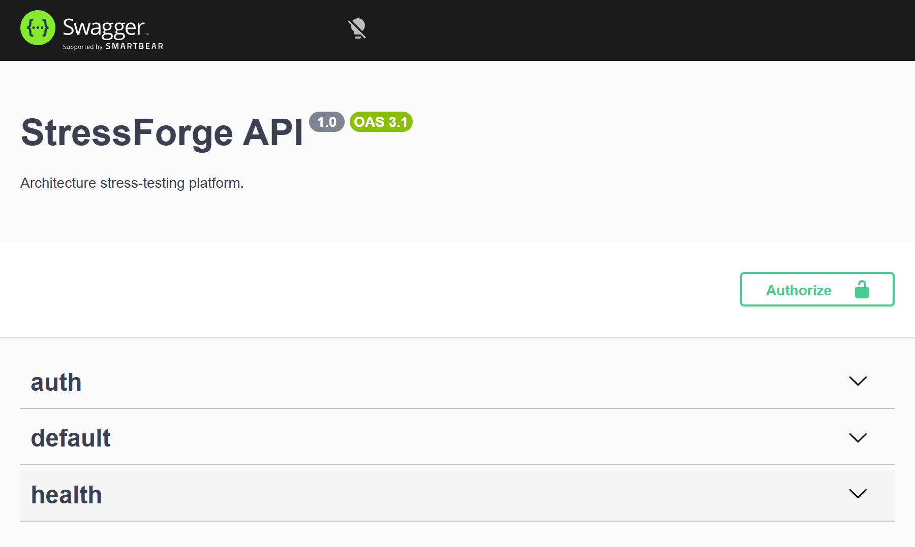
Figure 6.1: Swagger UI at /docs: the endpoint groups and the Authorize button
Registration returns a token and the user, never the hash.
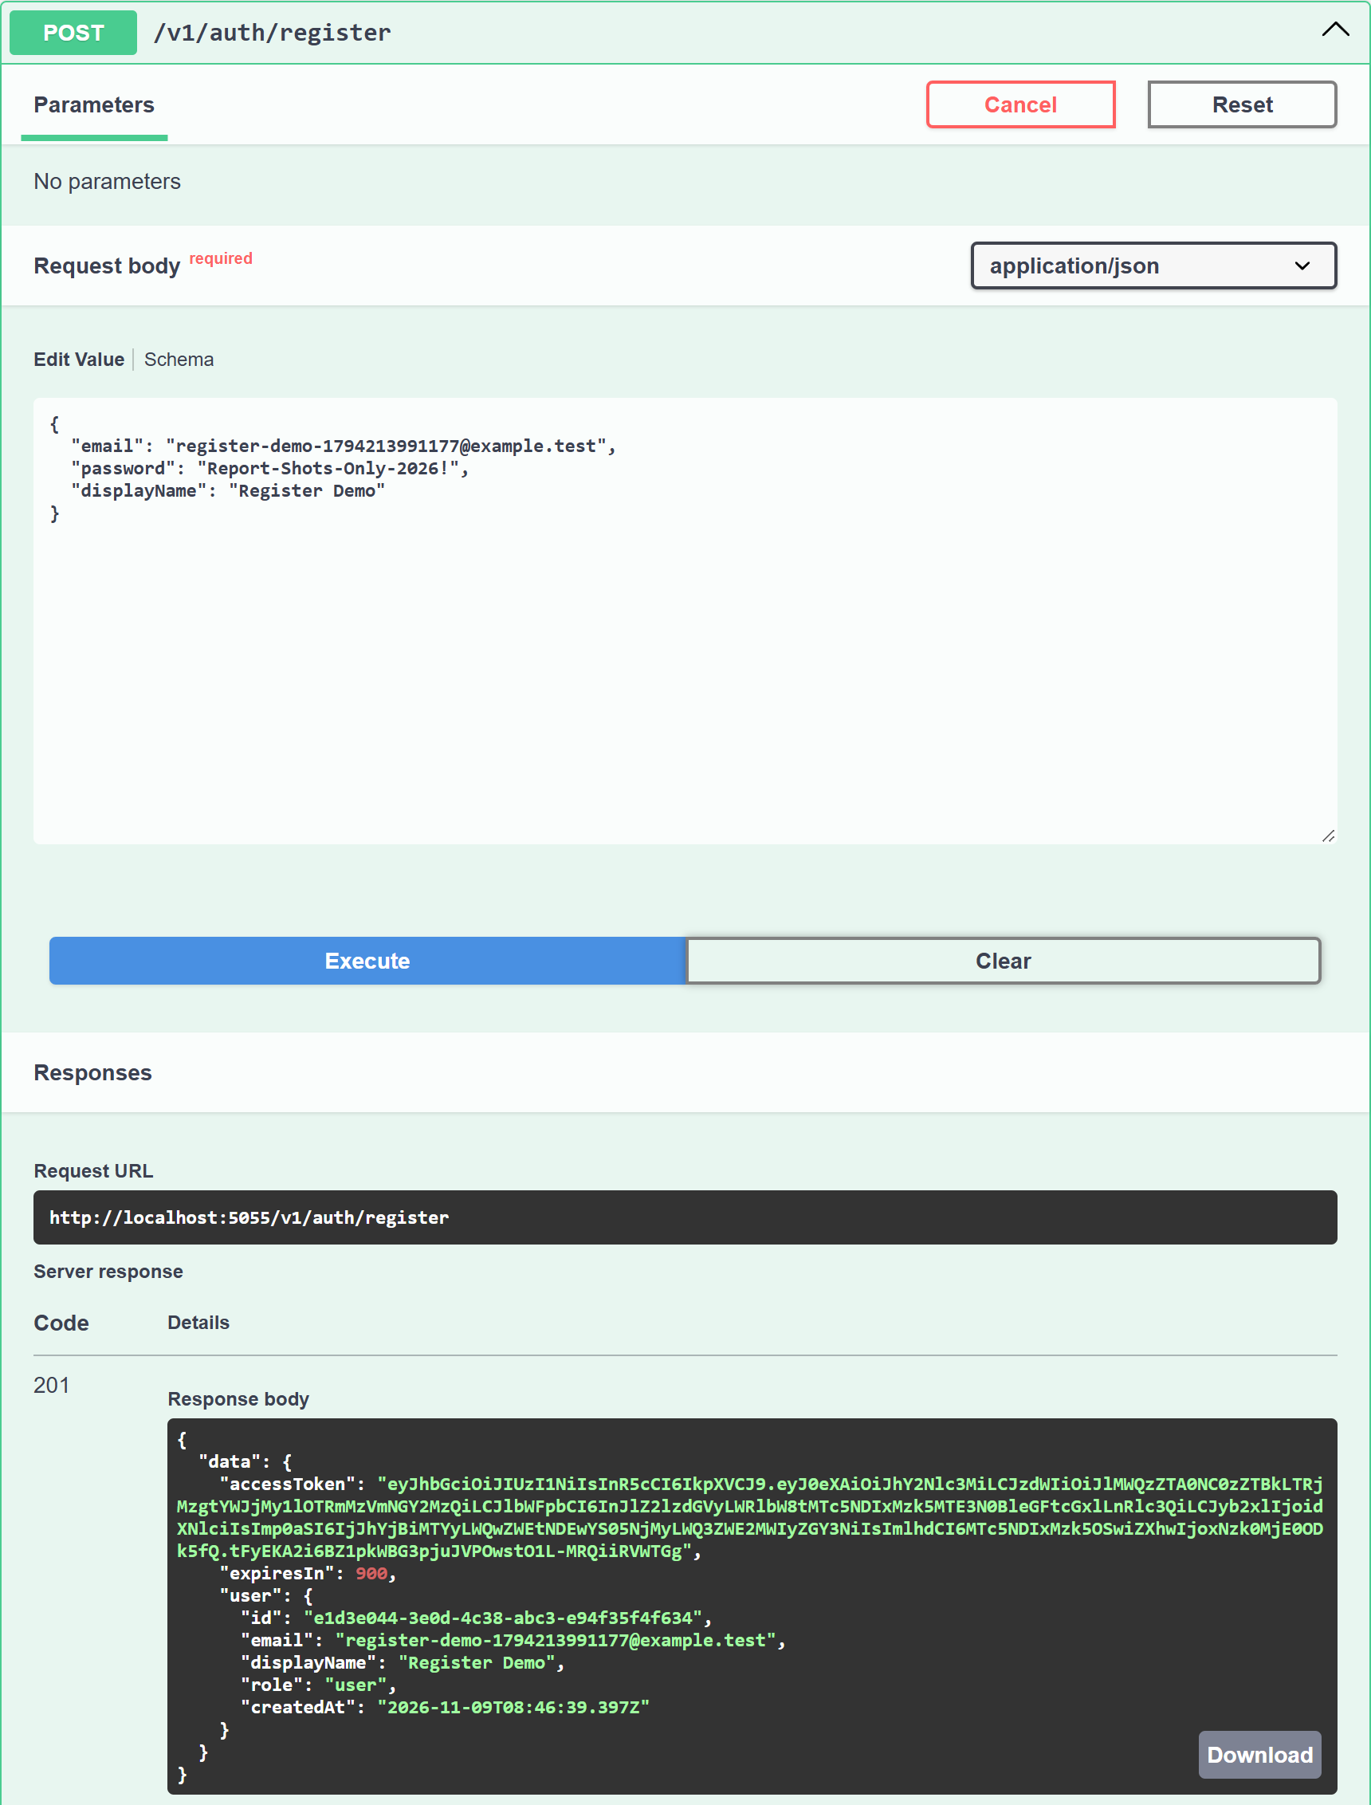
Figure 6.2: POST /v1/auth/register, 201 Created; the response contains no password hash
Login with the account created in the same session.
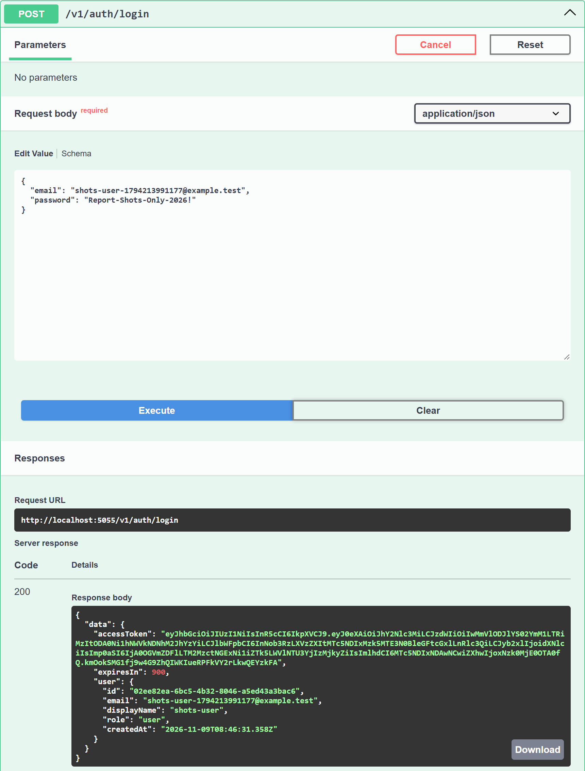
Figure 6.3: POST /v1/auth/login returns a JWT access token
A protected route refuses a request without a token.
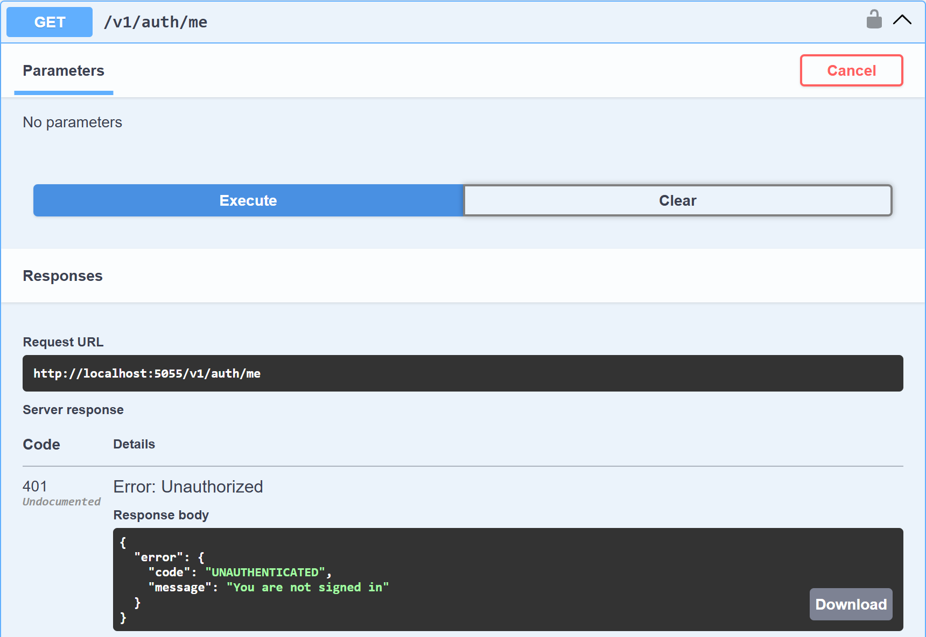
Figure 6.4: GET /v1/auth/me without a token, 401 Unauthorized
A valid token without the Admin permission is refused.
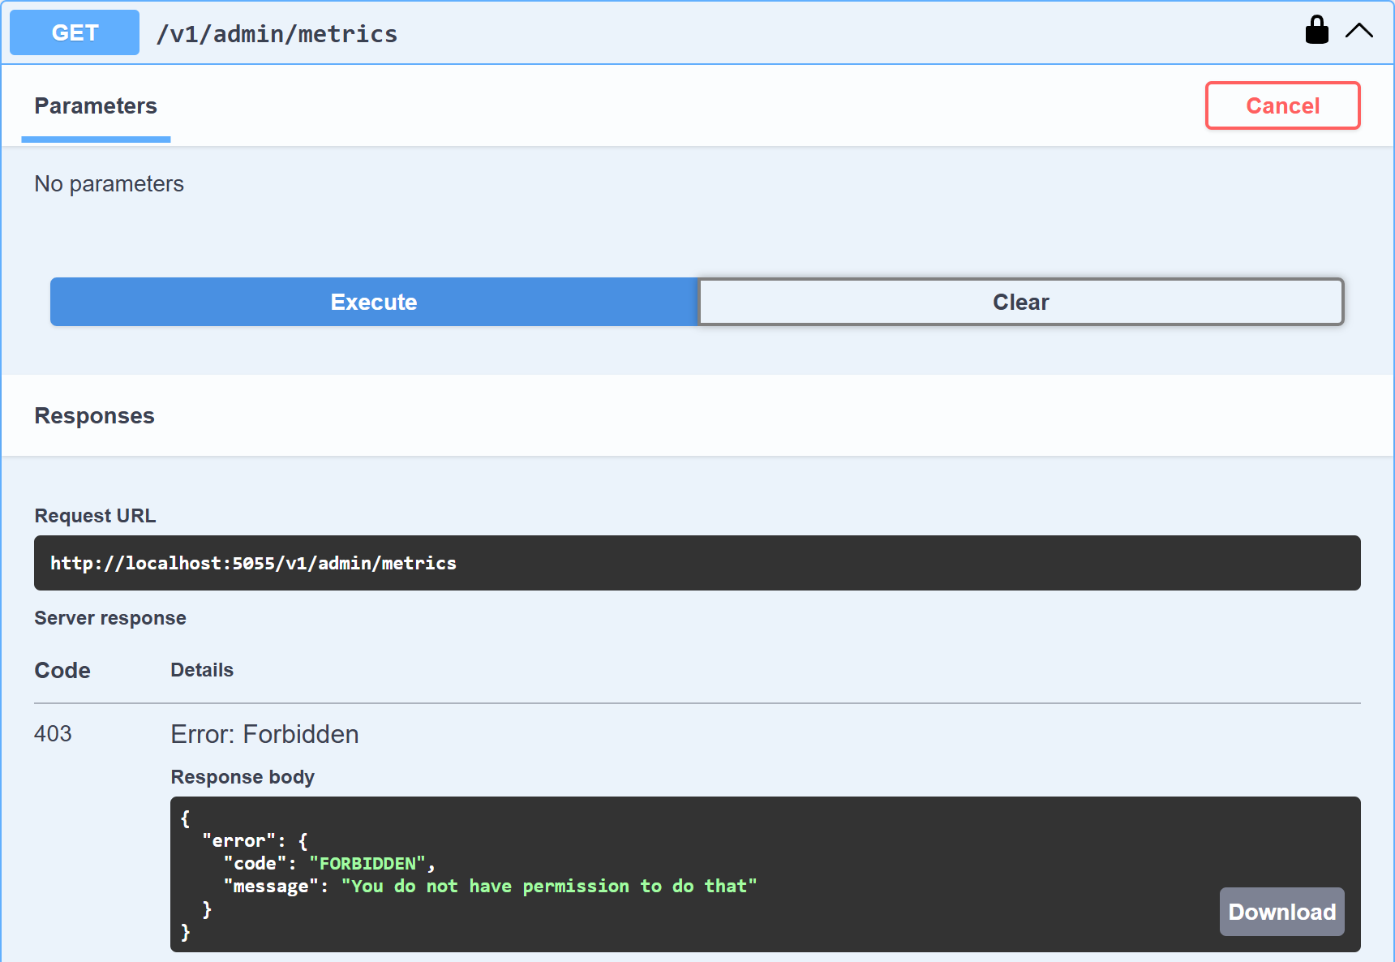
Figure 6.5: an ordinary user calls GET /v1/admin/metrics, 403 Forbidden
Creating a design (the guide's "create book").
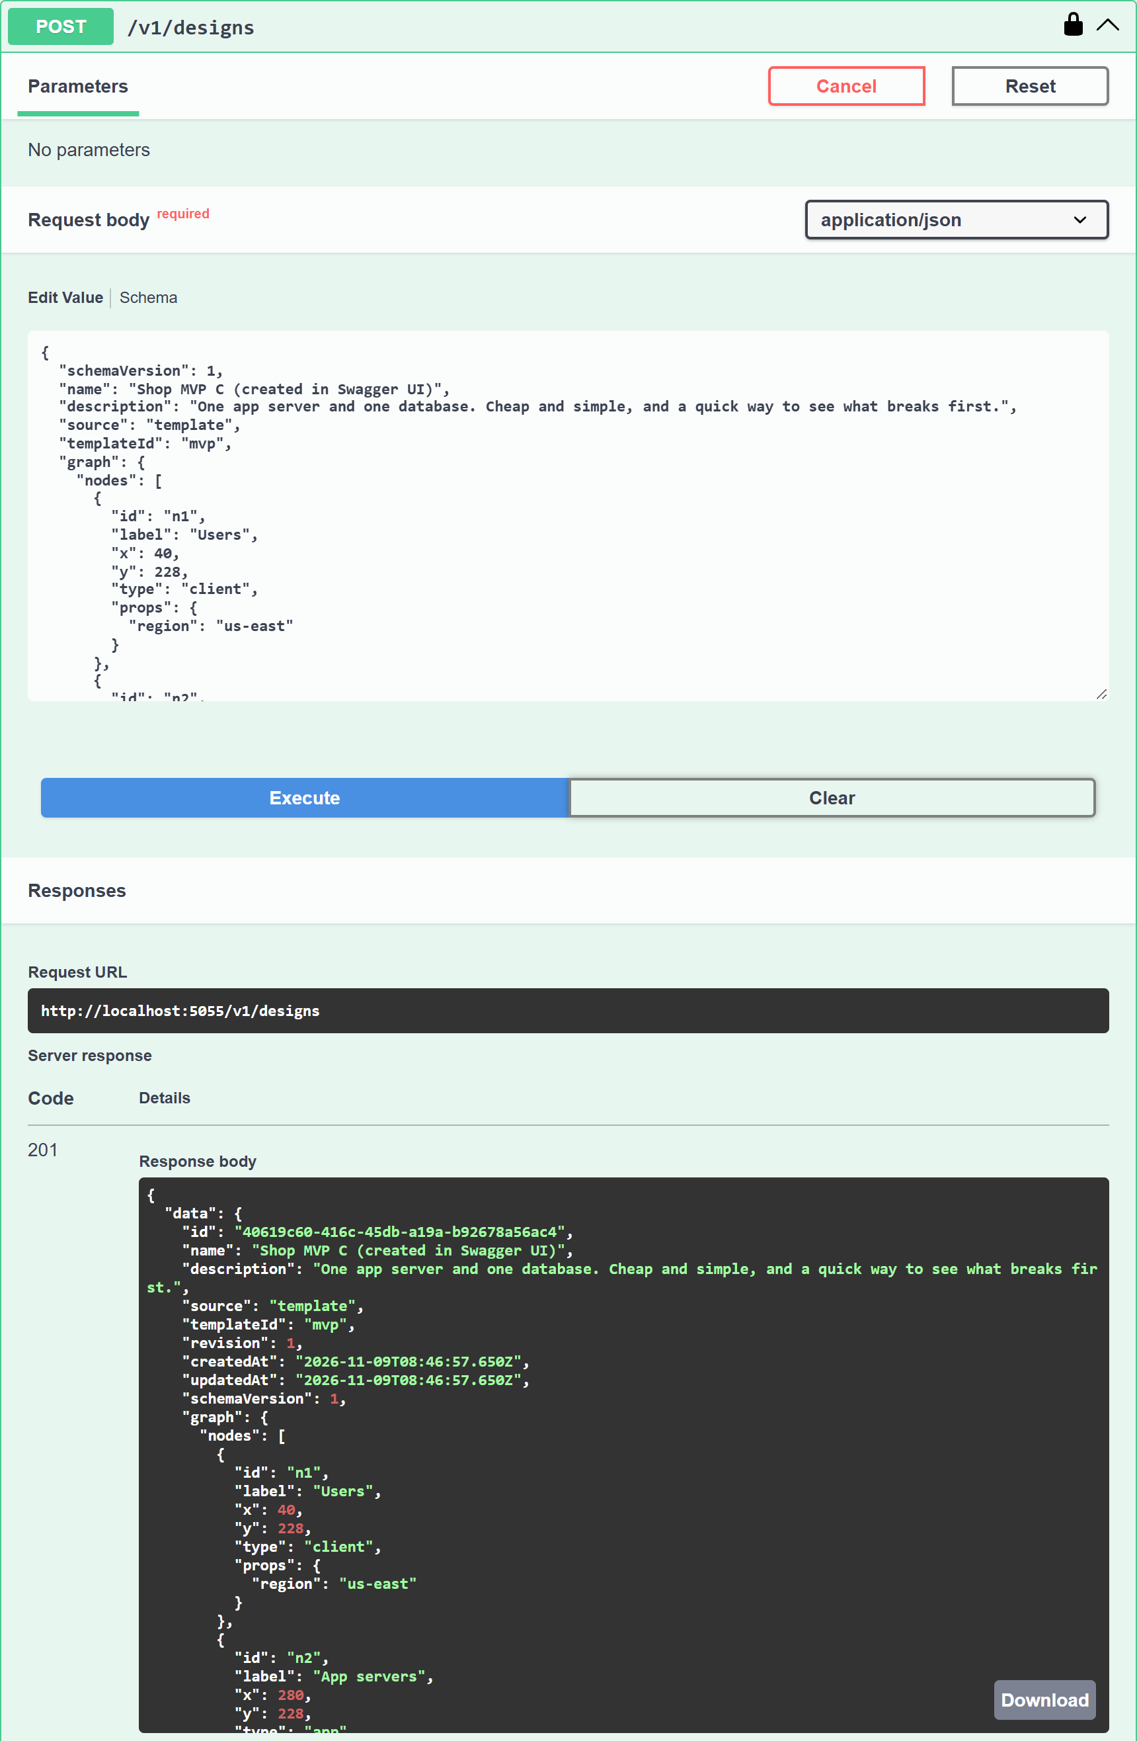
Figure 6.6: POST /v1/designs with the MVP template graph, 201 Created
Validation error. This API returns 422 where the guide says 400.
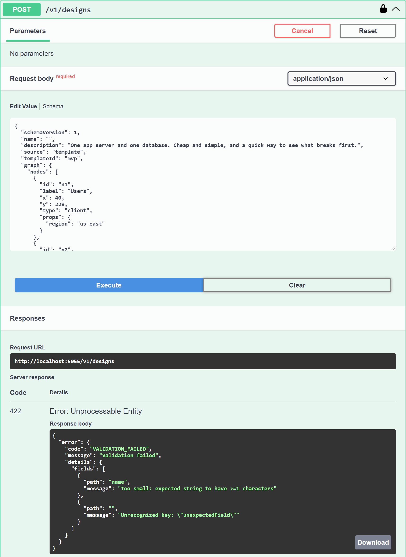
Figure 6.7: POST /v1/designs with an empty name and an unknown field, 422 with each failing field named
Optimistic-concurrency conflict (the guide's duplicate-value 409).
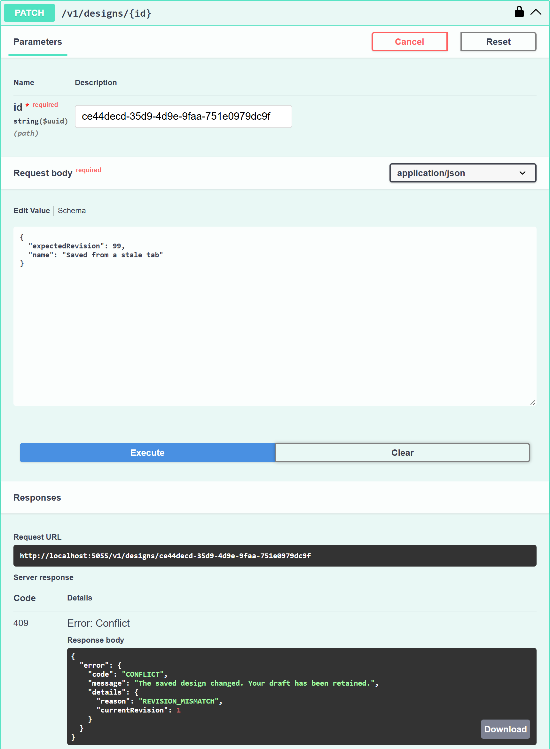
Figure 6.8: PATCH /v1/designs/{id} with a stale expectedRevision, 409 Conflict
List with pagination.
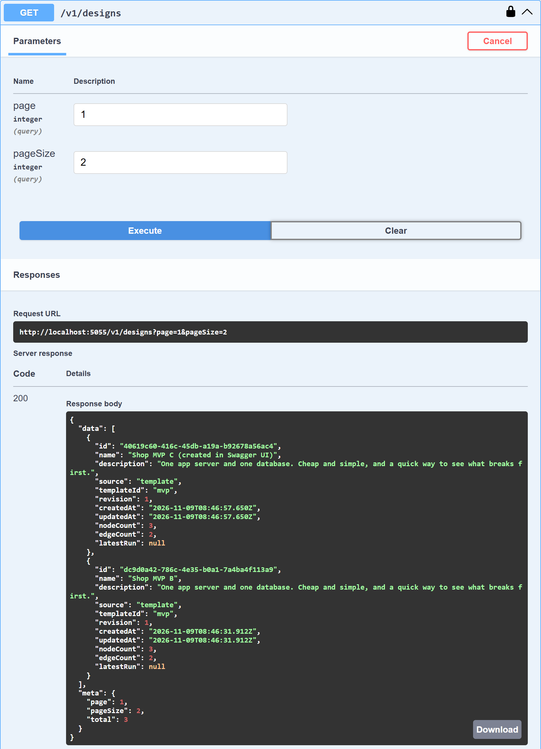
Figure 6.9: GET /v1/designs?page=1&pageSize=2 with the paging metadata
Transaction success, request side.
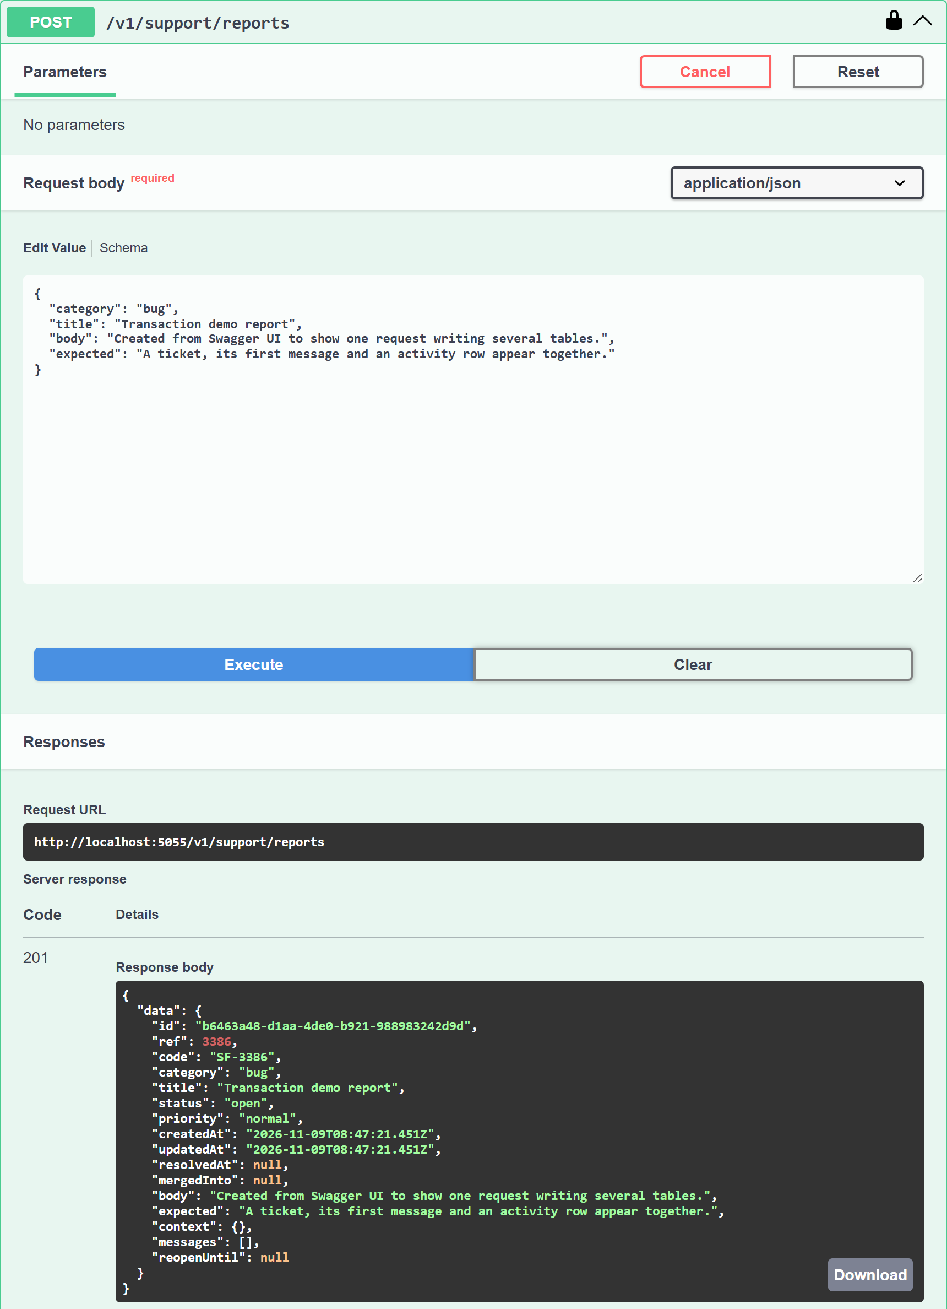
Figure 6.10: POST /v1/support/reports, 201 Created: one request, one transaction
Transaction success, database side. Real psql output, rendered from the terminal.
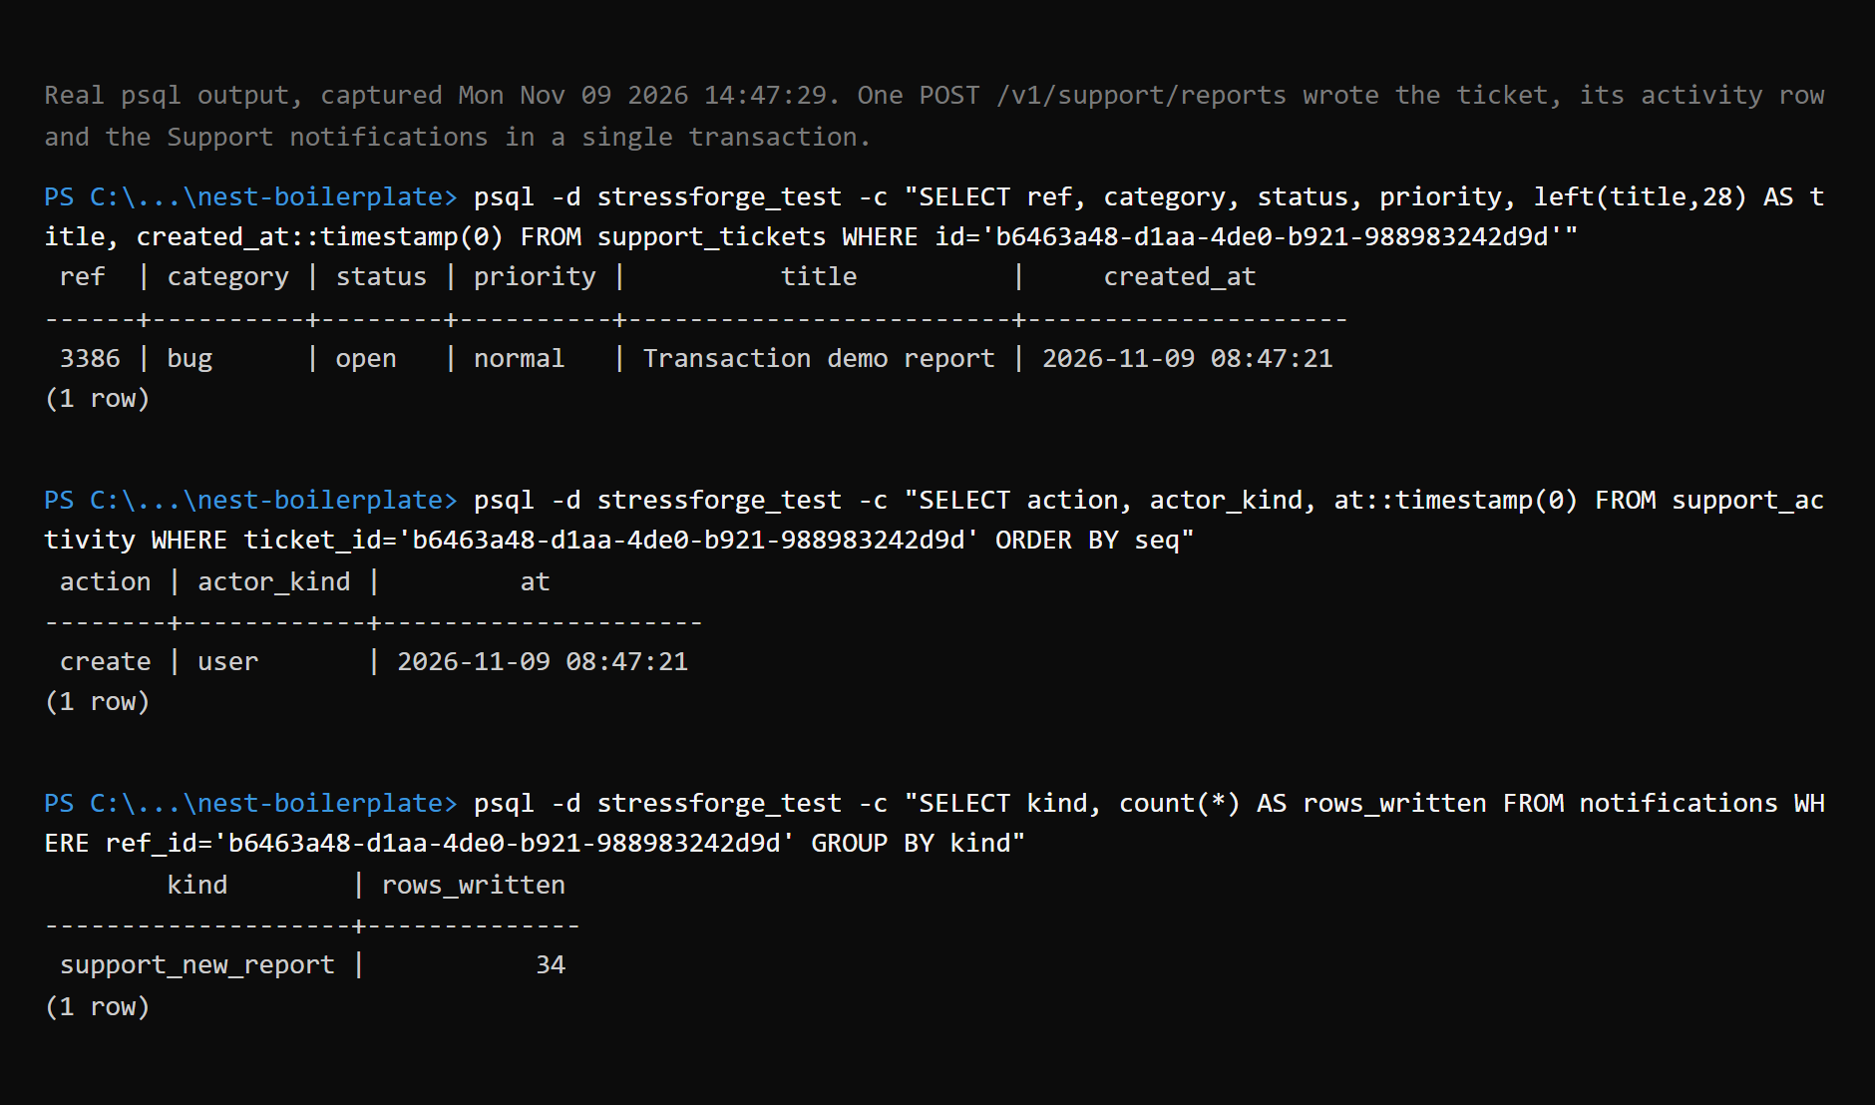
Figure 6.10b: the rows the same request wrote (ticket, activity row and Support notifications), read with psql
Rollback on failure. The failure is injected inside the server, so this is a test run, not a Swagger call.
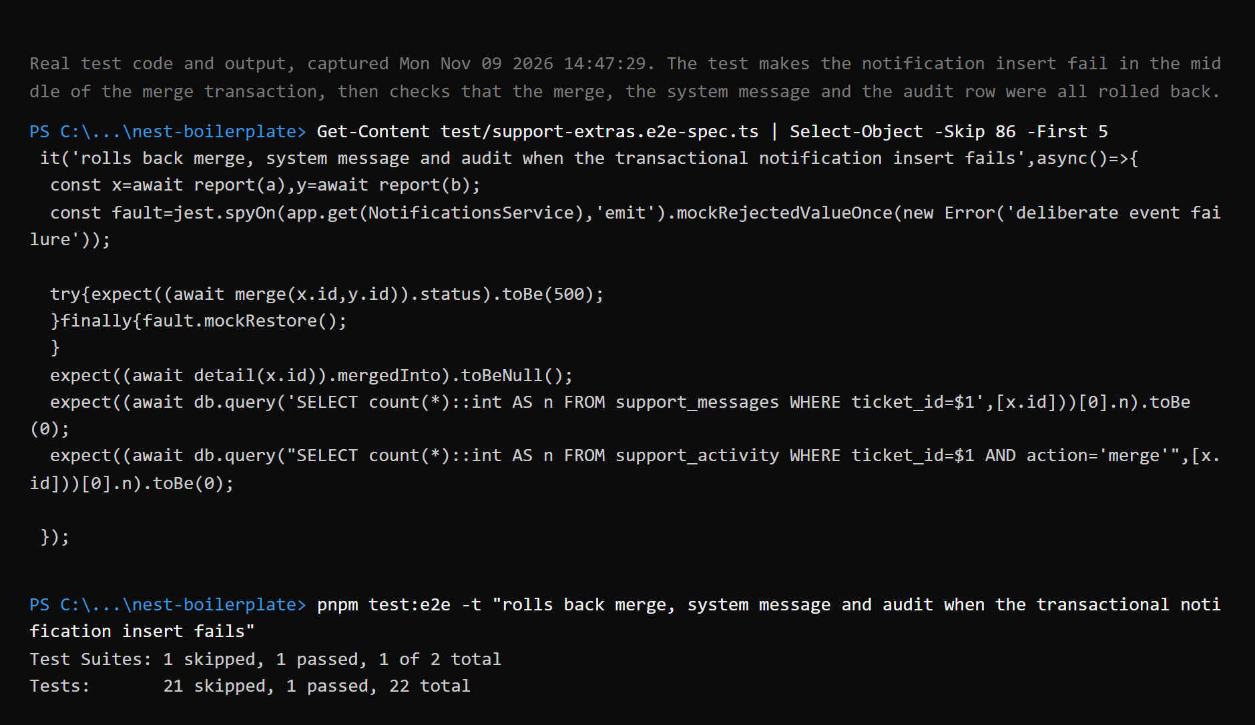
Figure 6.11: a test forces a failure in the middle of the merge transaction and checks that nothing was saved
An asynchronous run accepted (stands in for the guide's "return book with late fine").
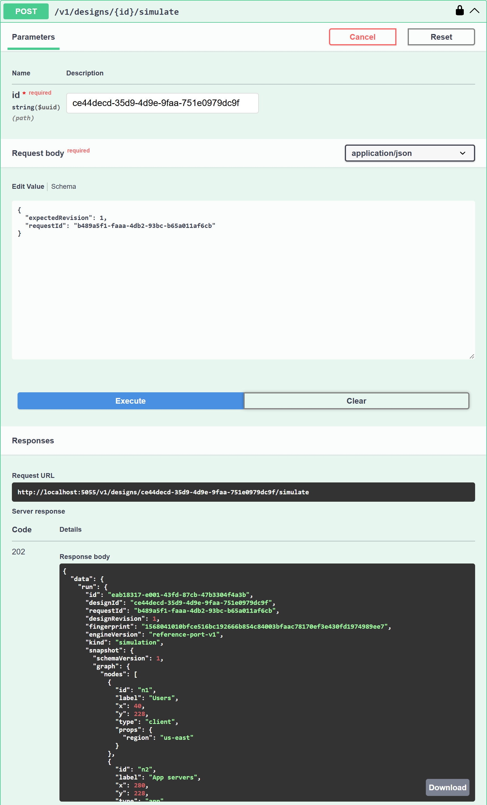
Figure 6.12: POST /v1/designs/{id}/simulate, 202 Accepted
Audit log listing.
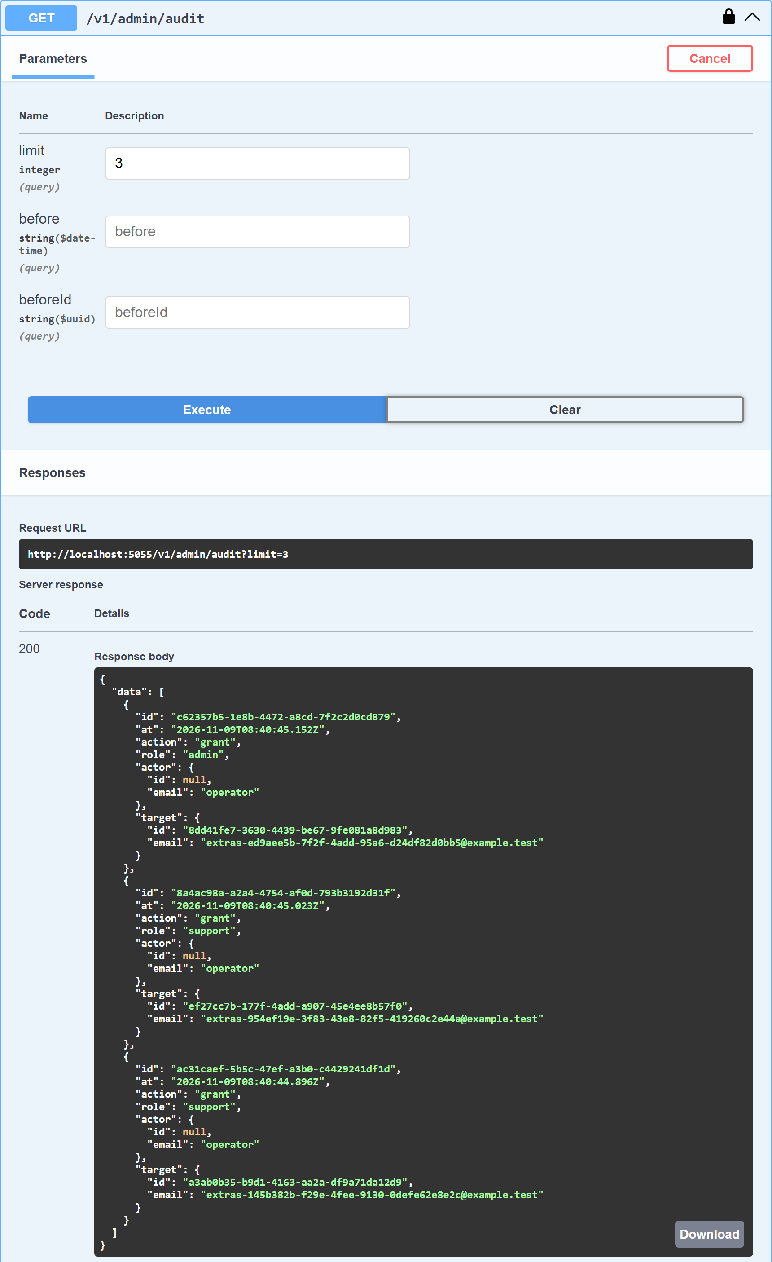
Figure 6.13: GET /v1/admin/audit?limit=3 as an Admin
Email in the Mailtrap inbox. The mail contains the report number and a link, never the text of the report.
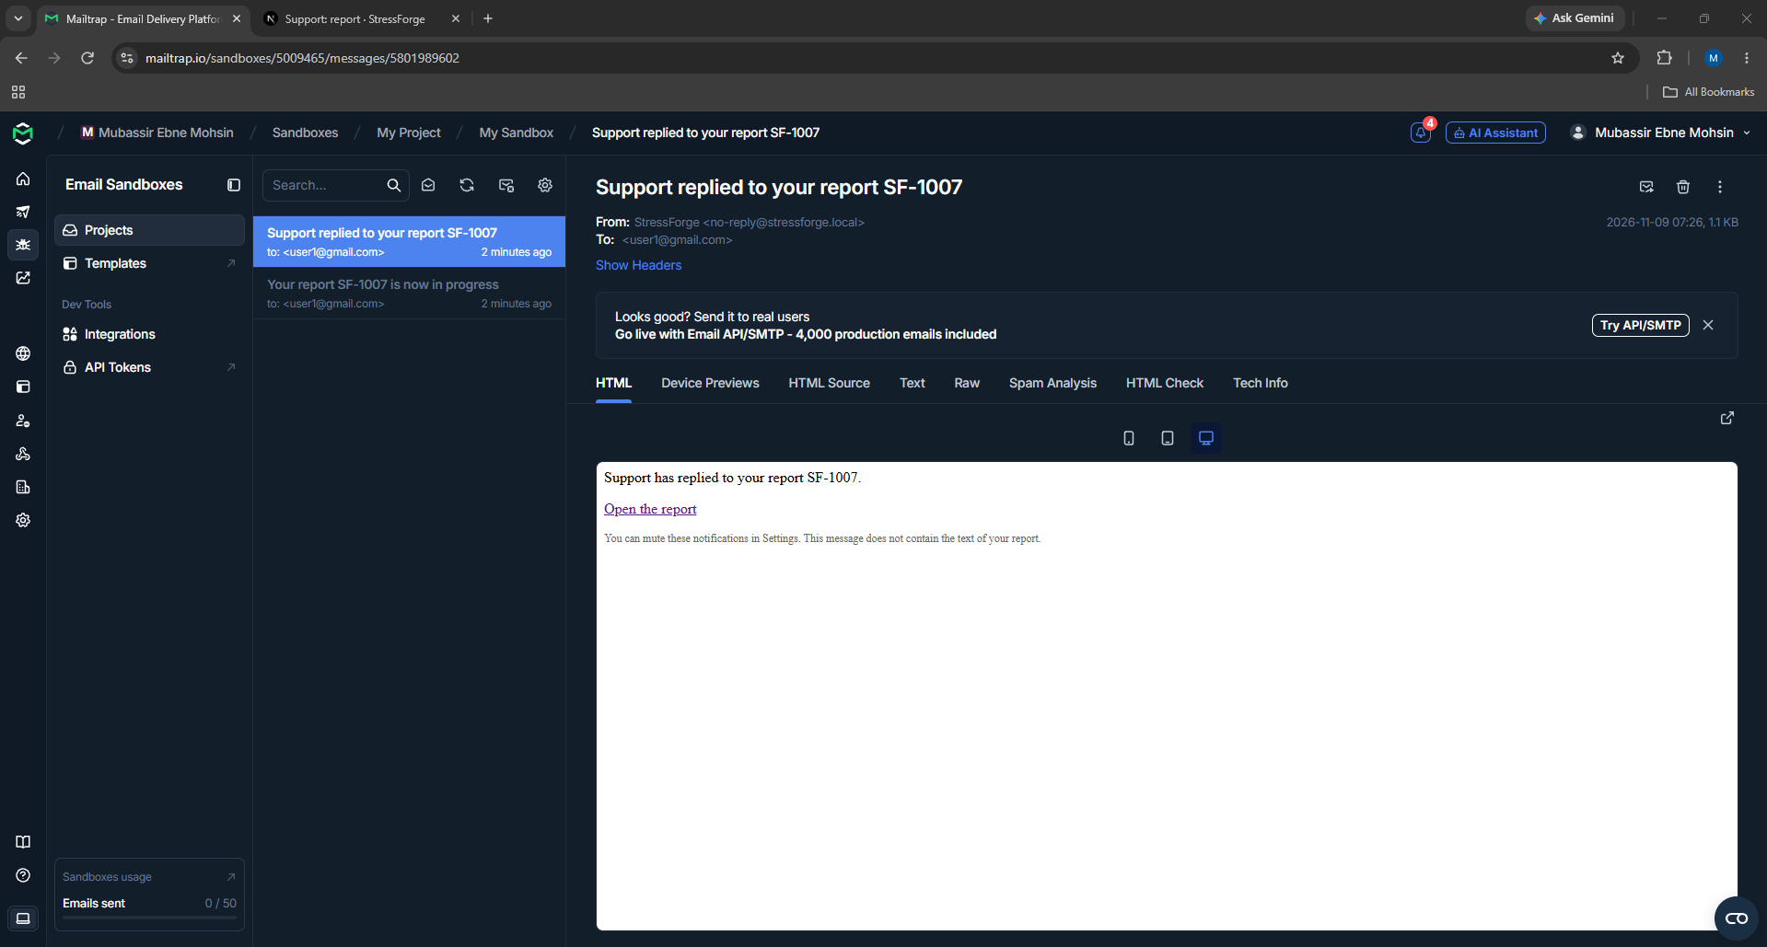
Figure 6.14: the email "Support replied to your report" in the Mailtrap sandbox inbox
The second email, sent when Support changed the status. It also contains only the report number, a status word and a link.
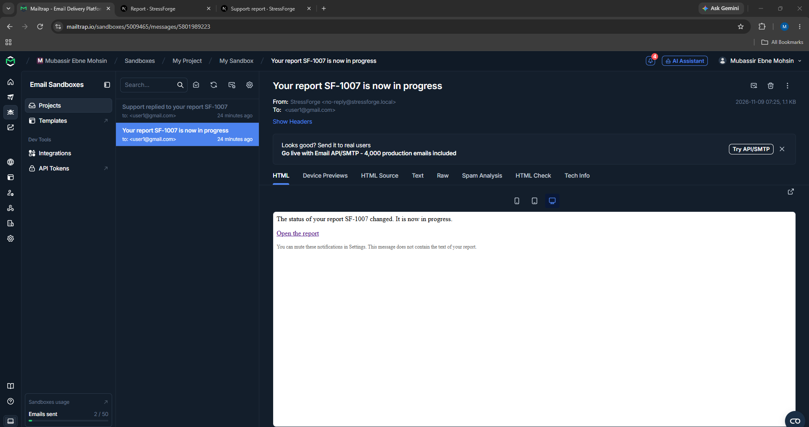
Figure 6.14b: the email "Your report SF-1007 is now in progress" in the same Mailtrap inbox
Migrations on an empty database. Real terminal output, rendered; the database was deleted afterwards.
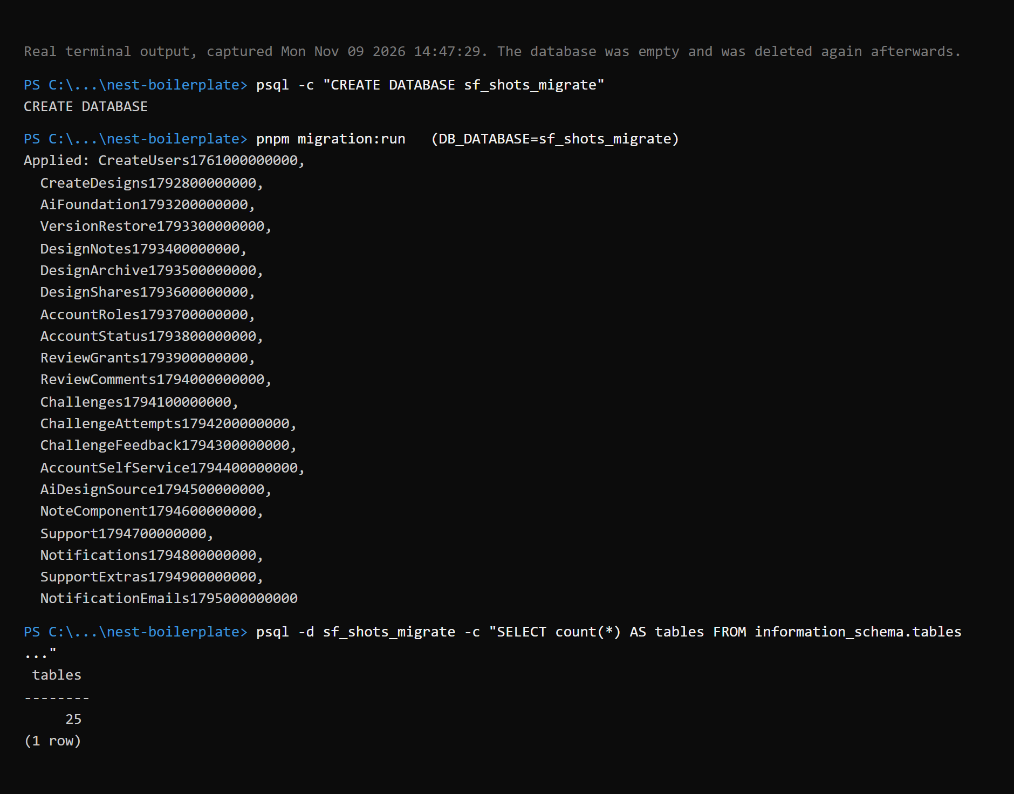
Figure 6.15: pnpm migration:run on an empty database applies all 21 migrations

7. Implementation Highlights
The excerpts are copied from the repository; where lines are left out for length the omission is marked with // ....

7.1 A strict request contract
A request body is described once, as a Zod schema. z.strictObject rejects any key that is not listed, so nothing extra (or sensitive) can be smuggled in; every text field has a minimum and maximum length and refuses control characters. The same schema supplies the TypeScript type and the Swagger documentation. File: src/common/contracts/phase3/support.schema.ts.
export const createReportSchema = z.strictObject({
category: categorySchema,
title: plain(TITLE_MIN, TITLE_MAX),
body: plain(BODY_MIN, BODY_MAX),
expected: plain(1, EXPECTED_MAX).optional(),
context: reportContextSchema.default({}),
/** Set after the person has been told they already have an open report with this title. */
confirmDuplicate: z.boolean().optional(),
});

7.2 Creating a report inside a transaction
Creating a report counts the account's recent reports, checks for a duplicate title, inserts the ticket, writes the activity row and creates the notifications for Support staff. All of it runs in one transaction. A per-account advisory lock at the start makes two quick requests from the same account run one after the other, so both cannot slip under the limit of 5 reports an hour. If any step throws, PostgreSQL rolls everything back. File: src/modules/support/support.service.ts.
async create(user: AuthUser, raw: unknown) {
const parsed = createReportSchema.safeParse(raw);
if (!parsed.success) throw invalid(parsed.error);
const input = parsed.data;
const id = await this.db.transaction(async (m) => {
// One account's reports are counted and added one at a time, so two quick requests cannot both slip under the limit.
await m.query("SELECT pg_advisory_xact_lock(hashtext($1))", ["sf-support-create:" + user.id]);
// ... counting query, then the two limit checks that throw AppException("RATE_LIMITED", ...)
if (!input.confirmDuplicate) {
// ... look for an open report with the same title; throw AppException("CONFLICT", ..., { reason: "DUPLICATE_OPEN" })
}
const [row] = (await m.query(
`INSERT INTO support_tickets (author_id, category, title, body, expected, context, created_at, updated_at, last_user_activity_at)
VALUES ($1, $2, $3, $4, $5, $6::jsonb, ${NOW}, ${NOW}, ${NOW}) RETURNING id, ref`,
[user.id, input.category, input.title, input.body, input.expected ?? null, JSON.stringify(input.context)],
)) as Row[];
await this.activity(m, { id: row.id as string, ref: row.ref as number }, "create", { kind: "user", id: user.id, email: user.email }, null, "open");
await this.notifications.team(m,"support_new_report",row.id as string,user.id);
return row.id as string;
});
return this.own(user.id, id);
}

Figure 6.10b shows the rows this transaction wrote, and Figure 6.11 shows an end-to-end test that makes the notification step fail on purpose and then checks that the ticket changes, the system message and the audit row were all rolled back.

7.3 Permissions read from the database on every call
The global PermissionGuard reads the permission a route declares with @RequirePermission and compares it with the account's roles loaded from the `user_roles` table at that moment, not from the token. A role revoked a second ago therefore stops working immediately, even while the account still holds a valid access token. File: src/modules/roles/permission.guard.ts.
async canActivate(context: ExecutionContext): Promise<boolean> {
const needed = this.reflector.getAllAndOverride<Permission | undefined>(PERMISSION_KEY, [context.getHandler(), context.getClass()]);
if (!needed) return true;
const user = context.switchToHttp().getRequest<IRequest>().user;
if (!user) throw new AppException("UNAUTHENTICATED", "You are not signed in");
if (!hasPermission(await this.roles.rolesOf(user.id), needed)) throw new AppException("FORBIDDEN", "You do not have permission to do that");
return true;
}

Guards are registered once in app.module.ts as global providers in a fixed order (rate limit, authentication, ranked role check, permission), so no controller can forget them.

7.4 Timing-safe login
A login for an email that does not exist still performs an argon2 verification against a dummy hash, so the response time does not reveal which emails have accounts. A suspended account is reported only after the password is correct, for the same reason. File: src/modules/auth/auth.service.ts.
const DUMMY_HASH_PROMISE = argon2.hash("not-a-real-password");
// ...
const user = await this.users.findByEmail(dto.email);
const hash = user?.passwordHash ?? (await DUMMY_HASH_PROMISE);
const ok = await argon2.verify(hash, dto.password);
if (!user || !ok)
throw new AppException("UNAUTHENTICATED", BAD_CREDENTIALS);

7.5 One exception filter for every error
Every failure leaves the server through one global filter, so the client sees one shape and never a stack trace. A unique-key violation that reaches the filter (a race, or a path that did not check first) becomes 409 Conflict with a generic message; constraint and column names stay in the database. File: src/common/filters/all-exceptions.filter.ts.
/** PostgreSQL error 23505 (unique_violation), whether it arrives wrapped by TypeORM or straight from pg. */
export function isUniqueViolation(exception: unknown): boolean {
if (!(exception instanceof Error)) return false;
const direct = (exception as { code?: unknown }).code;
const wrapped = (exception as { driverError?: { code?: unknown } })
.driverError?.code;
return direct === "23505" || wrapped === "23505";
}
// ...
if (isUniqueViolation(exception)) {
return this.build(409, "CONFLICT", "That value already exists");
}
return this.build(500, "INTERNAL", "Something went wrong");

7.6 Optional email that cannot hurt a request
The mailer is a Bull repeating job that reads notifications which already exist, sends a short email for the two reporter-facing kinds, and records the outcome in notification_emails. It edits no existing write path and never runs inside a request, so a mail failure can delay an email but never affect a Support action. The module is not even loaded unless MAIL_ENABLED=true. File: src/modules/mails/mail-outbox.service.ts.
try {
const message = renderMail(row.kind, {
ref: row.ref,
status: row.status,
url: reportUrl(this.options.frontendUrl, row.ref_id),
});
await this.sender.send({ to: row.email, ...message });
await this.record(row.id, "sent", attempts, null);
result.sent++;
} catch (error) {
const code = String((error as { code?: unknown })?.code ?? "SEND_FAILED").slice(0, 40);
const final = attempts >= MAX_ATTEMPTS;
await this.record(row.id, final ? "failed" : "retry", attempts, code);
// No address, subject or server message: those can carry personal data or credentials.
this.log.warn(`Email not sent (${code}), attempt ${attempts} of ${MAX_ATTEMPTS}`);
}

7.7 Verification
The following commands were run on the final code on 2026-11-09.
Layer | How it runs | Result
Backend unit tests | npx jest | 63 suites run (1 skipped), 791 tests passed, 2 skipped
Backend end-to-end tests | jest --config ./test/jest-e2e.json --runInBand against a real PostgreSQL database stressforge_test | 33 suites, 429 tests passed
Lint and types | eslint and tsc on the changed files | Clean (one pre-existing type error in a test file of the admin dashboard, unrelated to this work)
Route access | Every route called without a token and with an ordinary user's token (Chapter 5) | 115 routes; declared permissions and observed 403s agree
Deliberate breaks of the mailer | Four deliberate bugs introduced one at a time (replaying old notifications, ignoring the hourly cap, unlimited retries, mailing staff kinds) | All four were caught by the tests; the code was restored
Live email | A real SMTP send to a Mailtrap sandbox inbox | Delivered; no report text in the message (Figures 6.14 and 6.14b)
Migrations | pnpm migration:run on an empty database | 21 migrations applied; 25 tables including the bookkeeping table (Figure 6.15)

8. Conclusion and References
STRESSFORGE meets the guide's five minimum requirements and implements the bonus items listed in Section 5.3: middleware, custom decorators, an optional mailer, Swagger UI, an interceptor, environment configuration, migrations, a response envelope and advanced transactions. The audit log is partial (role changes and Support activity, not every create, update and delete). The system has 115 endpoints on 24 application tables, five roles enforced by a database-backed permission guard, and a simulation engine whose results are saved with the exact inputs that produced them.
Three differences from the guide are deliberate and stated: argon2 instead of bcrypt, Zod instead of class-validator, and HTTP 422 instead of 400 for validation errors. Approval requested on 19 November 2026.

Known limits
- The model is a mathematical estimate. It does not measure real systems and is not calibrated against load-test data from a deployed system.
- The optional AI features are off by default; the planned acceptance run against the hosted model has not been completed.
- Email is verified only against a sandbox inbox, and an email is sent only for Support replies and status changes.
- Not every create, update and delete is written to an audit log.
- The simulation admission queue is per API instance; running several instances would need a shared queue.
- The web client has no accessibility audit beyond keyboard support and contrast checks, and no translation.

Next steps
- A general audit interceptor for every create, update and delete.
- Failure injection (switch a component or region off) and a cost estimate per design.
- Calibration of the model against real load-test measurements.
- Support access to one frozen design revision, by the reporter's consent.

References
- NestJS documentation. https://docs.nestjs.com
- TypeORM documentation. https://typeorm.io
- PostgreSQL documentation. https://www.postgresql.org/docs/
- M. Jones, J. Bradley, N. Sakimura. JSON Web Token (JWT). RFC 7519. https://datatracker.ietf.org/doc/html/rfc7519
- R. Fielding, M. Nottingham, J. Reschke. HTTP Semantics. RFC 9110. https://datatracker.ietf.org/doc/html/rfc9110
- A. Biryukov, D. Dinu, D. Khovratovich, S. Josefsson. Argon2 Memory-Hard Function for Password Hashing. RFC 9106. https://datatracker.ietf.org/doc/html/rfc9106
- Zod documentation. https://zod.dev
- OpenAPI Specification 3.1. https://spec.openapis.org/oas/v3.1.0
- Next.js documentation. https://nextjs.org/docs
- Bull job queue. https://github.com/OptimalBits/bull
- Nodemailer. https://nodemailer.com
- Mailtrap Email Sandbox. https://mailtrap.io

