**Question# 01**

//Muhammad Mubbashir

//SP20-BSCS-0084

#include <stdio.h>

int main()

{

int input1,input2;

printf("Enter value of p in binary: ");

scanf("%d", &input1);

printf("Enter value of q in binary: ");

scanf("%d", &input2);

printf("-----------------------");

if((input1==0||input1==1)||(input2==1||input2==0))

{

printf("\n The conjuction of p and q is: %d",(input1&&input2));

printf("\n The disjuction of p or q is: %d",(input1||input2));

printf("\n The Exclusive of p or q is: %d",(input1^input2));

if(input1==1 && input2==0)

{

printf("\n The conditional of p and q is: 0");

}

else{

printf("\n The conditional of p and q is: 1");

}

if((input1==1 && input2==1)||(input1==0 && input2==0)){

printf("\n The biconditional of p and q is: 1");

}

else {

printf("\n The biconditional of p and q is: 0");

}

}

else{

printf("Please Input 0 and 1");

}

}

**OUTPUT:**

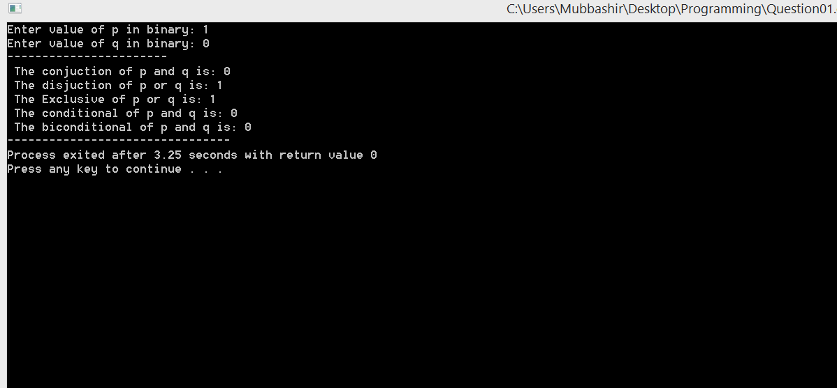

**Question# 02**

//Muhammad Mubbashir

//SP20-BSCS-0084

#include <stdio.h>

#include <stdlib.h>

#include <string.h>

int main()

{

char Value1[40];

char Value2[40];

char n1 = '0';

char n2 = '1';

char Result[40];

int Value_lenght;

printf("\n Enter Bitwise Value 1: ");

scanf("%s",&Value1);

Value_lenght=strlen(Value1);

printf("\n Enter Bitwise Value 2: ");

scanf("%s",&Value2);

printf("\n");

//---------------------------XOR------------------

for (int i = 0; i < Value_lenght; i++)

{

if (Value1[i] == Value2[i])

{

Result[i] = n1;

}

else

{

Result[i] = n2;

}

}

printf("bitwise XOR is: %s\n", Result);

//---------------------------AND------------------

for (int i = 0; i < Value_lenght; i++)

{

if (Value1[i]=='1' && Value2[i]=='1')

{

Result[i] = n2;

}

else

{

Result[i] = n1;

}

}

printf("Biwise AND is: %s\n", Result);

//---------------------------OR------------------

for (int i = 0; i < Value_lenght; i++)

{

if (Value1[i]=='0' && Value2[i]=='0')

{

Result[i] = n1;

}

else

{

Result[i] = n2;

}

}

printf("Biwise OR is: %s\n", Result);

}

**OUTPUT:**

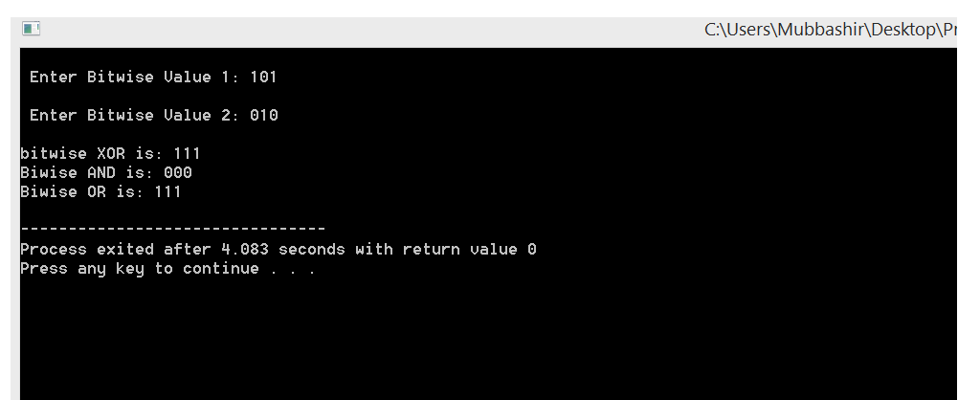

**Question# 03**

//Muhammad Mubbashir

//SP20-BSCS-0084

#include <stdio.h>

#include <stdlib.h>

int main()

{

int Domain_Range=0 ,Co_Domain_Range=0,count1=0, count2=0;

int Domain[Domain_Range],Co_Domain[Co_Domain_Range];

printf("Enter Range for Domain: ");

scanf("%d",&Domain_Range);

printf("\n Input elements for domain([1,2,,...,n]): \n");

for(int i=0;i<Domain_Range;i++){

scanf("%d",&Domain[i]);

if(Domain[i]>=0){

count1++;

}

else{

printf("\nplx enter positive number");

exit(0);

}

}

printf("Enter Range for Co_domain: ");

scanf("%d",&Co_Domain_Range);

printf("\n Input elements for codomain(set of integers):\n ");

for(int i=0;i<Co_Domain_Range;i++){

scanf("%d",&Co_Domain[i]);

count2++;

}

//--------------print------------

printf("\n Domain ");

for(int i=0;i<Domain_Range;i++){

printf("\n %d",Domain[i]);

}

printf("\n Co_domain ");

for(int i=0;i<Co_Domain_Range;i++){

printf("\n %d",Co_Domain[i]);

}

if(count1<=count2){

printf("\n\nIt is one to one function ");

}

else{

printf("\n\nIt is not one to one function ");

}

}

**OUTPUT:**

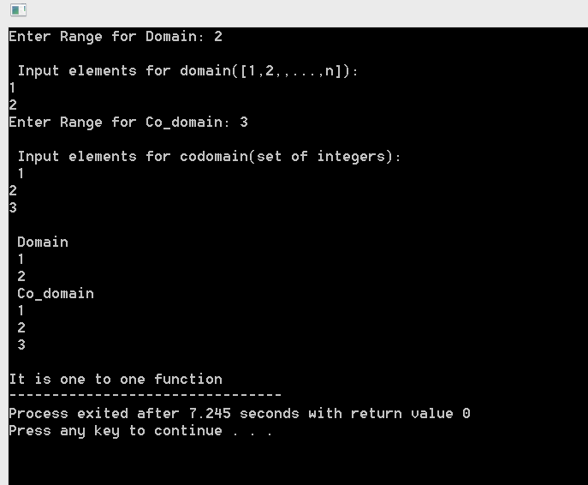

**Question# 04**

//Muhammad Mubbashir

//SP20-BSCS-0084

#include <stdio.h>

#include <stdlib.h>

int main()

{

int Domain_Range=0 ,Co_Domain_Range=0,count1=0, count2=0;

int Domain[Domain_Range],Co_Domain[Co_Domain_Range];

printf("Enter Range for Domain: ");

scanf("%d",&Domain_Range);

printf("\n Input elements for domain([1,2,,...,n]): \n");

for(int i=0;i<Domain_Range;i++){

scanf("%d",&Domain[i]);

if(Domain[i]>=0){

count1++;

}

else{

printf("\nplx enter positive number");

exit(0);

}

}

printf("Enter Range for Co_domain: ");

scanf("%d",&Co_Domain_Range);

printf("\n Input elements for codomain(set of integers): \n ");

for(int i=0;i<Co_Domain_Range;i++){

scanf("%d",&Co_Domain[i]);

count2++;

}

//--------------print------------

printf("\n Domain ");

for(int i=0;i<Domain_Range;i++){

printf("\n %d",Domain[i]);

}

printf("\n Co_domain ");

for(int i=0;i<Co_Domain_Range;i++){

printf("\n %d",Co_Domain[i]);

}

if(count1>=count2){

printf("\n\nIt is onto function ");

}

else{

printf("\n\nIt is not onto function ");

}

}

**OUTPUT:**

