

**KARNATAKA SCIENCE COLLEGE DHARWAD**

**DEPARTMENT OF COMPUTER SCIENCE**

**2022-2023**



**PROJECT REPORT ON**

**“POLIO VACCINATION SYSTEM’’**

**UNDER THE GUIDANCE OF**

**SMT.LALITHA.R. NAIK**

**SUBMITTED BY**

**Mubbassirkhan Jahagirdar (20M10017)**

**Madhu Kalakeri(20M10013)**

**BSC(CS) 5th SEM**

**KARANTAK SCIENCE COLLEGE , DHARWAD**

**DEPARTMENT OF COMPUTER SCIENCE**

**2021-2022**



**CERTIFICATE**

This is to certify that ***Mrs.Mubbassirkhan Jahagirdar*** *and* ***Mis.Madhu Kalakeri*** has satisfactorily completed the project work entitled **"Polio Vaccination System"** for the partial fulfilment of degree in Bachelor of Computer Science from the Karnataka University, Dharwad for the year 2022-2023

**Project Associates: Project Guide Mubbassirkhan Jahagirdar SMT.LALITHA.R.NAIK**

**Madhu Kalakeri**

**Examiners: Head Of The Department**

**1-………………………...**

**2-…………………… SMT.LALITHA.R. NAIK**

**ACKNOWLEDGEMENT**

Nothing in life is ever successful without the co-operate effort many gifted people who are willing to network and submit their talent experience and passion for a common goal. This work is a product of countless individuals whose thoughts ideas, perspectives and work have us the exposure to knowledge.

The satisfaction and happiness we feel at the successful completion of our project entitled **"Polio Vaccination System"** would be incomplete if did not remember the people who made it possible and crowned our efforts with success. First and Fore most we thank our parents and almighty for their blessings on us at all times in all circumstances.

We are grateful to our beloved principal **Dr S C.Chougala** and Co-ordinate **Smt. Lalitha R. Naik** Department of Computer Science for your kind support.

We express our deep sense of indebtedness to our guide **SMT.LALITHA R. NAIK,** for her dynamic guidance and encouragement. Finally, we thank our Department Faculties **Smt. Ambika R, Smt. Kalpana Dalwai, Dr Nagaraj S, prof. Rajashekhar V.B** for their kind support.

**Project Associates**

**Mubbassirkhan Jahagirdar**

**Madhu Kalakeri**

**ABSTRACT**

Polio is one of the virus which can be eradicate by the vaccine called polio vaccine. This describes a method designed to aid government decision makers in establishing priorities for accelerated development of vaccines against diseases of importance in developing countries. The method is based on a quantitative model in which vaccine candidates are ranked according to their potential health benefits (reduction of morbidity and mortality). The model also provides the capacity to utilize “affordability” (willingness to pay for benefit) as a supplementary criterion.

The approach uses the same (incomplete) information that could theoretically be used in other methods of decision making. Because the information is incomplete and because the method entails, in some instances, predicting the future, gaps must be filled by estimates or judgments by experts. It can use to develop the all children information with respected to their getting vaccine and avoid all respected deseases. Its helps to easily get the children details and vaccine details by this project.

**Table of Contents**

1. Introduction
   1. Problem Definition
   2. Objective of Project
2. Literature Survey
   1. Existing System Disadvantage
   2. Proposed System Advantages
   3. Feasibility Study
3. System Analysis & Design
   1. Requirement Specification
   2. Modules
   3. System Design
   4. DFD Diagram
4. Implementation
   1. Languages Used
   2. Source Code
5. Results
   1. Screenshots
6. Future Enhancement
7. Conclusion
8. References

**CHAPTER-1**

**INTRODUCTION**

1. **Problem Definition:**

Develop a website for polio vaccination, It basically involves giving information through online register. User can directly use their children details easily and where they submits child details by registering themselves by valid password.

Modules**:**

* Admin
* Staff
* User

Polio is also known as ***poliomyelitis*,** it is a RNA virus which flows from person to person. It is a life threatening diseases which causes Paralysis to the children. To overcome from this disease all the children must get all related vaccine that make them strong and healthy.

Two types of vaccines are there. They are:

* 1. OPV: Oral Polio Vaccine
  2. IPV: Inactive Polio Vaccine

First dose is given at birth, second dose is given when the child is 6 weeks old and this procedure is continued till the child is 6 years old. It is the parents responsibility to provide the polio vaccine to their children at the time.

1. **Objective of Project:**

The aim of the project is giving children the ability to fight off the poliovirus means maintaining high population immunity through strong immunization, routine activities as well as schedule of compaigns. Immunize the children and disappear the polio virus from children through getting vaccine and getting all respected doses in respected time. All doses must be known by the respected child parents.

**CHAPTER-2**

**LITERATURE SURVEY**

Literature survey involves the detail study of existing system and invitation to overcome the limitations of the requirement is Reanalysed an the new system is proposed. The new proposed system should provide more facilities than existing system by reciding in same constraints.

**a. Existing system:**

In existing system managing the data/information of child is very difficult, because the information is stores in the form of hard copies (mother card and child card).At present situation parents have to go to hospital and get the vaccine or polio drops to their child. But parents does not know weather their child should get vaccine or not if the child is sick.

Parents have to maintain the queue for getting the vaccine done to their child. If the child does not get the vaccine at time, it might defected by various diseases like diphtheria, Hepatitis-B, titanus, pertusis and haemophilus influenza etc.

**Disadvantages:**

* Children not get vaccine on time.
* Sometimes failure of vaccine delivery at the time of vaccination.
* Parents get the information after arrival to the hospital, if the child is ill or having fever then it should not be given the vaccine.
* The parents doesn’t know whether the vaccine should be postponed or avoided.
* Children who are delayed in getting vaccine, all recommended doses should start as soon as possible but exactly not known to them.
* If children don’t take vaccines at the time then they may get diseases like:
  + Measles which may cause brain swelling and blindness
  + Tetanus which can cause painful muscle contractions and difficulty n eating and breathing.

1. **Proposed System:**

To overcome the problems facing in the Existing System, we are creating a website .In this website users (parents) can register themselves for the polio related information. Parents can book the appointment for the first dose and then for the next dose they receives an SMS to their registered mobile number from the Hospital staffs.

By this website children can get the polio vaccine or drops on the time. Parents can also easily get the information about **polio vaccination system**.

**Advantages:**

* Parents will know all the vaccine related information easily.
* Children get vaccine easily on time.
* Message will be received by parents at every vaccination time.
* Parents easily get the children vaccine details.
* Users can easily book the appointment at the time of vaccination.
* Parents should sure whether the vaccine should postponed or avoided.

**c**. **Feasibility Study:**

Whenever we design new system, normally the management will ask for a feasibility report of the new system. The management wants to know the technicalities and cost involved in creation of new system.

1. Operational Feasibility
2. Economical Feasibility
3. Legal Feasibility
4. Schedule Feasibility
5. Technical Feasibility
6. **Operational Feasibility:**

In Operational Feasibility degree of providing service to requirements is analysed along with how much easy product will be to operate and maintenance after deployment. Along with this other operational scopes are determining usability of product, Determining suggested solution by software development team is acceptable or not etc.

1. **Economic Feasibility:**

In Economic Feasibility study cost and benefit of this website is analysed. Means under this feasibility study a detail child information analysis is carried out what will be cost of the website for development which includes all required cost for final development like hardware and software resource required, design and development cost and operational cost and so on. After that, all which can be analysed by website admin whether project will be beneficial in terms of finance for organization or not.

1. **Legal Feasibility:**

In Legal Feasibility study project is analysed in legality point of view. This includes analysing barriers of legal implementation of project, data protection acts or social media laws, project certificate, license, copyright etc. Overall it can be said that Legal Feasibility Study is study to know if proposed our project conform legal and ethical requirements. Once get the vaccine legally they get another one that all details present in this website.

1. **Schedule Feasibility:**

Schedule Feasibility Study mainly timelines/deadlines is analysed for proposed project which include in every vaccine time. Once we get polio vaccine doses to children it may saved in respected cards in the form of hard copies or soft copies and includes how many times it will take to complete final project which has a great impact on the organization as purpose of this project may fail if it can’t be completed on time means not getting vaccine on time.

1. **Technical Feasibility:**   
    In Technical Feasibility current resources both hardware software along with required technology are analysed/assessed to develop website. This technical feasibility study gives report whether there exists correct required resources and technologies which will be used for website development. Along with this, feasibility study also analyses technical skills and capabilities of technical team, existing technology can be used or not, maintenance and up-gradation is easy or not for chosen technology etc.

**CHAPTER-3**

**SYSTEM ANALYSIS AND DESIGN**

1. **Requirement specification**

A software requirements specification (SRS) is a software system to be developed. It lays out functional and non-functional requirements, and may include a set of use cases that describe user interactions that the software must provide. The purpose of this requirement specification is to outline the requirements for a getting vaccine web project. The aim of the project is to create a user-friendly and functional website for a getting vaccine that makes children healthy and their information in this web project.

**User Requirements:**

**User Roles**: Staff, Administrators, and vaccinators

**User Interface Requirements:**

The user interface shall be web-based, allowing users to access the system and several applications. Users will be able to use the service through applications such as Microsoft Internet Explorer, Mozilla Firefox etc.

User Authentication and Authorization Requirements:

1. Secure login and registration functionality
2. The password reset functionality

* **Functional Requirements:**

These are the requirements that the end user specially demands as basic facilities that the system should offer. All these functionalities needs to be necessary incorporated into the system as part of the contract.

* **Admin management:**

1. Admin can ability to view, edit the information.
2. Ability to send the message to the user during vaccine time.
3. Ability to maintain the children details and vaccine details.
4. Integration with a secure payment for payment processing.
5. Ability to maintain the book appointment in hospital areas.

* User management:

1. Register with themselves and ability to view, add, edit, and delete respected information using register number.
2. Every vaccination time, book the appointment for get the vaccine to the child.

* Reports and Data Analysis:

1. Ability to generate reports on child vaccination, and other information.
2. Ability to see the all data which can be stored in website.

* **Non-Functional Requirements:**
* Performance Requirements:

1. Get all vaccine details and child details.
2. Fast page loading times and minimal downtime
3. Ability to handle high volumes of traffic and data.

* Security Requirements:

1. Secure storage of sensitive user information.
2. Only user can open their website with respect to password and register number

* Usability Requirements:

1. Easy-to-use interface for users and administrators
2. Ability to access the website and its features from different devices and browsers with respected register number and password.

* Scalability Requirements:

1. Ability to accommodate future growth and changes in requirements.
2. Ability to integrate new features and functions as needed.

* **Technical Requirements:**

1. Compatible with popular web browsers (Chrome, Firefox, Safari, etc.)
2. Responsive design that adapts to different devices and screen sizes.

* **Technology Stack**:

1. Front-end development using HTML, CSS, and JavaScript
2. Back-end development using a popular web framework (express.js)

* **Database Design and Management:**

1. Non-Relational database (Nosql (monogodb)) for storing user information and vaccine details.
2. Data backup and recovery functionality.

* **Hardware Requirements**

• HARD DISK: 500GB or above

• RAM: 2GB or above

* **Security Requirements**

1. The platform must include measures to protect sensitive information and prevent unauthorized access, including the following requirements:
2. Secure authentication and authorization
3. Secure payment and book appointment and all details.

**Requirement Specification:**

1. Software Requirements
2. Server Requirements
3. Hardware Requirements

* **Software Requirements**
* Front End :HTML,CSS
* Back End :MYSQL
* Scripting :Java Script
* Middleware :PHP
* server :XAMPP Server
* **Server Requirements**
* Hard disk : 100GB above
* RAM : 2GB above
* **Hardware Requirement**
* Hard disk : 100GB above
* RAM : 2GB above

1. **Modules**

In this website, three modules are there mainly: Admin, Staff and User.

* **Admin** :

Admin can login into the website with respect to the valid password for secure. If password not valid, then again goes back to the page. Admin can able to stores all the databases of User, Staff and Vaccine View. Admin can send the message to User in every Vaccination time. He also manages the all the modules and their respected functions.

* **Staff :**

Staff can login into the website with respect to valid password for security purpose. Staff can stores the databases of User and Vaccine View.

* **User** :

User can login into the website with respect to valid password for secure. If password invalid, then goes back to page. User can stores all the databases of User Details and Vaccine View. It can help to user to get all vaccination details easily. User can also book the appointment for getting vaccine to their child.

1. **System Design**

Systems design is the process of defining elements of a system like modules, architecture, components and their interfaces and data for a system based on the specified requirements. System design is the first step in moving from problem domain towards solution domain. The goal of the design is to produce a model or the representation of the system, which can later use to build that system.

At the first level of the design, the focus is on deciding which modules is needed for the system, the specification of these modules and how the modules should be interconnected this called system design or top-level design.

The system design controls the major structural characteristics of system. The input to the design phase is a complete, unambiguous and stable specification for the system .The output of the design phase is system design. The design can be function oriented or object oriented .in the function oriented design, the design consists of module definition, with each module supporting functional Abstraction. The goal of the design phase is to produce the best possible design within limitations imposed by requirements and the physical and social environment in which the system will operate. The design of the system will correct if a system built precisely according to the design satisfies the requirements of the system. A design should clearly verifiable, complete and traceable.

1. **Data Flow Diagram**

Data flow diagram used to graphically represent the flow of data in a business information system DFD describe the processes that are involved in a system to transfer data from the input to the file storage and reports generation. The physical data flow diagram describes the implantation of the logical data flow, DFD graphically representing the function, or processes, which capture, manipulate, store, and distribute data between a system and its environment and between components of a system. The visual representation makes it a good communication tool between User and System designer. Structures of DFD allow starting from a broad overview and explain it to a hierarchy of detailed diagrams. DFD has often been used due to the following reasons:

* Logical information flow of the system
* Determination of physical system construction requirements
* Simplicity of notation
* Establishment of manual and automated systems requirements

Data Flow

It is represented by an arrow line. A data flow connects the output of an object or process to input of another object or process. The arrows label with a description of the data, usually its name or type.

**Functional Processing**:

It is representing by oval. Process shows what system do, each process has one or more data inputs and produce one or more data outputs.

Source or slink:

Source and Destination are represented by rectangle in DFD .it used for specifying from where data comes and where it reaches.

**Data Stores: -**

Each data store is represented by an cylinder in DFD.A data store is a repository of data processes can enter data into a store or retrieve Data from the source.

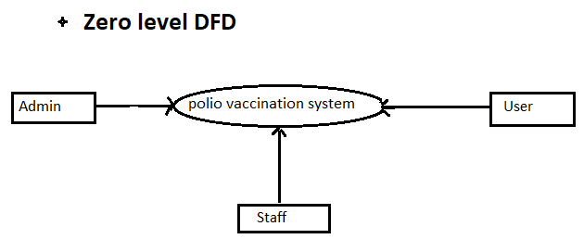

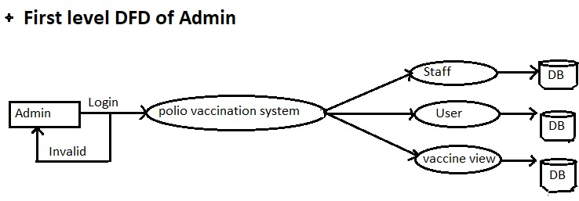

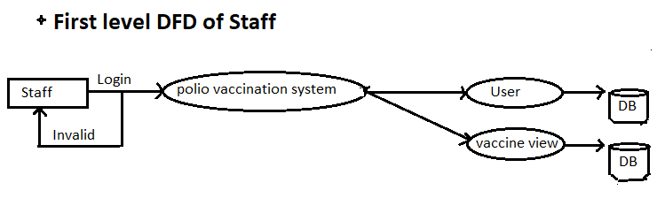

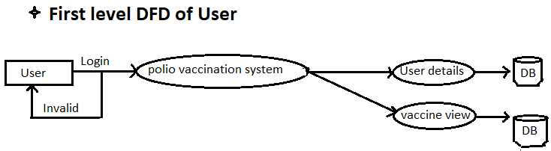

**CHAPTER-4**

**IMPLEMENTATION**

Implementation is realization of application, or execution of plan, idea, model design, specification, standard algorithm, or policy and it is process of having the systems personnel check out and put new equipment use . The factor to be considered in the implementation phase in the application of the hardware and software.

**a.** **Languages used:**

1. **HTML:**

HTML stands for Hyper Text Mark-up Language. It is standard mark-up language for creating web pages. It describe the structure of web page. It consists of series of elements, elements tells the browser how to display the content.

**Features of HTML**:

* It is not a programming language.
* It is not a data description language.
* It is simple to understand and implement.
* HTML constructs are very easy to comprehend, and can be used effectively by anybody.
* The methodology used by HTML to mark-up information is independent of its representation on particular hardware or software architecture.
* HTML syntax is worldwide standard.

1. **CSS:**

CSS stands for Cascading Style Sheets. It describes how HTML elements are to be displayed on the Screen, paper, or in other media. It saves a lot of work. It can control the layout of multiple web pages all at once. External style sheets are stored in CSS file.

CSS is designed to enable the separation of presentation and content, include layout, colour, and fonts. This separation can improve content accessibility, provide more flexibility and control in the specification of presentation characteristics, enable multiple web pages to share formatting by specifying the relevant CSS in separate CSS file, and reduce complexity and repletion in structural content.

1. **PHP:**

The term PHP is an acronym for PHP: Hypertext Pre-processor (Personal Home Page). PHP is server-side scripting language designed specifically for web development. It open-source which means it is free to download and use. Huge community.it is executed in server and can be integrated with many databases such as Oracles, Microsoft SQL Server, MySQL, Sybase. It can easily embedded in HTML. The files have the extension “.php”.

1. **JavaScript:**

JavaScript is dynamic computer programming language. It is Light-weight and most commonly used as a part of web pages, whose implementations allow client-side script to interact with the user and make dynamic pages. It is an interpreted programming language with object oriented capabilities.

**Benefits of JavaScript:**

* JavaScript has number of benefits to anyone who wants to make their web site dynamic.
* It is widely supported in Web browsers.
* It gives easy access to document object and can manipulate most of them.
* JavaScript can give interesting animation without the long download times associated with many multimedia data types.
* Web surfers do not need a special plug-in to use scripts.
* JavaScript is relatively secure-JavaScript can neither read from our hard drive nor write to it, and we cannot get a virus infection directly from JavaScript.

**B. SOURCE CODE**

**HOME :**

<!DOCTYPE html>

<html lang="en">

<head>

<title>POLIO-HOME</title>

<link rel="stylesheet"

href="https://cdnjs.cloudflare.com/ajax/libs/material-design-iconic-font/2.2.0/css/material-design-iconic-font.min.css">

</head>

<style>

body {

background-color: white;

background-repeat: no-repeat;

background-size: 100%;

background-size: cover;

}

* {

margin: 0px;

padding: 0px;

box-sizing: border-box;

}

#head {

background: linear-gradient(#0f5847, #035c4f);

display: flex;

justify-content: center;

color: white;

text-shadow: 4px 4px 4px black;

height: 40px;

text-align: center;

font-family: 'Franklin Gothic Medium', 'Arial Narrow', Arial, sans-serif;

}

#nav {

background: linear-gradient(#19a991f3, #18ad94f3);

text-align: end;

color: blanchedalmond;

height: 43px;

}

a {

padding: 5px;

border: 1.6px solid white;

border-radius: 4px;

text-decoration: none;

color: white;

text-shadow: 4px 4px 4px black;

}

#nav ul li {

display: inline-flex;

margin: 10px;

margin-right: 8px;

font-size: 11px;

background-color: #035c4f;

border-radius: 4px;

}

input {

border: 1px rgb(8, 8, 8);

border-radius: 2px;

background-color: rgb(255, 254, 217);

}

a:hover {

text-decoration: underline;

box-shadow: 0 0 3px #50e3f3, 0 0 7px #4ff2f4, 0 0 20px #28c02b;

}

#pic {

margin-right: 10pc;

}

#bodycont {

height: 28pc;

display: flex;

justify-content: start;

}

#picind {

margin-top: 20px;

margin-right: 2pc;

}

#content, #content:before #content:after {

padding: 0;

margin: 0;

box-sizing: border-box;

}

#content {

margin-left: 4pc;

/* border: 2px solid black; */

display: flex;

display: grid;

place-items: center;

height: 20pc;

}

#wrapper {

color: #035c4f;

font-size: 24px;

text-shadow: 1PX 2pX 2PX black;

box-sizing: content-box;

/* background-color:#06a983; */

height: 50px;

padding-left: 10px;

display: flex;

width: 605px;

/* box-shadow:0px 0px 0px #3a3a3a,0px 0px 0px #474545, 0 0 10px #3d3c3c; */

}

span {

width: 40pc;

display: flex;

height: 70px;

padding: 2px;

animation: spin_word 15s infinite;

/* border: 2px solid orange; */

}

.words {

overflow: hidden;

}

@keyframes spin_word {

10% {

transform: translateY(-112%);

}

25% {

transform: translateY(-100%);

}

35% {

transform: translateY(-212%);

}

50% {

transform: translateY(-200%);

}

60% {

transform: translateY(-312%);

}

75% {

transform: translateY(-300%)

}

85% {

transform: translateY(412%);

}

100% {

transform: translateY(-400);

}

}

.btn {

margin-top: -30px;

}

.btn a {

margin: 1pc;

width: 20px;

font-size: 11px;

background-color: #035c4f;

border-radius: 4px;

padding: 6px;

border-radius: 4px;

color: white;

border: 2px solid white;

}

.btn a:hover {

text-transform: uppercase;

box-shadow: 0 0 3px #50e3f3, 0 0 7px #4ff2f4, 0 0 20px #06fd59;

}

</style>

</head>

<body>

<div id="container">

<div id="head">

<!-- <div id="pic">

<img src="plogo2.jpg" alt="" width="180px" height="80px">

</div> -->

<div id="h1">

<h1>POLIO VACCINATION SYSTEM</h1>

</div>

</div>

<NAV id="nav">

<ul>

<li><a href="index.html">Home</a></li>

<li><a href="login.html">LogIn/SignUp</a></li>

<li><a href="book.html">Boook Vaccine</a></li>

<li><a href="vac-detail.html">Vaccine Details</a></li>

<li><a href="child-detail.html">Child Details</a></li>

<li><a href="about.html">About Us</a></li>

<i class="zmdi zmdi-search material-design-iconic-font"></i>

<input type="search" placeholder="Search" aria-label="Search">

</ul>

</NAV>

<!-- <div class="btn">

<i class="zmdi zmdi-rotate-ccw" style="margin-left: 1pc; color: white; margin-right: -11px;"></i>

<a href="javascript: history.back()" class="btn">Go Back</a>

</div> -->

</div>

<div id="bodycont">

<div id="content">

<div>

<img src="phome2.png" alt="" width="100%">

</div>

<div id="wrapper">

<!-- <h1>Coding is : </h1> -->

<div class="words">

<span>

<h2>Do Boond Zindagi Ke</h2>

</span>

<span>

<h2>Spare The Children, Give The Vaccine</h2>

</span>

<span>

<h2>Life With Polio Is Full Of Challanges</h2>

</span>

<span>

<h2>Let Us Kick Out Polio From Our Lives</h2>

</span>

</div>

</div>

</div>

<div>

<img src="independance.svg" alt="" width="340px" id="picind">

</div>

</div>

<div id="midbody">

<img src="phome1.jpg" alt="">

<div>

<h1>What is polio?</h1>

<p>Polio, or poliomyelitis, is a disabling and life-threatening disease caused by the poliovirus. The virus

can infect a person’s spinal cord, causing paralysis (can’t move parts of the body). Paralysis caused by

poliovirus occurs when the virus replicates in and attacks the nervous system. The paralysis can be

lifelong, and it can be deadly.</p> <br>

<h1>The Polio Shot Is Safe</h1>

<p>The polio shot is very safe, and is effective at preventing polio. Vaccines like any medicine, can have

side effects. These are usually mild and go away on their own.</p>

</div>

</div>

</body>

<footer>

<div id="one">

<h1>VACCINATION SERVICE</h1><br>

<h4>Register Member</h4>

<h4>Book Vaccination Slot</h4>

<h4>Management Appointment</h4>

</div>

<div id="one">

<h1>PLATFORM</h1><br>

<h4>Vaccinator</h4>

<h4>Department Login</h4>

<h4>Vaccination Statistics</h4>

</div>

<div id="one">

<h1>RESOURCES</h1><br>

<h4>How To Get Vaccinated</h4>

<h4>Do's & Dont</h4>

<h4>OverView</h4>

<h4>Guidelines</h4>

</div>

<div id="one">

<h1>SUPPORT</h1><br>

<h4>Frequently Asked Question</h4>

<h4>Queries</h4>

<h4>Contact</h4>

<h4>Mail</h4>

</div>

</footer>

<style>

#midbody {

color: #035c4f;

text-align: center;

display: flex;

background-color: rgb(239, 239, 113);

margin-bottom: 1pc;

}

footer {

width: 100%;

display: flex;

color: wheat;

background-color: #035c4f;

}

#one {

font-size: small;

margin: 5pc;

margin-left: 5px;

}

#one h4 {

text-decoration: dotted;

text-align: center;

}

</style>

</html>

**REGISTER:**

<!DOCTYPE html>

<html lang="en">

h2 {

margin-top: 2pc;

margin-bottom: -3.7pc;

color: #035c4f;

font-size: 26px;

border-bottom: 2px solid white;

text-align: center;

}

.register input {

margin: 1pc;

font-size: 14px;

text-align: center;

border-bottom: 2px solid black;

border-top: 2px solid transparent;

border-left: 2px solid transparent;

border-right: 2px solid transparent;

transition: all 0.s ease;

background-color: #fff;

}

#hcontainer {

width: 100%;

}

#container {

box-shadow: -1px -1px 0px #000000, 1px 1px 0px #000000, 0 0 20px #000000;

display: flex;

margin-top: 70px;

position: relative;

width: 600px;

height: 300px;

}

#cont1 {

color: white;

background-color: #19a991f3;

text-align: center;

width: 260px;

}

#cont2 {

text-align: center;

margin-left: 3pc;

}

h3 {

color: #035c4f;

padding: 1pc;

}

h4 {

margin: 2pc;

font-size: 20px;

}

p {

font-size: 18px;

}

#one, #two {

margin-top: 2pc;

color: #000000;

box-shadow: none;

text-shadow: none;

}

#one:hover, #two:hover {

box-shadow: 0 0 3px #000000, 0 0 7px #ffffff, 0 0 20px #333232;

background-color: #06a983;

}

#pass {

margin-top: 2pc;

}

#three input {

font-size: small;

padding: 5px;

border-radius: 10px;

}

#three input:hover {

background-color: #06a983;

}

.btn {

margin-top: -30px;

}

.btn a {

margin: 1pc;

width: 20px;

font-size: 11px;

background-color: #035c4f;

border-radius: 4px;

padding: 6px;

border-radius: 4px;

color: white;

border: 2px solid white;

}

.btn a:hover {

text-transform: uppercase;

box-shadow: 0 0 3px #50e3f3, 0 0 7px #4ff2f4, 0 0 20px #06fd59;

}

</style>

</head>

<body>

<div id="hcontainer">

<div class="btn">

<i class="zmdi zmdi-rotate-ccw" style="margin-left: 1pc; color: white; margin-right: -11px;"></i>

<a href="javascript: history.back()" class="btn">Go Back</a>

</div>

</div>

<h2>LOG-IN HERE</h2>

<div id="container">

<div id="cont1">

<h4>WELCOME!!!</h4>

<p>Hello Welcome To Login Page </p>

</div>

<form>

<div id="cont2">

<div>

<h3>LOGIN-IN</h3>

</div>

<div class="register">

<i class="zmdi zmdi-account material-design-iconic-font"></i>

<input required type="text" name="uname" id="uname" placeholder="Enter User-Name">

</div>

<div class="register">

<i class="zmdi zmdi-lock material-design-iconic-font"></i>

<input required type="password" name="password" id="password" placeholder="Enter Passward">

</div>

<div id="three">

<!-- <input type="submit" value="LOG-IN">--><a href="index.html"

style="color: #000000; text-shadow: none; background-color: #06a983;">Log-In</a>

</div>

<div id="pass">

<a href="forgot.html" id="one">FORGOT PASSWARD</a>

<a href="register.html" id="two">SIGN-UP</a> </div>

</div>

</form>

</div>

</body>

</html>

**BOOK VACCINE:**

<!DOCTYPE html>

<html lang="en">

<head>

<title>Book Vaccine</title>

<link rel="stylesheet"

href="https://cdnjs.cloudflare.com/ajax/libs/material-design-iconic-font/2.2.0/css/material-design-iconic-font.min.css">

</head>

<body>

<div id="hcontainer">

<div class="btn">

<i class="zmdi zmdi-rotate-ccw" style="margin-left: 1pc; color: white; margin-right: -11px;"></i>

<a href="javascript: history.back()" class="btn">Go Back</a>

</div>

</div>

<div id="container">

<h2>BOOK FOR VACCINE</h2>

<form>

<div id="cont1">

<div id="welcome">

<h2 style="color: white; border-bottom: none;">REGISTER FOR VACCINATION</h2> <br>

<p>Your<b> Photo ID</b> will be verified at the <br> time of your vacccination appointment. <br>

Please provide the details of the Photo ID <br> you will carry for vacccination.</p>

</div>

<div id="cont2">

<div class="forgot">

<h3>BOOK VACCINE</h3>

</div>

<div class="forgot">

<i class="zmdi zmdi-female material-design-iconic-font"></i>

<input required type="text" name="mname" id="mname" placeholder="Mother Name">

</div>

<div class="forgot">

<i class="zmdi zmdi-male material-design-iconic-font"></i>

<input required type="text" name="fname" id="fname" placeholder="Father Name">

</div>

<div class="forgot">

<i class="zmdi zmdi-account-add material-design-iconic-font"></i>

<input required type="text" name="cname" id="cname" placeholder="Child Name">

</div>

<div class="forgot">

<label for="dob">DOB</label>

<input required type="date" name="dob" id="dob">

</div>

<div class="forgot">

<select name="id" id="id">

<option>Select ID Proof</option>

<option value="adhar">ADHAR CARD</option>

<option value="pan">PAN CARD</option>

<option value="dl">DRIVING LICENCE</option>

<option value="ration">RATION CARD</option>

</select>

</div>

<div class="forgot">

<input required type="text" name="idno" id="idno" placeholder="Enter ID Proof Number"></div>

<div id="forgot">input type="submit" value="BOOK"></div>

</div>

</div>

</form>

</div>

</body>

</html>

**CHILD DETAILS:**

<!DOCTYPE html>

<html lang="en">

<head>

<title>Book Vaccine</title>

<link rel="stylesheet"

href="https://cdnjs.cloudflare.com/ajax/libs/material-design-iconic-font/2.2.0/css/material-design-iconic-font.min.css">

</head>

<body>

<div id="hcontainer">

<div class="btn">

<i class="zmdi zmdi-rotate-ccw" style="margin-left: 1pc; color: white; margin-right: -11px;"></i>

<a href="javascript: history.back()" class="btn">Go Back</a>

</div>

</div>

<div id="container">

<h2>BOOK FOR VACCINE</h2>

<form>

<div id="cont1">

<div id="welcome">

<h2 style="color: white; border-bottom: none;">REGISTER FOR VACCINATION</h2> <br>

<p>Your<b> Photo ID</b> will be verified at the <br> time of your vacccination appointment. provide the details of the Photo ID <br> you will carry for vacccination.</p>div>

<div id="cont2">

<div class="forgot">h3>BOOK VACCINE</h3></div>

<div class="forgot">

<i class="zmdi zmdi-female material-design-iconic-font"></i>

<input required type="text" name="mname" id="mname" placeholder="Mother Name"></div>

<div class="forgot">

<i class="zmdi zmdi-male material-design-iconic-font"></i>

<input required type="text" name="fname" id="fname" placeholder="Father Name"></div>

<div class="forgot">

<i class="zmdi zmdi-account-add material-design-iconic-font"></i>

<input required type="text" name="cname" id="cname" placeholder="Child Name">

</div>

<div class="forgot">label for="dob">DOB</label>

<input required type="date" name="dob" id="dob"> </div>

<div class="forgot">

GENDER

<label for="male">Male</label>

<input type="radio" name="gender" id="male">

<label for="female">Female</label>

<input type="radio" name="gender" id="female">

<label for="other">Other</label>

<input type="radio" name="gender" id="other">

</div>

<div class="forgot">

<select name="id" id="id">

<option>Select ID Proof</option>

<option value="adhar">ADHAR CARD</option>

<option value="pan">PAN CARD</option>

<option value="dl">DRIVING LICENCE</option>

<option value="ration">RATION CARD</option>

</select>

</div>

<div class="forgot"><input required type="text" name="idno" id="idno" placeholder="Enter ID Proof Number"></div>

<div id="forgot"><input type="submit" value="BOOK"></div>

</div>

</div>

</form>

</div>

</body>

</html>

**VACCINE DETAILS**:

<!DOCTYPE html>

<html lang="en">

<head>

<meta charset="UTF-8">

<meta http-equiv="X-UA-Compatible" content="IE=edge">

<meta name="viewport" content="width=device-width, initial-scale=1.0">

<title>Child Details</title>

<link rel="stylesheet"

href="https://cdnjs.cloudflare.com/ajax/libs/material-design-iconic-font/2.2.0/css/material-design-iconic-font.min.css">

<style>

.btn {

margin-top: -30px;

}

.btn a {

margin: 1pc;

width: 20px;

font-size: 11px;

background-color: #035c4f;

border-radius: 4px;

padding: 6px;

border-radius: 4px;

color: white;

border: 2px solid white;

}

.btn a:hover {

text-transform: uppercase;

box-shadow: 0 0 3px #50e3f3, 0 0 7px #4ff2f4, 0 0 20px #06fd59;

</style>

</head>

<body>

<div id="hcontainer">

<div class="btn">

<i class="zmdi zmdi-rotate-ccw" style="margin-left: 1pc; color: white; margin-right: -11px;"></i>

<a href="javascript: history.back()" class="btn">Go Back</a>

</div>

</div>

<div class="box1">

<a href="childsubmit.html">Submit Child Details</a>

<a href="childget.html">Get Child Details</a>

</div><br>

<div id="head2">

<h5>Four doses of the polio shot for children are recommended by doctors as the best way to protect against

polio.</h5>

<h5>Your Child Will Needs <b>One Dose</b> At Each Of The Following</h5>

</div><br>

<div id="boydcontainer">

<div class="d1">

<div id="d1">

<h1>1st Dose</h1><br><br><br><br><br><br>

<a href="dose1.html">Click Here</a>

</div>

</div>

<div class="d2">

<div id="d2">

<h1>2nd Dose</h1><br><br><br><br><br><br>

<a href="dose2.html">Click Here</a>

</div>

</div>

<div class="d3">

<div id="d3">

<h1>3rd Dose</h1><br><br><br><br><br><br>

<a href="dose3.html">Click Here</a>

</div>

</div>

<div class="d4">

<div id="d4">

<h1>4th Dose</h1><br><br><br><br><br><br>

<a href="dose4.html">Click Here</a>

</div>

</div>

</div>

<div id="detcontainer">

<div id="detail1">

<h1>Why should my child get the polio shot?</h1>

<li>Protects your child from polio, a potentially serious disease.</li>

<li>Protects your child from developing lifelong paralysis from polio.</li>

</div>

<div id="detail2">

<h1>Prepare for your child's vaccine visit and learn about how you can:</h1>

<li>Research vaccines and ready your child before the visit</li>

<li>Comfort your child during the appointment</li>

<li>Care for your child after the shot</li>

</div>

</div>

</body>

<style>

#head2 {

text-align: center;

padding: 1pc;

margin-top: 0pc;

background-color: rgb(222, 218, 218);

}

#detcontainer {

display: flex;

}

#detail1 {

background-color: rgb(155, 217, 242);

margin: 1pc;

padding: 2pc;

}

#detail2 {

background-color: rgb(248, 248, 142);

margin: 1pc;

padding: 2pc;

}

#boydcontainer {

margin-top: 1pc;

display: flex;

}

.box {

height: 315px;

width: 430px;

padding-top: 1pc;

margin: 1pc;

text-align: center;

}

.box img {

width: 400px;

box-shadow: 0 0 5px #000000, 0 0 7px #000000, 0 0 20px #000000;

}

.box:hover {

box-shadow: 0 0 5px #000000, 0 0 7px #000000, 0 0 20px #000000;

}

.box1 {

cursor: pointer;

display: flex;

text-align: center;

margin-bottom: 0;

padding-top: 9.5px;

}

#b1, #b2 {

box-shadow: 0 0 5px #000000, 0 0 7px #000000, 0 0 20px #000000;

background-image: url("vaccine2.jpg");

background-size: 470px;

padding-top: 20%;

border-radius: 50%;

background-color: #06a983;

height: 270px;

width: 270px;

margin: 1pc;

}

#b1, #b2 {

margin-right: 10pc;

}

.box1 a {

color: #000000;

font-size: larger;

}

.box1 a {

margin: 1pc;

}

h5 {

color: #035c4f;

font-size: larger;

}

.d1, .d2, .d3, .d4 {

background-image: url("vaccine1.webp");

background-size: 400px;

border-radius: 3px;

cursor: pointer;

margin: 2pc;

padding: 10px;

height: 200px;

width: 180px;

margin-top: 0;

box-shadow: 0 0 2px #000000, 0 0 2px #000000, 0 0 10px #000000;

}

#d1 a, #d2 a, #d3 a, #d4 a, #d1 h1, #d2 h1, #d3 h1, #d4 h1 {

margin-right: 2pc;

}

#d1, #d2, #d3,#d4 {

width: 190px;

height: 200px;

text-align: center;

}

#d1 a, #d2 a, #d3 a, #d4 a {

color: #000000;

font-size: large;

}

#d1 a:hover, #d2 a:hover, #d3 a:hover, #d4 a:hover {

box-shadow: 0 0 2px #000000, 0 0 2px #000000, 0 0 10px #000000;

}

</style>

</html>

**DOSE 1:**

<!DOCTYPE html>

<html lang="en">

<head>

<title>POLIO-HOME</title>

<link rel="stylesheet"

href="https://cdnjs.cloudflare.com/ajax/libs/material-design-iconic-font/2.2.0/css/material-design-iconic-font.min.css">

</head>

<style>

</head>

<body>

<div id="container">

<div id="bodycontainer">

<div>img src="dose1pic.png" alt="" width="90%"></div>

<div class="content">

<h1>What vaccines will my baby get?</h1>

<ul>

<h5>At 1 to 2 months, your baby should receive vaccines to protect them from the following diseases: </h5>

<li>Hepatitis B (HepB) (2nd dose)</li>

<li> Diphtheria, tetanus, and whooping cough (pertussis) (DTaP) (1st dose)</li>

<li>Haemophilus influenzae type b disease (Hib) (1st dose)</li>

<li>Polio (IPV) (1st dose)</li>

<li>Pneumococcal disease (PCV) (1st dose)</li>

<li>Rotavirus (RV) (1st dose)</li>

</ul>

<h1>After vaccinations</h1>

<ul>

<h5>Sometimes children have mild reactions from vaccines, such as pain at the injection site or a rash.

These reactions are normal and will soon go away.</h5>

<li>Read the Vaccine Information Sheet(s) your baby’s doctor gave you to learn about side effects your

baby may experience.</li>

<li>Swaddle.</li>

<li>Offer breastmilk or formula more often. It is normal for some babies to eat less during the 24 hours

after getting vaccines.</li>

<li>Pay extra attention to your baby for a few days. If you see something that concerns you, call your

baby’s doctor.</li>

</ul>

</div>

</div>

<style>

#bodycontainer {

justify-content: center;

margin-top: 1pc;

}

.content {

margin: 3pc;

}

</style>

</html>

**CHAPTER-5**

**RESULTS**

**HOME:**

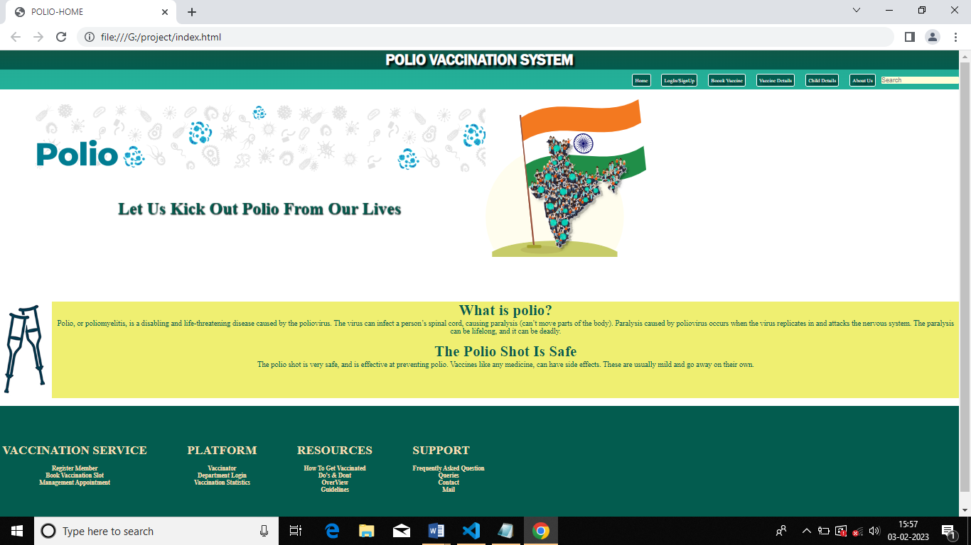

**REGISTER:**

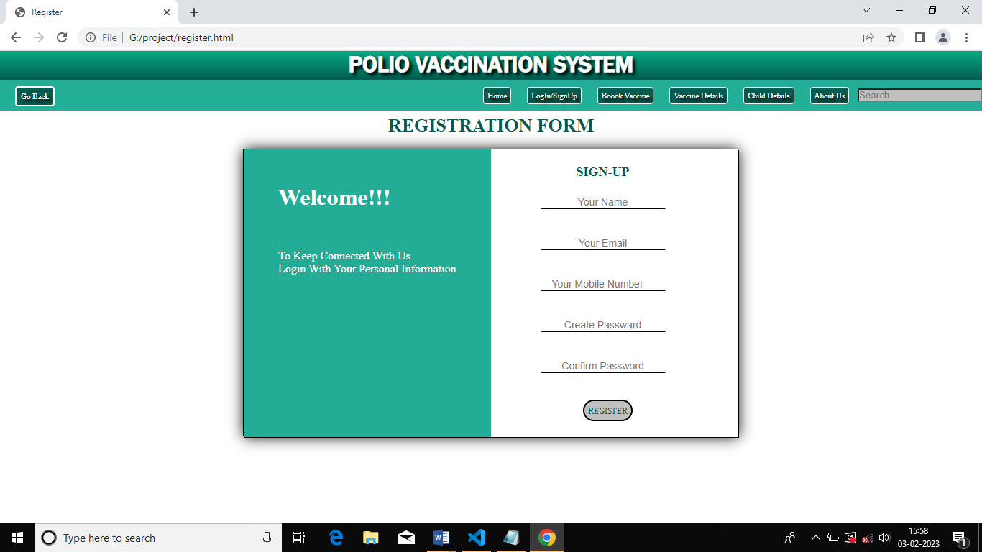BOOK

**VACCINE:**

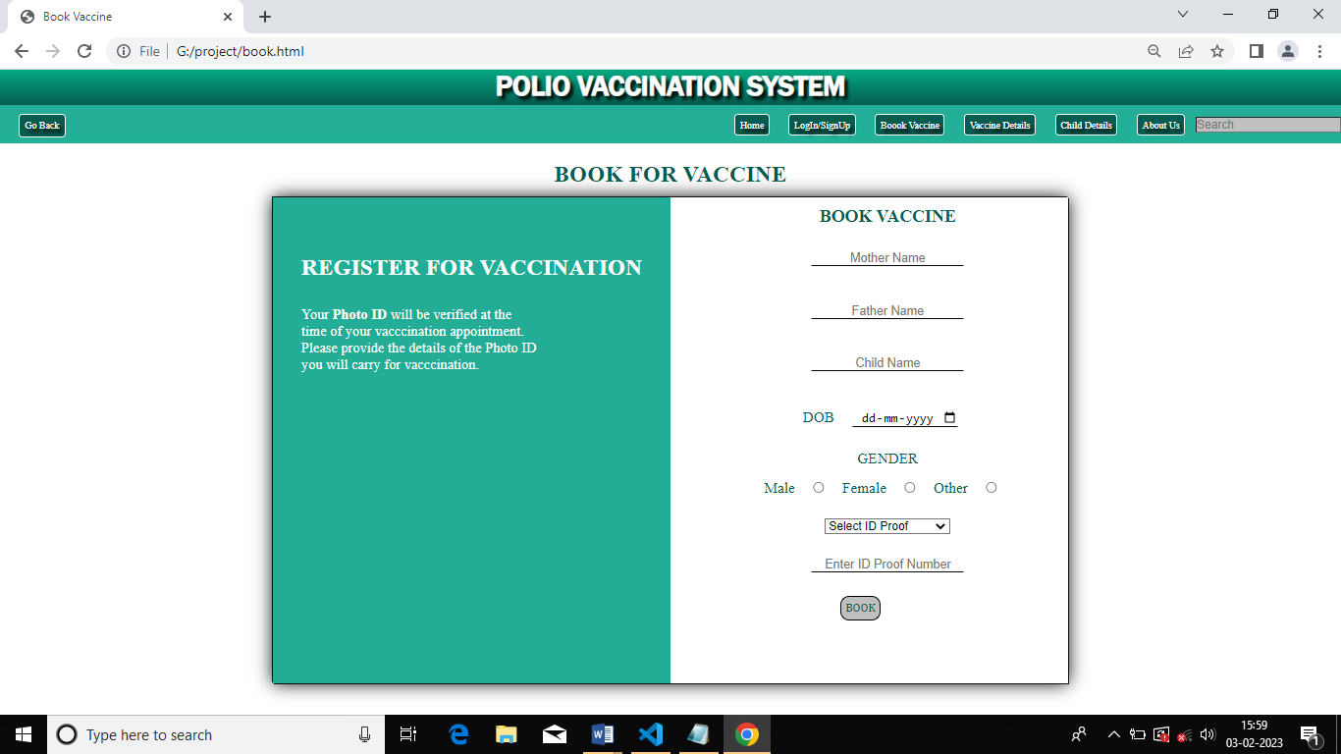

**VACCINE-DETAILS:**

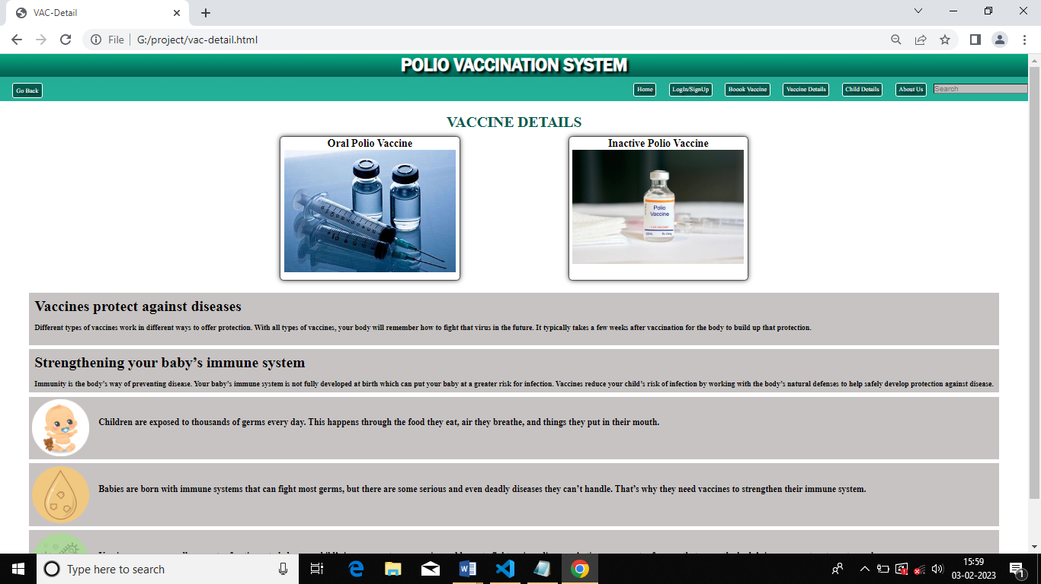

**CHILD-DETAILS :** **DOSES:**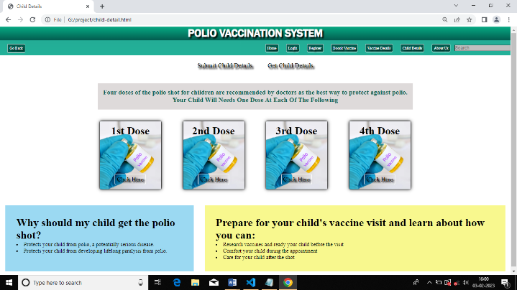

­­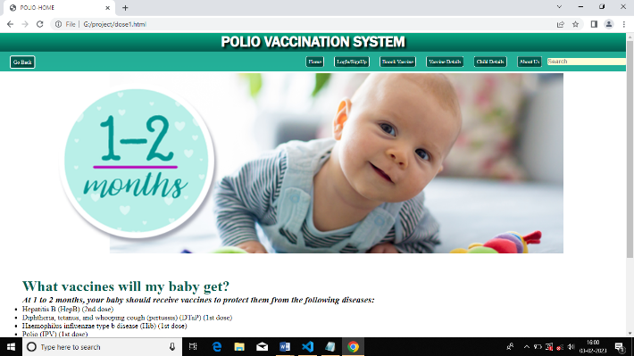

**CHAPTER-7**

**FUTURE ENHANCEMENT**

* After Booking the vaccine slot the nurse will go to respected house and give the vaccine.
* Giving health insurance.
* Making a User friendly mobile application.
* Continue all the child information for future life time.

**CHAPTER-8**

**CONCLUSIONS**

The polio vaccination system has been a crucial factor in the global effort to eradicate polio. Through widespread immunization campaigns and strong surveillance systems, the incidence of polio has been reduced dramatically, leading to the near-eradication of the disease. However, continued efforts are necessary to maintain high levels of immunity and to ensure that outbreaks do not occur. Ultimately, a successful conclusion to the polio vaccination system will result in a world free from the disease.

We conclude by our project that, children will get respected doses on time without failure and if they want their relative information they can get easily in the respective month and time.

**CHAPTER-8**

**REFERENCES**

**Books**

1. “Software Engineering “.by Ian Somerville, Sixth Edition, Pearson Education Ltd 2007.
2. “Web programming”, by ‘Chris Bates ’Wiley Dreamtech India, 2nd Edition.

**Websites**

1. [www.google.com](http://www.google.com)
2. [www.w3school.com](http://www.w3school.com)
3. [www.youtube.com](http://www.youtube.com)
4. www.cdc.gov
5. www.who.int