**WISABI BANK**

**Table of Contents**

Cover Page1

Table of Content2

**Tables3**

Executive Summary 3

Entity Relationship Diagram 4

Data Analysis Approach 5

Objective 5

Queries 5

Results, Visualization, Insights 9

Recommendation 16

**Wisabi Bank**

**Executive Summary:**

This dataset provides a comprehensive view of transactions, ATM locations, cardholder details, transaction types, and temporal information for Wisabi Bank. It can be used to analyze ATM transactions and customer behavior to identify patterns, trends, and insights for optimizing banking services and customer experience.

The dataset consists of transactional data captured in the Fact Transaction Table, which includes information such as transaction ID, start and end datetime, cardholder ID, location ID, transaction type ID, and transaction amount.  
There are 5 transactional tables that can be unioned to provide a comprehensive view of the bank's ATM operations across all locations.

The ATM Location Lookup table provides details about ATM locations, including location ID, location name, number of ATMs, city, state, and country.  
The Customer Lookup table contains information about cardholders, such as cardholder ID, first name, last name, gender, ATM ID, age, occupation, account type, and whether they are customers of Wisabi Bank.  
The Transaction Type Lookup Table defines different transaction types and their corresponding IDs and names.

The Data Dictionary contains more information on this dataset.

**Entity Relationship Diagram:**

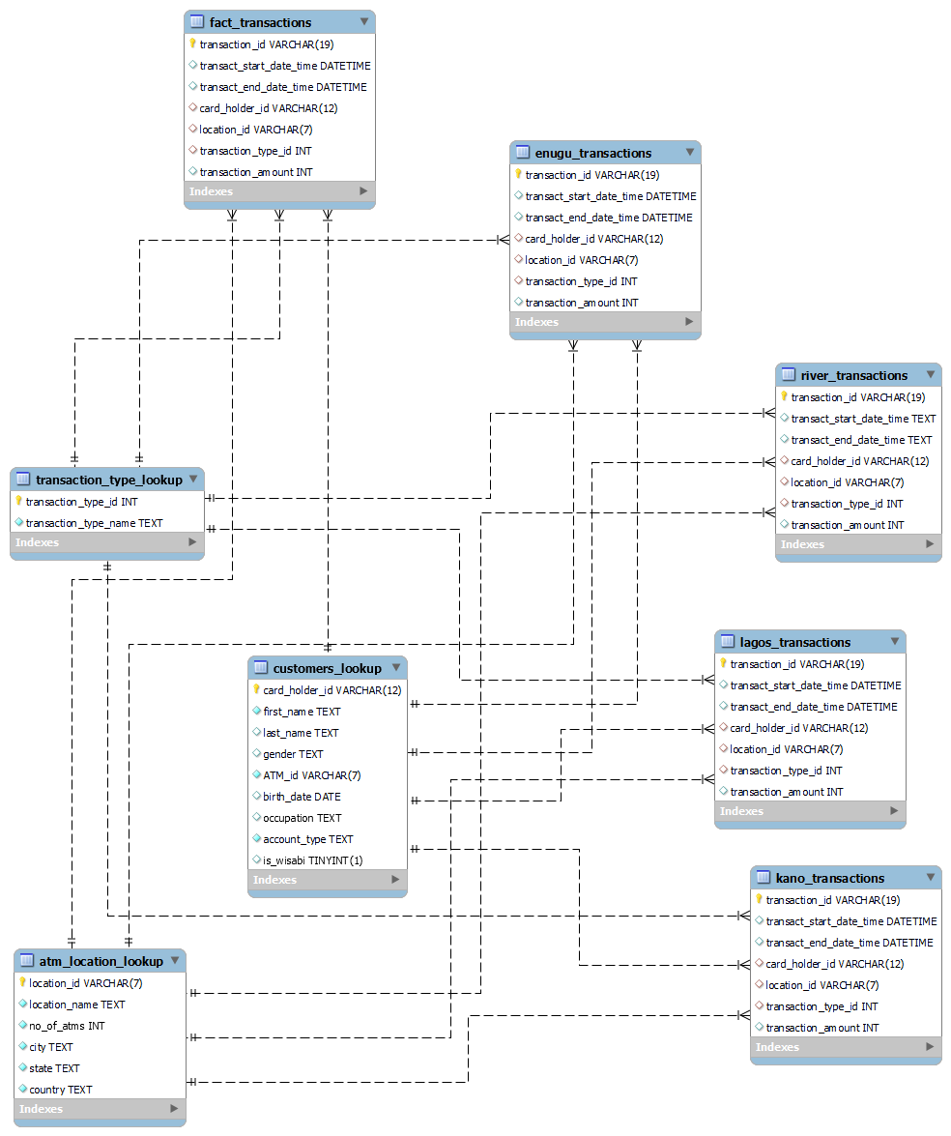

**Data Analysis Process/Approach:**

**Data Gathering:** Gathered the ATM and customer-related data of Wisabi Bank from an online source.

**Data** **Importing:** The collected data is imported into the MYSQL Workbench for further analysis.

**Processing:** The imported data is organized by creating tables and relations between the tables and ensures data integrity. Then some of the field needs to be transformed for the feasible analysis like data and time columns format. The dataset was large so for better performance, a view table with named “combined table” is created to append the data of all five transaction tables in one table to write the optimized query.

**Insights:** The insights are performed after analysis and build some recommendations according to the insights.

**Objective:**

Analyze ATM transactions and customer behavior to identify patterns, trends, and insights for optimizing banking services and customer experience.

**Queries:**

**Query 1:** What are the most common transaction types, and how do they contribute to overall transaction volume?

SELECT tt.transaction_type_id, tt.transaction_type_name, COUNT(*) AS TransactionCount

FROM (

SELECT transaction_type_id FROM fact_transactions

UNION ALL

SELECT transaction_type_id FROM enugu_transactions

UNION ALL

SELECT transaction_type_id FROM lagos_transactions

UNION ALL

SELECT transaction_type_id FROM kano_transactions

UNION ALL

SELECT transaction_type_id FROM river_transactions

) AS CombinedTables

JOIN transaction_type_lookup AS tt

ON CombinedTables.transaction_type_id = tt.transaction_type_id

GROUP BY tt.transaction_type_id, tt.transaction_type_name

ORDER BY TransactionCount DESC;

**Query 2:** What is the relationship between transaction types and transaction amounts, and how can we use this information to improve our service offerings?

SELECT transaction_type_id, AVG(combined_tables.transaction_amount) AS avg_transaction_amount

FROM (

SELECT transaction_type_id, transaction_amount FROM fact_transactions

UNION ALL

SELECT transaction_type_id, transaction_amount FROM enugu_transactions

UNION ALL

SELECT transaction_type_id, transaction_amount FROM kano_transactions

UNION ALL

SELECT transaction_type_id, transaction_amount FROM lagos_transactions

UNION ALL

SELECT transaction_type_id, transaction_amount FROM river_transactions

) AS combined_tables

JOIN transaction_type_lookup AS tt

ON combined_tables.transaction_type_id = tt.transaction_type_id

GROUP BY transaction_type_id

ORDER BY transaction_type_id;

**Query 3:** What is the average transaction amount for "withdrawal" transactions, categorized by account type, and how does this amount vary across different ATM locations?

SELECT location_name,cl.account_type, AVG(transaction_amount) AS avg_transaction_amount

FROM (

SELECT location_id,transaction_type_id, card_holder_id, transaction_amount

FROM fact_transactions

UNION ALL

SELECT location_id,transaction_type_id, card_holder_id, transaction_amount

FROM enugu_transactions

UNION ALL

SELECT location_id,transaction_type_id, card_holder_id, transaction_amount

FROM lagos_transactions

UNION ALL

SELECT location_id,transaction_type_id, card_holder_id, transaction_amount

FROM kano_transactions

UNION ALL

SELECT location_id,transaction_type_id, card_holder_id, transaction_amount

FROM river_transactions

) AS combined_tables

JOIN atm_location_lookup AS al

ON combined_tables.location_id = al.location_id

JOIN transaction_type_lookup AS tt

ON combined_tables.transaction_type_id = tt.transaction_type_id

JOIN customers_lookup cl

ON combined_tables.card_holder_id = cl.card_holder_id

WHERE tt.transaction_type_name = 'Withdrawal'

GROUP BY al.location_name, cl.account_type

ORDER BY al.location_name, avg_transaction_amount DESC;

**Query 4:** Is there a correlation between transaction volume and ATM availability in different cities, and how can we optimize ATM deployment for improved service?

SELECT city, COUNT(*) AS ATMs, SUM(TransactionCount) AS TotalTransactions

FROM (

SELECT city, location_name, COUNT(*) AS TransactionCount

FROM (

SELECT l.city, l.location_name

FROM fact_transactions ft

JOIN atm_location_lookup l ON ft.location_id = l.location_id

UNION ALL

SELECT l.city, l.location_name

FROM enugu_transactions et

JOIN atm_location_lookup l ON et.location_id = l.location_id

UNION ALL

SELECT l.city, l.location_name

FROM kano_transactions kt

JOIN atm_location_lookup l ON kt.location_id = l.location_id

UNION ALL

SELECT l.city, l.location_name

FROM lagos_transactions lt

JOIN atm_location_lookup l ON lt.location_id = l.location_id

UNION ALL

SELECT l.city, l.location_name

FROM river_transactions rt

JOIN atm_location_lookup l ON rt.location_id = l.location_id

) AS location_data

GROUP BY city, location_name

) AS Subquery

GROUP BY city

ORDER BY ATMs;

**Query 5:** Are there seasonal trends in transaction amounts, and how can we use this information to optimize cash reserves and marketing strategies?

SELECT MONTH(transact_start_date_time) AS months, AVG(transaction_amount) AS avg_transaction_amount

FROM (

SELECT transact_start_date_time, transaction_amount FROM fact_transactions

UNION ALL

SELECT transact_start_date_time, transaction_amount FROM kano_transactions

UNION ALL

SELECT transact_start_date_time, transaction_amount FROM enugu_transactions

UNION ALL

SELECT transact_start_date_time, transaction_amount FROM lagos_transactions

UNION ALL

SELECT transact_start_date_time, transaction_amount FROM river_transactions

) AS CombinedTables

GROUP BY months

ORDER BY months;

**Query 6:** Monitor transaction volume trends to identify peak months for service optimization.

SELECT month(transact_start_date_time) AS months, COUNT(*) AS transaction_count

FROM combined_transactions

GROUP BY months

ORDER BY months, transaction_count DESC;

**Query 7:** What are the most common types of transactions conducted by students, and how do they differ from transactions made by customers in other occupations?

SELECT cl.occupation,ct.transaction_type_id, COUNT(*) AS TransactionCount

FROM customers_lookup cl

JOIN combined_transactions ct ON cl.card_holder_id = ct.card_holder_id

WHERE cl.occupation = 'Student' OR cl.occupation <> 'Student'

GROUP BY cl.occupation, ct.transaction_type_id

ORDER BY TransactionCount DESC;

**Query 8:** What is the transaction behavior, in terms of transaction counts, across different occupations for both Wisabi Bank and non-Wisabi Bank customers, and how does it vary among these occupational groups?

SELECT

cl.is_wisabi,

cl.occupation,

COUNT(*) AS transaction_count

FROM

combined_transactions ct

JOIN

customers_lookup cl

ON ct.card_holder_id = cl.card_holder_id

GROUP BY

cl.is_wisabi, cl.occupation

ORDER BY

cl.occupation DESC;

**Results, Insights, And Visualization:**

**Query 1:**

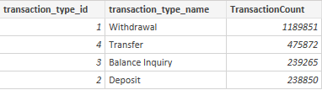

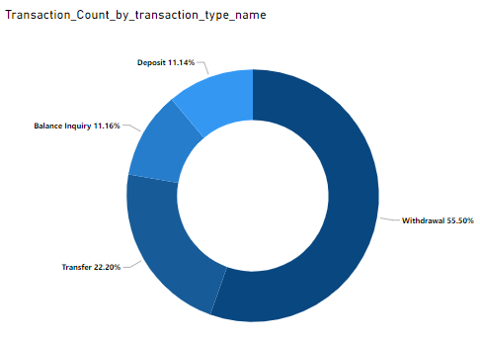

**Insights:** The analysis of transaction types has revealed that the most common transaction type is "withdrawal," which accounts for a significant portion of overall transactions. These findings indicate that customers primarily use ATMs for accessing cash and checking their account balances.

**Query 2:**

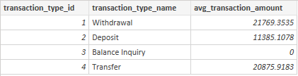

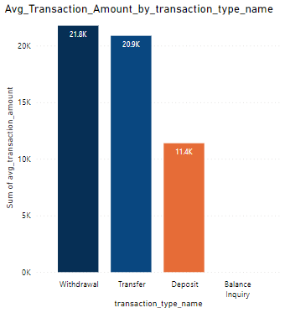

**Insights:** There is variation in the average transaction amounts for different transaction types, with withdrawals involving larger amounts with a slight difference of transfers, and deposits have fewer amounts.

**Query 3:**

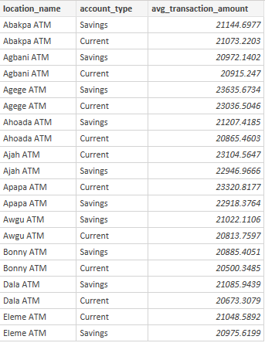

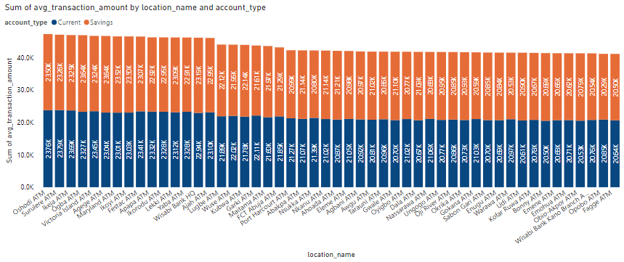

**Insight:** The analysis of "withdrawal" transactions reveals that the average transaction amount varies across different ATM locations and is further influenced by the account type of the customers. Customers with current accounts tend to withdraw larger amounts compared to those with saving accounts. This information provides valuable insights into the withdrawal behavior of customers in different areas.

**Query 4:**

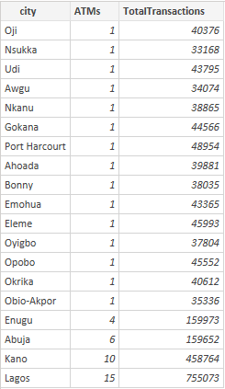

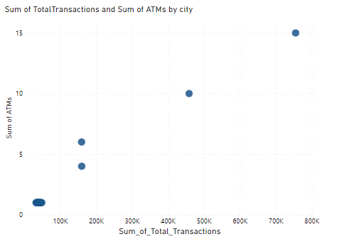

**Insight:** Our analysis has revealed significant differences in the number of ATMs across cities. Most cities have just one ATM, while two cities have 10 and 15 ATMs respectively. This variation suggests a mismatch between ATM availability and transaction demand.

**Query 5:**

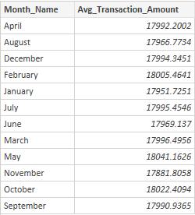

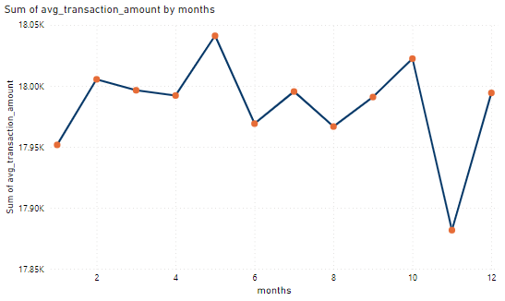

**Insights:** Our analysis has revealed distinct seasonal patterns in transaction amounts throughout the year. Specifically, we've observed that there are months when transaction averages are notably higher compared to others.

**Query 6:**

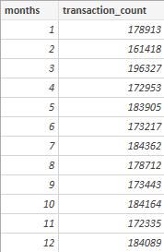

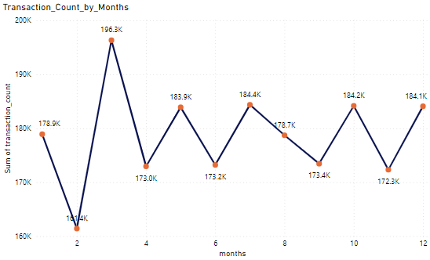

**Insights:** Variations in transaction volume across months may indicate seasonal trends, economic factors, or changes in customer behavior.

**Query 7:**

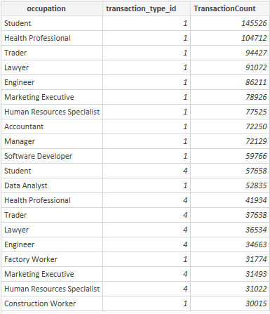

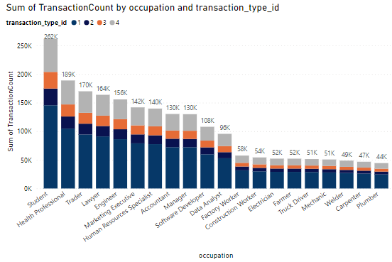

**Insights:** Withdrawal" transactions are notably more common among customers specifically among students compared to other transaction types, suggesting a greater reliance on cash for daily expenses.

**Query 8:**

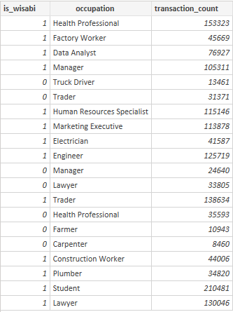

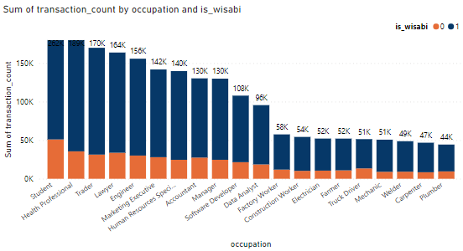

**Insights:** The query shows that there is significant variation in transaction behavior across different occupations. In particular, "students" have a much higher transaction count compared to other occupations, indicating that they engage in financial transactions more frequently. Also, this indicates that customer behavior varies based on their professions and financial needs.

**Recommendations:**

1. Given that "withdrawal" transactions are the most common, consider increasing ATM availability in areas with high transaction demand to ensure that customers have convenient access to cash. Optimize ATM maintenance schedules to minimize downtime, especially for ATMs in high-traffic areas. Implement real-time monitoring and alerts for ATM cash levels to prevent cash shortages, which could disturb withdrawal transactions. Influence the understanding of transaction types to customize service offerings. For example, offer promotions or incentives for using ATMs for "withdrawal" transactions, such as fee waivers or rewards programs. To increase the transfer rate, develop user-friendly and secure mobile banking apps, consider reducing or eliminating fund transfer charging fees, and offer promotions or incentives for using transfer services like cashback rewards, discounts, or loyalty points for customers who make a specific number of transfers in a specified period, and lastly provide educational resources and guides on how to make secure and efficient fund transfers because customers may be more likely to use these services if they understand them better. To maximize the deposits, offer competitive interest rates on savings accounts. High-yield savings accounts can attract customers looking for better returns on their savings. Highlight the bank's commitment to security and trustworthiness in all communications. Customers are more likely to deposit their funds in banks they observe as secure.
2. For customers with savings accounts who tend to withdraw larger amounts, offer customized promotions or services that align with their preferences, for example, reduce monthly maintenance fees or withdrawal fees, and run occasional promotions like referral bonuses to attract new savings account holders.
3. Consider relocating or adding ATMs in cities with fewer machines but high transaction volume to reduce customer wait times and improve service quality. Introduce self-service kiosks or mobile banking options in areas with limited ATM access to provide alternative transaction channels and reduce pressure on ATMs.
4. Utilize the knowledge of seasonal trends in transaction amounts to optimize cash reserves. Allocate cash resources more efficiently by ensuring higher reserves during peak transaction months and adjusting them during periods of lower activity. This proactive approach can minimize the risk of cash shortages during high-demand periods. Create marketing campaigns that align with the specific needs and behaviors of customers during peak months. For instance, promote savings accounts or loan products during times when transaction averages are high, or offer targeted promotions and incentives to attract more customers during these periods. Develop and promote seasonal financial products to cater to customers during peak months like offering special holiday-themed savings accounts or credit card rewards programs that coincide with increased spending.
5. Continuously monitor and analyze transaction volume trends to identify not only peak months but also emerging patterns and shifts in customer behavior.
6. Develop and offer financial products and services tailored to the specific needs and behaviors of students. Consider student-friendly accounts, low-fee or no-fee options, and educational resources designed to help students manage their finances effectively. Offer financial literacy programs and resources geared toward students to help them make informed financial decisions. Topics may include budgeting, saving, and responsible credit usage. Highlight specific services that align with the transaction behaviors of each occupation. For example, emphasize cash management solutions for students who rely more on cash transactions.
7. Actively seek feedback from customers in different occupations to understand their experiences and gather suggestions for improvement. Use this feedback to refine services and offerings. Develop a long-term strategy that incorporates occupational segmentation and customization of banking services. This approach ensures that the bank remains adaptable and responsive to changing customer needs over time.