**Project Overview**   
  
**Contact Person: Mr. Zain Mohammad  
Apps’ Category: Lifestyle**   
  
Application Brief

|  |  |
| --- | --- |
| **Application Platforms** | **Application Languages** |
| iOS: iPhone, iPod and iPad  Android: Phones & Tablets  ***Note: For iPad and iPod application would be provided in compatibility mode only.***  **Operating Systems**  iOS 8 till iOS 9 Android ICS till Android Marshmallow 6.0  **Development Tools**   * Xcode 7.2. * Android Studio 1.5.1. | * English |
| **Design** |  |
| Adobe Photoshop CC |  |
| Adobe Illustrator CC |  |

**Brief Description:**

The application will be the complete occasion planner for the users. The users will be able to find different vendors for their occasions like birthdays, weddings, etc. Vendors will also have an interface in the application.

**Application Structure Details**

**Super Admin**

The owner will have access to super admin area of the application. This will be a web application with the Admin panel. The Admin shall basically moderate the application. With the access to all the profiles of the registered users and vendors, the Admin shall make sure that the application provides the correct information to the users.

**Users**

Users of the application will be those people who will use the application to find vendors for the occasions and book the vendors.

**Vendors**

The application shall allow the Vendors to maintain their profile on the application. the vendor will be updating their profile and when a User books a vendor, the vendor will be receiving an email and a notification.

**APPLICATION FLOW – USER INTERFACE**

|  |  |
| --- | --- |
|  | |
| **Attributes** | **Details** |
| Splash Screen | The application shall start with an appealing and interactive splash screen, which shall display the app’s name and logo.  This Screen will appear for 5 seconds on the mobile application. The splash screen’s concept is that it covers the time while the app is loading and it shows the company logo in order to promote the app. Different options of the splash screen shall be provided to the client and final selection shall be the upon client’s discretion. |
| Sign-Up and Sign-In | Right after the Splash screen, the User shall be moved to the Sign-Up screen. Of course, this screen will only appear if the user is not registered with the app. There will be two types of users of the mobile application:   * Normal Users * Vendors   If a User (normal or Vendor) is already logged in, the application shall move the User to the particular home screen. If the user is already registered with the application, but has not logged in, then they can login to the application.  When a new user decides to Sign-Up with the application, first they have to select whether they need to sign-up as a Normal User or a Vendor. Once the user selects one of these options, the respective Sign-Up screen appears.   * **Normal User Sign-Up Screen**   The app will offer two modes of sign up for a normal user which are mentioned below:   1. Conventional Sign-Up 2. Sign-Up via Social Media 3. **Conventional Sign-Up**   The following fields shall be available on the normal user Sign-Up screen:   * Full Name * Age * Gender * City * Email address * Password * Confirm password * Phone number * Profile picture (option shall be available for the user to tab and choose an image from the phone gallery)   After signing up, the User will be able to Login to the application. The User shall be able to update further information about them through their respective profile screens.   1. **Sign-Up via Social Media**   We will incorporate facebook SDK and google+  Connect API to execute this feature. This feature will  essentially allow users to instantly sign up with the  app inputting their facebook/google+ credentials (user  Name & password). This medium of sign up will be comparatively convenient for users.  **Note –** the Sign-Up via Social Media option shall only be available for Normal Users. Vendor Users shall only have the option of conventional Sign-Up.   * **Vendors Sign-Up**   The following fields shall be available on the Driving School user Sign-Up screen:   * Name * Email address * Password * Confirm password * Description of their services * Hours * Profile picture (choose from phone gallery)   After signing up, the Vendors will be able to Login to the application. The User shall be able to update further information about them through their respective profile screens.  **Note: Approval Process Vendors Sign-Up.** Once the sign-up process is completed by the Vendor, a pop-up shall appear on the mobile screen informing them that the information is sent to the Admin for approval, and asking to please wait for 24-48 hours. The data shall be forwarded to the Admin. The Admin shall go through the details and approve or disapprove the account. Once the account is approved by the Admin, an automated email shall be sent to the Vendor informing that the account has been approved. |
| Normal User Home Screen | The User home screen will present the following types of occasions to the user:   * Wedding * Birthday * Baby Shower * Dinner * Bridal Shower * Graduation * Anniversary * Other Occasion – this will allow the user to Input an Occasion that does not exist above.   **Selecting any of the above Occasions will move the user to the Select Date screen.**  On the top bar, there will be the Icon of notifications. If the user taps on it they will be re-directed to the notifications screen.  **The home screen will also present a countdown of days for the users who have booked an occasion with the vendor.**  The home screen will also accommodate a “Sidebar button”. The side bar will host the following set of options in the same sequence:   * Vendors nearby * Search * Profile * Notifications * Settings * My Bookings   Upon tapping the side bar the newsfeed will move towards right side of the phone’s screen and major area of the screen will be covered by the sidebar. The purpose of associating side bar is to add convenience to the user’s navigational experience of the app.  Apart from the above mentioned attributes the application will also host the following three features respectively;   * User Protection * IAds/AdMob Integration & Add free button   The above mentioned features are strictly functional attributes and would not appear in a specific area of the application, however they would be integrated within the application based on their functional properties. |
| Select Date screen | This app will present a calendar view to the user, and the user will be able to select a date. Once the date is selected the user will be moved to the Services Type screen. |
| Services Type screen. | This screen will present a list of services offered by vendors. The exact services to be included in this area shall be determined in the development phase.  The user will be able to tap on any of the type of services, view the vendors offering the particular service and book any of the vendors for different types of services.  This list might include the following:   * Catering * Decoration * Flowers * Jewelry * Invitations * Makeup Artists * Designers   When the user taps on any one of the types of services, they will be moved to the vendors list of that particular category, for e.g. catering vendors list screen, decoration vendors list screen, and so on. This will be the vendors’ list screen.  **Note: This screen will also comprise of the Estimated Budget Icon. When the User books vendors from the application, the estimated price of that service will be added to the Estimated Budget. When the user has booked several types of services, the Estimated Budget will present the total estimated price of all the vendors. This estimate will be calculated based on a specific algorithm, to be discussed in the development phase.** |
| Vendors list screen | This screen will present a complete list of vendors offering the services selected by the user. The screen will present the following details about the vendor:   * Display Picture * Name of the Vendor   Tapping on the name of any vendor will move the user to the Vendor Detail screen.  Note: The screen will also have a Back button. |
| Vendors detail screen | This screen will mention the details of the vendor. The following details will be mentioned here:   * Display Picture * Name of the Vendor * Service Type * Description of Services * Hours of working * Website * Pictures of Service/Venue * Complete address with the City. * Rate Card – this will move the user to the **Rate Card screen**. * Book Vendor. Pressing this button will take the User to the **Book Vendor screen.** * Social Media Links. This will allow the Users to share the Vendor screen details on different social networks like Facebook, Twitter, Instagram, WhatsApp, etc. * Ratings Received * Report Vendor   Note: The screen will also have a Back button |
| Rate Card screen | This screen will present the complete rate card of the vendor to the user. The following details will be mentioned here:   * Category * Name of Service * Rate * Short Description |
| Book Vendor screen | The user has already selected the occasion, and the date of the occasion.  This screen will allow the user to mention other description and send the booking inquiry to the vendor.  The screen will contain a **Description and Details** field, and the user will be able to write text in the field and press the Book Vendor button.  Pressing the Book Vendor button will forward the booking inquiry to the Vendor via Email and Application notification.  Note: The screen will also have a Back button. The Back button will move the user back to the **Services Type screen,** so the user would be able to view vendors of other services. |
| Vendors Nearby | On this screen, the User shall be able to view the list of Vendors. This list shall be sorted out by the application based on the following aspects:   * Vendors registered with the application * Within the 25 Mile radius of the user   The information about the Driving School will only be:   1. Name of Vendor 2. Display Picture   The User will be able to access the further information when they press the tab and then they will be moved to **Vendor Details screen.** |
| Search | The search bar shall allow the User to search for any Vendor through the search bar. The names of all Vendors shall be of course stored in the database, and the search bar shall fetch the results from the database. |
| Profile | This screen will allow the user to view their profile and Edit their profile. The following information can be edited by the user:   * Full Name * Age * Gender * City * Email address * Change Password * Confirm password * Phone number * Profile picture (option shall be available for the user to tab and choose an image from the phone gallery) * Ratings Given to Vendors |
| Settings | The settings screen shall have the following options:   * Sign-Out. If the user taps on the Sign-Out button, a pop-up with appear for the confirmation. If the User selects “Yes” they will be logged out of the application, and moved back to the Login screen. * Edit Profile. If the User presses the Edit Profile tab, they will be moved to the Edit Profile Screen. * Terms & Conditions. * Feedback/Suggestions * About Us. |
| My Bookings | This screen will present the list of all the Bookings completed by the user on the application. the following details will be mentioned:   * Occasion Name * Date * Service Types and Vendors * Rate Vendor - user should be able to rate the services provided by vendor. After the short description from the user, I want the user could be able to add some pictures from their gallery that shows the results of the experience they had with any vendor. These pictures will be made part of user & vendors profiles for others to see. |
| User Protection / Enhanced Privacy | The app will offer enhanced privacy options to users. In order to minimize intolerable activities on the application, each user would have to option to report abuse and alert the admin regarding inappropriate activities of other users or businesses. |
| IAds/AdMob Integration & Add free button | We will basically integrate IAds and AdMob in the app. This feature would serve as a secondary monetization factor for the app. Through this feature the platforms (IOS and Android) will have the ability to promote their other apps through your app by displaying vertical and horizontal banner advertisements. |
| Vendor Home Screen | The following options/features shall be present at the home screen of the Vendor:   * **Vendor Profile**   The Vendor shall be creating, updating and maintaining their profile on the application mostly. Most of the information on the profile shall be already provided by the Vendor at the time of sign-up. The other information can be updated on the profile once the account is active. The following information shall be provided by the Vendor in the Profile:   * Display Picture * Name of the Vendor * Service Type * Description of Services * Hours of working * Website * Pictures of Service/Venue * Complete address with the City and Zip Code. * Phone Number. * Rates * Ratings Received * **Notifications**   There will be the notifications icon on the home screen that will show the number of new notifications. Tapping on the notifications icon will move the Vendor to the **Notifications screen**.  The home screen will also accommodate a “Sidebar button”. The side bar will host the following set of options in the same sequence:   * Rate Card * Vendors My Bookings * My Financial Information   Upon tapping the side bar, the Profile will move towards right side of the phone’s screen and major area of the screen will be covered by the sidebar. The purpose of associating side bar is to add convenience to the user’s navigational experience of the app. |
| Vendor Notifications Screen | The Vendor shall receive notification when a User sends a Booking inquiry to the Vendor. The notification shall mention the name of the User, and tapping on the name of the user, the vendor will be moved to the **Vendors** **My Booking screen.** |
| Vendors My Booking screen | This screen will present all the booking inquiries submitted by users to the vendor. The vendor will be able to read the inquiry and contact the User from outside the application.  **Note: When a user books a vendor for an occasion a specific amount will be deducted from their bank account. Credit or debit card which ever they have integrated.** |
| Rate Card screen | The application will allow the Vendor to Create a Rate Card and to Edit the existing Rate Card as well. This Screen will give the following options to the Vendor, and then show the preview of the Rate Card to the Vendor. If the Vendor presses the Go button, the Rate Card will be made live.   * Category * Name of Service * Rate * Short Description |
| My Financial Information | This screen will allow the vendor to input their Credit Card information, so the payment could be deducted for every booking.  Vendor will enter the following information:   * Card Number * Card Type * Expiration * Security Code * Billing Address * Ship To: Name * Street 1 * Street 2 * City |
| Normal User Profile to Vendor | The vendor will be able to view the profile of the User that has sent the booking inquiry. The following information will be available on the screen:   * Full Name * Age * Gender * City * Email address * Phone number * Profile picture (option shall be available for the user to tab and choose an image from the phone gallery) * Report User |

**ADMIN PANEL FEATURES BREAKDOWN & FLOW**

|  |  |
| --- | --- |
| Super Admin Console: This module of the application would be used by the Super Admin. The Admin Console shall allow the Super Admin to moderate and manage the application conveniently. The following shall be the features and options in the Super Admin Console: | |
| **Attributes** | **Details** |
| Manage Users | The Admin shall have complete access to the profiles of all the Users of the application. Besides viewing the profile, the Admin shall also have the rights to Add/Delete a User from the application. |
| Manage Vendors | The Admin shall have complete access to the profiles of all the Vendors of the application. Besides viewing the profile, the Admin shall also have the rights to Add/Delete a Vendor from the application. |
| New Vendors Approval | On this area, the Admin shall be able to see the list of the new Vendors that have registered with the application and are awaiting approval from the Admin. The Admin shall review the profile of the place and Approve or Disapprove the Membership. A system-generated email shall be dispatched to the business owner in both the scenario. |
| View Inquiries | The Admin shall also have complete access to all the booking inquiries submitted by users to the vendors. |
| Spam User Management | This section shall allow the Admin to review the reports submitted by all the Users and Vendors.  If the report is submitted by a normal user or a vendor, the Admin shall review the profile of the reported, and might ignore the report or Delete the reported Vendor or Normal User from the system. |
| Financial Transactions | Super Admin shall be able to see the complete list of all the financial transactions. Vendors shall be paying a specific amount upon booking to the Admin. The Admin shall have complete history of all these financial transactions. |
| System Generated Emails Text | This section will allow the Admin to write the text for the system-generated emails dispatched from the system. These emails will be dispatched on the following occasions:   * User sign-up * Vendor sign-up * Forgot Password * Vendor account approval * Occasion Booking |

Wireframes

Some examples about how the screens would look like. Actual application screens would not look exactly as pasted below but they have been used just to give an idea about some major involved flow.

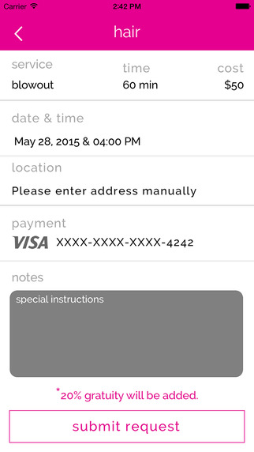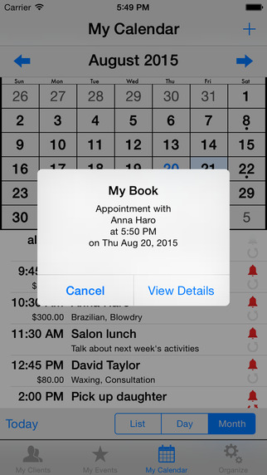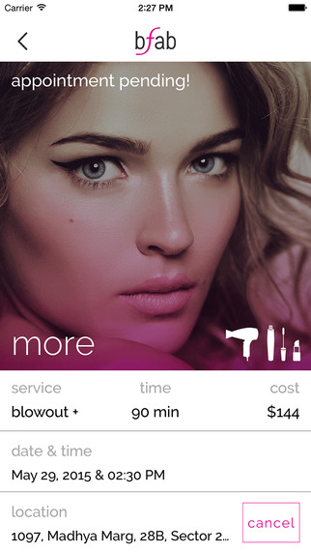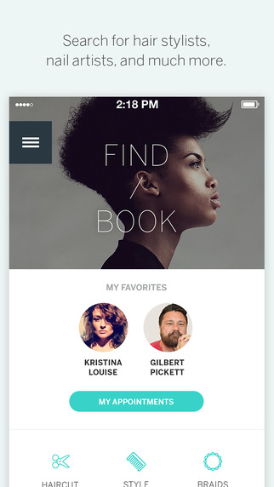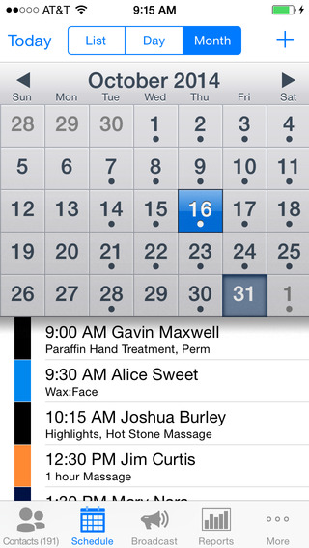

Architectural Flow

