SIMATS ENGINEERING (SAVEETHA SCHOOL OF ENGINEERING)
Department of Artificial Intelligence and Data Science
CO1 - ASSESSMENT TOOL 1 - APPLICATION BASED QUESTIONS
Course Code | DSA03 | Course Title | Natural Language Processing
CO Assessed | CO1 - Imitation (L1) | Assessment | Assessment Tool 1
Student Name | T.MUBEENA | Reg. No. | 192425295
Section / Batch | 2024 | Date | 20/10/26

Code of Conduct: I certify that this submission is my original work and that I have adhered to the guidelines specified for this assessment.
Signature of the Student: ____________________

Contents
- Question 1: Resume Information Extraction
- Question 2: Product Search System
- Question 3: University Registration System
- Appendix: GUI program (gui_app.py)

Question 1: Regular Expressions - Resume Information Extraction

Problem Statement
A recruitment company receives thousands of text resumes daily. An automated system is required to extract candidate details using Regular Expressions and to shortlist eligible candidates (minimum 2 years of experience and Python skill).

Approach
- Resumes are stored as plain-text strings.
- One compiled regular expression is used for each field (name, email, mobile, experience, skills).
- extract_profile() returns a dictionary (structured profile) for each resume.
- is_eligible() applies the shortlisting rule: experience >= 2 years AND Python in skills.
- The main block prints every profile summary and the final shortlisted list; try/except handles errors.

Regular Expressions Used
Pattern | Meaning
^Name\s*:\s*([A-Za-z .]+)$ | Captures the name after the 'Name:' label (MULTILINE mode).
\b[\w.+-]+@[\w-]+(?:\.[\w-]+)+\b | Local part, '@', domain and one or more dot-separated suffixes.
(?:\+91[-\s]?)?\b[6-9]\d{9}\b | Optional +91 prefix followed by 10 digits starting with 6-9.
(\d+(?:\.\d+)?)\+?\s*years? | Integer or decimal number followed by 'year' or 'years'.
\b(Python|Java|SQL|Machine Learning|NLP)\b | Whole-word, case-insensitive match of the required skills.

Python Program (q1_resume.py)
import re

# ---------- Regular expression patterns ----------
NAME_RE = re.compile(r"^Name\s*:\s*([A-Za-z .]+)$", re.MULTILINE)
EMAIL_RE = re.compile(r"\b[\w.+-]+@[\w-]+(?:\.[\w-]+)+\b")
MOBILE_RE = re.compile(r"(?:\+91[-\s]?)?\b[6-9]\d{9}\b")
EXP_RE = re.compile(r"(\d+(?:\.\d+)?)\+?\s*years?", re.IGNORECASE)
SKILL_RE = re.compile(r"\b(Python|Java|SQL|Machine Learning|NLP)\b", re.IGNORECASE)

def extract_profile(text):
"""Extract all required fields from one resume using regex."""
text = text.replace("\r\n", "\n") # handle Windows line endings
name = NAME_RE.search(text)
email = EMAIL_RE.findall(text)
mobile = MOBILE_RE.findall(text)
exp = EXP_RE.search(text)
canon = {"python": "Python", "java": "Java", "sql": "SQL",
"machine learning": "Machine Learning", "nlp": "NLP"}
skills = sorted({canon[s.lower()] for s in SKILL_RE.findall(text)})
return {
"name": name.group(1).strip() if name else "Not found",
"email": email[0] if email else "Not found",
"mobile": mobile[0] if mobile else "Not found",
"skills": skills,
"experience": float(exp.group(1)) if exp else 0.0,
}

def is_eligible(profile):
"""Minimum criteria: >= 2 years experience and Python skill."""
return profile["experience"] >= 2 and "Python" in profile["skills"]

resumes = [
"""Name: Arjun Kumar
Email: arjun.kumar@gmail.com | Mobile: +91 9876543210
Skills: Python, SQL, Machine Learning, NLP
Experience: 3 years as Data Analyst""",
"""Name: Priya Sharma
Email: priya.sharma@outlook.com | Mobile: 8123456789
Skills: Java, SQL
Experience: 4.5 years in backend development""",
"""Name: Rahul Menon
Email: rahul_m@yahoo.in | Mobile: 9012345678
Skills: Python, NLP
Experience: 1 year as Intern""",
"""Name: Divya Lakshmi
Email: divya.l@saveetha.com | Mobile: 7001234567
Skills: Python, Java, Machine Learning
Experience: 2 years as ML Engineer""",
]

if __name__ == "__main__":
profiles = []
print("=" * 55)
print(" STRUCTURED CANDIDATE PROFILE SUMMARY")
print("=" * 55)
for i, resume in enumerate(resumes, 1):
try:
p = extract_profile(resume)
except Exception as err:
print(f"Resume {i}: error -> {err}")
continue
profiles.append(p)
print(f"\nCandidate {i}")
print(f" Name : {p['name']}")
print(f" Email : {p['email']}")
print(f" Mobile : {p['mobile']}")
print(f" Skills : {', '.join(p['skills']) or 'None'}")
print(f" Experience : {p['experience']} years")
print(f" Eligible : {'YES' if is_eligible(p) else 'NO'}")

print("\n" + "=" * 55)
print(" SHORTLISTED (>= 2 yrs experience AND Python skill)")
print("=" * 55)
for p in filter(is_eligible, profiles):
print(f" * {p['name']:<15} {p['experience']} yrs {p['email']}")

Output (Screenshot)
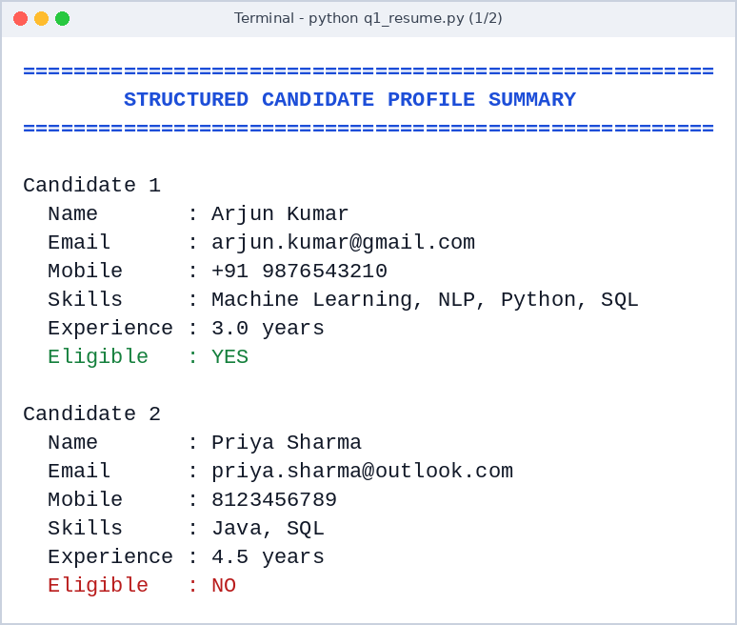
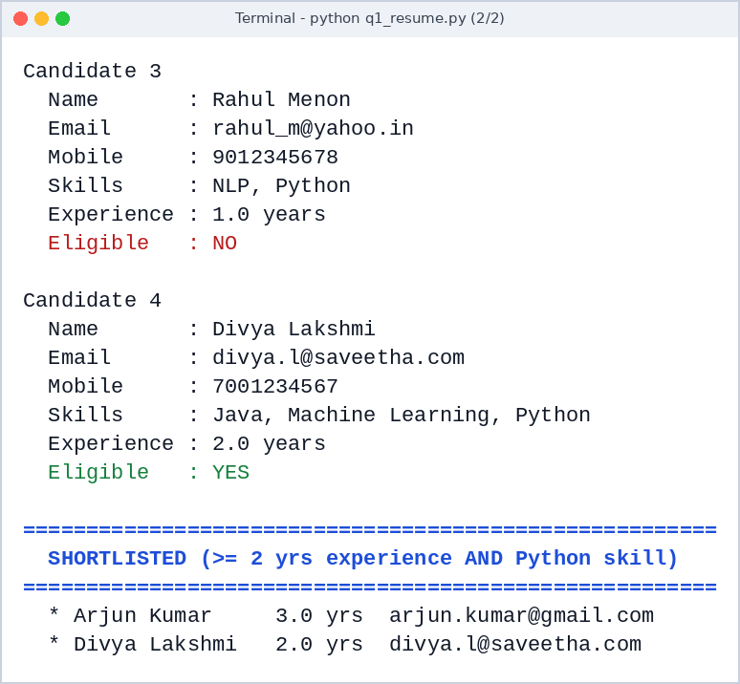

GUI Output (Screenshot)
The resumes are pasted into the text box; clicking Extract & Shortlist shows every candidate profile and the shortlisted candidates (at least 2 years of experience and Python skill).
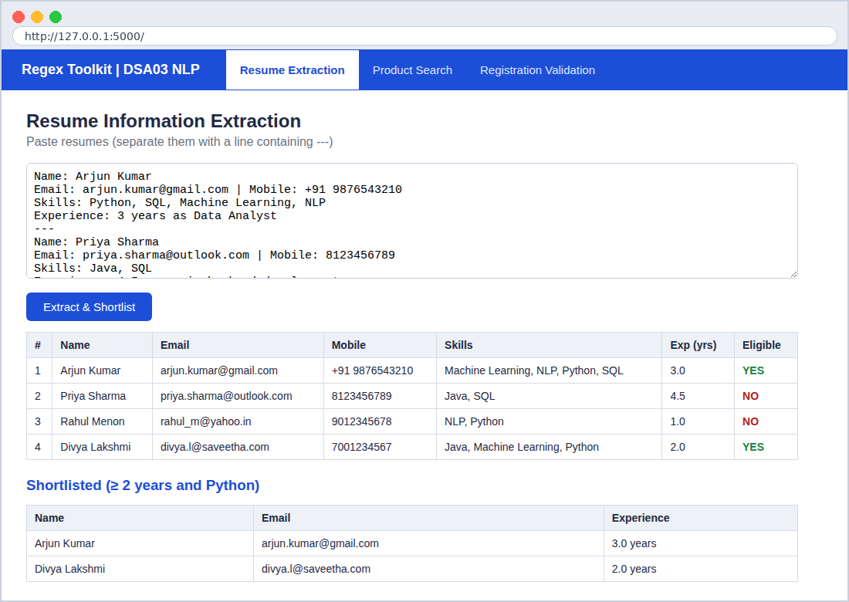

Justification of Output
- Arjun Kumar (3 years, Python) and Divya Lakshmi (2 years, Python) satisfy both conditions, so they are shortlisted.
- Priya Sharma has 4.5 years of experience but no Python skill, so she is rejected.
- Rahul Menon knows Python but has only 1 year of experience, so he is rejected.
- The '+91 ' mobile prefix and the decimal experience value (4.5) are both extracted correctly.

Question 2: Regular Expressions - Product Search System

Problem Statement
An e-commerce company wants flexible keyword matching in its product search. The system must support exact, prefix, suffix, partial and case-insensitive searches, display all matching products and report the number of matches for each search.

Approach
- A single function build_pattern() creates the regex for the selected search mode.
- re.escape() treats the user's keyword as plain text, so special characters cannot break the pattern.
- re.IGNORECASE makes every search case-insensitive.
- search() returns all matching product names; an empty keyword raises ValueError.
- A report table lists the number of matches for each search and the overall total.

Regular Expressions Used
Pattern | Meaning
^keyword$ | Exact - the whole product name equals the keyword.
^keyword | Prefix - the name starts with the keyword.
keyword$ | Suffix - the name ends with the keyword.
keyword | Partial - the keyword appears anywhere in the name.
\bkeyword\b | Whole word - the keyword appears as a separate word.
re.IGNORECASE | Flag that makes all searches case-insensitive.

Python Program (q2_search.py)
import re

products = ["Laptop Bag", "Gaming Laptop", "Wireless Mouse", "Mouse Pad",
"Bluetooth Speaker", "Smart Watch", "Watch Strap", "USB Cable",
"Laptop Stand", "Mechanical Keyboard", "Keyboard Cover",
"Wireless Headphones", "Smartphone", "Phone Case"]

def build_pattern(keyword, mode):
"""Return a compiled, case-insensitive regex for the chosen search mode."""
kw = re.escape(keyword) # treat input as plain text
patterns = {
"exact": rf"^{kw}$", # whole product name
"prefix": rf"^{kw}", # name starts with keyword
"suffix": rf"{kw}$", # name ends with keyword
"partial": kw, # keyword anywhere
"word": rf"\b{kw}\b", # exact word anywhere
}
return re.compile(patterns[mode], re.IGNORECASE) # case-insensitive

def search(keyword, mode):
if not keyword.strip():
raise ValueError("Search keyword cannot be empty")
regex = build_pattern(keyword.strip(), mode)
return [p for p in products if regex.search(p)]

tests = [("laptop bag", "exact"), ("LAPTOP", "prefix"), ("watch", "suffix"),
("wire", "partial"), ("MOUSE", "word"), ("key", "prefix"),
("case", "suffix"), ("tablet", "partial")]

if __name__ == "__main__":
report = []
for keyword, mode in tests:
try:
matches = search(keyword, mode)
except ValueError as err:
print(err); continue
report.append((keyword, mode, len(matches)))
print(f"\nSearch: '{keyword}' | Type: {mode.upper()}")
print(" Matches:", ", ".join(matches) if matches else "No products found")

print("\n" + "=" * 46)
print(f"{'SEARCH REPORT':^46}")
print("=" * 46)
print(f"{'Keyword':<14}{'Search Type':<14}{'Matches':>8}")
print("-" * 46)
for k, m, n in report:
print(f"{k:<14}{m.capitalize():<14}{n:>8}")
print("-" * 46)
print(f"{'Total matches':<28}{sum(n for _,_,n in report):>18}")

Output (Screenshot)
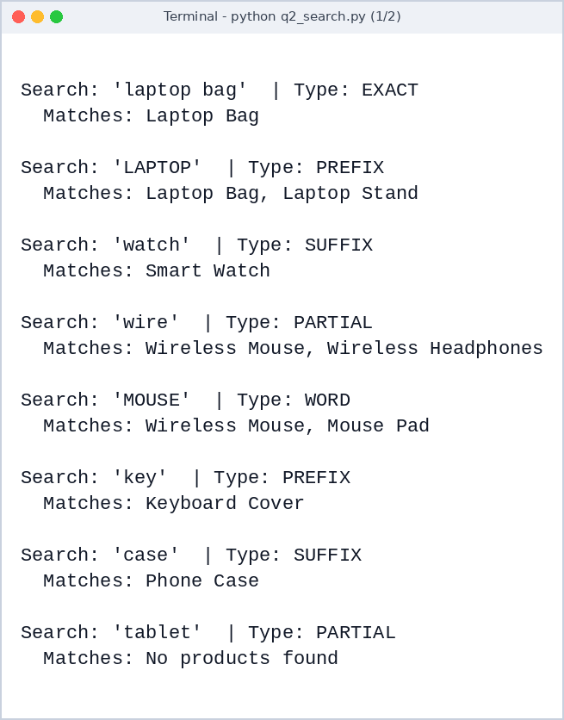
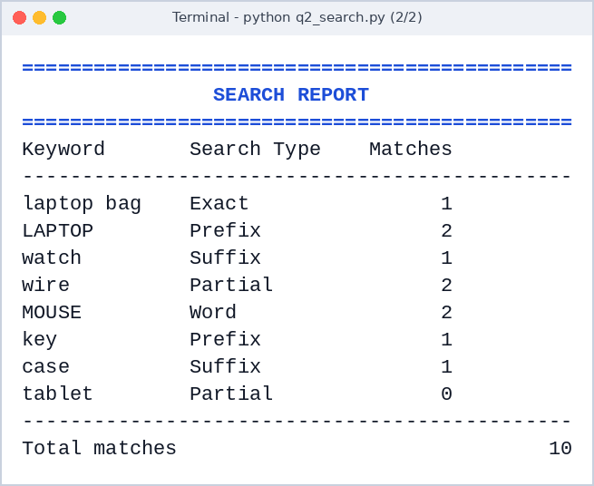

GUI Output (Screenshot)
Top: prefix search for LAPTOP (case-insensitive) listing the matching products. Bottom: the Search Report with the number of matches for each search and the total.
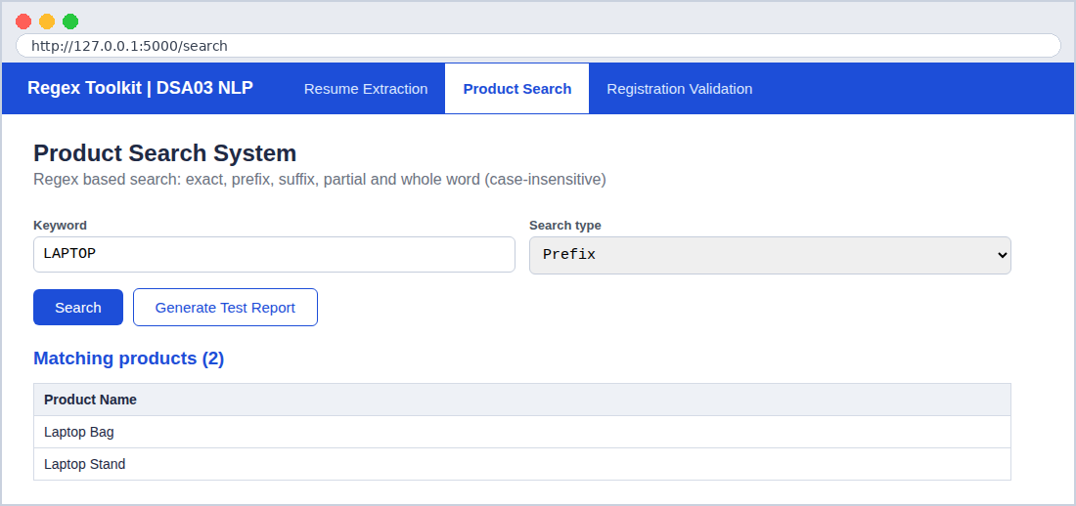
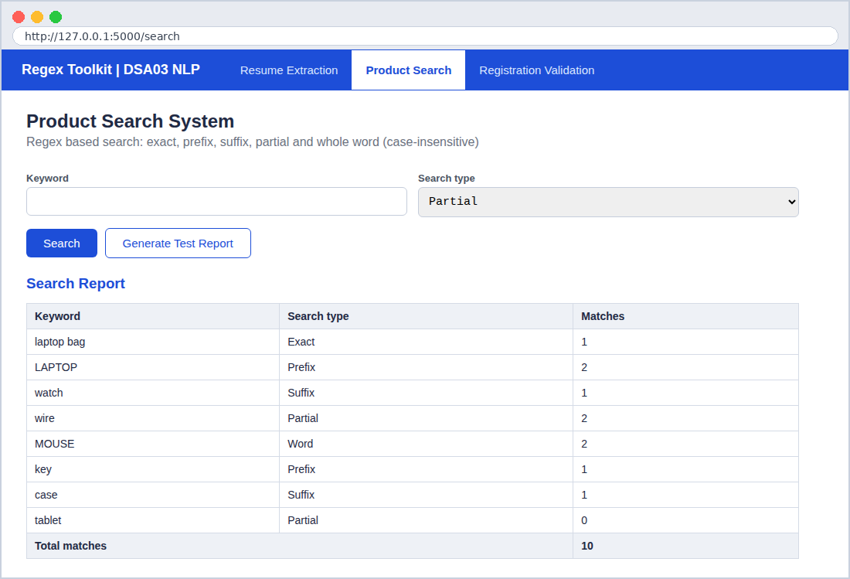

Justification of Output
- 'laptop bag' (exact) matches only 'Laptop Bag'; 'LAPTOP' (prefix) matches two products despite the capital letters.
- 'watch' as a suffix returns 'Smart Watch' but not 'Watch Strap' (it starts with 'Watch').
- 'wire' (partial) finds both Wireless products; 'tablet' correctly returns 0 results.
- Report total = 1 + 2 + 1 + 2 + 2 + 1 + 1 + 0 = 10 matches.

Question 3: Regular Expressions - University Registration System

Problem Statement
A university portal must verify student information before course enrollment. The system must validate the register number, institutional email, course code, semester and mobile number, show a message for every field, and generate a final registration status report.

Approach
- A RULES dictionary maps each field to (regular expression, hint message).
- re.fullmatch() ensures the entire value matches the pattern.
- validate_student() returns PASS/FAIL with a message for each field.
- Registration is successful only if all fields are valid (all()).
- Three test students are used: all valid, all invalid, and one invalid field.

Regular Expressions Used
Pattern | Meaning
^(19|2[0-9])\d{7}$ | Register number: 9 digits starting with 19 or 2X.
^[a-zA-Z0-9._%+-]+@saveetha\.com$ | Institutional email ending with @saveetha.com.
^[A-Z]{3}\d{2}$ | Course code: 3 capital letters + 2 digits (e.g. DSA03).
^[1-8]$ | Semester: a single digit from 1 to 8.
^[6-9]\d{9}$ | Mobile: 10 digits starting with 6, 7, 8 or 9.

Python Program (q3_register.py)
import re

RULES = {
"Register Number": (r"^(19|2[0-9])\d{7}$",
"9 digits, starting with 19 or 2X (e.g. 192411234)"),
"Email": (r"^[a-zA-Z0-9._%+-]+@saveetha\.com$",
"must end with @saveetha.com"),
"Course Code": (r"^[A-Z]{3}\d{2}$",
"3 capital letters + 2 digits (e.g. DSA03)"),
"Semester": (r"^[1-8]$",
"a single digit from 1 to 8"),
"Mobile": (r"^[6-9]\d{9}$",
"10 digits starting with 6, 7, 8 or 9"),
}

def validate_student(student):
"""Validate every field; return a list of (field, value, ok, message)."""
results = []
for field, (pattern, hint) in RULES.items():
value = student.get(field, "").strip()
ok = re.fullmatch(pattern, value) is not None
msg = "Valid" if ok else f"Invalid - {hint}"
results.append((field, value, ok, msg))
return results

students = {
"Student 1": {"Register Number": "192411234", "Email": "rahul.k@saveetha.com",
"Course Code": "DSA03", "Semester": "5", "Mobile": "9876543210"},
"Student 2": {"Register Number": "1924ABC12", "Email": "anu@gmail.com",
"Course Code": "dsa3", "Semester": "9", "Mobile": "5123456789"},
"Student 3": {"Register Number": "202312345", "Email": "meena_s@saveetha.com",
"Course Code": "CSE12", "Semester": "3", "Mobile": "98765"},
}

if __name__ == "__main__":
summary = {}
for name, data in students.items():
print("=" * 62)
print(f"{name} - Validation Results")
print("=" * 62)
results = validate_student(data)
for field, value, ok, msg in results:
print(f" [{'PASS' if ok else 'FAIL'}] {field:<16}: {value:<22} {msg}")
summary[name] = all(ok for _, _, ok, _ in results)
print()

print("=" * 62)
print(" FINAL REGISTRATION STATUS REPORT")
print("=" * 62)
for name, ok in summary.items():
print(f" {name:<12}: {'REGISTRATION SUCCESSFUL' if ok else 'REGISTRATION FAILED'}")

Output (Screenshot)
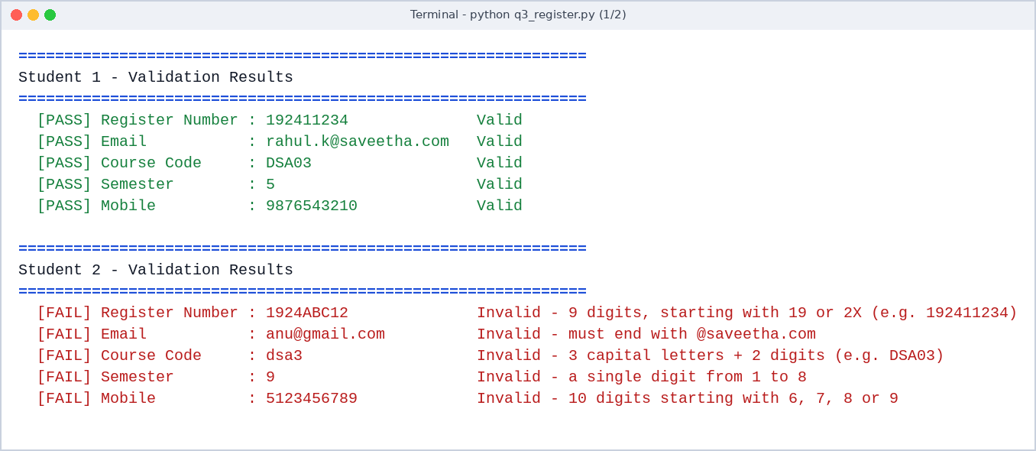
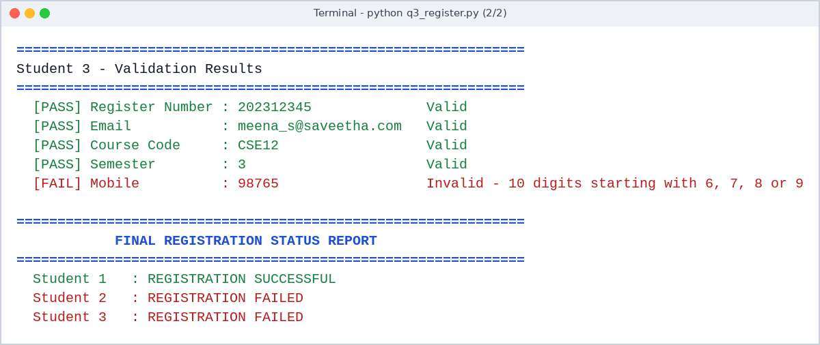

GUI Output (Screenshot)
Top: a student with all valid fields - registration successful. Bottom: a student with invalid fields - each field shows a FAIL message and the registration fails.
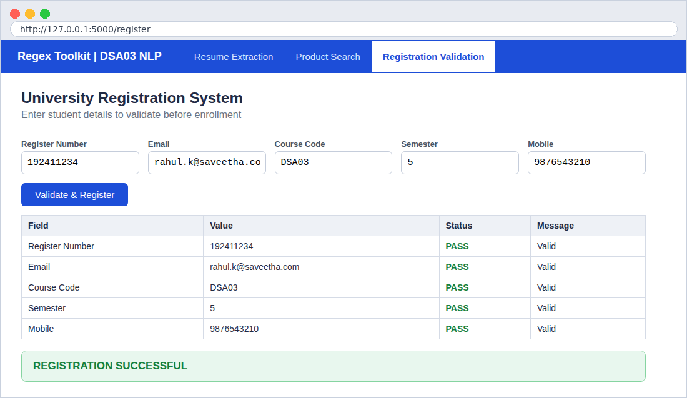
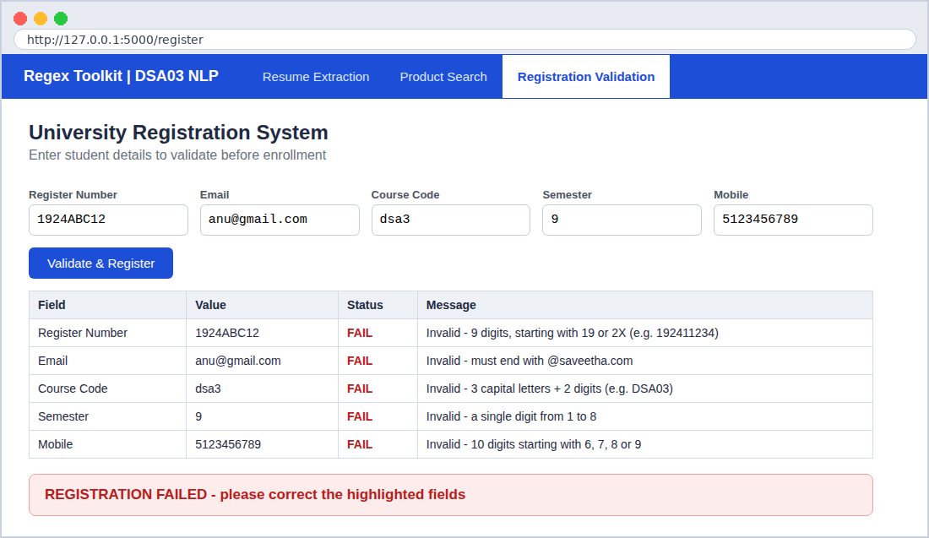

Justification of Output
- Student 1 passes all five rules, so the registration is successful.
- Student 2 fails every rule (letters in the register number, gmail domain, lowercase course code, semester 9, mobile starting with 5).
- Student 3 has valid data except a 5-digit mobile number, so the registration fails.
- A registration succeeds only when every field is valid.

Appendix: GUI Program (gui_app.py)
The GUI is a browser-based application written in Python (Flask). It imports the logic of the three programs above (q1_resume.py, q2_search.py, q3_register.py) and gives each one a form-based interface. To run it: install Flask (pip install flask), keep the four files in the same folder, run python gui_app.py and open http://127.0.0.1:5000 in a web browser.
from flask import Flask, request, render_template_string
import q1_resume as resume # Question 1 logic
import q2_search as product # Question 2 logic
import q3_register as registration # Question 3 logic

app = Flask(__name__)

PAGE = """
<!doctype html><title>Regex Toolkit - DSA03</title>
<style>
body{font-family:Segoe UI,Arial,sans-serif;margin:0;background:#fff;color:#1f2a44}
nav{background:#1d4ed8;padding:0 28px;display:flex;align-items:center}
nav b{color:#fff;font-size:18px;margin-right:34px;padding:16px 0}
nav a{color:#dbe6ff;text-decoration:none;padding:17px 18px;font-size:15px}
nav a.on{background:#fff;color:#1d4ed8;font-weight:600}
main{padding:26px 34px;max-width:1000px}
h2{margin:0 0 4px} p.sub{color:#6b7280;margin:0 0 18px}
textarea,input,select{font:15px Consolas,monospace;padding:9px;border:1px solid #c5cddb;border-radius:6px;box-sizing:border-box}
textarea{width:100%;height:150px}
label{display:block;font:600 13px Segoe UI,Arial;margin:12px 0 4px;color:#4b5563}
button{background:#1d4ed8;color:#fff;border:0;border-radius:6px;padding:10px 22px;font-size:15px;margin:14px 10px 0 0;cursor:pointer}
button.alt{background:#fff;color:#1d4ed8;border:1px solid #1d4ed8}
table{border-collapse:collapse;width:100%;margin-top:14px;font-size:14px}
th{background:#eef1f6;text-align:left} th,td{border:1px solid #d5dbe6;padding:8px 10px}
.ok{color:#15803d;font-weight:600}.bad{color:#b91c1c;font-weight:600}
.banner{margin-top:18px;padding:14px 18px;border-radius:8px;font-size:17px;font-weight:600}
.banner.ok{background:#e8f7ee;border:1px solid #86d4a1}.banner.bad{background:#fdecec;border:1px solid #f1a1a1}
.row{display:flex;gap:14px}.row>div{flex:1}
h3{margin:22px 0 0;color:#1d4ed8}
</style>
<nav><b>Regex Toolkit | DSA03 NLP</b>
<a href="/" class="{{'on' if page=='q1'}}">Resume Extraction</a>
<a href="/search" class="{{'on' if page=='q2'}}">Product Search</a>
<a href="/register" class="{{'on' if page=='q3'}}">Registration Validation</a></nav>
<main>
{% if page=='q1' %}
<h2>Resume Information Extraction</h2><p class="sub">Paste resumes (separate them with a line containing ---)</p>
<form method="post"><textarea name="resumes">{{ text }}</textarea><button>Extract &amp; Shortlist</button></form>
{% if profiles %}
<table><tr><th>#</th><th>Name</th><th>Email</th><th>Mobile</th><th>Skills</th><th>Exp (yrs)</th><th>Eligible</th></tr>
{% for p in profiles %}<tr><td>{{loop.index}}</td><td>{{p.name}}</td><td>{{p.email}}</td><td>{{p.mobile}}</td>
<td>{{p.skills|join(', ')}}</td><td>{{p.experience}}</td>
<td class="{{'ok' if p.eligible else 'bad'}}">{{'YES' if p.eligible else 'NO'}}</td></tr>{% endfor %}</table>
<h3>Shortlisted (&ge; 2 years and Python)</h3>
<table><tr><th>Name</th><th>Email</th><th>Experience</th></tr>
{% for p in profiles if p.eligible %}<tr><td>{{p.name}}</td><td>{{p.email}}</td><td>{{p.experience}} years</td></tr>{% endfor %}</table>
{% endif %}
{% elif page=='q2' %}
<h2>Product Search System</h2><p class="sub">Regex based search: exact, prefix, suffix, partial and whole word (case-insensitive)</p>
<form method="post"><div class="row">
<div><label>Keyword</label><input name="keyword" value="{{ keyword }}" style="width:100%"></div>
<div><label>Search type</label><select name="mode" style="width:100%">
{% for m in modes %}<option value="{{m}}" {{'selected' if m==mode}}>{{m|capitalize}}</option>{% endfor %}</select></div></div>
<button name="action" value="search">Search</button><button class="alt" name="action" value="report">Generate Test Report</button></form>
{% if matches is not none %}
<h3>Matching products ({{ matches|length }})</h3>
<table><tr><th>Product Name</th></tr>{% for m in matches %}<tr><td>{{m}}</td></tr>{% else %}<tr><td>No products found</td></tr>{% endfor %}</table>
{% endif %}
{% if report %}
<h3>Search Report</h3><table><tr><th>Keyword</th><th>Search type</th><th>Matches</th></tr>
{% for k,m,n in report %}<tr><td>{{k}}</td><td>{{m|capitalize}}</td><td>{{n}}</td></tr>{% endfor %}
<tr><th colspan="2">Total matches</th><th>{{ report|sum(attribute=2) }}</th></tr></table>
{% endif %}
{% else %}
<h2>University Registration System</h2><p class="sub">Enter student details to validate before enrollment</p>
<form method="post"><div class="row">
{% for f in fields %}<div><label>{{f}}</label><input name="{{f}}" value="{{ data.get(f,'') }}" style="width:100%"></div>{% endfor %}</div>
<button>Validate &amp; Register</button></form>
{% if results %}
<table><tr><th>Field</th><th>Value</th><th>Status</th><th>Message</th></tr>
{% for f,v,ok,msg in results %}<tr><td>{{f}}</td><td>{{v}}</td><td class="{{'ok' if ok else 'bad'}}">{{'PASS' if ok else 'FAIL'}}</td><td>{{msg}}</td></tr>{% endfor %}</table>
{% if success %}<div class="banner ok">REGISTRATION SUCCESSFUL</div>
{% else %}<div class="banner bad">REGISTRATION FAILED - please correct the highlighted fields</div>{% endif %}
{% endif %}
{% endif %}
</main>"""

@app.route("/", methods=["GET", "POST"])
def resume_page():
text = request.form.get("resumes", "\n---\n".join(resume.resumes)) if request.method == "POST" \
else "\n---\n".join(resume.resumes)
profiles = []
if request.method == "POST":
for block in text.split("---"):
if block.strip():
p = resume.extract_profile(block.strip())
p["eligible"] = resume.is_eligible(p)
profiles.append(p)
return render_template_string(PAGE, page="q1", text=text, profiles=profiles)

@app.route("/search", methods=["GET", "POST"])
def search_page():
keyword = request.form.get("keyword", ""); mode = request.form.get("mode", "partial")
matches, report = None, None
if request.method == "POST":
if request.form.get("action") == "report":
report = [(k, m, len(product.search(k, m))) for k, m in product.tests]
elif keyword.strip():
matches = product.search(keyword, mode)
return render_template_string(PAGE, page="q2", keyword=keyword, mode=mode, matches=matches,
report=report, modes=["exact", "prefix", "suffix", "partial", "word"])

@app.route("/register", methods=["GET", "POST"])
def register_page():
fields = list(registration.RULES)
data = {f: request.form.get(f, "") for f in fields}
results, success = None, False
if request.method == "POST":
results = registration.validate_student(data)
success = all(ok for _, _, ok, _ in results)
return render_template_string(PAGE, page="q3", fields=fields, data=data, results=results, success=success)

if __name__ == "__main__":
app.run(port=5000) # open http://127.0.0.1:5000 in the browser

