**SCOPE OF THE DOCUMENT**

Creating a resume using HTML and CSS can be a great way to showcase my skills and qualifications in a visually appealing format. With HTML and CSS, you have full control over the design and layout of your resume. CSS is used for styling, allowing you to define fonts, colours, layout, and responsiveness.

Ultimately, the goal is to create a visually appealing, well-organized, and easily readable document that highlights your skills and experience to potential employers or recruiters.

**FOLDER STRUCTURE**

Mubeena-Resume

* Code html& css
* Mubeena_Resume.html
* Images
* M_photo.jpg
* Screenshots

Screenshots of the website are present in this folder.

* Resume_Doc

**CONTROL FLOW STRUCTURE**

Click

**TECHNOLOGIES**

Technologies used for creating this web page are:

**1) HTML**

**2) CSS**

**HTML**

HISTORY OF HTML:

HTML stands for Hyper Text Markup Language.

* It is used to share the information over the internet.
* HTML id developed by Tim Berner’s Lee in 1991.But officially in 1993.
* The First version of HTML consists of “18 tags”
* HTML follows certain rules and regulations setup by “ISO”.

(International Organization for standardization). These set of rules and regulation are present in ‘SGML document’.

Versions of HTML:

1. HTML-1 version in the year 1993.
2. Html-2 version in the year 1995.
3. HTML-3.02 version in the year 1997.
4. HTML-4.1 version in the year 1999.
5. HTML-5 version in the year 2014

Features of HTML:

* It is easy to Learn.
* It is a tag based language.
* HTML is supported by multiple browsers.
* First web browser is Netscape navigation which was developed by the “Mosiac”.
* It is a portable language.
* WORA ( write once run anywhere).

Limitation of HTML:

* HTML has less designing capabilities.
* It is dependent on other technology such as CSS in order to develop well designed Web pages.
* HTML has no programming capabilities.
* Using HTML and CSS we can develop only static Web page.
* In order to write the HTML code required an editor such as

VS Code, Notepad, Eclipse.

* In order to execute the HTML code we required Web browsers.

Like Chrome, Firefox, edge, Opera Safari .

**CSS**

* CSS stands for Cascading Style Sheets.
* It was developed by W3C to add styling’s to the HTML elements.
* W3C stands for World Wide Web.com

Versions of CSS:

1. CSS-1 (level-1) in the year 1996.
2. CSS-2 (level-2) in the year 1998.
3. CSS-3 (level-3) in the year 1999.

Why do we required CSS ?

* Since HTML has less designing capabilities we cannot create well designed or most appealing Websites.
* Using HTML we cannot add style, animation and transitions to the Webpage.
* Therefore we require CSS to create well designed Webpages.

Advantages of CSS:

* It allows to add styles, animation and various effects to the Webpage.
* It allows us to develop the Webpage rapidly. It is also know as RAD ( rapid application Developer).
* It allows us to separate from formatting develop page to the presentation of Webpage.
* It allows to create well designed Websites.

Limitations of CSS:

* Using CSS we can perform static styles for the Webpages.
* In order to create dynamic styling for the Websites. We must make use of scripting language such as JavaScript and Libraries of JavaScript.

Types of CSS:

1. Inline CSS
2. Internal CSS
3. External CSS
4. Default Browser CSS

1. Inline CSS:

Defining all the CSS properties within the style attribute inside the opening of the tag is referred to as Inline CSS.

2. Internal CSS:

Defining all the CSS properties within <style> inside the HTML document is referred to as Internal CSS.

3. External CSS:

Defining all the CSS properties within as external Script or File with an extension CSS is referred to as External CSS.

* In order to link external CSS file within the HTML document we must use of <link>.
* The value for the ‘ref’ attribute should be ‘stylesheet’.

**SOURCE CODE**

<!DOCTYPE html>

<html lang="en">

<head>

    <meta charset="UTF-8">

    <meta name="viewport" content="width=device-width, initial-scale=1.0">

    <title>RESUME</title>

    <style>

        body{

            margin: auto;

        }

        #name{

            width: 100%;

            height: 120px;

            background-color:skyblue;

        }

        h2{

            margin-top: 0px;

            padding: 20px;

        }

        a{

            color: white;

            text-decoration: none;

            line-height: 23px;

        }

        .class1{

            margin-top: -10px;

            padding: 40px;

            margin-left: 100px;

            font-family: sans-serif;

            font-size:xx-large;

            text-align: center;

        }

    </style>

</head>

<body>

    <div style="width: 80%;height: 1050px;margin-left: 135px;font-family: sans-serif;">

        <div id="name">

           <h1 class="class1" style="margin-left: -10px;">SHAIK.MUBEENA</h1>

           <p align="center" style="margin-top: -60px;font-family: sans-serif;">Full Stack Developer</p>

        </div>

        <div style="width: 70%;height: 1170px;border-left: 2px solid black;float: right;">

           <img src="M_photo.jpg.jpg" style="height: 150px;width: 150px;float: right;border-radius: 45px 45px;margin-top: -100px;margin-right: 130px;border: 4px solid black;">

            <div style="width: 22%;height: 30px;border: 2px solid black;margin-top: 30px;margin-left: 20px;border-radius: 0px 20px 20px 0px;background-color: skyblue;"><h2 style="margin-top: -18px;font-family: sans-serif;margin-left: -20px;">Summary</h2></div>

            <div style="width: 90%;height: 60px;margin-left: 20px;margin-top: 10px;text-align: justify;line-height: 25px;">&nbsp;&nbsp;&nbsp;&nbsp;&nbsp;&nbsp;&nbsp;I am a graduate in Electrical and Electronics Engineering.I have additional certifications on Java Full Stack Development at Global Quest Technologies.I am a keen learner.I am good at time management.I can contribute 100% on productivity and quality.</p></div>

            <div style="width: 22%;height: 30px;border: 2px solid black;margin-top: 15px;margin-left: 20px;border-radius: 0px 20px 20px 0px;background-color: skyblue;margin-top: 30px;"><h2 style="margin-top: -18px;font-family: sans-serif;margin-left: -20px;">Certifications</h2></div>

            <div style="width: 90%;height: 90px;margin-left: 20px;margin-top: 10px;text-align: justify;font-family: sans-serif;line-height: 25px;">

                <ul>

                    <li class="class2">NPTEL certification on Data Analytics with Python.</li>

                    <li class="class2">NPTEL certification on Fuzzy Stes,Logics Systems & Applications</li>

                    <li class="class2">Certification on Java Full Stack Development</li>

                </ul>

            </div>

            <div style="width: 22%;height: 30px;border: 2px solid black;margin-left: 20px;border-radius: 0px 20px 20px 0px;background-color: skyblue;margin-top: -15px;margin-top: 2px;"><h2 style="margin-top: -18px;font-family: sans-serif;margin-left: -20px;">Projects</h2></div>

            <div style="width: 90%;height: 310px;margin-left: 20px;margin-top: 10px;text-align: justify;font-family: sans-serif;">

                <p style="font-family: sans-serif;text-align: justify;"><b>1.MP3 Player using ARDUINO:</b></p>

                <p style="font-family: sans-serif;text-align: justify;line-height: 25px;">&nbsp;&nbsp;&nbsp;&nbsp;&nbsp;&nbsp;The goal of this project is to demonstrate the use of this module with

                    Arduino, using the push buttons to instruct the Arduino to send serial

                    commands to the module and control mp3. We will use three buttons to

                    achieve this. The first button will serve as the “previous” button that will

                    enable us to play the previous song. The second button will be to “play/pause”

                    the file currently being played and the third button will be used to play the

                    next file.</p>

                <p style="font-family: sans-serif;text-align: justify;"><b>2.Real Time Face Detection using MATLAB:</b></p>

                <p style="font-family: sans-serif;text-align: justify;line-height: 25px;">&nbsp;&nbsp;&nbsp;&nbsp;&nbsp;&nbsp;This project is to determine whether there are any faces in the image and detection of face. While this appears to be a trivial task for human beings, it is very challenging task for computers.Although

                        there have been hundreds of reports approaches for face detection,

                        if one were asked to name a single face detection algorithm that has

                        most impact in recent decades, it will most likely be the Viola and

                        Jones face detection, which is capable of processing images

                        extremely rapidly and achieve high detection rates.</p>

            </div>

            <div style="width: 22%;height: 30px;border: 2px solid black;margin-left: 20px;border-radius: 0px 20px 20px 0px;background-color: skyblue;margin-top: 70px;"><h2 style="margin-top: -18px;font-family: sans-serif;margin-left: -20px;">Internship</h2></div>

            <div style="width: 90%;height: 150px;margin-left: 20px;margin-top: 10px;text-align: justify;font-family: sans-serif;">

                <p style="font-family: sans-serif;text-align: justify;"><b>Solar PV-Simulation and Design:</b></p>

                <p style="font-family: sans-serif;text-align: justify;line-height: 25px;">&nbsp;&nbsp;&nbsp;&nbsp;&nbsp;&nbsp;The objective of this project was to design, build, and operate solar electricity generation at County facility sites.This also aims to provide electricity to the regions like highways, urban and rural areas.This report concludes that how solar energy is the techno-economic feasible option specially for a energy deficient country like India.</p>

            </div>

            <div style="width: 22%;height: 30px;border: 2px solid black;margin-left: 20px;border-radius: 0px 20px 20px 0px;background-color: skyblue;margin-top: 10px;"><h2 style="margin-top: -18px;font-family: sans-serif;margin-left: -20px;">Skills</h2></div>

            <div style="width: 90%;height: 83px;margin-left: 20px;margin-top: 10px;line-height: 25px;">

                <ul>

                    <li>Conceptual Skills</li>

                    <li>Team Work</li>

                    <li>Adaptability</li>

                    <li>Decision Making</li>

                </ul>

            </div>

        </div>

        <div style="width: 30%;height: 1170px;color: white;background-color: rgba(0,0,0,0.7);">

        <h2 style="margin-top: 0px;"><b>Technical Skills</b></h2>

            <ul style="margin-top: -20px;font-family: sans-serif;line-height: 25px;">

                <li >C, CORE JAVA, CORE PYTHON</li>

                <li >HTML5, CSS3, BOOTSTRAP</li>

                <li >JAVASCRIPT (ES6)</li>

                <li>GIT,GITHUB (Basics)</li>

            </ul>

        <h2 style="margin-top: -17px;"><b>Education</b></h2>

        <p style="padding: 30px;font-family: sans-serif;margin-top: -120px;line-height: 25px;"> <li style="line-height: 25px;padding: 30px;"> B-Tech - 2023 in Electrical & Electronics Engineering with CGPA - 7.87 at R.V.R&J.C College of Engineering</p></li>

        <p style="padding: 30px;font-family: sans-serif;margin-top: -60px;line-height: 25px;"><li style="margin-top: -65px;line-height: 25px;padding: 30px;">Intermediate - 2019 at Xperts Junior College with CGPA - 9.21</li>

        <h2 style="margin-top: -40px;"><b>Contact</b></h2>

        <p style="margin-top: -60px;padding: 30px;font-family: sans-serif;line-height: 25px;"><span style="font-size: x-large;">&#9990;</span>&nbsp;&nbsp;+91 6305971592 <br> <span style="font-size: x-large;">&#9993;</span>&nbsp;&nbsp;mubbenasultana27@gmail.com <br>

        <img src="linked1.jpg" width="20px" height="20px">

        <a href="https://www.linkedin.com/in/shaik-mubeena-7233b222b" target="_blank">&nbsp;&nbsp;Shaik Mubeena</a> <br> Yelahanka Satellite Town, <br>Bengaluru,Karnataka 560064.</p>

        <h2 style="margin-top: -50px;">Hobbies</h2>

        <ul style="padding: 30px;font-family: sans-serif;margin-top: -60px;line-height: 25px;">

            <li>Cooking</li>

            <li>Listening to music</li>

            <li>Drawing</li>

        </ul>

        <h2 style="margin-top: -50px;">Languages Known:</h2>

            <ul style="padding: 30px;font-family: sans-serif;margin-top: -60px;line-height: 25px;">

                <li>English</li>

                <li>Hindi</li>

                <li>Telugu</li>

                <li>Urdu</li>

            </ul>

        <h2 style="margin-top: -50px;">Personal Details:</h2>

            <ul style="padding: 30px;font-family: sans-serif;margin-top: -60px;line-height: 25px;">

                <li>DOB: 27/02/2002</li>

                <li>Gender: Female</li>

                <li>Passport Number: WS802540</li>

            </ul>

        </div>

    </div>

</body>

</html>

**Screenshots:**

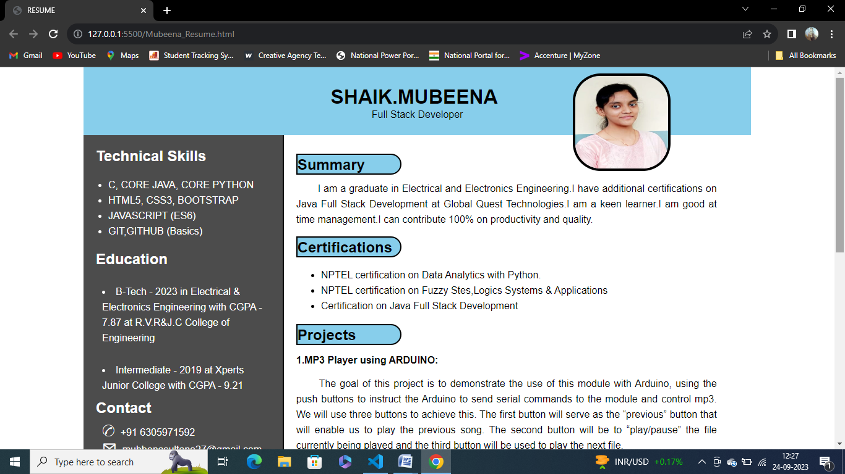

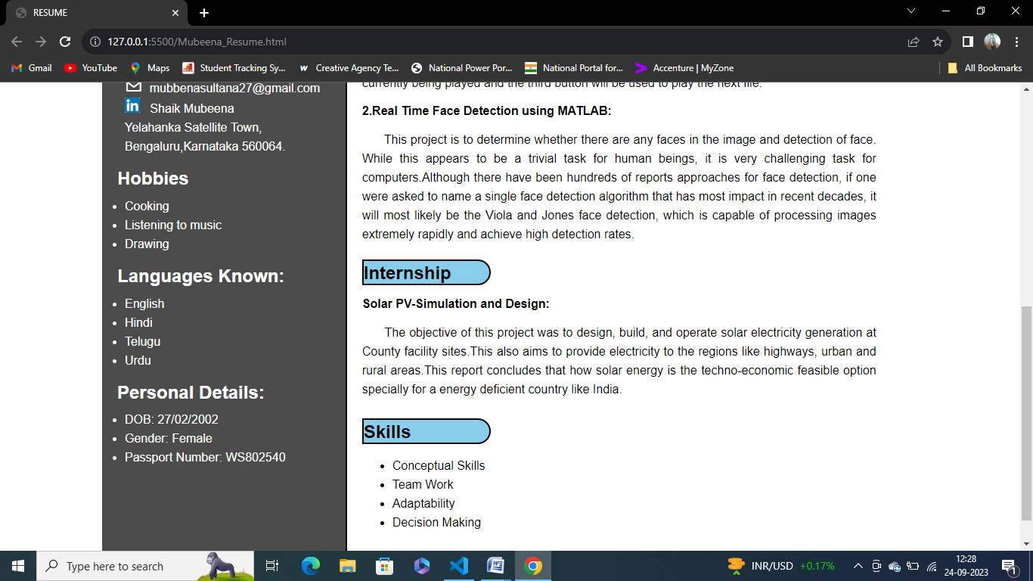

**CONCLUSION**

In conclusion, using HTML and CSS to create your resume gives you the freedom to design a visually appealing and interactive document that can help you stand out in today's competitive job market. Just remember to strike a balance between creativity and professionalism, ensuring that your resume effectively communicates my qualifications and experiences to potential employers.