NM PROJECT DOCUMENTATION
PROJECT REPORT

LegalEase
AI-Powered Legal Document Generator
AI-Assisted Legal Document Drafting and Management System

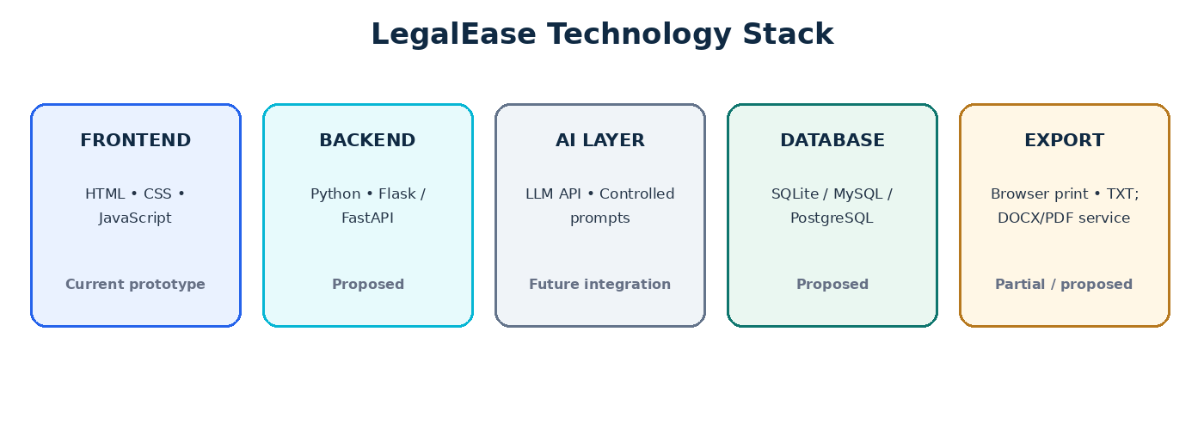

TEAM LEADER
Mubena A
TEAM MEMBERS
Sandhiya V • Gayathri A • Poongodi K

Prepared as an academic project report

Abstract
LegalEase is a web-based project concept designed to make the preparation of common legal-document drafts more structured and approachable. The supplied website prototype provides a document library, guided input fields, a draft preview, local draft saving, and print/PDF and TXT export options. It includes six document categories: Rental Agreement, Employment Agreement, Affidavit, Simple Legal Notice, Confidentiality Agreement, and Non-Disclosure Agreement (NDA).
The report distinguishes implemented prototype behaviour from the proposed full-stack design. In the current standalone HTML/CSS/JavaScript version, document text is assembled from entered fields; an external AI API, server backend, login system, and database are not connected. These are described as future implementation components rather than completed features.

Keywords
Generative AI • Legal document drafting • HTML • CSS • JavaScript • Templates • Document review • Web application

Report Contents
Page | Section | Focus
1 | Cover Page | Project title and team
2 | Abstract and Contents | Summary and report map
3 | Introduction | Background, motivation, users and significance
4 | Problem, Objectives and Scope | Requirements and project boundaries
5 | System Analysis and Features | Existing challenges and proposed solution
6 | Workflow and Use Case | End-to-end generation workflow
7 | System Architecture | Layered architecture and data movement
8 | Frontend and Current Prototype | Website screens and implemented behaviour
9 | Backend and AI Design | Proposed services and responsible generation
10 | Database and API Design | Data entities and endpoint plan
11 | Testing and Evaluation | Test plan and acceptance criteria
12 | Security, Limitations and Future Scope | Privacy, risks and enhancements
13 | Conclusion and References | Summary and team details

1. Introduction

1.1 Background
Legal documents often follow formal structures and contain specific details such as names, addresses, dates, amounts, responsibilities, and declarations. A person who is unfamiliar with document structure may find it difficult to know which information to include and how to organize it consistently. Repeated manual typing can also create avoidable omissions and formatting differences.
LegalEase proposes a guided web workflow in which a user selects a document category, completes a relevant form, generates a structured draft, reviews the result, and exports a copy. The project brings together front-end web development and a planned AI-assisted drafting layer.

1.2 Motivation
The motivation is to reduce repetitive drafting effort and provide a clear starting point for common document types. Instead of beginning with a blank page, users can work through named fields and inspect a consolidated draft. The project is also a practical academic demonstration of interface design, data validation, template-driven content generation, local persistence, and future API integration.

1.3 Target Users
- Students and individuals who need a structured starting point for a basic document draft.
- Small organizations that prepare recurring, template-based documents.
- Project demonstrators who need to show a complete document-creation workflow.

1.4 Importance of the Project
- Guided forms make required information easier to collect systematically.
- A consistent structure can reduce repetitive formatting work.
- An editable preview gives users an opportunity to check the draft before export.
- The modular concept can later support AI services, document storage and additional templates.

1.5 Responsible Use
LegalEase is a drafting aid, not a law firm or a source of guaranteed legal advice. Generated content may be incomplete or unsuitable for a particular jurisdiction. A qualified legal professional should review a document before it is signed or relied upon.

2. Problem Statement, Objectives and Scope

2.1 Problem Statement
People who need a basic legal-document draft may rely on copied templates or manual typing. These approaches can be time-consuming and may leave missing fields, inconsistent wording or poorly organized sections. LegalEase addresses the need for a guided process that collects information, creates a structured draft and provides a review step before export.

2.2 Main Objectives
- Provide a simple interface for selecting a supported document type.
- Collect document-specific information through guided fields.
- Check required information before generating a draft.
- Create a readable, consistently structured document preview.
- Allow the user to edit, save, reopen and export draft content.
- Design a path toward secure accounts, persistent storage and AI integration.
- Make the prototype’s limitations and need for human review explicit.

2.3 Scope
The supplied prototype covers six categories: rental agreement, employment agreement, affidavit, simple legal notice, confidentiality agreement, and NDA. Its main workflow is browser-based and does not require a server to demonstrate the current features. The report also outlines a proposed backend, database, AI service and DOCX/PDF export service for a future full-stack version.

2.4 Functional Requirements
ID | Requirement | Expected behaviour
FR-01 | Select document | Load fields appropriate to the chosen category.
FR-02 | Input details | Collect names, dates, addresses, terms and other fields.
FR-03 | Validate | Prompt the user when the first required fields are missing.
FR-04 | Generate draft | Display a structured draft based on the entered values.
FR-05 | Review/edit | Let the user inspect and edit the preview.
FR-06 | Save/history | Store and reopen drafts in the same browser.
FR-07 | Export | Print/save through the browser or download TXT.

2.5 Non-Functional Requirements
Usability, predictable formatting, responsive layout, maintainability, privacy, secure access and reliable export are important quality goals. Account security, cross-device persistence and server-side reliability remain proposed requirements for a later implementation.

3. System Analysis and Key Features

3.1 Existing Challenges
- Users may not know which details are relevant to each document type.
- Manual drafting can result in missing or inconsistent information.
- Formal legal wording can be difficult for non-specialist users.
- Repeated formatting and copying consume time.
- A document copied from the internet may not fit the user's situation.

3.2 Proposed Solution
LegalEase uses a document-type-specific form schema and a consolidated preview. Each category has its own set of input fields. The draft is built from those fields and displayed in a readable format. Users can review, copy, print, save a local draft, or download a text file.

3.3 Main Features in the Supplied Website
Feature | Description | Prototype status
Document library | Six selectable document categories with template buttons. | Implemented
Dynamic form | Fields change according to selected document type. | Implemented
Required-field check | Checks the first two fields before draft generation. | Basic validation
Draft preview | Shows a structured text draft and allows editing. | Implemented
Local history | Saves up to 20 drafts in browser localStorage. | Implemented
Copy / TXT | Copy preview text or download a .txt file. | Implemented
Print / PDF | Uses browser print dialog; user may choose Save as PDF. | Browser-dependent
AI API integration | Connects an LLM to generate legal language. | Not connected
Accounts / database | Server login and persistent database storage. | Not connected

3.4 Why Templates Matter
Templates provide a stable structure and predictable headings. A future clause library could supply reviewed clause options based on document type and input conditions. AI should adapt or explain content within controlled boundaries rather than being treated as the sole authority for legal structure.

3.5 Example
For a rental agreement, the user enters landlord and tenant details, property address, rent, deposit, tenancy dates, notice period, utility arrangements and maintenance responsibilities. The prototype places those values into a structured draft. The user must check every value and clause before using it.

4. System Workflow and Use Case
The workflow below reflects the intended user journey. In the current prototype, the validation and draft-building steps occur in the browser. AI service calls and server-side storage are future extensions.
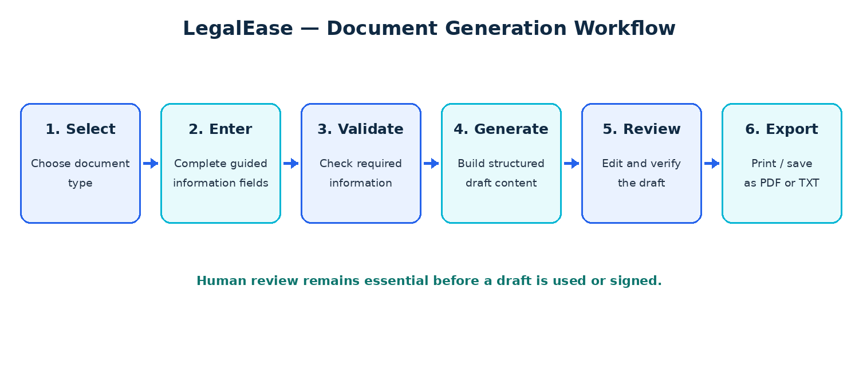
Figure 1. LegalEase document-generation workflow

4.1 Workflow Steps
- Select a document type from the document library or generator dropdown.
- Complete the relevant guided form fields and provide accurate information.
- Run basic validation; required information must be supplied before generation.
- Build the structured draft using the selected document schema and entered values.
- Review the preview for names, dates, amounts, responsibilities and missing details.
- Edit if necessary, then save the draft locally, copy it, print/save as PDF or download TXT.

4.2 Primary Use Case
Item | Description
Actor | Individual user
Precondition | Website is open in a modern browser.
Trigger | User selects a document type and starts entering details.
Main flow | Fill fields → generate → review/edit → save or export.
Alternative flow | If required fields are missing, the website displays a prompt.
Postcondition | A draft is shown and may be saved or exported by the user.

4.3 Human Review Checkpoints
The user should verify spelling, dates, monetary values, party roles, jurisdiction-specific requirements and all obligations. The system should never describe an automatically generated draft as legally valid merely because it has been produced successfully.

5. System Architecture
The proposed full-stack architecture separates the user interface from application logic, data storage, templates, AI generation and export. This separation improves maintainability and allows individual components to be tested independently.
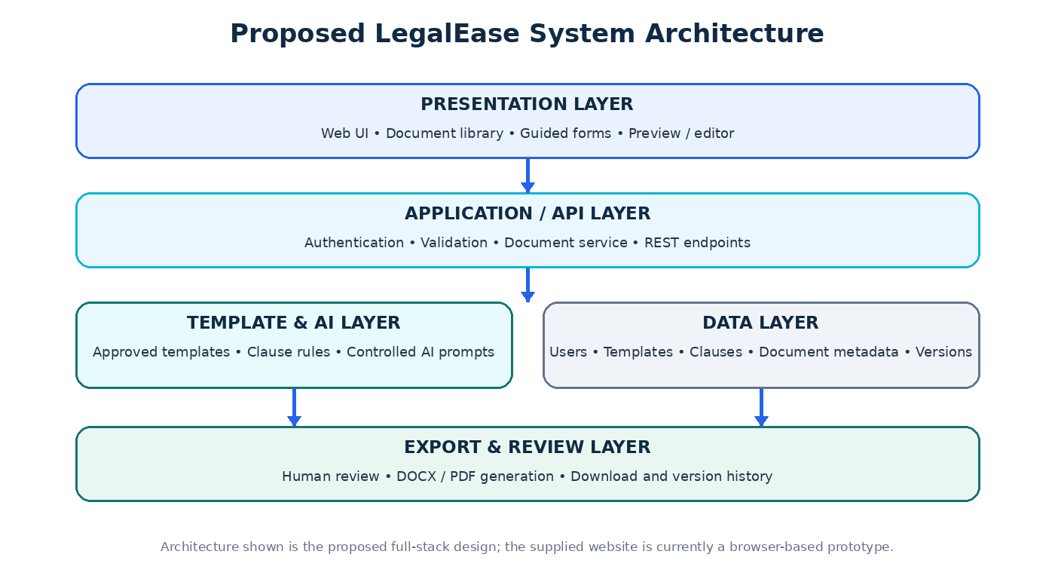
Figure 2. Proposed layered architecture for a future full-stack version

5.1 Presentation Layer
Provides the document library, dynamic forms, preview/editor, history and export controls. The supplied prototype uses HTML, CSS and JavaScript.

5.2 Application / API Layer
A future Python backend using Flask or FastAPI can validate incoming requests, enforce authorization, select templates, coordinate AI generation, save document versions and return results to the frontend.

5.3 Template, Clause and AI Layer
This layer selects the correct document structure and any approved clauses. It can construct a controlled prompt for an LLM, receive proposed wording and run consistency checks before returning a draft.

5.4 Data and Export Layers
A database can store account records, template metadata, clauses and document versions. An export service can create consistently formatted DOCX/PDF files after user review. In the current prototype, drafts are stored in browser localStorage and printing is handled by the browser.

6. Frontend and Current Prototype Implementation
Figure 3. Technology overview; labels identify current and proposed components

6.1 Frontend Technologies
Technology | Role in LegalEase
HTML | Defines page sections, navigation, forms, cards, preview and FAQ.
CSS | Controls colour palette, responsive layouts, spacing, cards and typography.
JavaScript | Loads form schemas, validates initial fields, assembles drafts, manages local history and export actions.
Browser localStorage | Stores saved draft entries on the current browser/device.

6.2 Main User Interface Areas
- Home / hero area introduces LegalEase and links to the generator and document library.
- Document Library presents six document categories with template-selection actions.
- Generator workspace places document fields beside the generated draft preview.
- My Documents lists saved local drafts and provides open/delete actions.
- FAQ explains the prototype, local storage behaviour and AI integration status.

6.3 Implementation Notes
The website uses predefined field schemas for each document category. The generated text includes a document heading, the entered field values, a drafting note and signature placeholders. The preview can be edited before printing or downloading.
Important accuracy note: although the page describes an AI-powered project concept and includes an AI-style workflow, the supplied standalone code does not call a Gemini or other LLM API. Its current draft assembly is template/field-based. A genuine AI integration requires a backend or secure server-side API layer; secret API keys should not be placed in public frontend code.

7. Proposed Backend and AI Integration

7.1 Backend Responsibilities
A backend service would act as the trusted coordinator between the frontend, templates, database, AI provider and export service. Python with Flask or FastAPI is a suitable proposed option; the exact framework can be selected during implementation.
Service | Responsibility
Request validation | Check document type, field types, required values and input length.
Template service | Load the correct structure and versioned approved clauses.
Generation service | Build a controlled prompt and call the configured AI provider.
Post-processing | Check key values, required sections and output structure.
Document service | Create, update, retrieve and version draft records.
Export service | Generate a formatted file after user review.

7.2 AI-Assisted Generation Pipeline
- Receive only the fields required for the selected document.
- Choose a maintained template and any approved clauses relevant to the case.
- Build a document-specific prompt that instructs the model not to invent missing facts.
- Call the AI provider from the backend using a protected API key.
- Check the response for required headings, missing values and unexpected changes.
- Show the result as an editable draft with a clear review notice.

7.3 Prompt and Output Controls
- Use a separate prompt template for each supported document type.
- Treat user input as data, not as instructions that can override system rules.
- Represent missing values explicitly; do not invent names, dates, amounts or laws.
- Keep a record of the selected template and document version where appropriate.
- Do not claim legal validity or replace review by a qualified professional.

7.4 AI Provider Integration
The project document mentions a generative AI/LLM service and a possible future verified legal knowledge base. No provider is connected in the supplied HTML file. Provider selection, privacy terms, costs, data retention and jurisdiction-specific source verification must be assessed before integration.

8. Proposed Database and API Design

8.1 Suggested Data Entities
Entity | Example fields | Purpose
Users | user_id, name, email, password_hash, created_at | Account and access management
DocumentTypes | type_id, name, description, status | Supported document categories
Templates | template_id, type_id, content, version | Reusable document structure
Clauses | clause_id, type_id, name, content, condition | Approved reusable clauses
GeneratedDocuments | document_id, user_id, type_id, title, status, timestamps | Document ownership and metadata
DocumentVersions | version_id, document_id, content, version_number, created_at | Revision history

A relational database such as SQLite, MySQL or PostgreSQL could be used. For a small academic prototype, SQLite may be sufficient; production use would require suitable access controls, backups and deployment planning.

8.2 Example REST API Endpoints
Method / Endpoint | Purpose
POST /api/auth/register | Create an account.
POST /api/auth/login | Authenticate a user.
GET /api/document-types | Return supported document categories.
GET /api/document-types/{id}/form | Return the fields for one category.
POST /api/documents/generate | Validate input and create a draft.
GET /api/documents | List the authenticated user's documents.
GET /api/documents/{id} | Retrieve one authorized document.
PUT /api/documents/{id} | Update an editable draft.
POST /api/documents/{id}/export | Create a downloadable output file.

8.3 Proposed Project Folder Structure
Folder | Contents
frontend/ | Pages, reusable components, styles and API client
backend/routes/ | Authentication, document and export endpoints
backend/services/ | Validation, templates, AI orchestration and export logic
backend/models/ | Database models and schemas
backend/templates/ | Document templates and approved clause sets
database/ | Schema, seed data and migration files
docs/ | Project report, test cases and sample outputs

These entities, endpoints and folders are proposed design elements; they are not present as a running server in the supplied standalone website.

9. Testing and Evaluation Plan
Testing should confirm that each supported document type loads the correct fields, that entered values appear accurately in the draft, and that save/export controls behave as expected. The following tests are recommended for the supplied prototype and for any later full-stack implementation.
Test ID | Test scenario | Expected result
T-01 | Open website in a modern browser | Main sections load without layout-breaking errors.
T-02 | Choose each of six document categories | Correct category and field set are displayed.
T-03 | Leave one of the first two required fields blank | Generation is blocked and a prompt appears.
T-04 | Enter valid sample details and generate | Draft preview contains the submitted values.
T-05 | Edit preview text | Edited content remains visible before export.
T-06 | Save a generated draft | Draft appears in My Documents on that browser.
T-07 | Reopen and delete a saved draft | Correct draft opens; delete removes it from local history.
T-08 | Download TXT | A text file is created with the preview content.
T-09 | Print / Save PDF | Browser print dialog opens; output is checked for layout.
T-10 | Clear form | Input fields and current preview are reset.
T-11 | Future backend: access another user's document | Unauthorized access is denied.
T-12 | Future AI integration: use incomplete or conflicting input | System flags uncertainty and does not invent facts.

9.1 Evaluation Criteria
- Functional correctness: fields, buttons, preview and local history behave as designed.
- Content accuracy: entered names, dates and amounts appear without unintended changes.
- Usability: a first-time user can complete a draft with minimal guidance.
- Formatting: headings, paragraphs and signatures remain readable in exported output.
- Responsible messaging: the draft warning remains visible and unambiguous.

9.2 Testing Limitation
This report defines a test plan; it does not claim that all tests have been executed. Actual results should be recorded after the website is run in the target browser and each case is checked.

10. Security, Limitations and Future Scope

10.1 Security and Privacy
- Collect only information needed for the selected document.
- Avoid storing sensitive legal content longer than necessary.
- For a backend version, hash passwords securely and authenticate every private-document request.
- Use parameterized database operations and validate inputs on the server as well as the frontend.
- Keep AI API keys on the server; never embed secret credentials in browser JavaScript.
- Explain whether document content is sent to an external AI provider and how it is handled.

10.2 Current Prototype Limitations
- The supplied implementation is a standalone browser prototype, not a deployed full-stack application.
- Draft generation assembles structured text from entered fields; a live AI API is not connected.
- Saved drafts use localStorage and are not synchronized across browsers or devices.
- There is no user registration, login, server database or cloud backup in this version.
- The required-field check is basic and does not validate every field or legal requirement.
- Printing to PDF depends on browser print settings; direct DOCX export is not implemented.
- Generated wording is not a guarantee of legal sufficiency or compliance.

10.3 Future Enhancements
Enhancement | Value
Secure accounts and database | Private, persistent document history.
Live LLM integration | More flexible natural-language drafting within controlled templates.
DOCX/PDF export service | Consistent document formatting and download.
Expanded validation | Check dates, amounts, field formats and cross-field consistency.
Multilingual interface | Support additional Indian languages after quality review.
Verified legal retrieval | Retrieve relevant, licensed and maintained sources with traceability.
Version comparison | Highlight changes between draft versions.
Accessibility improvements | Keyboard support, clear labels and assistive-technology compatibility.

Each enhancement should be tested for reliability, privacy and responsible use before it is presented as complete.

11. Conclusion
LegalEase demonstrates a practical way to organize the preparation of common legal-document drafts through guided forms, reusable structures, a reviewable preview and simple export options. The supplied website provides the foundation for a browser-based demonstration with six document categories and local draft history.
The project also defines a path toward a more complete system that connects a frontend to a backend API, database, controlled AI generation service and document export layer. Keeping those components separate can improve maintainability and make future expansion easier. However, the current HTML prototype should not be described as having a connected AI API, authentication system or server database, because those features are not implemented in the supplied file.
The central design principle is responsible assistance: LegalEase can help structure information and create a starting draft, while users retain control over review and final approval. All drafts should be checked for factual accuracy and suitability for the intended situation and applicable law.

Project Summary
Item | Details
Project title | LegalEase — AI-Powered Legal Document Generator
Current frontend | HTML, CSS and JavaScript
Current persistence | Browser localStorage
Current output | Editable preview, browser print/save PDF, TXT download
Proposed backend | Python with Flask or FastAPI
Proposed database | SQLite / MySQL / PostgreSQL
Proposed AI layer | LLM service with controlled prompts and approved templates
Core workflow | Select → Input → Validate → Generate → Review → Export

Source Documents and References
- User-provided file: LegalEase.html.docx — source code for the standalone LegalEase website prototype.
- User-provided file: NM LegalEase_AI_Powered_Legal_Document_Generator-.docx — original NM project concept and proposed full-stack design.
- Technology choices and API endpoints in this report are documented as proposed design options, not evidence of an already deployed service.

Team Members
Team Leader: Mubena A
Team Members: Sandhiya V • Gayathri A • Poongodi K

— END OF REPORT —

