MONOPOLISTIC COMPETITION

Monopolistic competition is one of the four market structures, which includes perfect competition, monopolistic competition, oligopoly and monopoly. Monopolistic competition is a market model where many firms compete by selling similar but not identical products. In monopolistic competition, firms have some control over the price they charge due to product differentiation, but they face competition from other firms in the industry.

Here are the key characteristics of monopolistic competition:

1. Large number of firms: The market consists of numerous firms, each having a relatively small market share. There is no single dominant firm that controls the entire market.
2. Differentiated products: Each firm produces a slightly different product or offers a unique brand, creating product differentiation. This differentiation can be based on factors such as quality, design, packaging, location, or marketing.
3. Easy entry and exit: Firms can enter or exit the market relatively easily due to low barriers to entry.
4. Some control over price: Due to product differentiation, firms have some degree of control over the price they charge. However, they cannot charge a price that is significantly higher than their competitors, or else consumers will switch to a close substitute.
5. Non-price competition: Firms engage in non-price competition, such as advertising and promotion, to differentiate their products and attract customers.

EXAMPLE

To better understand monopolistic competition, let's take an example of a Pakistani market, the clothing industry. In this industry, there are many firms that produce and sell clothes, such as Khaadi, Gul Ahmed, Alkaram, and many others. Each firm offers slightly different designs, materials, and quality, creating product differentiation. Consumers choose a particular brand based on their personal preferences, budget, and style. Although firms have some control over the price they charge, they cannot charge significantly higher prices than their competitors, or else consumers will switch to a close substitute.

GRAPHS

MONOPOLISTICALLY COMPETITIVE FIRM IN THE SHORT RUN

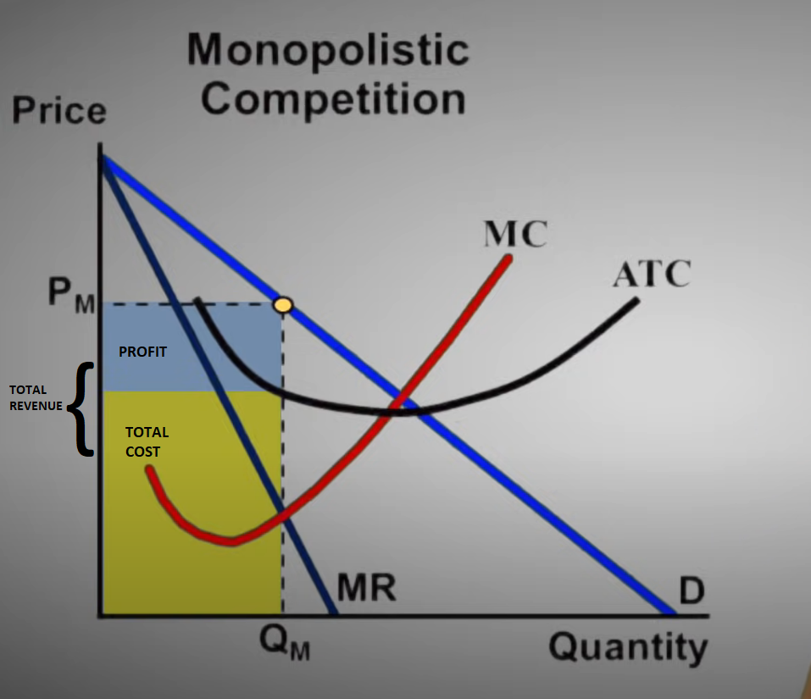

MONOPOLISTICALLY COMPETITIVE FIRM IN THE LONG RUN

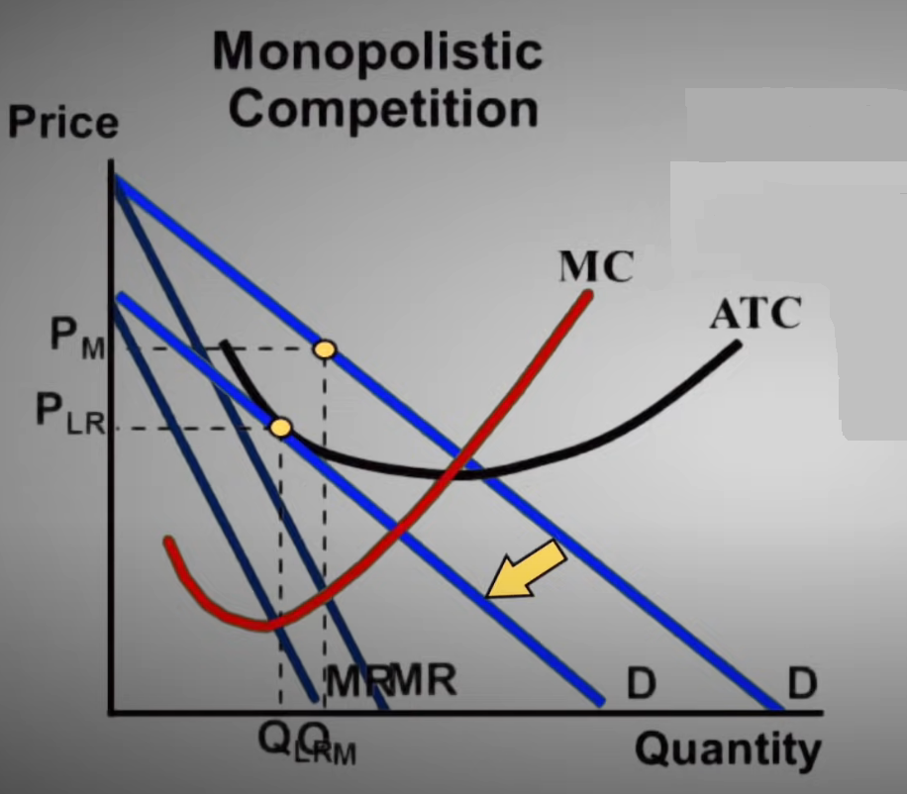

When new firms enter the market, ATC does not shift but consumers get more substitutes so the demand falls.

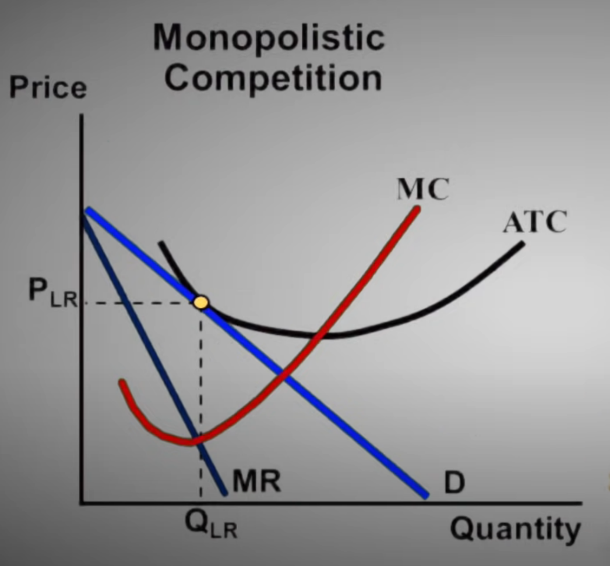

The total revenue is equals to the total cost so there is no profit in the long run.