**Oligopoly**

**s**

**Definition and Characteristics:**

Oligopoly is derived from the Latin words olgoi,meaning "few," and plé, which means "to sell.", hence the word "few sellers".

In Economics, an oligopoly is a market structure where a small number of dominant companies have significant market power and control. Due to their market dominance, oligopolistic enterprises can somewhat regulate the prices, output, and other market factors. Oligopolies exist in a number of sectors like: banking, telecommunications, and car manufacturing. It is an important concept in economics since it is crucial to understand in economics. You can determine an oligopoly by utilizing the concentration ratio or the Herfindahl-Hirschman Index.

An Oligopoly market has 6 main characteristics:

**1. A Few Companies with a Significant Market Share:**

An oligopoly market is dominated by a few large companies.

**2. High barriers to entry:**

High barriers to entry such as economies of scale, capital requirements, and government regulations, brand loyalty make it difficult for new companies to enter the market.

**3. Interdependence:**

Oligopoly companies are interdependent. This means that the actions of one company can have a significant impact on other companies in the market.

**4. Each firm has little market power of its own:**

Due to their interdependence and inability to set their own prices, oligopolistic firms often engage in non-price competition such as advertising, product differentiation, and innovation to gain competitive advantage. Price rigidity:

**5. Higher price than perfect competition:**

Since Oligopoly firms have accumulated market power they tend to keep prices high in order to generate greater profits.

**6. Product Differentiation:**

It refers to a company's strategy in the market to differentiate its products from its competitors. Since there are few competitors, companies can differentiate their products in various ways such as quality, design, function and branding to gain competitive advantage.

**Example:**

When we consider the Pakistani market, several Oligopoly examples come to our mind like the cement sector, pharmaceuticals, telecom and oil. Today we will be discussing the Pakistani automobile industry. Suzuki,Toyota and Honda are the major shareholder of the automobile referred to as “The Big Three”. In recent years, many new players (Hyundai,Kia) have entered the market however they couldn’t make an impact due to barriers like: brand loyalty, spare availability of the big three products,etc. The recent dollar freefall shows that interdependence of the market, with Toyota initiating the price raise followed by Suzuki Honda and the others. However if one of them does it only they will lose their clientele hence they engage in non price competition like advertising,etc. Moreover since they have the market power and share, their significantly higher. The big three remain safe because of their large operations which is really expensive for the new entrants.

**Graphs:**

There are several graphs to understand an Oligopoly market but we will be looking at a Kinked Demand Curve:

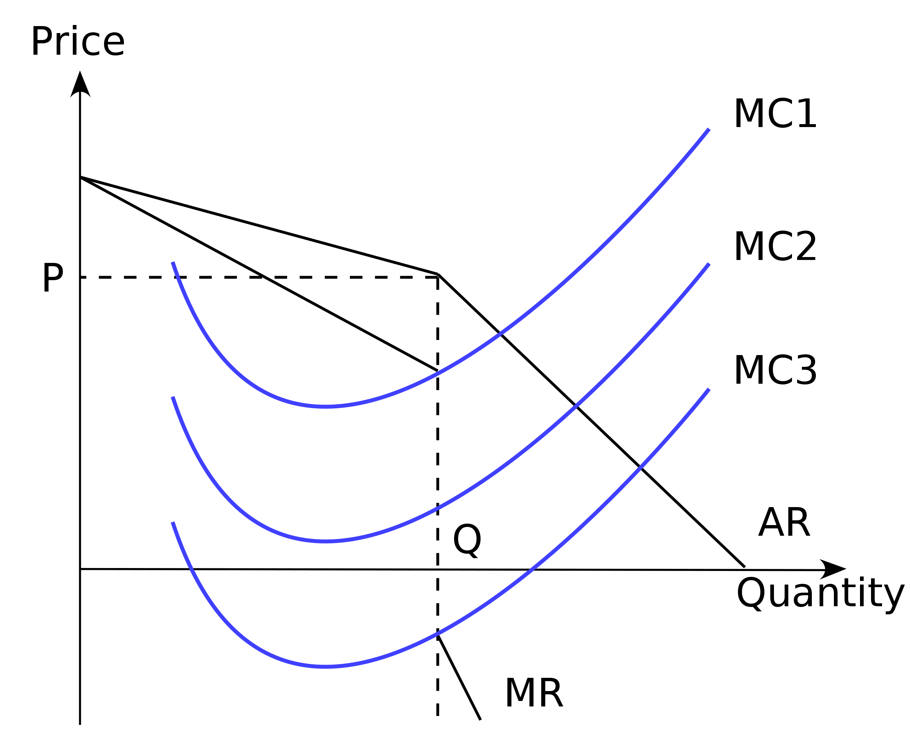

In the Kinked demand curve model, firms maximize profits at P1 in the first quarter. where MR=MC. Therefore, changing the MC cannot change the market price. This suggests that prices will remain fairly stable.

A curved demand curve makes certain assumptions

1. Business is profit maximization.
2. If one company raises prices, other companies will not follow suit. Therefore, demand becomes price elastic when prices rise.
3. When one firm lowers its price, others follow suit because they don't want to lose market share. Therefore, demand becomes price inelastic when prices fall.

This is how you get the "Kinked demand curve".However, it has its limits;

1. It is not explained how the award came about in the first place.
2. Businesses can compete on price.